Supplementary Material

Evolution of Nb-oxide nanoprecipitates in Cu during reactive mechanical alloying
Qun Li^{1, *}, Xuekun Shang^{2, *}, Blanka Janicek¹, Pinshane Y. Huang¹, Pascal Bellon¹ and Robert S. Averback¹

¹Department of Materials Science and Engineering,

University of Illinois at Urbana-Champaign, IL 61801, USA

²Collaborative Innovation Center of Steel Technology,

University of Science and Technology Beijing, Beijing 100083, China

STEM-EELS acquisition and processing
Aberration-corrected STEM-EELS was performed on a Nion UltraSTEM 100 equipped with a Gatan Enfinia spectrometer and operated at 100 kV. Images and spectra were acquired with a 25 mrad convergence angle, ~ 40 pA probe current, and 0.25 eV dispersion. The pixel size in the spectral maps was varied from 0.3-0.6 nm using a range of dwell times from 0.1-0.5 seconds/pixel. Elemental maps were generated by performing power-law background subtraction and integration of the O-K, Nb-M_{4,5}, and Cu-L_{2,3} edge in matlab. To improve signal to noise all spectra included were lightly smoothed using a Savitsky-Golay filter.

5 nm
Fig. S1. EELS composite elemental map from the encircled core-shell precipitate in Fig. 5(a). Nb is in red, O in green and Cu in blue.

Effect of post-annealing on stoichiometry and coarsening resistance of Nb oxides
The XRD results of as-annealed samples are shown in Fig. S2. During heat treatment, Ag precipitated out while NbO₂ was the only Nb-oxide phase detected by XRD, and the stoichiometry of the niobium oxide phase, NbO₂, reflects the quantitative ratio between Nb and O globally in the powder system. Using Scherrer equation and FWHM of the NbO₂ peaks, we find the size of NbO₂ to be ~ 30 nm. Figs. S3(a, b) are HAADF-STEM images of (8+4) samples annealed at 500 ºC and 700 ºC for two hours; the dark precipitates are Nb oxides and the bright regions are Ag grains. A precipitate size distribution taken from each STEM image is presented in Figs. S3(c) and S3(d); a bimodal size distribution extracted from each histogram is shown, indicating that after annealing there are two groups of Nb oxide precipitates centered around very different averages sizes. The group of larger precipitates is believed to have transformed from core-shell precipitates during heat treatment, whose average size falls in a somewhat narrow range (~ 26.2 ± 2nm after 500 ºC annealing and ~ 31.6 ± 1.4nm after 700 ºC annealing) similar to that deduced from XRD. The other group of precipitates is much smaller (~ 9.8 ± 0.6nm after 500 ºC annealing and ~ 9.6 ± 0.5nm after 700 ºC annealing). These precipitates have a similarly high number density as the larger ones, and a narrow size distribution. It is possible that these are smaller NbO₂ that have transformed from nano-crystalline NbO, but they could also be another oxide that was not detected by XRD due to their smaller size.
The stable bimodal size distribution indicates that two types of Nb oxides show very good coarsening resistance. It could be attributed to a low interface energy of nano-crystalline NbO and core-shell Nb oxides in Cu that significantly reduce the driving force for thermal coarsening, in spite of an increased mobility of Nb atom at 500 ºC (the lowest annealing temperature) and a prominent difference in the size of two groups of Nb oxide precipitates (Ostwald ripening).

Fig. S2. XRD results on (8+4) hours samples annealed at 500 °C, 600 °C, 700 °C for 2 hours. Besides Ag, NbO₂ (~ 30nm) precipitated out.

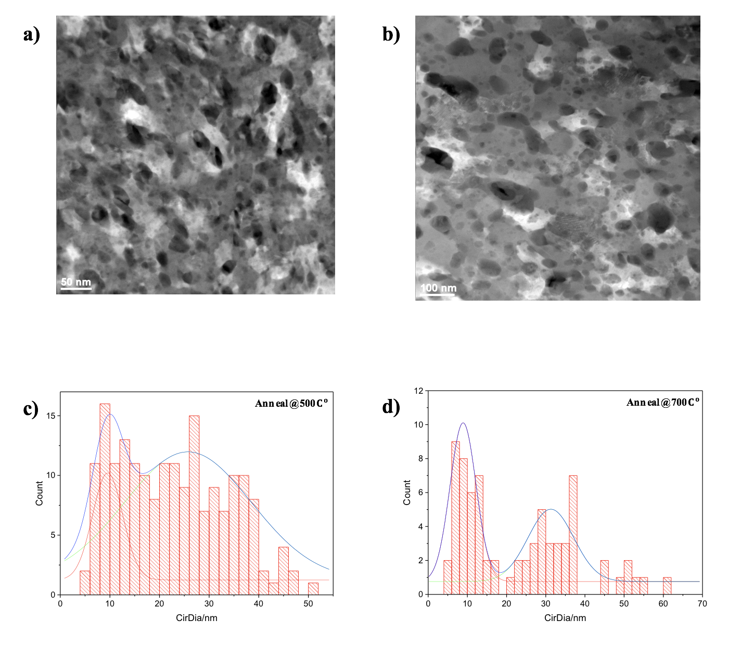
Fig. S3. HAADF-STEM images of (8+4) samples annealed at 500 °C and 700 °C, size distribution of precipitates for each heat treatment condition. (a) Microstructure after annealing at 500 °C for 2 hours, bright regions are Ag-rich. (b) Microstructure after annealing at 700 °C for 2 hours. (c) Precipitate size distribution after annealing at 500 ºC for 2 hours. (d) Precipitate size distribution after annealing at 700 °C for 2 hours. A bimodal distribution is shown after profile deconvolution: one is centered around 10nm and the other peak is centered around 20 ~ 30nm.

