Supporting Information
Epitaxial Growth of Mg_{x}Ca_{1-x}O on 4H-SiC (0001) and β-Ga₂O₃(-201) Wide Bandgap Semiconductors with ALD
Xiabing Lou‡, Xian Gong‡, Sang Bok Kim, Roy G. Gordon
X. Lou, S.B. Kim, Prof. Roy G. Gordon
Department of Chemistry and Chemical Biology
Harvard University
Cambridge, MA 02138, USA

X. Gong, Prof. Roy G. Gordon
John A. Paulson School of Engineering and Applied Sciences
Harvard University
Cambridge, Massachusetts 02138, United States

X.Lou‡ and X.Gong‡ contributed equally.

Corresponding Author
Prof. R. G. Gordon
E-mail: gordon@chemistry.harvard.edu

Keywords: epitaxy, atomic layer deposition, dielectric

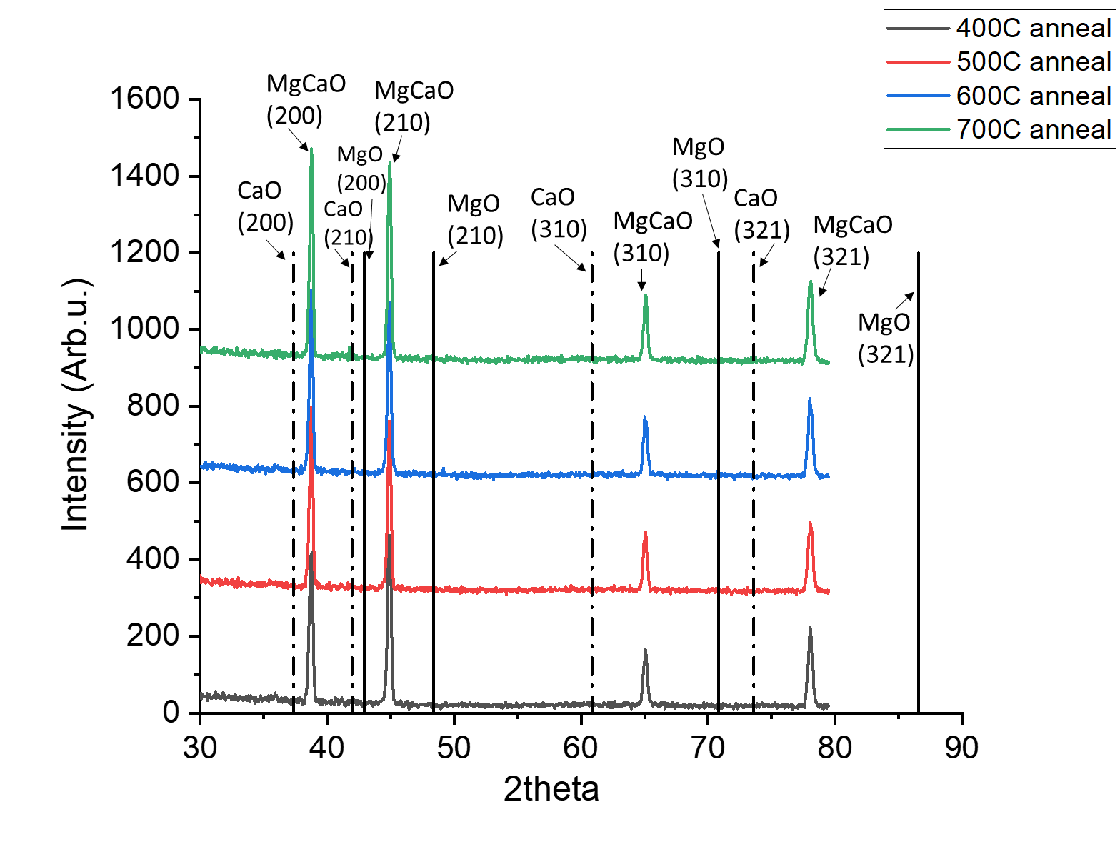
Figure S1. XRD of annealed Mg_{0.25}Ca_{0.75}O film under 400℃, 500℃, 600℃, 700℃. No phase separation is observed. Black dash lines are representing CaO diffraction peaks while black solid lines are MgO diffraction peaks.

Figure S2. TEM diffraction pattern of pure Ga₂O₃ substrate.

