Supplementary material for:

Phase evolution of RF magnetron sputtered Cr-rich (Cr,Zr)₂O₃ coatings studied by in situ synchrotron X-ray diffraction during annealing in air or vacuum

L. Landälv^{,a,b}, L. Rogström^{c} , J. Luª, D. Ostach^{d}, F. Erikssonª, M. Junaidª, N. Ghafoorª, E. Ekströmª,
C.-L. Hsiaoª, H. Leiste^{e}, M. Ahlgren^{b}, E. Göthelid^{b}, B. Alling^{f}, L. Hultmanª, M. Stüber^{e}, N. Schell^{d}, J. Birchª,
P. Eklund^{,a}

ª Thin Film Physics Division, Department of Physics, Chemistry, and Biology (IFM), Linköping University, Linköping SE-581 83, Sweden
^{b} Sandvik Coromant AB, Stockholm SE-126 80, Sweden
^{c} Nanostructured Materials, Department of Physics, Chemistry and Biology (IFM), Linköping University, Linköping SE 581 83, Sweden
^{d} Helmholtz-Zentrum Geesthacht, Max-Planck-Str. 1, D-215 02 Geesthacht, Germany
^{e} Karlsruhe Institute of Technology (KIT), Institute for Applied Materials (IAM), 763 44 Eggenstein-Leopoldshafen, Germany
^{f} Theoretical Physics, Department of Physics, Chemistry, and Biology (IFM), Linköping University, Linköping SE-581 83, Sweden

- Additional experimental details
For the air annealed sample, the diffractogram acquired before starting the computer macro used during the annealing study (controlling the diffractogram capture) was only 1 capture instead of 5 as described in experimental details. Hence, for this work, the intensity in this diffractogram is multiplied by five to match the intensity scale of the other diffractograms.

- Heating rate and calibration of annealing temperature
The air annealing started by a single heating step to reach 540 °C, matching roughly the deposition temperature of 500 °C, which took 13.5 min and correspond to a voltage of 8 V. This was followed by a hold period of 11 min. The voltage was then increased every 5 min in steps of 0.5 V from 8 V (590 °C thermocouple calibrated temp) up to a max value of 17.5 V corresponding to 1180 °C (thermocouple calibrated temp). The entire gradual heating step from 8-17.5 V before starting to cool to RT took 110 min. The cooling down to RT took 21 min.
The heating rate during annealing in vacuum was 50 °C/min from the starting hold temperature of 400 °C (calibrated T). The annealing time from this hold temperature until max T (1600 °C pyro T, 1140 °C calibrated T) was 21.5 min followed by a hold period of 7 min. The time to reach the same temperature as the maximum temperature reached for the air annealed sample (1300 °C pyrometer T, 975 °C calibrated temperature) was 15.5 min.
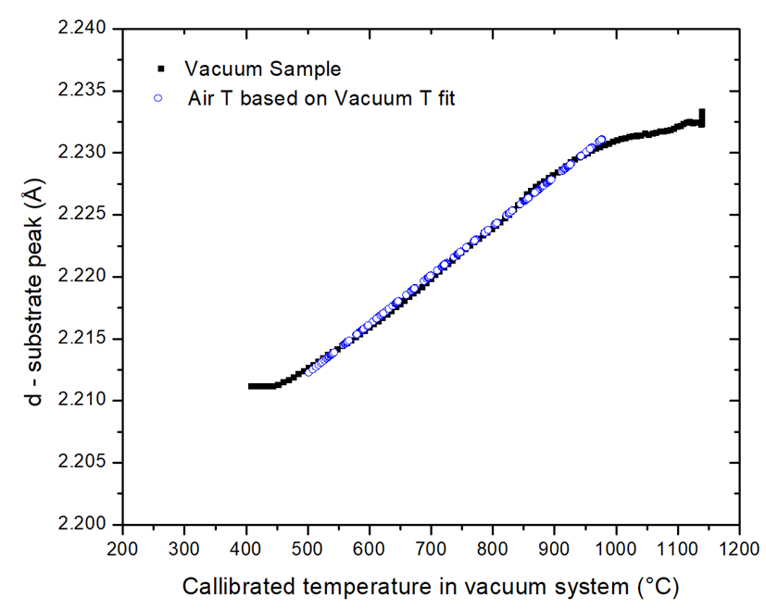
When evaluating the data based upon the original temperature calibration with thermocouple the thermal expansion of the substrate didn’t match. Three substrate planes (d-spacing 1.17, 2.20, and 4.06 Å) obtained through diffraction in the vacuum setup was then selected to be evaluated with respect to its thermocouple-calibrated temperature, d(T). The evaluation of d-spacing with temperature for these three substrate peaks gave linear relationships up to ~900 °C, followed by slightly decreased slope for further increased temperature. The change of slope was correlated with the onset of softening of the substrate. According to the specification of this high temperature resistant, TNB-V2 alloy, the working temperature of the alloy is up to ~900 °C, before mechanical properties are lost. The linear relationship d(T) obtained for the thermal expansion of the three substrate lattice planes was then rearranged to an expressions of T(d). Applying these respective linear relationships for each of the three studied peaks to the d-values obtained for the same three peaks in the air annealed samples resulted in a calibrated d(T) evolution for the air annealed sample. The three peaks evaluated gave slightly different maximum temperature (d-spacing 1.17 (976 °C), 2.20 (976 °C), and 4.06 Å (942 °C), where the two shorter lattice plane distances resulted in a 34 °C higher temperature. This value was judged the more reliable one due to larger shifts in d-value with changing temperature for smaller lattice spacing, hence larger delta d (T) relative the resolution of the XRD setup. This recalibration, based on the vacuum samples d(T), finally showed that the maximum temperature reached for the air-annealed samples was 976 °C instead of 1178 °C (according to air thermocouple calibration), ~160 °C lower than the maximum achieved temperature (1140 °C ) for the vacuum annealed sample. This difference in maximum attained annealing temperature needs to be considered when comparing the post-annealed properties of the air and vacuum sample. FIG. with calibrated substrate d-spacing, d(T), for vacuum and air samples can be found in supplementary information, FIG. S1. The reason for the discrepancy in annealing temperature is thought to be due to a too narrow focal range of the used heating lamp in the air annealing setup. This made the setup too sensitive to the sample position which inhibited the air annealed sample to reach the same temperature as the vacuum annealed sample.
FIG. S1. d-spacing of one substrate peak as a function of the calibrated temperature In the vacuum annealing chamber for the quick heating case 50 °C/min (black). The blue/white circles show the calibrated temperatures values for the air-annealed sample using the slope obtained from the linear part of the vacuum annealed T(d) data. (See web-version for color)

- Additional diffractograms
FIG. S2 show the XRD-pattern for the d-spacing range of 1.15-1.5 Å with increasing annealing temperature in vacuum, 50 °C/min heating rate. There one can see the increased peak intensity at ~1.9 Å with is attributed to the (211) of bbc-Cr. In FIG. S3 and S4 the bcc-Cr peaks after annealing (marked with green boxes) are compared to XRD-scan from as-deposited coatings.
FIG. S5 and S6 show the corresponding diffractograms of before and after annealing in air. They show the absence of similar large bcc-Cr-peaks.
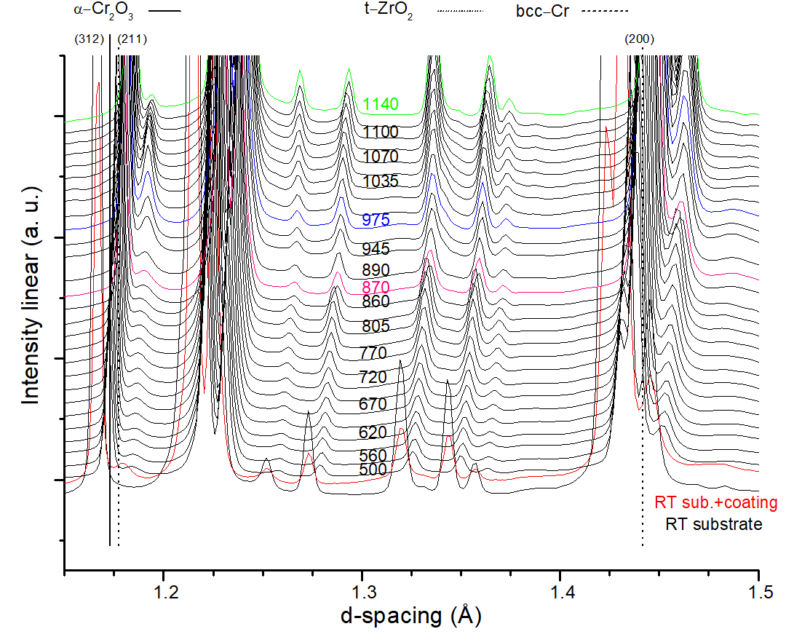
FIG. S7 and S8 show the comparison between the three annealed samples at the maximum annealing temperature of air (975 °C). This is the material used for relative peak intensities comparison and shows larger t-ZrO₂ fraction over α-Cr₂O₃ in vacuum compared to the air-annealed sample. Slower vacuum annealing heating rate, comparable to air annealing heating rate, gives larger t-ZrO₂ transformation.
FIG. S2. Vacuum annealing 50 °C/min, smaller lattice spacing showing the bcc-Cr peak evolution with increasing annealing temperature at ~1.9 Å. Temperature given in °C. (See web-version for color)
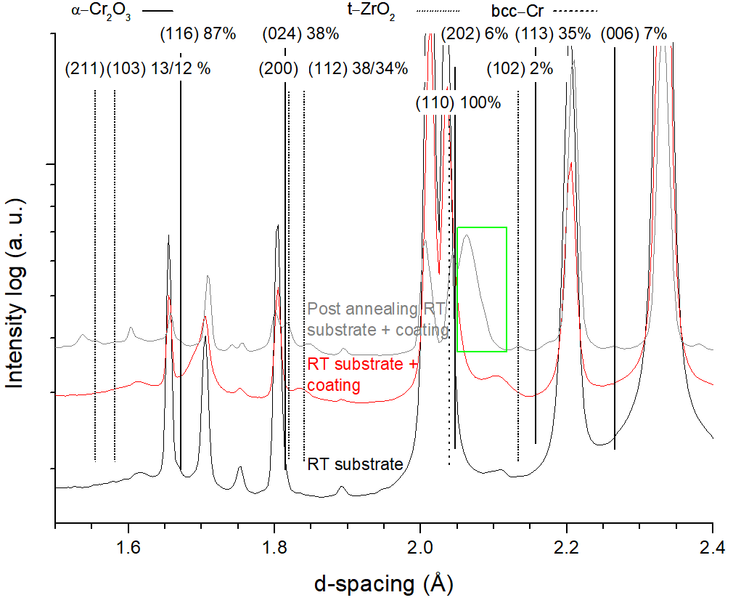
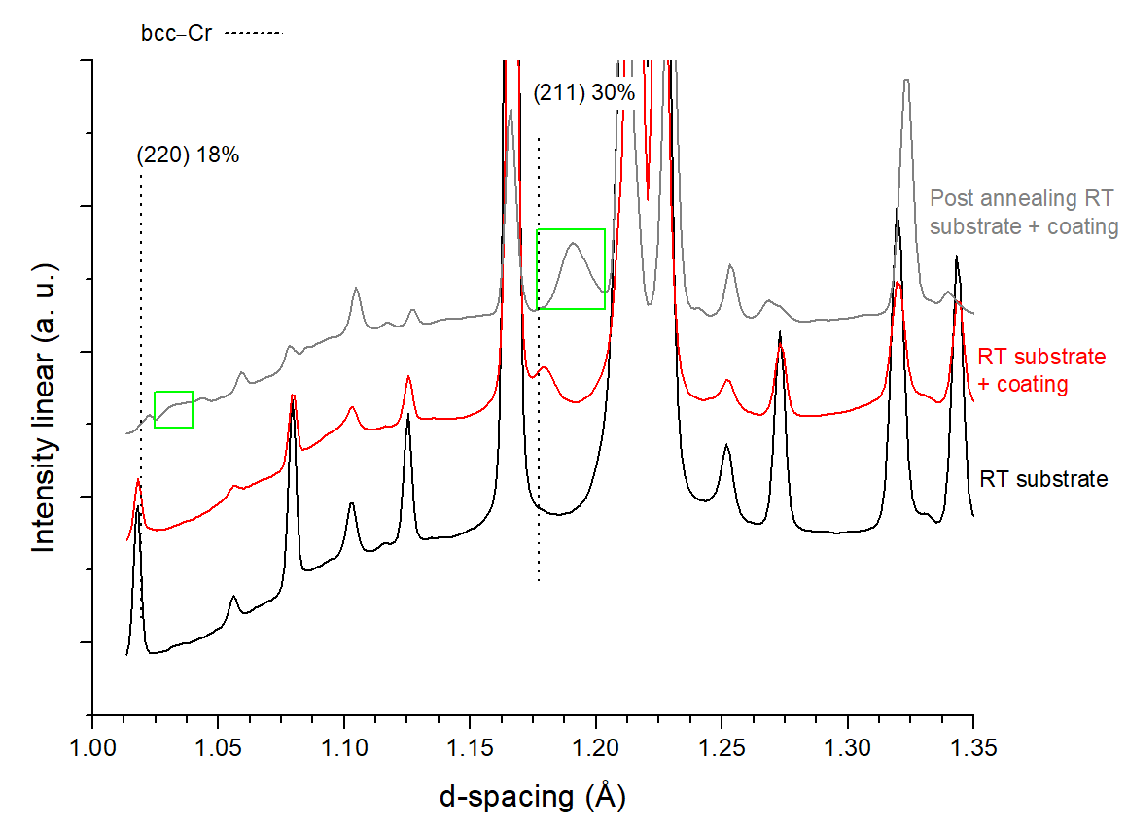
FIG. S3. Vacuum annealing 50 °C/min, 1-1.35 Å lattice spacing before and after annealing. The peaks attributed to the bcc-Cr peaks, primarily (211) at ~1.19 Å, are marked with green boxes. Data is shifted vertically for clarity. (See web-version for color)
FIG. S4. Vacuum annealing 50 °C/min, 1.5—2.4 Å lattice spacing before and after annealing showing the bcc-Cr peak, (110) at ~2.06 Å. (See web-version for color)

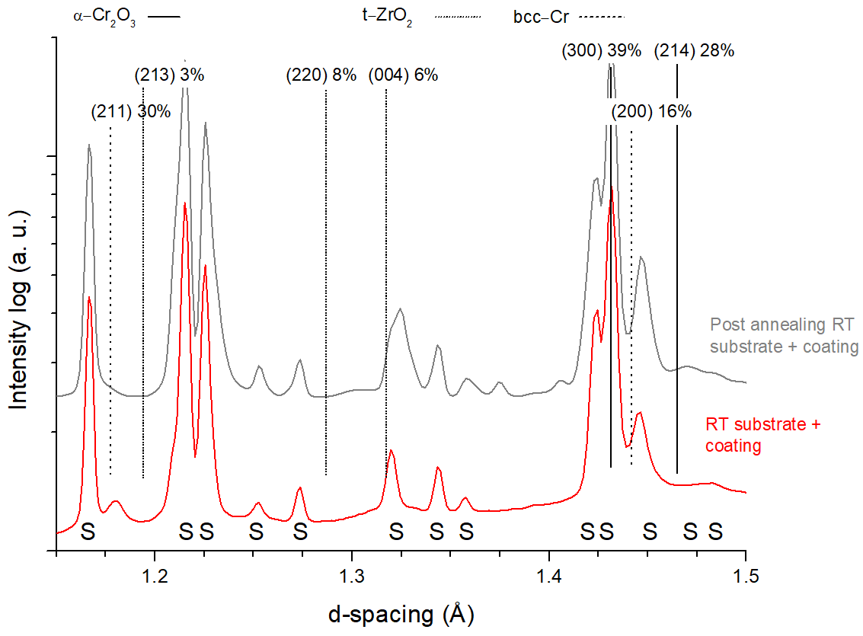
FIG. S5. Air annealing, 1.15—1.5 Å lattice spacing before and after annealing showing the bcc-Cr peak regions with no or very small visible peaks after annealing in the (211) and (200) positions at 1.19 and 1.47 Å, respectively, shifted with ~1-2%. (See web-version for color)
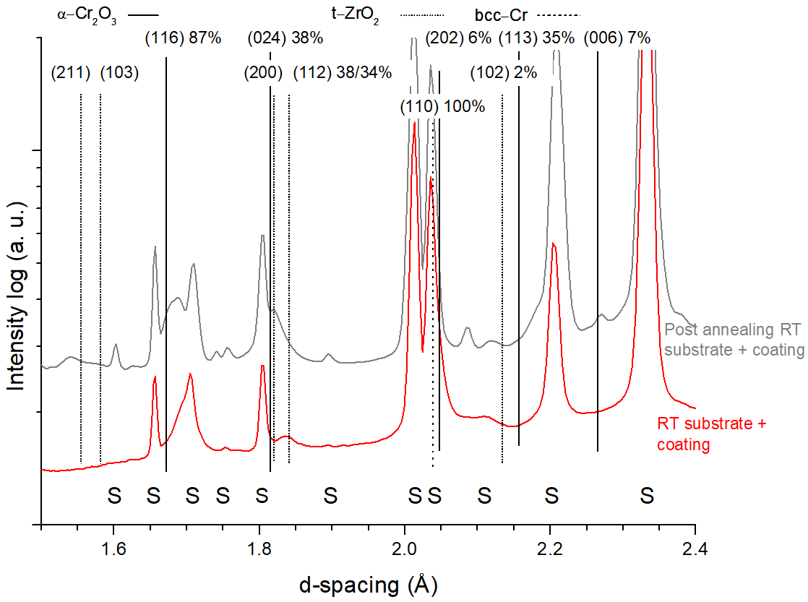
FIG. S6. Air annealing, 1.5—2.4 Å lattice spacing before and after annealing showing the bcc-Cr peak, (110) at ~2.086 Å. (See web-version for color)
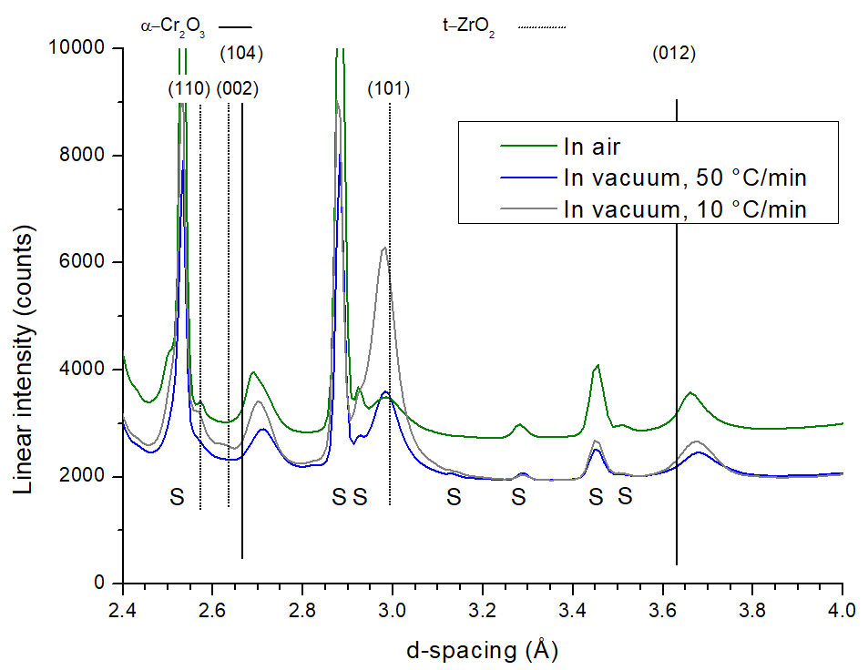
FIG. S7. XRD comparison at 975 °C annealing temperature for the 2.4—4 Å lattice spacing range, showing the difference in peak intensity for the primary Cr₂O₃ and ZrO₂ peaks when annealing in air compared to two different heating rates in vacuum. (See web-version for color)
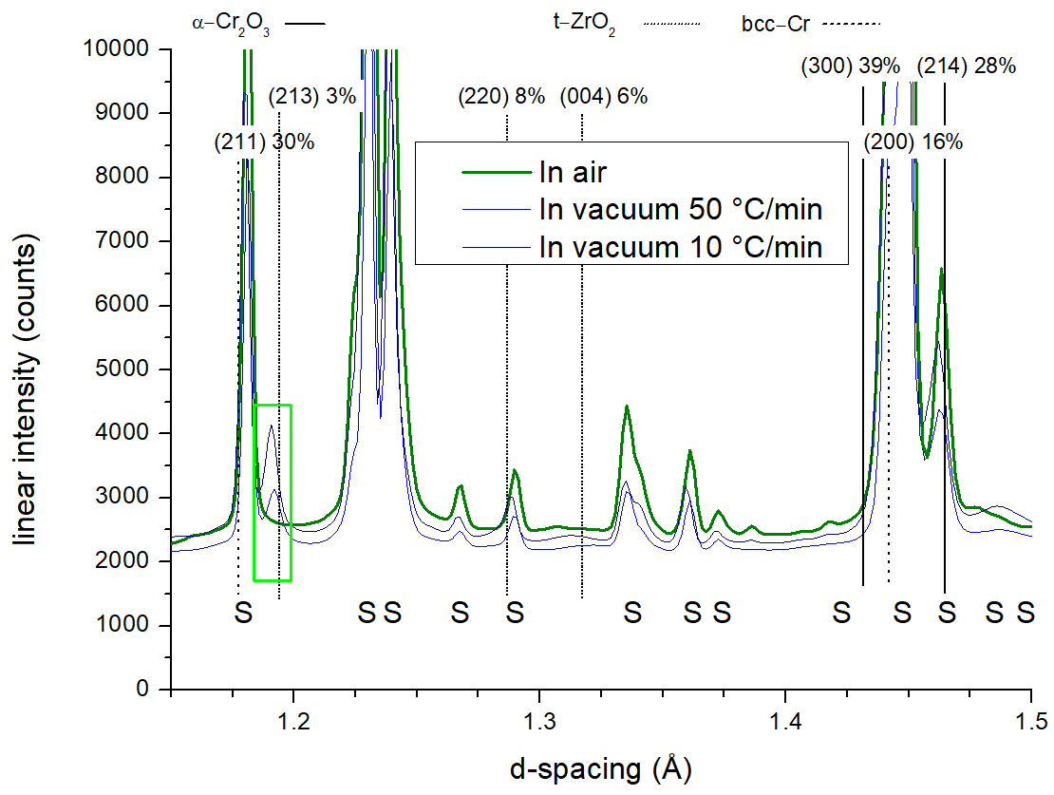
FIG. S8. XRD comparison at 975 °C annealing temperature for the 1.15—1.5 Å lattice spacing range, showing the bcc-Cr peak regions with no visible peak for (211) at 1.19 Å, shifted with ~1-2% to higher angles than RT-PDF-card when annealing in air but clear peak for vacuum-annealed samples. (See web-version for color)
An additional annealing run was performed in vacuum, with lower heating rate, 10 °C/min, resulting in a total annealing time comparable to the air-annealing run. The drawback was that the column, which the sample rested on, had time to thermally expand. This led to the need of manual adjustment of sample height causing jumps in the intensity of the diffraction pattern. The results from this run, FIG. S9, is similar to the 50 °C/min presented vacuum annealing run but with larger peak ratios between ZrO₂ and α-Cr₂O₃ at ~950 °C. The onset temperature for t-ZrO₂ formation was also earlier, ~750 °C, the later corresponding to what is observed for the air-annealed sample. The vacuum-annealed coating shows the onset of formation of the t-ZrO₂ phase at ~800 °C in the 50 °C/min heating rate case. The onset temperature for the lower heating rates, in both vacuum and air, matches the isothermal vacuum annealing test in previous work, also showing the first t-ZrO₂ signals at 750 °C. Hence, longer annealing time gives more time for diffusion to take place, creating larger t-ZrO₂ peaks at a given temperature.
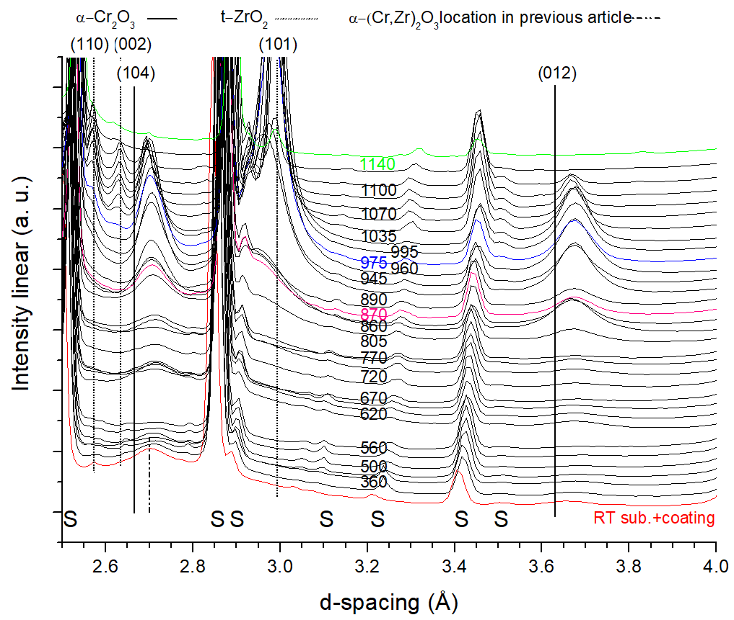
FIG. S9. X-ray- diffractograms of the coating annealed in vacuum with 10 °C/min heating rate. Green=max annealing temperature in vacuum, Blue=max temperature arrived when annealing in air, purple= isothermal vacuum annealing temperature from previous work. Curves shifted for clarity. Shift in intensities due to manual change of sample height. Temperature given in °C. (For interpretation of the references to color in this figure legend, the reader is referred to the web version of this article.)

