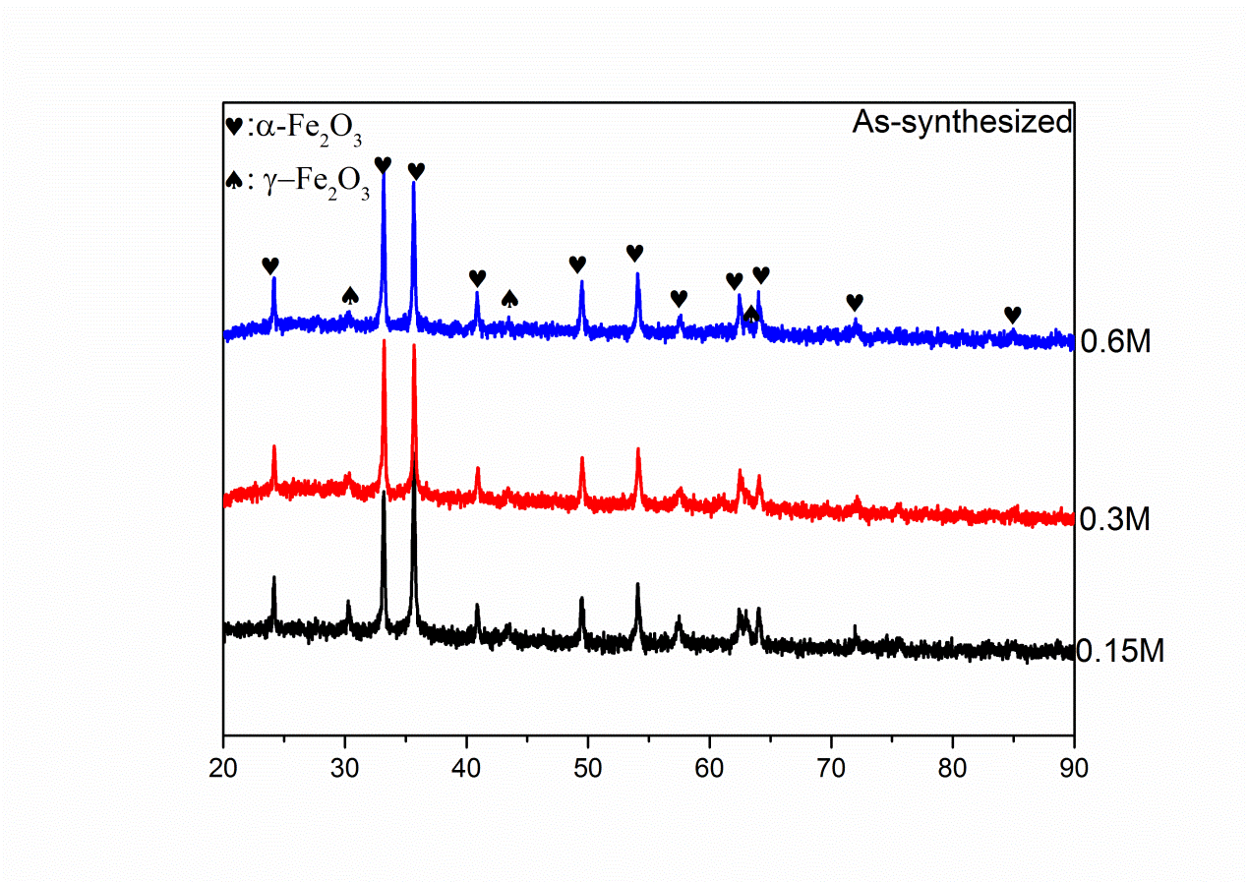
Figure S1. The XRD patterns of as-synthesized powder with different Fe concentration of precursor solution

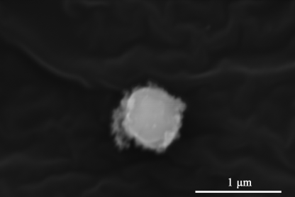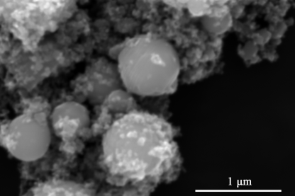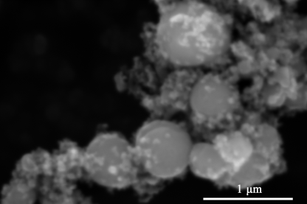
(a) (b) (c)
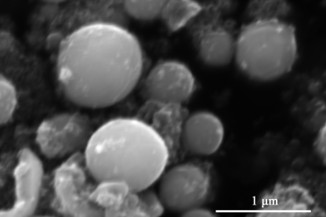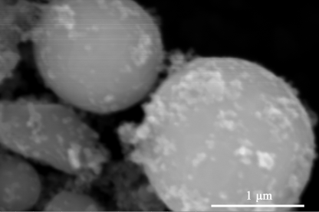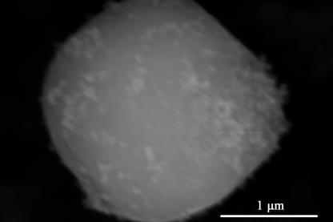
(d) (e) (f)
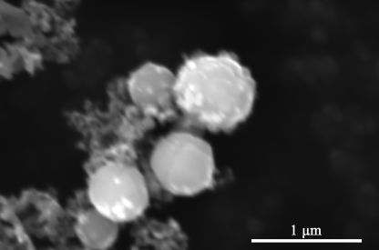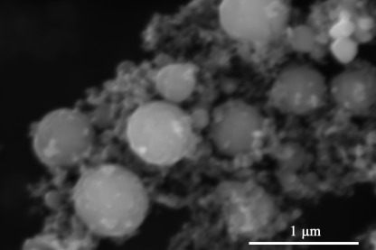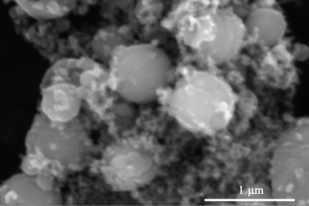
(g) (h) (i)
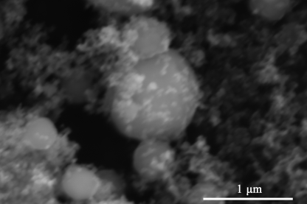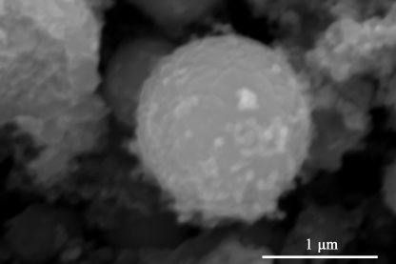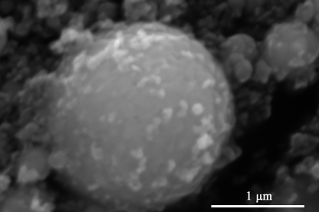
(j) (k) (l)
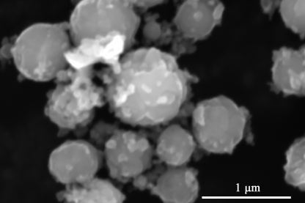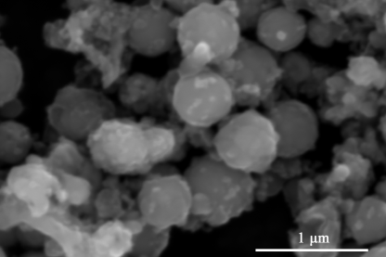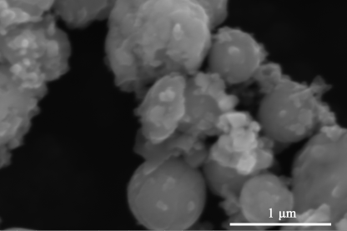
(m) (n) (o)
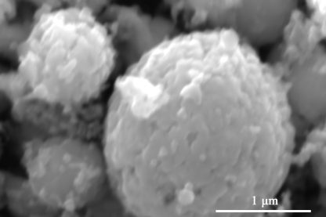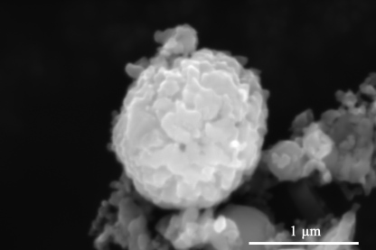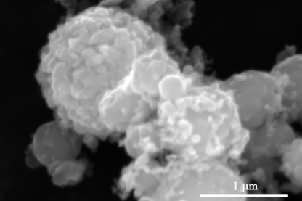
(p) (q) (r)
Figure S2. SEM images of the powder of different precursor concentration after reduction with different temperature: (a) and (d) 0.15M at 300°C; (b) and (e) 0.3M at 300°C; (c) and (f) 0.6M at 300°C; (g) and (j) 0.15M at 400°C; (h) and (k) 0.3M at 400°C; (i) and (l) 0.6M at 400°C; (m) and (p) 0.15M at 500°C; (n) and (q) 0.3M at 500°C; (o) and (r) 0.6M at 500°C;

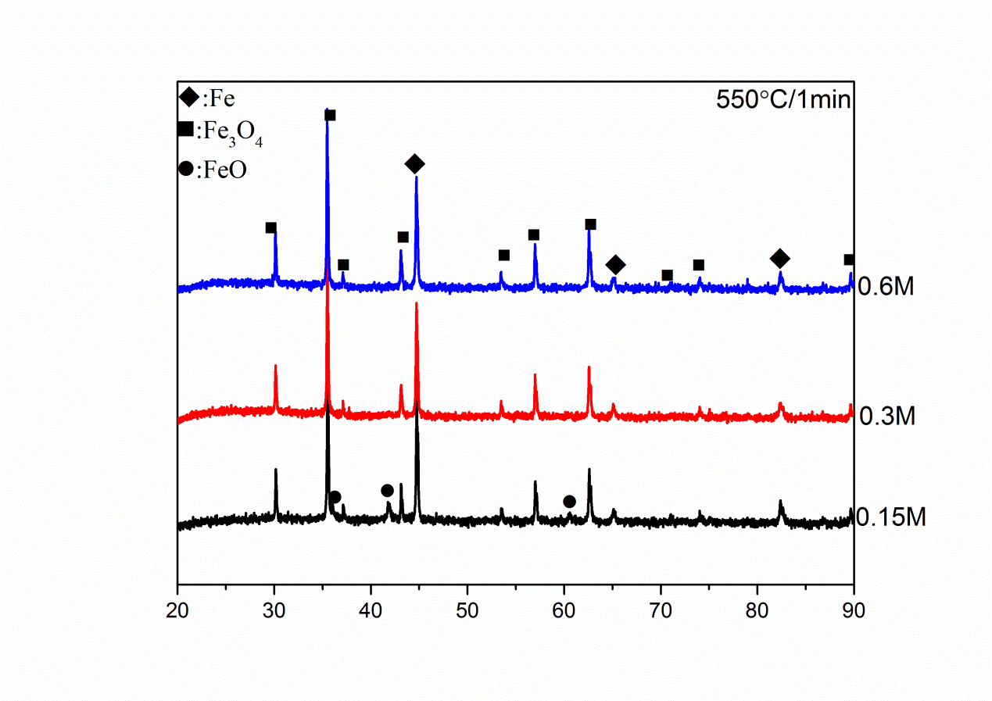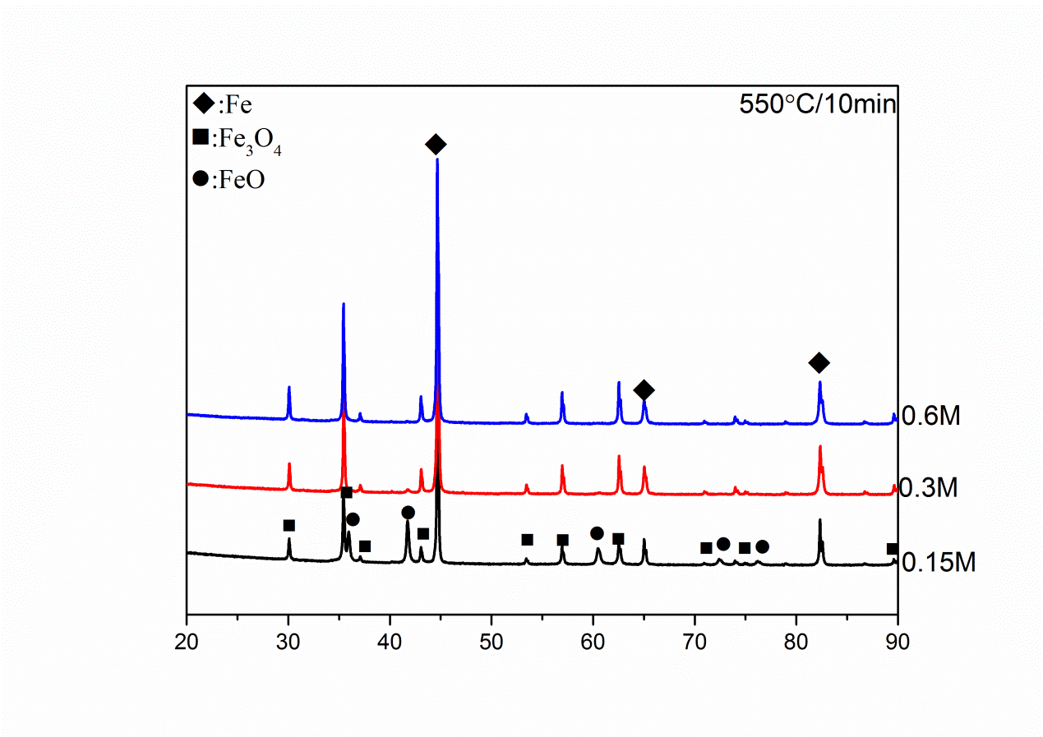
(a) (b)
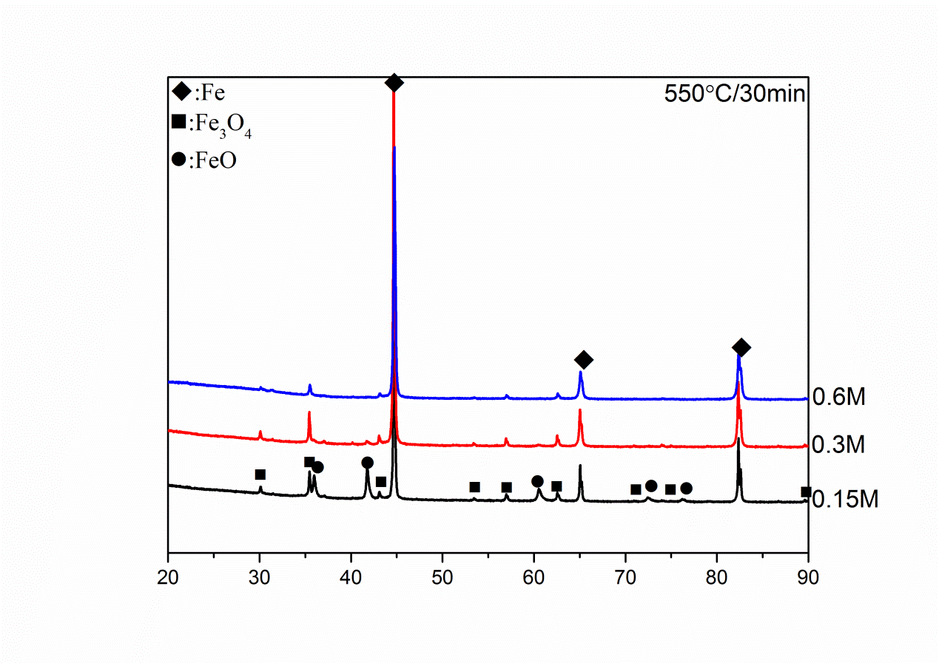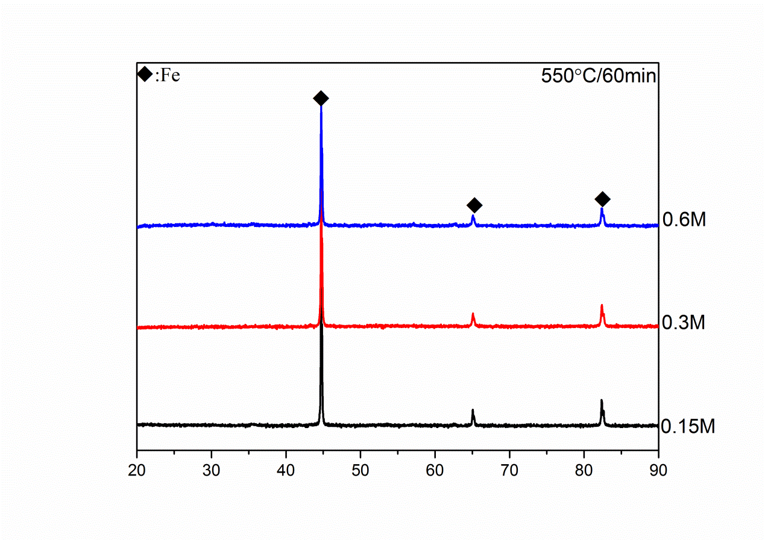
(c) (d)
Figure S3. The XRD patterns of the powder after reduction with different holding time under 550°C (a) 1 min; (b) 10 min; (c) 30 min; (d) 60 min;

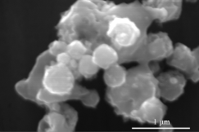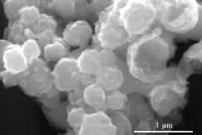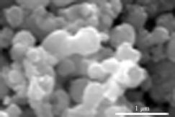
(a) (b) (c)
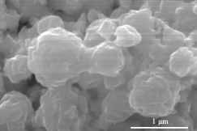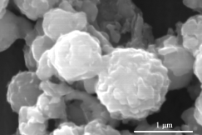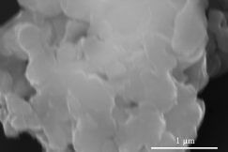
(d) (e) (f)
Figure S4 SEM images of the powder of different precursor concentrations after reduction with 550°C for 60min (a) and (d) 0.15 M; (b) and (e) 0.3 M; (c and (f) 0.6 M;
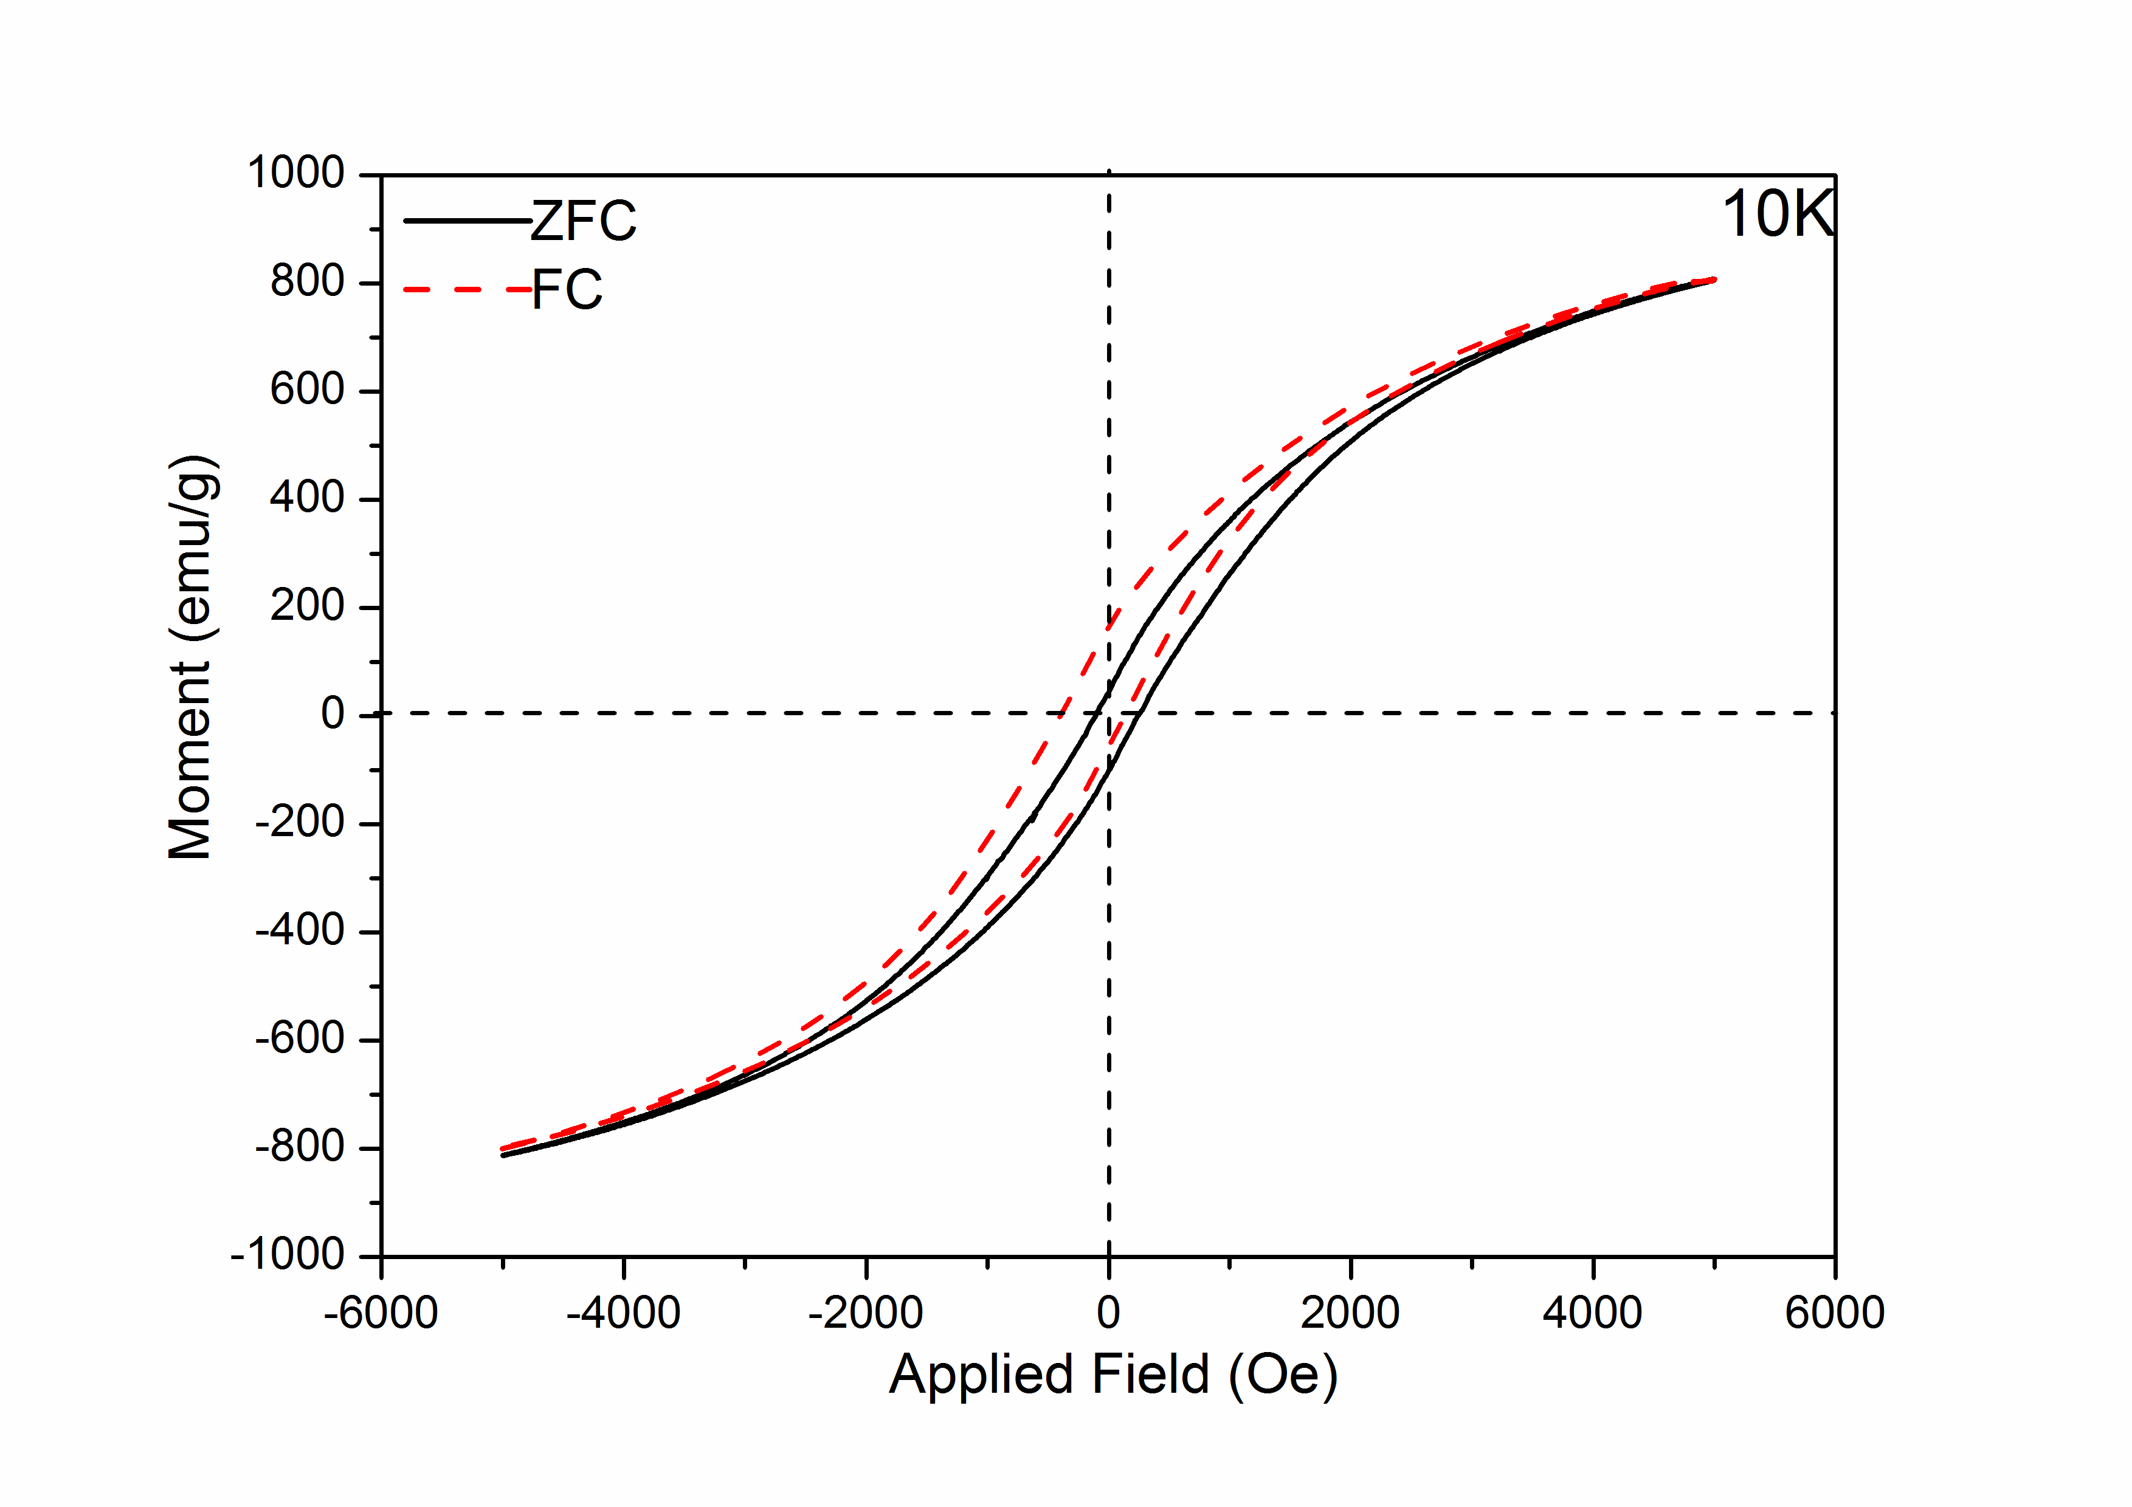
Figure S5. The ZFC and FC magnetic hysteresis loop of the 0.15 M powder of 550 °C for 10min at 10K.

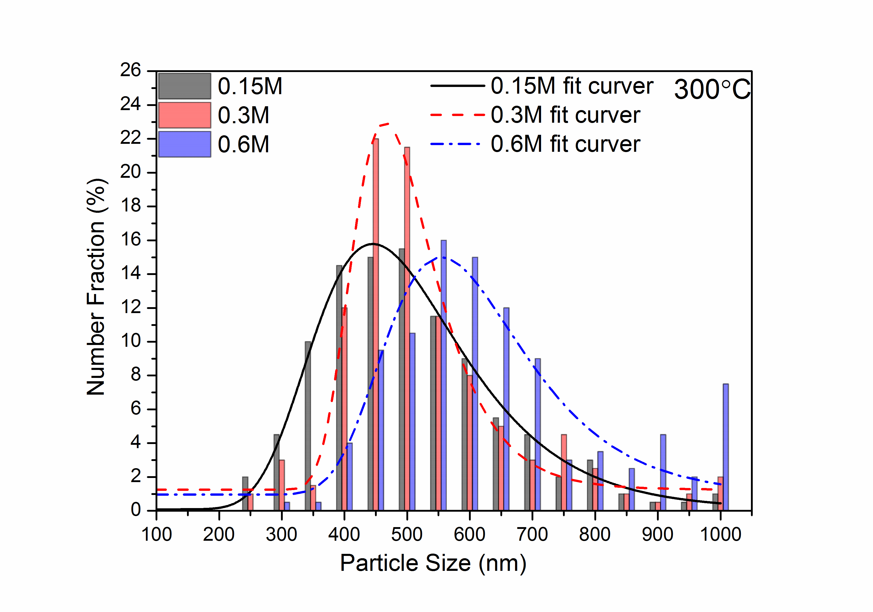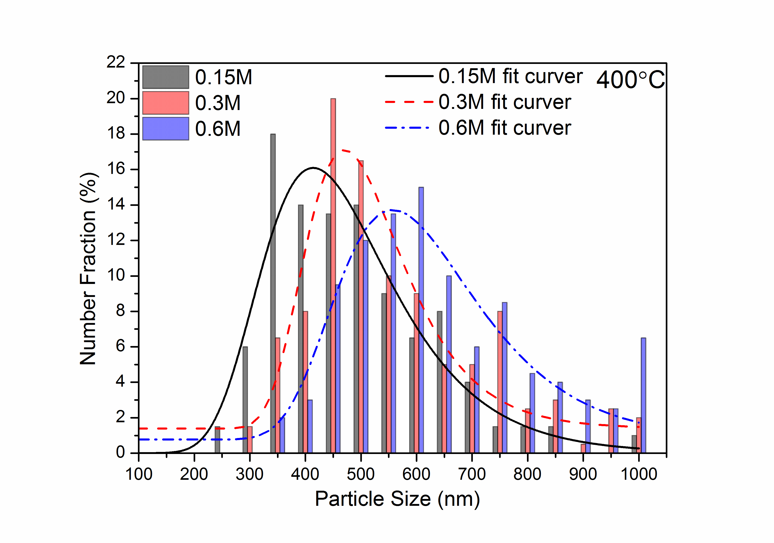
(a) (b)
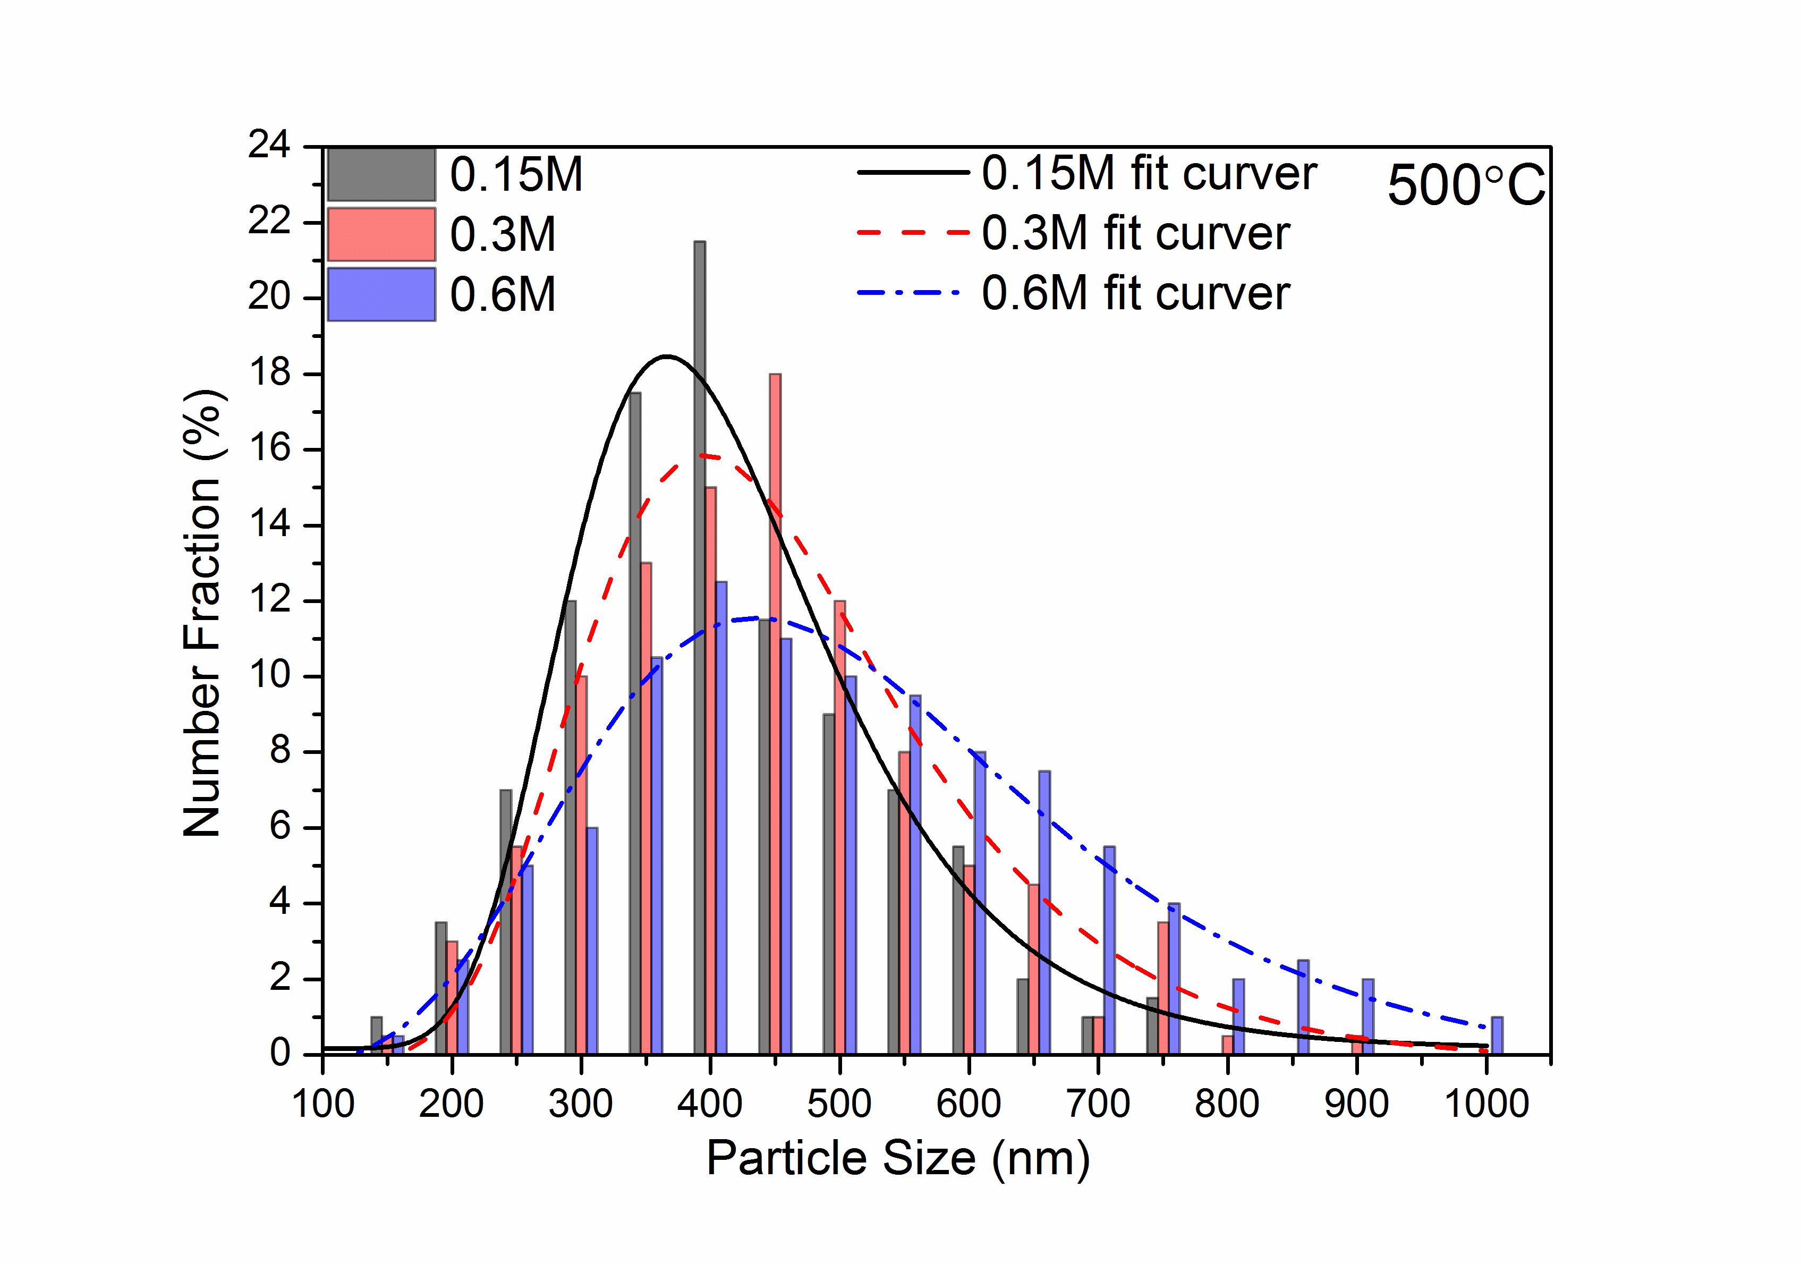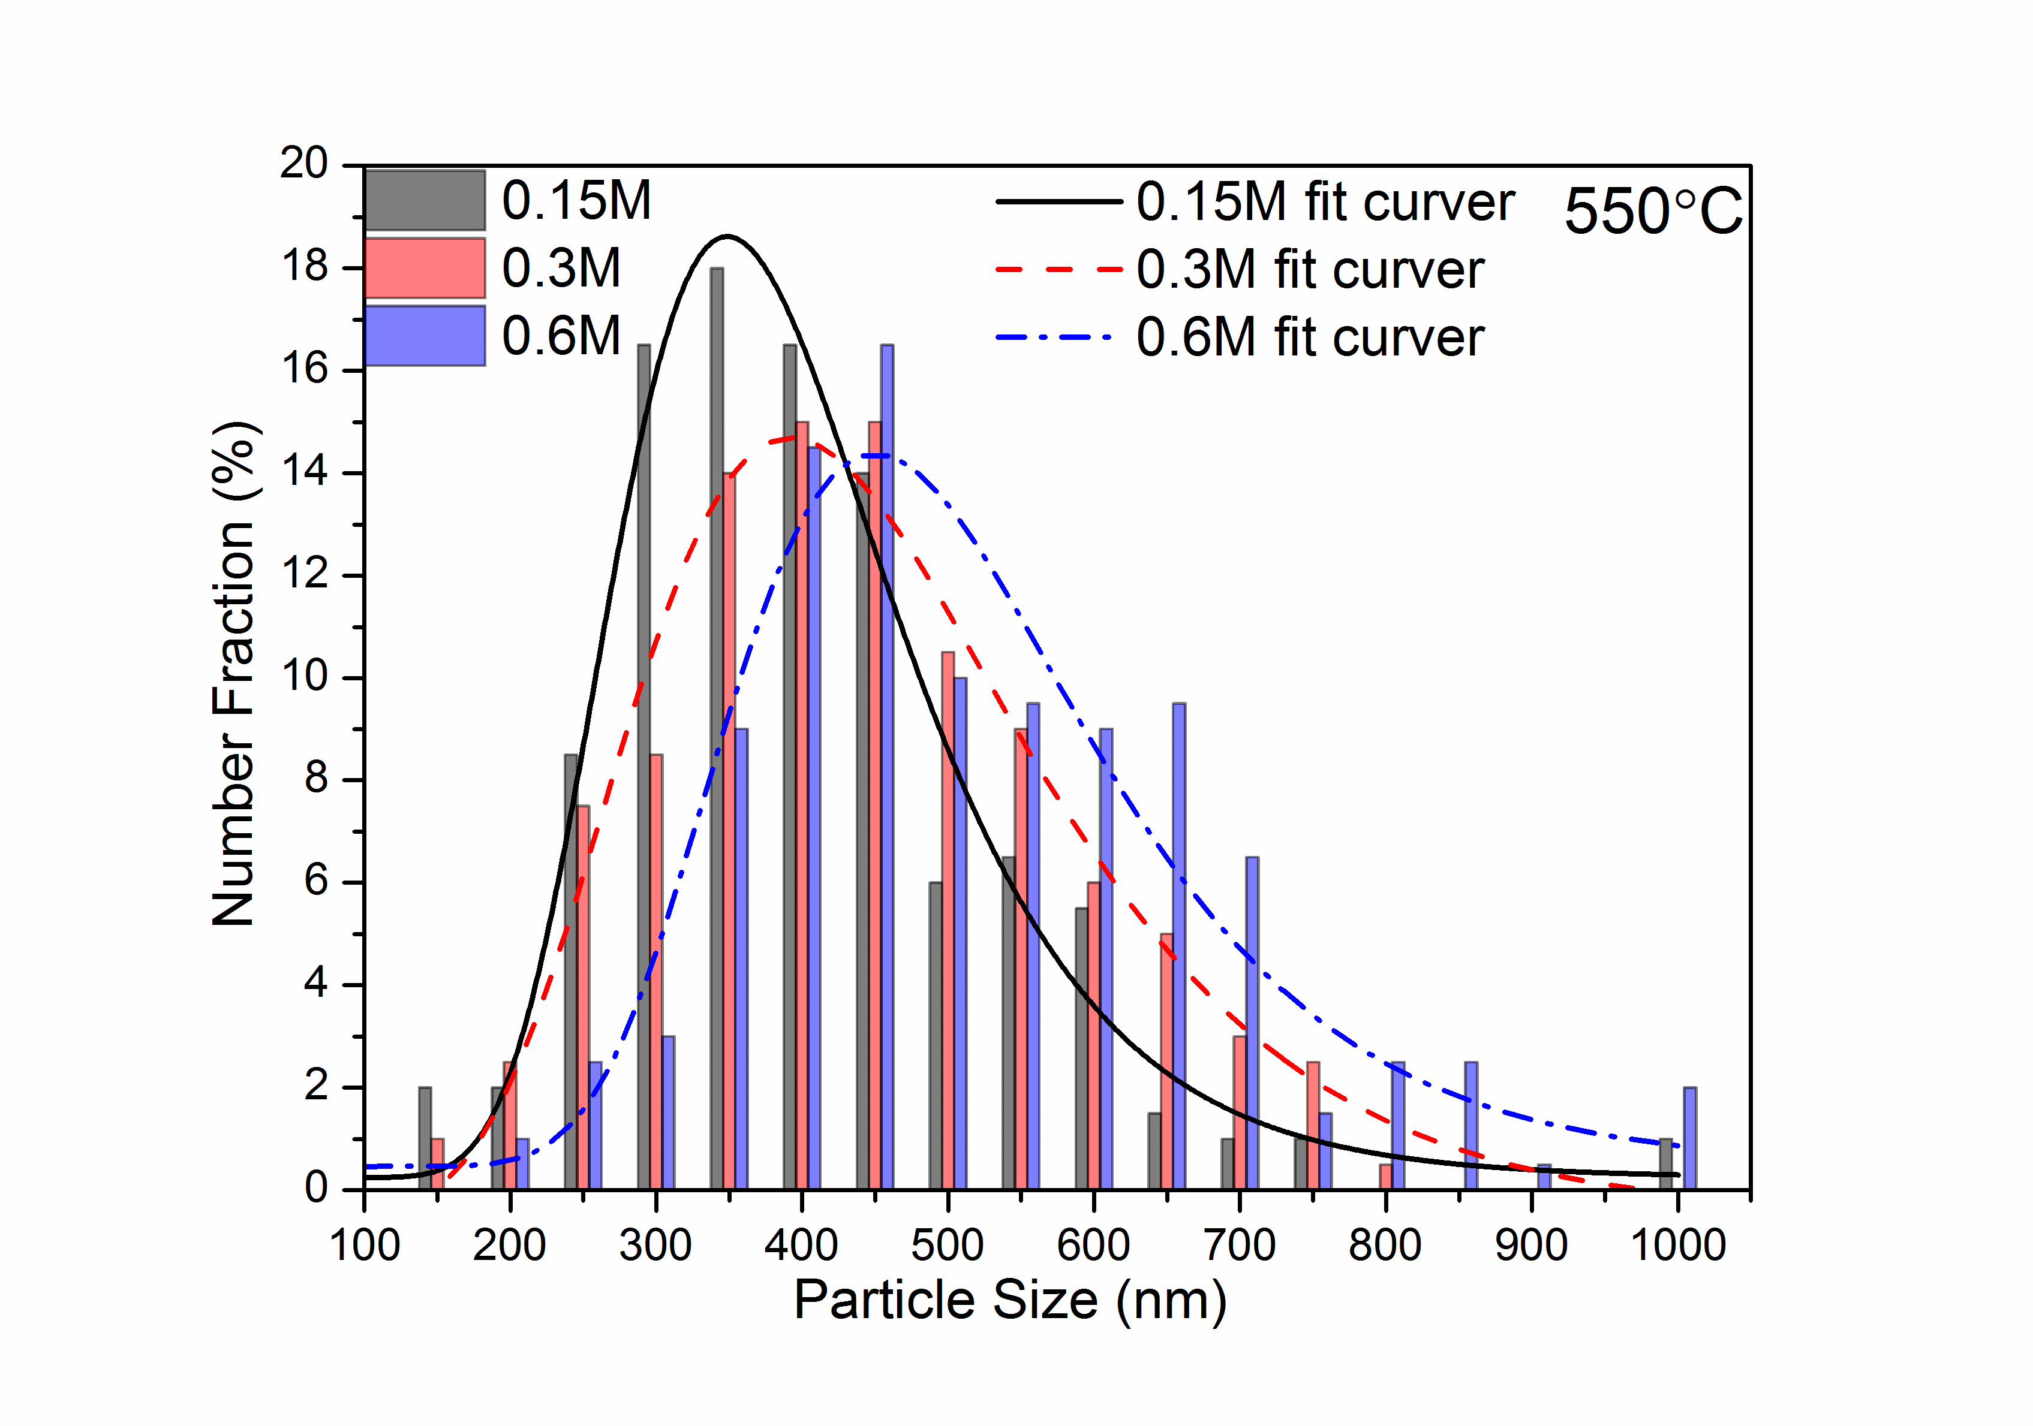
(c) (d)
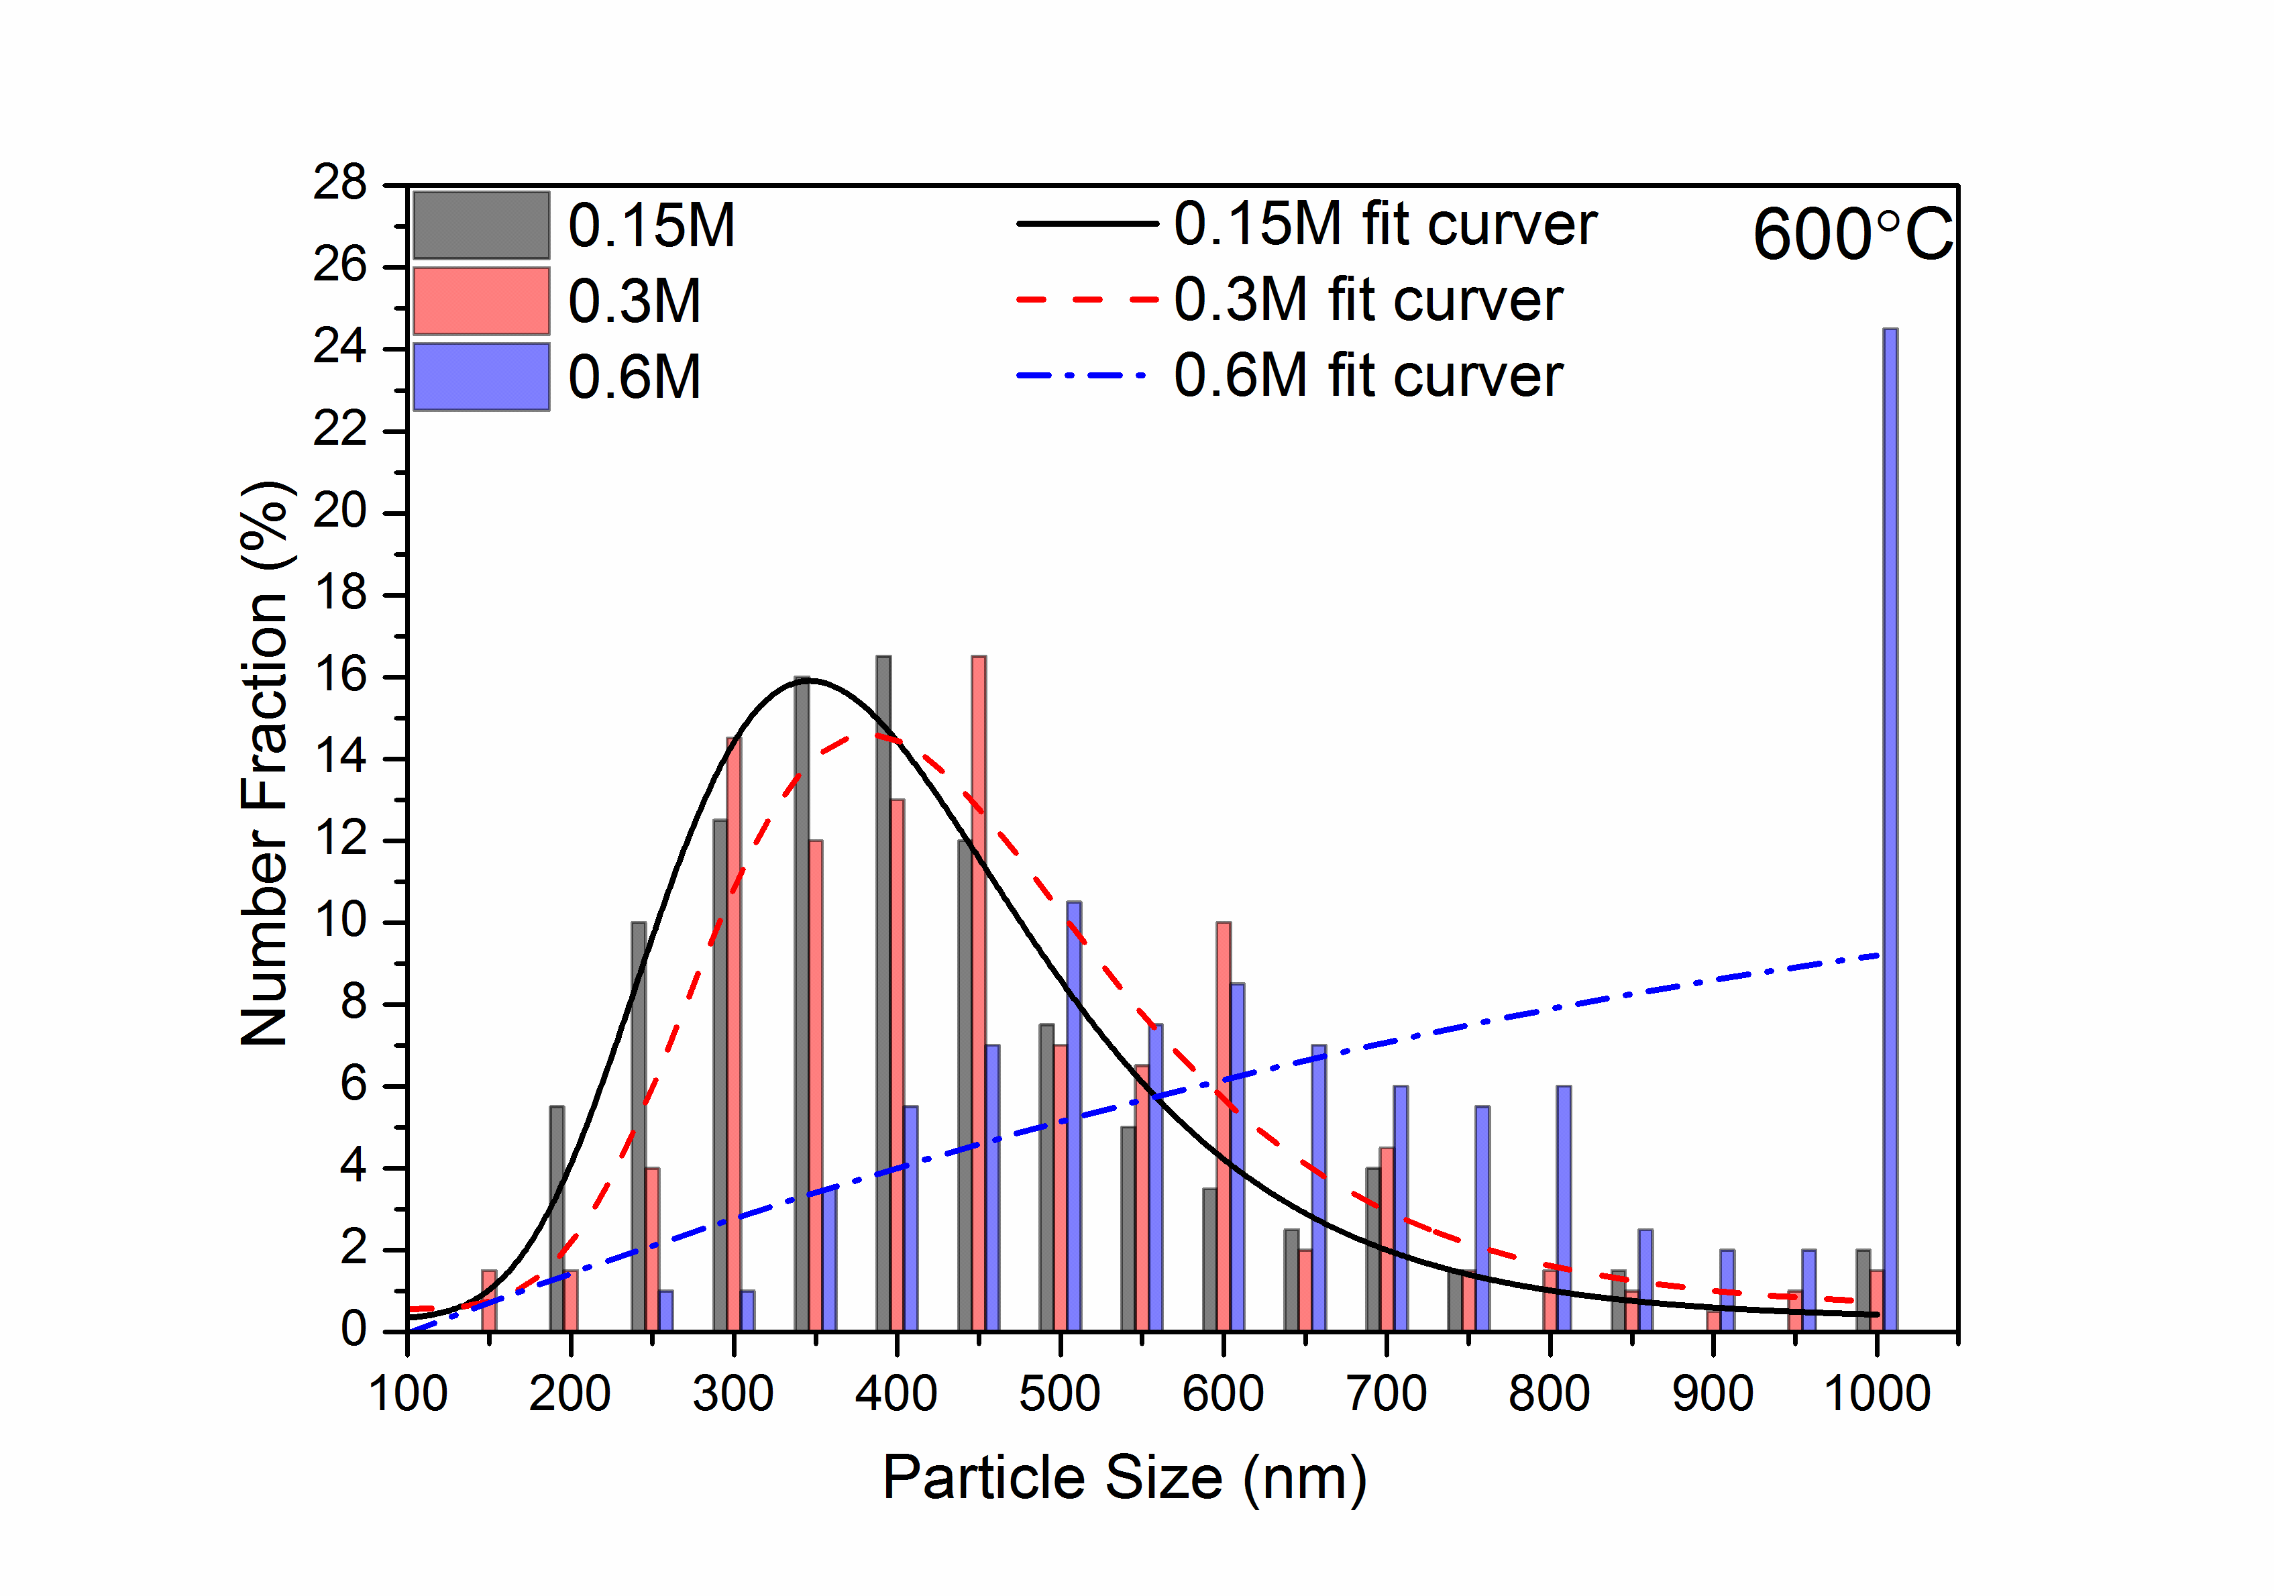
(e)
Figure S6. The particle size distribution of the powder after reduction with different temperature. (a) 300°C; (b) 400°C; (d) 500°C; (d) 550°C; (e) 600°C;
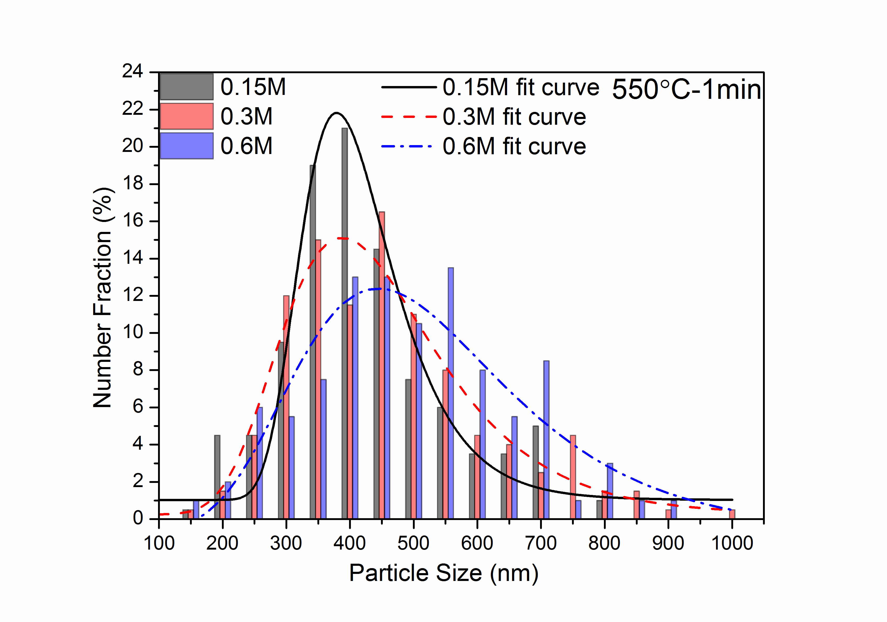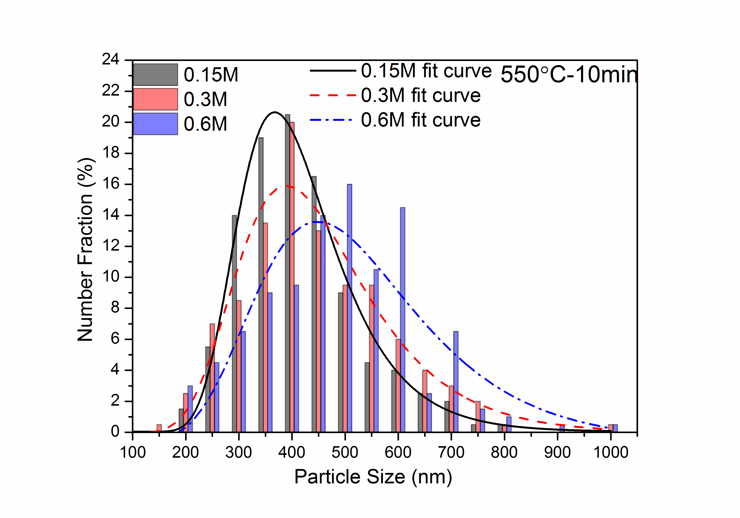
(a) (b)
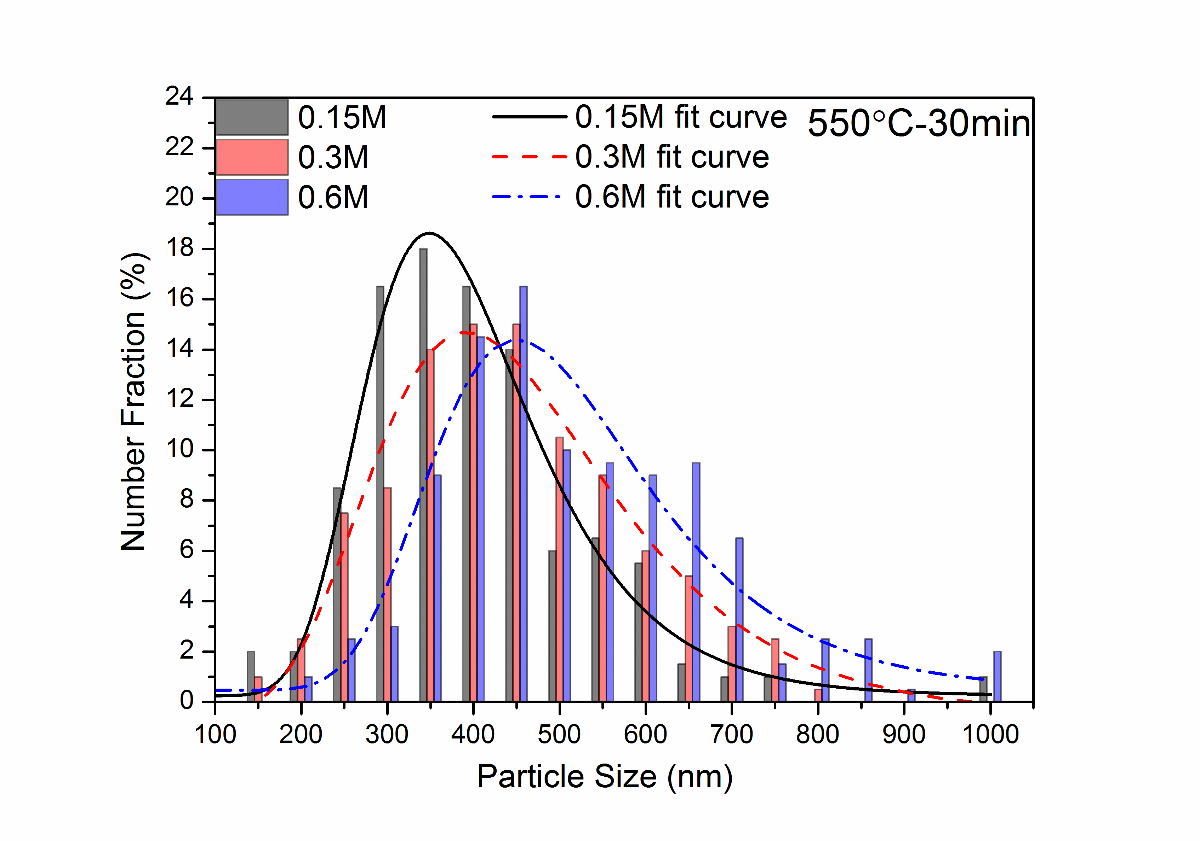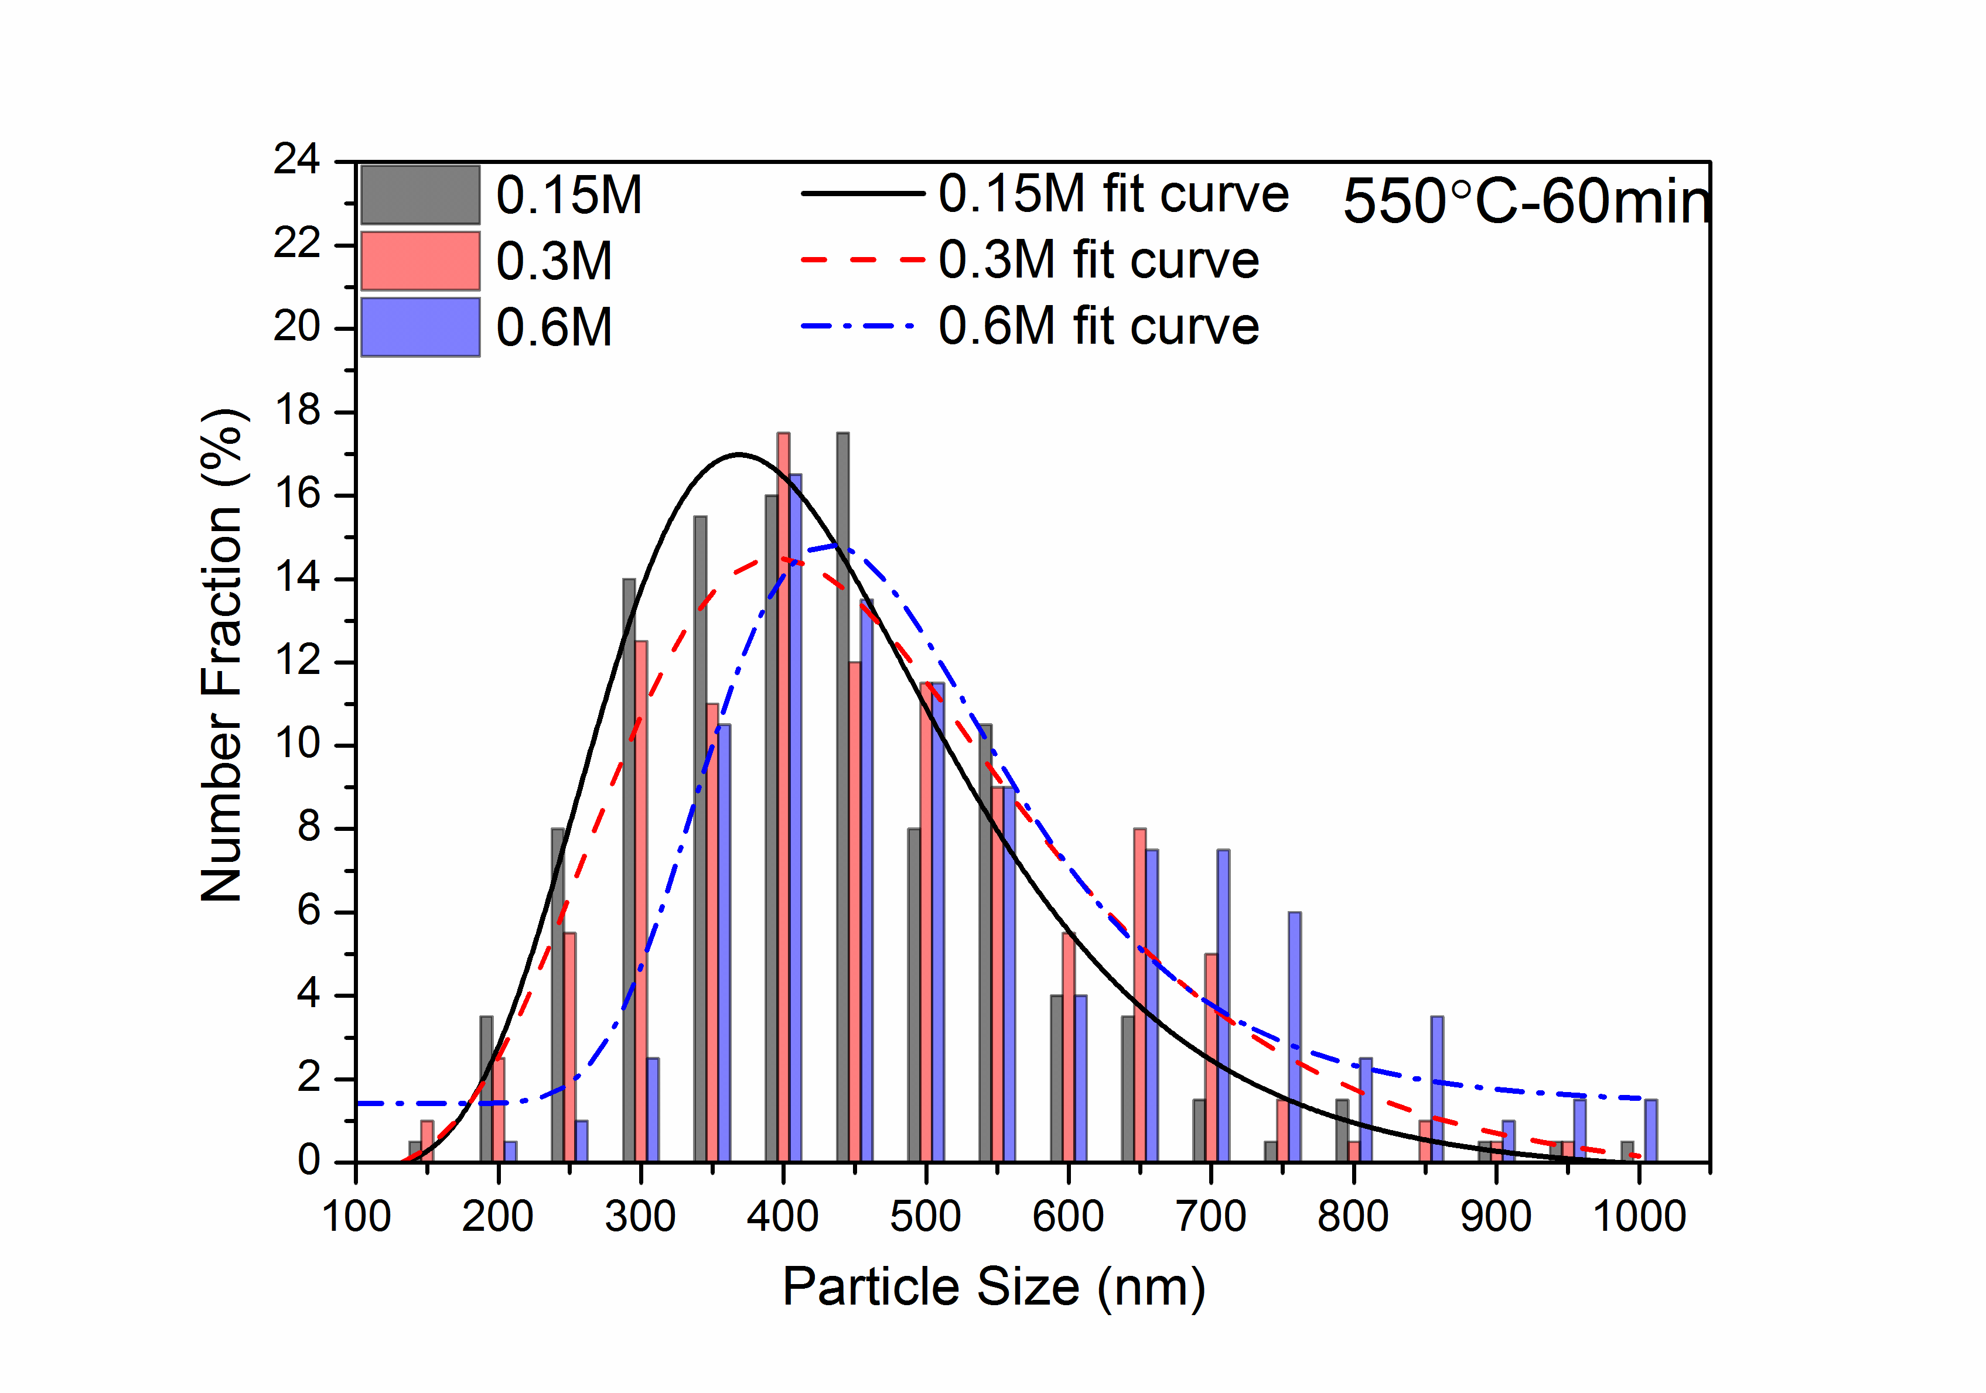
(c) (d)
Figure S7. The particle size distribution of the powder after reduction with different holding time under 550°C (a) 1 min; (b) 10 min; (c) 30 min; (d) 60 min;

