NiS_{x}@MoS₂ Heterostructure Prepared by Atomic Layer Deposition as high Performance Hydrogen Evolution Reaction Electrocatalysts in Alkaline Media
Zuyun He¹, Zheng Guo², Qingbo Wa², Xiao Zhong¹, Xinwei Wang² and Yan Chen^{1*}
¹Guangzhou Key Laboratory for Surface Chemistry of Energy Materials, Guangdong Engineering and Technology and Research Center for Surface Chemistry of Energy Materials, State Key Laboratory of Pulp and Paper Engineering, School of Environment and Energy, South China University of Technology, Guangzhou, 510006, China
²School of Advanced Materials, Shenzhen Graduate School, Peking University, Shenzhen 518055, China
*E-mail: escheny@scut.edu.cn

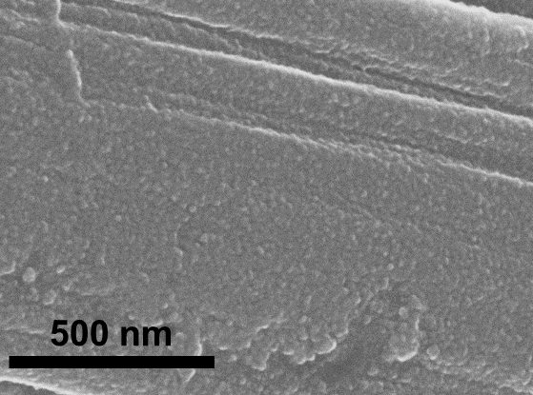
Figure S1. SEM image of NiS_{x} on CC with 600 cycles..

Table S1. The ohmic resistance (R_{s}), constant phase element and charge transfer resistance (R_{ct}) of pristine MoS₂, 5NiS_{x}@MoS₂, 25NiS_{x}@MoS₂ and 100NiS_{x}@MoS₂ heterostructure.
Sample | R_{s} (ohm) | CPE-T | CPE-P | R_{ct} (ohm)
MoS₂ | 4.52 | 1.20 | 0.94 | 38.22
5NiS_{x}@MoS₂ | 3.51 | 0.68 | 0.88 | 10.74
25NiS_{x}@MoS₂ | 3.584 | 0.83 | 0.89 | 4.52
100NiS_{x}@MoS₂ | 3.238 | 0.83 | 0.87 | 6.61

