Amino acid intercalated LDH core@ ordered porous silica shell as drug carriers: design and applications

Jianqiang Wang ^{1*}, Wenpei Zhang ¹, Lifeng Hao ^{2*} Jun Sun ¹, Wenqi Zhang ¹, Cheng Guo ¹, Yuhan Mu ³, Weiting Ji ³, Caiyuan Yu ³, Fangming Yuan ³
¹School of Chemistry and Molecular Engineering, Nanjing Tech University, 30 Puzhu South Road, Jiangsu, Nanjing, 211816, China, E-mail: jqwang@njtech.edu.cn
²Department of Engineering, Qiuzhen School, Huzhou University, 759 East 2nd Road, Zhejiang, Huzhou, 313000, China, E-mail:02578@zjhu.edu.cn
³College of Food Science and Light Industry, Nanjing Tech University, 30 Puzhu South Road, Jiangsu, Nanjing, 211816, China.

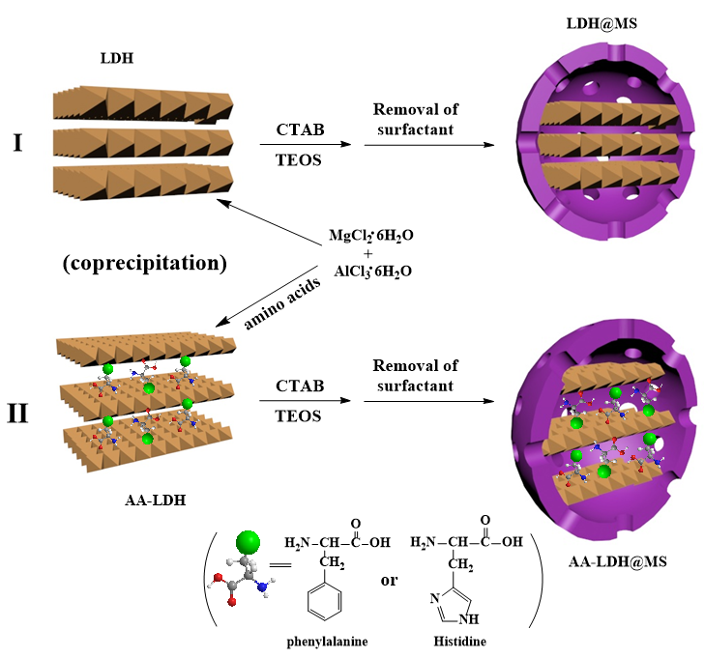
FIG. S1 Preparation of the materials LDH, LDH@MS, AA-LDH and AA-LDH@MS （AA denotes Phenylalanine or Histidine）

TABLE SI. Textural parameters from N₂ adsorption-desorption analysis of LDH, LDH@MS, Phe-LDH@MS and His-LDH@MS
Materials | S_{BET}, m²/g | Pore volume (cm³/g) | Average pore diameter(nm)
Phe-LDH@MS | 302 | 0.36 | 4.7
His-LDH@MS | 56 | 0.45 | 5.6
LDH@MS | 378 | 0.31 | 6.5
LDH | 191 | 0.48 | 5.1

FIG. S2. Kinetic plots of Korsmeyer-Peppas model for 5-FU release from the core-shell nanocomposites: AA-LDH@MS (including Phenylalanine and Histidine), LDH@MS and prinstine LDH at pH 4 and 7.4

TABLE SII Dynamic concentrations of the drug in the solution and solid during the release of 5-FU from Phe-LDH@MS, (C_{r} = Cumulative drug released to the solution in mg L⁻¹ and Q_{r} = Amount of drug remaining in the Mg/Al-LDH in mg g⁻¹).

pH | 4 |  | 7.4
Time (h) | Cr (mg/L) | Qr (mg/g) | Cr (mg/L) | Qr (mg/g)
0 | 0 | 300 | 0 | 300
0.5 | 41.7009 | 137.3667 | 30.9460 | 179.3108
1 | 49.4080 | 107.3087 | 43.6936 | 129.5950
2 | 55.6207 | 83.0794 | 47.2102 | 115.8803
3 | 57.4669 | 75.8791 | 47.7670 | 113.7088
4 | 58.0823 | 73.4791 | 48.4410 | 111.0802
5 | 59.0493 | 69.7076 | 49.3934 | 107.3658
6 | 59.3717 | 68.4504 | 49.8770 | 105.4800
7 | 60.0750 | 65.7074 | 50.2872 | 103.8800
8 | 61.0128 | 62.0502 | 50.8147 | 101.8228
9 | 62.0384 | 58.0501 | 50.9319 | 101.3656
11 | 62.1264 | 57.7072 | 52.0309 | 97.0797

TABLE SIII Dynamic concentrations of the drug in the solution and solid during the release of 5-FU from His-LDH@MS, (C_{r} = Cumulative drug released to the solution in mg L⁻¹ and Q_{r} = Amount of drug remaining in the Mg/Al-LDH in mg g⁻¹).

pH | 4 |  | 7.4
Time (h) | Cr (mg/L) | Qr (mg/g) | Cr(mg/L) | Qr(mg/g)
0 | 0 | 300 | 0 | 300
0.5 | 38.6551 | 149.2452 | 29.4982 | 184.9569
1 | 46.3373 | 119.2847 | 40.6018 | 141.6529
2 | 53.3907 | 91.7763 | 42.5971 | 133.8713
3 | 54.5361 | 87.3091 | 43.6593 | 129.7288
4 | 55.7514 | 82.5697 | 44.5838 | 126.1231
5 | 56.7334 | 78.7396 | 44.8316 | 125.1569
6 | 57.4489 | 75.9494 | 46.0283 | 120.4896
7 | 57.7904 | 74.6174 | 46.4433 | 118.8710
8 | 59.1214 | 69.4264 | 46.8724 | 117.1978
9 | 59.9856 | 66.0562 | 47.9604 | 112.9546
11 | 60.2651 | 64.9660 | 48.2670 | 111.7587

TABLE SIV Dynamic concentrations of the drug in the solution and solid during the release of 5-FU from LDH@MS, (C_{r} = Cumulative drug released to the solution in mg L⁻¹ and Q_{r} = Amount of drug remaining in the Mg/Al-LDH in mg g⁻¹).

pH | 4 |  | 7.4
Time(h) | Cr (mg/L) | Qr (mg/g) | Cr (mg/L) | Qr (mg/g)
0 | 0 | 300 | 0 | 300
0.5 | 43.3666 | 130.8703 | 33.6350 | 168.8237
1 | 51.1105 | 100.6691 | 45.9897 | 120.6403
2 | 57.5104 | 75.7096 | 50.9409 | 101.3306
3 | 58.4067 | 72.2141 | 51.9556 | 97.3731
4 | 59.6123 | 67.5121 | 52.9102 | 93.6502
5 | 61.4495 | 60.3470 | 53.4260 | 91.6385
6 | 61.8916 | 58.6226 | 53.7688 | 90.3018
7 | 62.7445 | 55.2965 | 54.0258 | 89.2993
8 | 63.6760 | 51.6636 | 54.6582 | 86.8330
9 | 64.6000 | 48.0601 | 55.7903 | 82.4176
11 | 66.0687 | 42.3322 | 56.1451 | 81.0339

TABLE SV Dynamic concentrations of the drug in the solution and solid during the release of 5-FU from pristine LDH, (C_{r} = Cumulative drug released to the solution in mg L⁻¹ and Q_{r} = Amount of drug remaining in the Mg/Al-LDH in mg g⁻¹).

pH | 4 |  | 7.4
Time (h) | Cr (mg/L) | Qr (mg/g) | Cr (mg/L) | Qr (mg/g)
0 | 0 | 300 | 0 | 300
0.5 | 32.2178 | 174.3506 | 26.3158 | 197.3684
1 | 36.6311 | 157.1387 | 34.4919 | 165.4818
2 | 40.0304 | 143.8811 | 36.8949 | 156.1101
3 | 41.1733 | 139.4239 | 37.4810 | 153.8243
4 | 41.4664 | 138.2810 | 37.6274 | 153.2528
5 | 43.3126 | 131.0808 | 37.8033 | 152.5671
6 | 43.3712 | 130.8522 | 38.0964 | 151.4242
7 | 44.5727 | 126.1664 | 38.3014 | 150.6242
8 | 45.012 | 124.4520 | 38.3894 | 150.2813
9 | 45.1002 | 124.1091 | 39.2685 | 146.8527
11 | 46.6533 | 118.0518 | 39.4151 | 146.2812

