Synergic effect of Nanostructuring and Excess Mn³⁺ Content in the Electrochemical Performance of Li₄Ti₅O₁₂ –LiNi_{0.5}Mn_{1.5}O₄ Li-Ion Full-cells
Anulekha K. Haridas ^{1, 2, #}, A. Jyothirmayi ¹, Chandra S. Sharma ^{2*} and Tata N. Rao ^{1*}

¹International Advanced Research Centre for Powder Metallurgy and New Materials (ARCI), Hyderabad, Telangana, India.
² Creative & Advanced Research Based on Nanomaterials (CARBON) Laboratory, Department of Chemical Engineering, Indian Institute of Technology Hyderabad, Kandi, Sangareddy, 502285, Telangana, India.

*Corresponding authors: cssharma@iith.ac.in, tata@arci.ac.in
# Current address: Department of Chemical and Bio-molecular Engineering, Rice University, Houston, Texas, United States.

Supporting Information

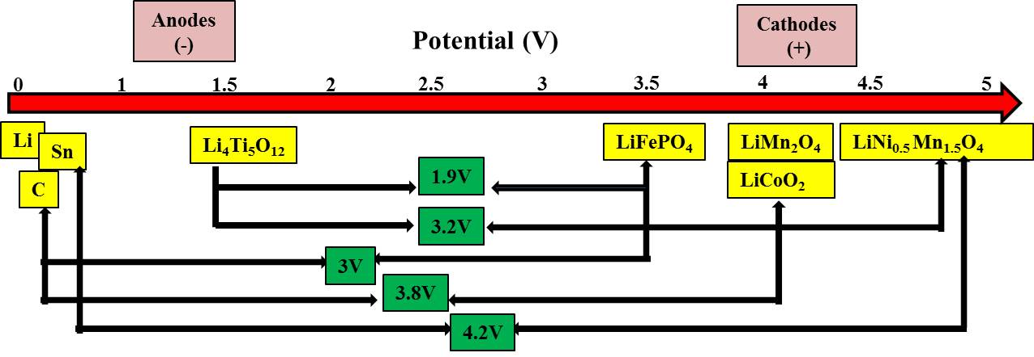
Figure S1: A representation of various full cell combinations of Li ion electrodes as a function of increase in potential with respect to Li. Full cell combining a low voltage anode and high voltage cathode provides high cell voltage which is directly related to the energy density of a battery.

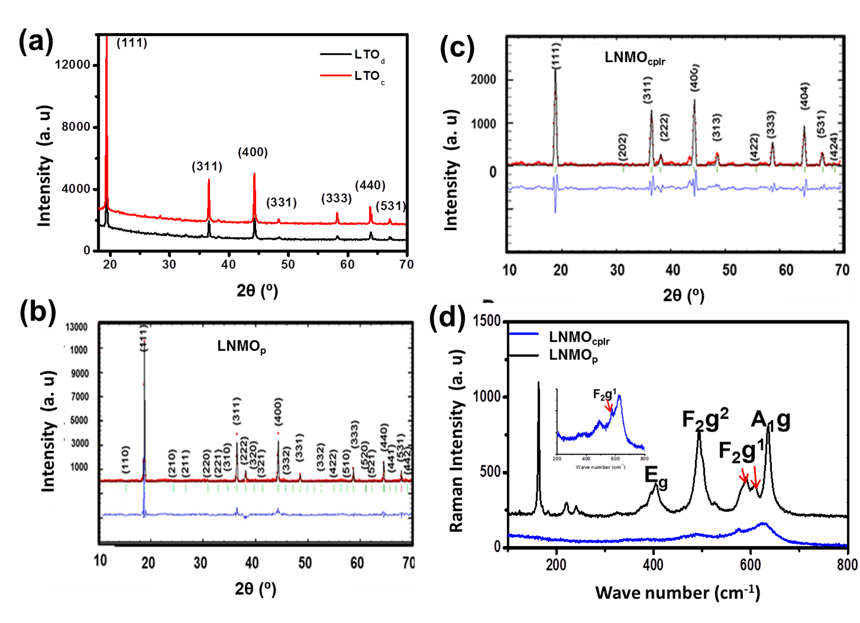
Figure S2: XRD and Raman studies of LTO and LNMO (a) XRD patterns of LTO_{d} and LTO_{c}, (b) and (c) Rietveld refined XRD patterns of LNMO_{p} and LNMO_{cplr}, (d) A comparative Raman spectra of LNMO_{p} and LNMO_{cplr}.

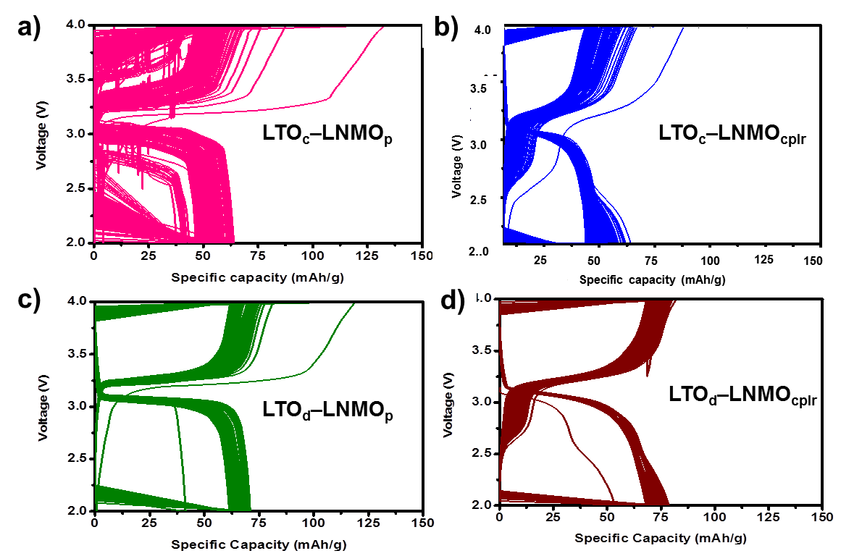
Figure S3. 200 cycle GCD voltage profiles of FCs at 1C rate. a) LTO_{c}–LNMO_{p} b) LTO_{c}–LNMO_{cplr} c) LTO_{d}–LNMO_{p} d) LTO_{d}–LNMO_{cplr}

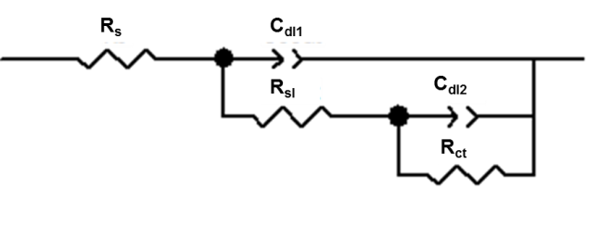
Figure S4. EIS equivalent circuit for LTO_{c}–LNMO_{p} FC

Table S1: A summary of full cell EIS studies
Full-Cells | R_{e} (Ω) | R_{sl} (Ω) | R_{ct} (Ω) | R_{w} (Ω)
LTO_{c} –LNMO_{p} | 4.34 | 545.4 | 15007 | -
LTO_{c} –LNMO_{cplr} | 4.62 | 57.57 | 135.26 | 136.03
LTO_{d} –LNMO_{p} | 4.06 | 39.50 | 90.02 | 316.60
LTO_{d} –LNMO_{cplr} | 4.12 | 30.31 | 79.13 | 245.52

