Supplementary Information
Fig. S1. Schematic for the VOCs degradation instrument.
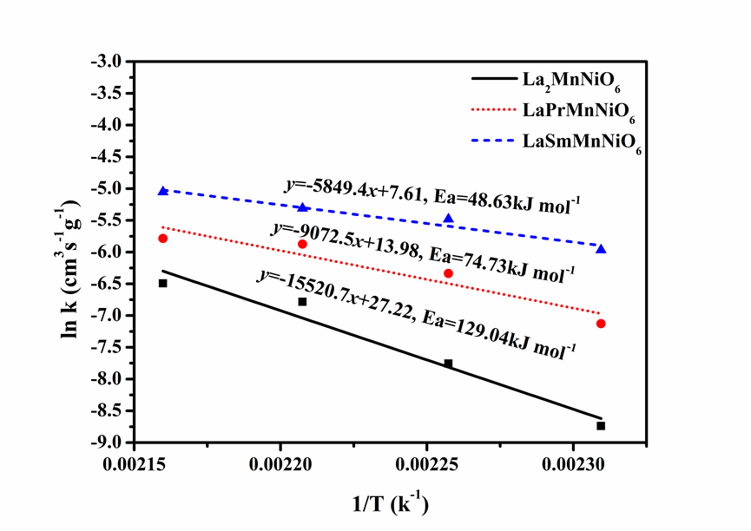
Fig. S2. Arrhenius plot for rate constant of C₇H₈ conversion with LaAMnNiO₆ (A = La, Pr, Sm).
TABLE SI. XPS results of LaAMnNiO₆ (A = La, Pr, Sm).
Catalysts | Surface atomic concentration (%) |  |  |  |  |  | Relative atomic ratio (%)
LaAMnNiO₆ | La | Pr | Sm | Mn | Ni | O | O_{abs.}/O_{latt} | Mn⁴⁺/ Mn³⁺
La₂MnNiO₆ | 14.55 | - | - | 10.37 | 25.03 | 50.05 | 0.93 | 0.67
LaPrMnNiO₆ | 5.54 | 5.53 | - | 9.95 | 16.17 | 62.82 | 0.95 | 0.81
LaSmMnNiO₆ | 6.45 | - | 6.49 | 9.12 | 17.58 | 60.41 | 0.99 | 0.83
TABLE SII. Data obtained from O₂-TPD.
Catalysts | O₂ consumption before 700 °C (cm³/g)
LaAMnNiO₆ | Total | O_{α} | O_{β}
La₂MnNiO₆ | 3.02 | 0.93 | 2.09
LaPrMnNiO₆ | 3.19 | 1.09 | 2.10
LaSmMnNiO₆ | 3.84 | 1.14 | 2.70
TABLE S III. Data obtained from H₂-TPR.
Catalysts | H₂ consumption before 700 °C (cm³/g)
LaAMnNiO₆ | Total | α | β | γ
La₂MnNiO₆ | 62.18 | 5.25 | 6.18 | 19.03
LaPrMnNiO₆ | 59.93 | 5.46 | 8.95 | 17.21
LaSmMnNiO₆ | 53.42 | 5.55 | 14.60 | 15.59
TABLE S IV. Comparison with single-phase perovskite with literature.
Catalysts | activity temperature (°C) | Ea (kJ/mol) | Reference
LaMnO₃ | 265 | 78 | [20]
LaCoO₃ | 270 | 143 | [20]
LaNiO₃ | 280 | 79 | [20]
La₂MnNiO₆ | 260 | 129 | This study
LaPrMnNiO₆ | 257 | 75 | This study
LaSmMnNiO₆ | 255 | 49 | This study

