SnO₂ nano-mulberries anchored onto RGO nanosheets for Lithium ion batteries
Feilong Gong ¹, Mengmeng Liu ¹, Lihua Gong ¹, Dandan Li ¹, Yu Li ¹ and Feng Li^{＊,1,2}
¹Key Laboratory of Surface and Interface Science and Technology, Zhengzhou University of Light Industry, Zhengzhou, 450002, Henan, P. R. China.
²American Advanced Nanotechnology, 3519 Double Lake Dr, Missouri City, TX 77459, USA.

1. The assembly of cells and measurements of electrochemical properties
As-prepared materials were mixed with acetylene black and poly-(vinyl difluoride) dissolved in N-methyl-pyrrolidone at a weight ratio of 8:1:1 to form a slurry. The slurry was pasted onto a copper foil, dried at 80 ºC for 12 h, and cut into circle slices with a diameter of 12 mm and the active materials of ~2.5 mg cm⁻² to make working electrodes. Lithium metal foils work as both reference electrode and counter. The electrolyte was LiPF₆ (1 M) in ethylene carbonate/dimethyl carbonate/diethyl carbonate (1:1:1in vol). Nickel plates were used as shims to help current collectors contact with cathode and anode. The cells were assembled in an argon-filled glove box. The cyclic voltammogram (CV) was carried out on a CHI660D electrochemical workstation at a scan rate of 0.1 mV s⁻¹ within the potential range of 0.01 - 3.0 V vs Li⁺/Li. The discharge and charge measurements of the batteries were performed on a NEWARE CT3008 electrochemical workstation between 0.01 and 3 V at room temperature. Electrochemical impedance spectroscopy (EIS) measurements were recorded on a CHI660D electrochemical workstation in the frequency range of 100 kHz to 10 mHz.
2. Physisorption isotherms and pore-size distributions
Figure S1. The physisorption isotherms and pore-size distributions of GT-1, GS-2 and GT-4.
3. FESEM and TEM images
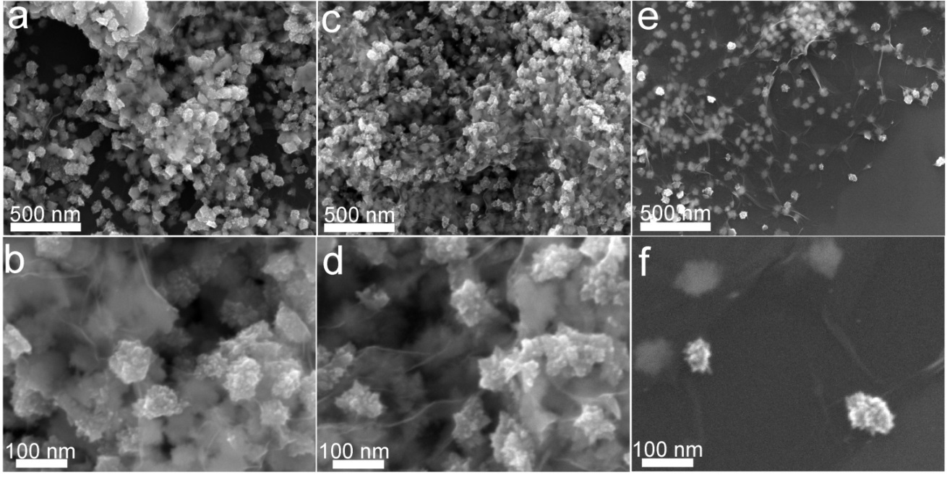
Figure S2. FESEM images of (a-b) GT-1, (c-d) GT-2 and (e-f) GT-4.

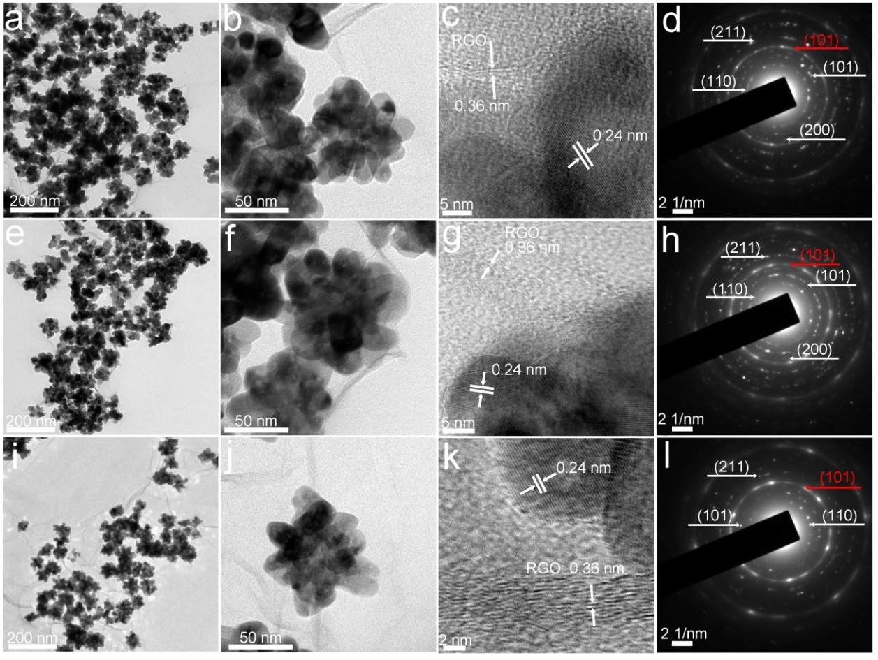
Figure S3. TEM, HRTEM and SAED images of GT-1, GT-2 and GT-4.
4. XPS spectra
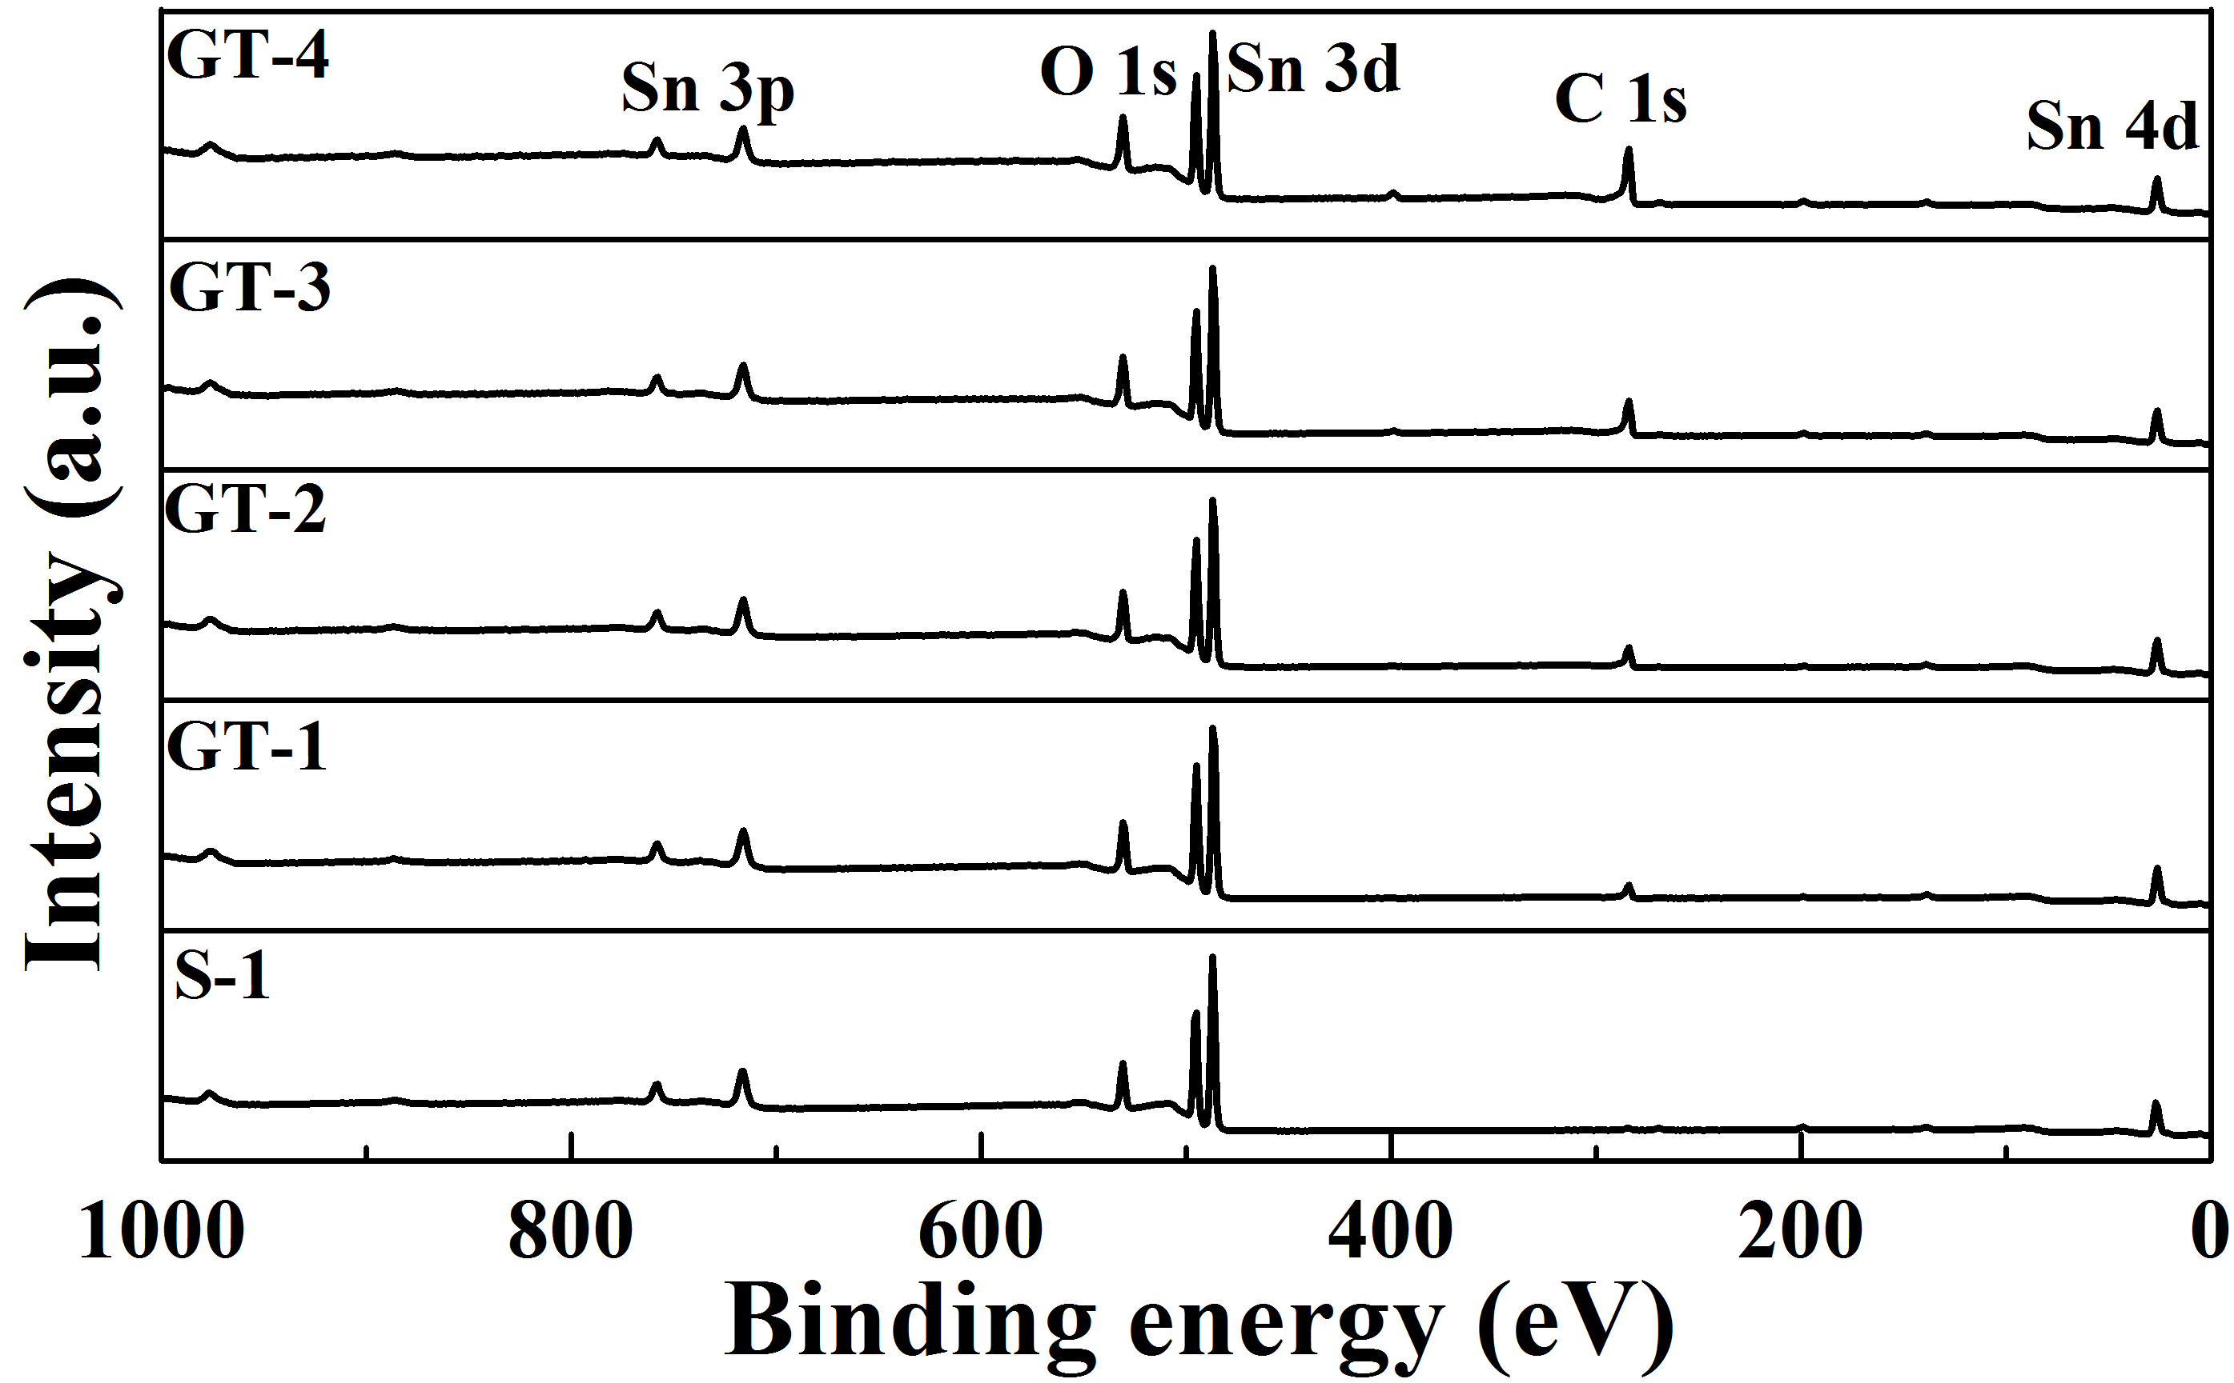
Figure S4. The survey XPS spectra of S-1 GT-1, GT-2, GT-3 and GT-4.
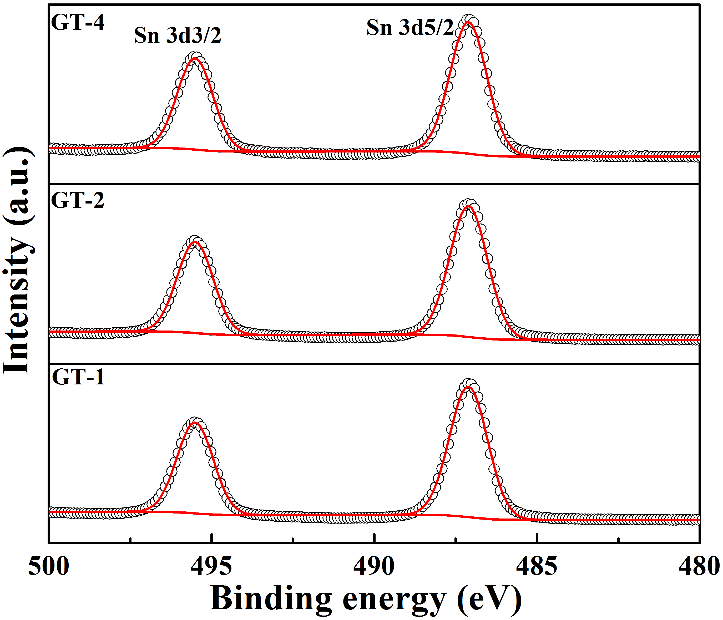
Figure S5. The high-resolution XPS spectra of Sn 3d in GT-1, GT-2 and GT-4.
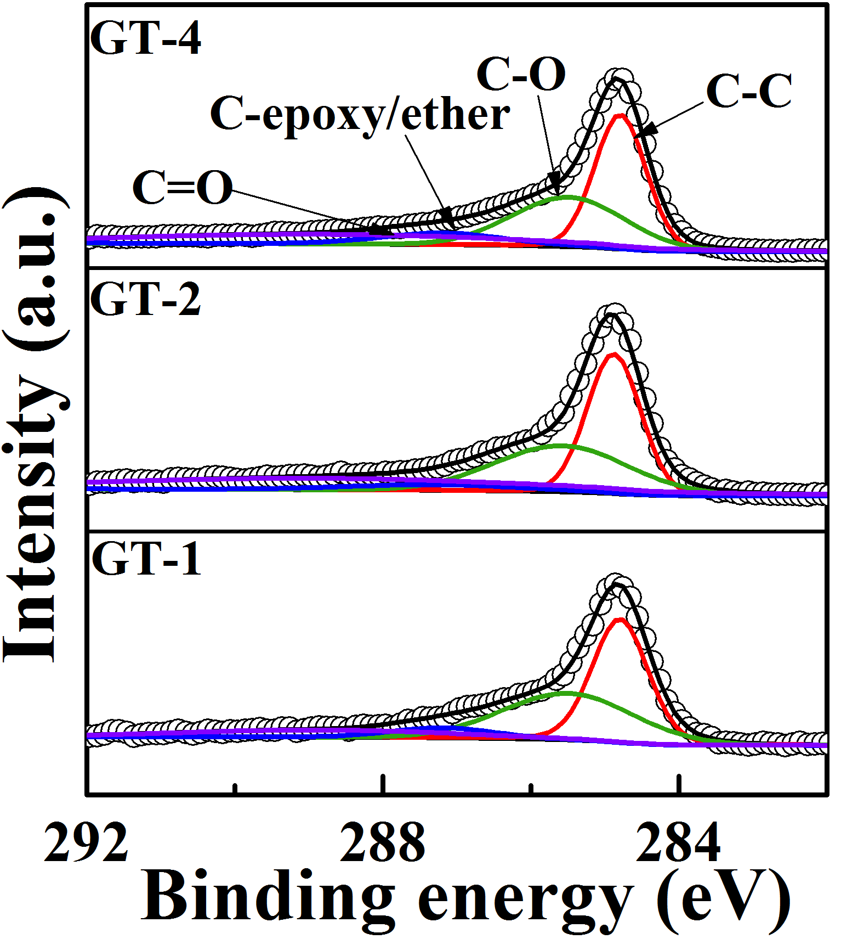
Figure S6. The high-resolution XPS spectra of C 1s in GT-1, GT-2 and GT-4.
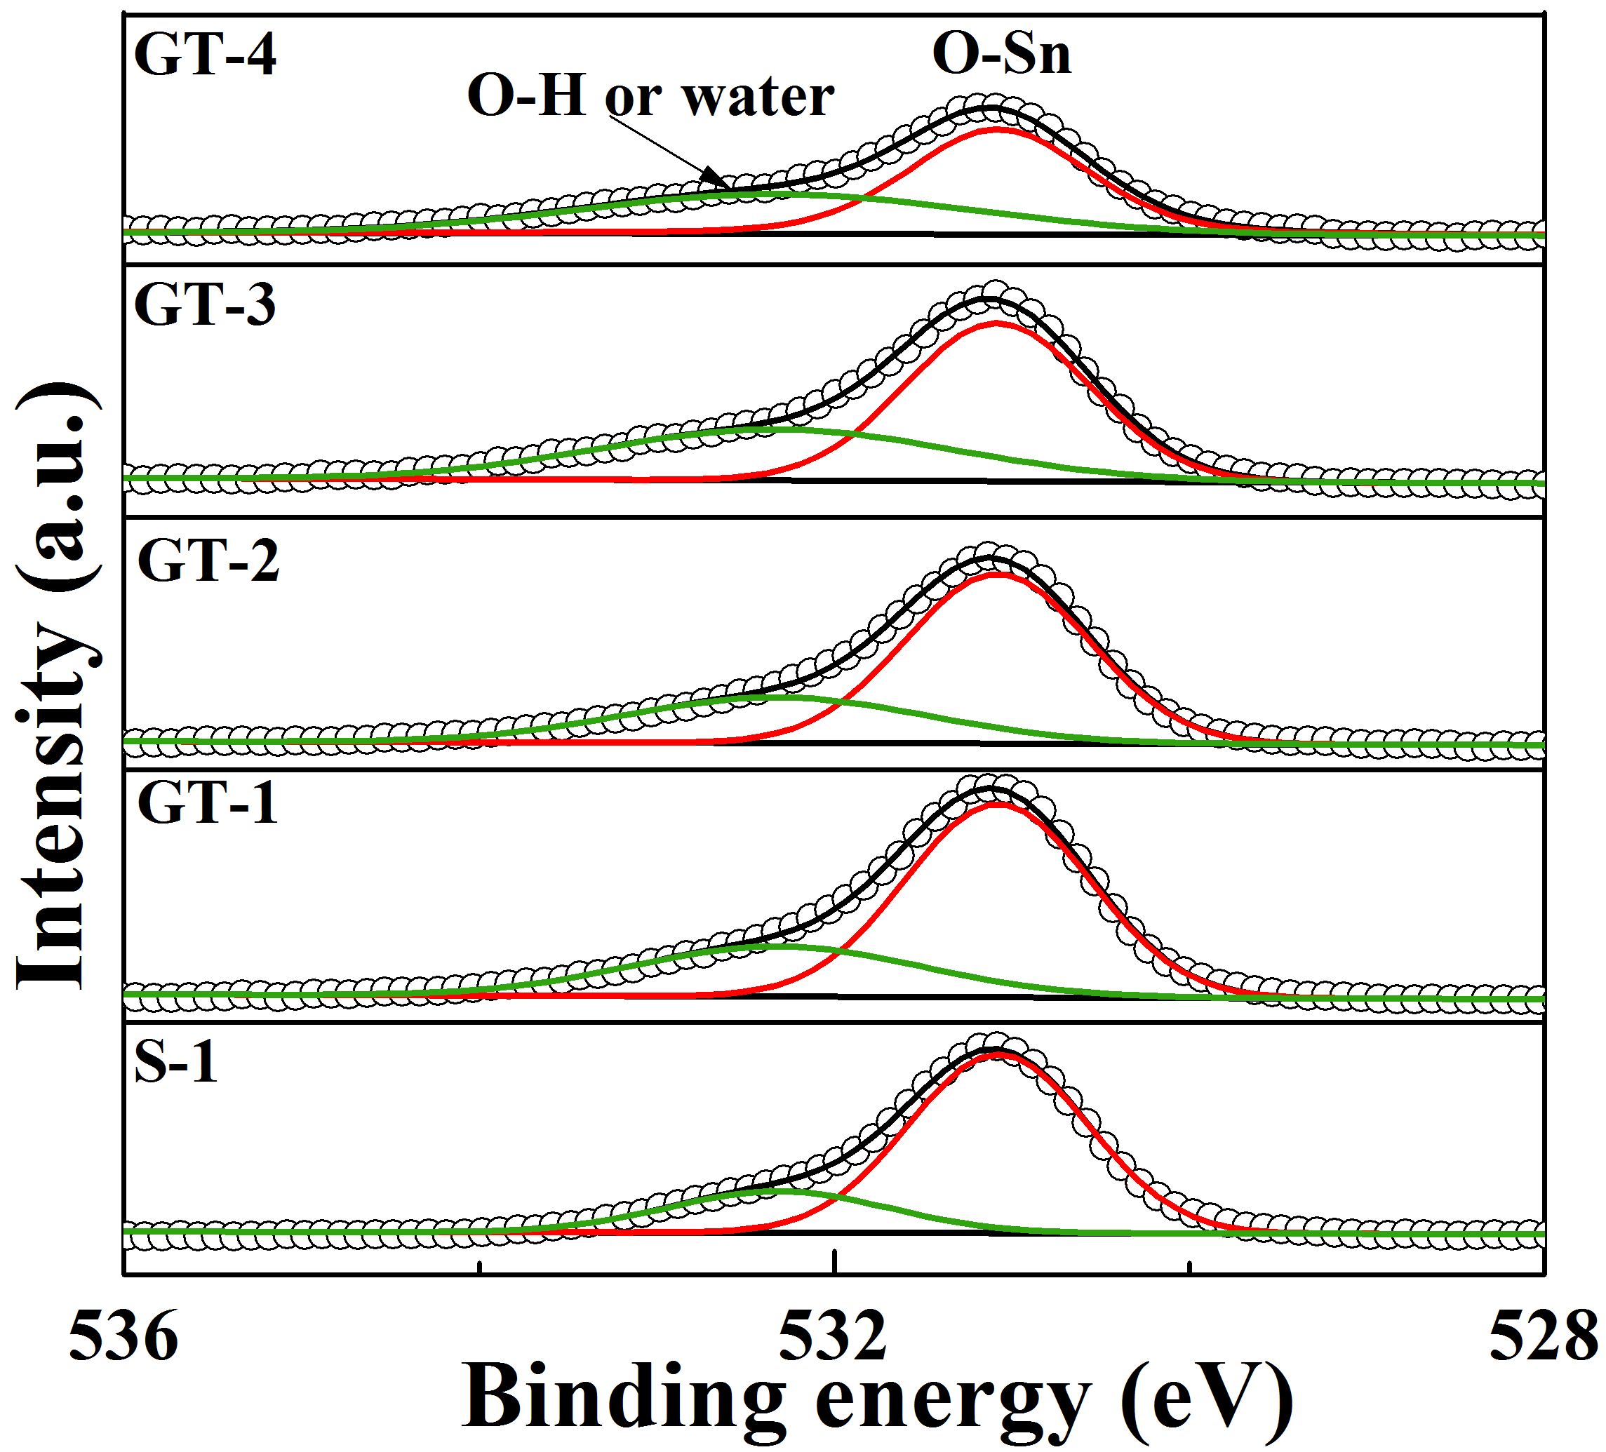
Figure S7. The high-resolution XPS spectra of O 1s in S-1, GT-1, GT-2, GT-3 and GT-4.
5. CV curves of SnO₂@RGO materials
Figure S8. CV curves (a) at a scan rate of 0.1 mV s⁻¹ of GT-1.
Figure S9. CV curves (a) at a scan rate of 0.1 mV s⁻¹ of GT-2.
Figure S10. CV curves (a) at a scan rate of 0.1 mV s⁻¹ of GT-4.
6. The conductivities of SnO₂, SnO₂@RGO composites, and RGO materials
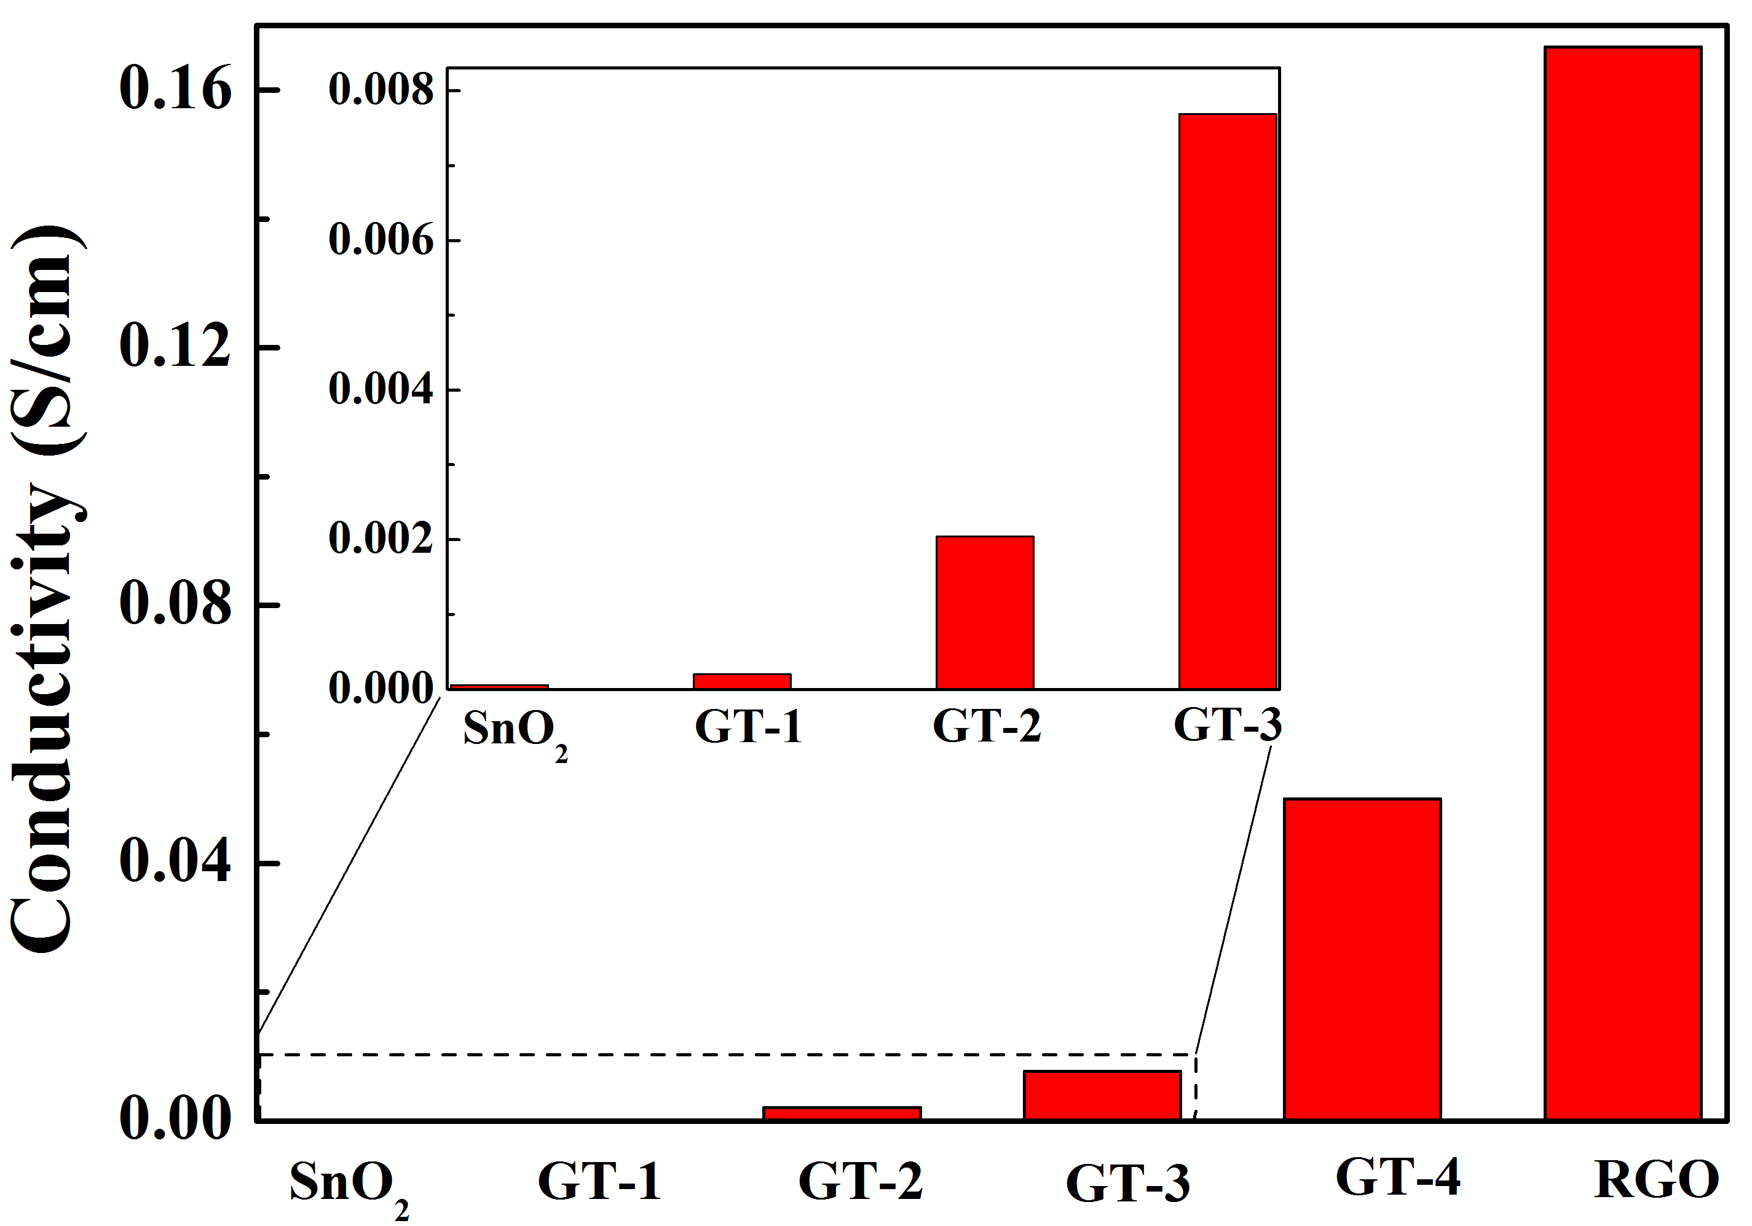
Figure S11. The conductivities of SnO₂, SnO₂@RGO composites, and RGO.

