Supplementary Material
A Facile Preparation of Epoxy-Polydimethylsiloxane (EP-PDMS) Polymer Coatings for Marine Applications
Shatakshi Verma^{1*}, Sonalee Das², Smita Mohanty^{1, 2}, and S.K. Nayak^{1,2}
¹Central Institute of Plastics Engineering and Technology (CIPET), Chennai.
²Laboratory for Advanced Research in Polymeric Materials (LARPM), Bhubaneswar

*Corresponding author.
E-mail: shatakshi.verma23@gmail.com; Tel.: +91-8594824218.
Full postal address: Central Institute of Plastics Engineering and Technology,
T.V.K. Industrial Estate, Guindy, Chennai, Tamil Nadu-600032, India.

TABLE SI. Composition of N-EP and EP-hPD blend systems.
Sample code | EP: h-PDMS (wt.%) | EP  (wt.%) | h-PDMS  (wt.%)
N-EP | 100:0 | 100 | 0
EP-hPD-90/10 | 90:10 | 90 | 10
EP-hPD-70/30 | 70:30 | 70 | 30
EP-hPD-50/50 | 50:50 | 50 | 50
EP-hPD-30/70 | 30:70 | 30 | 70
EP-hPD-10/90 | 10:90 | 10 | 90

FIG. S1. Stress-strain graphs of N-EP and EP-hPD blend films.
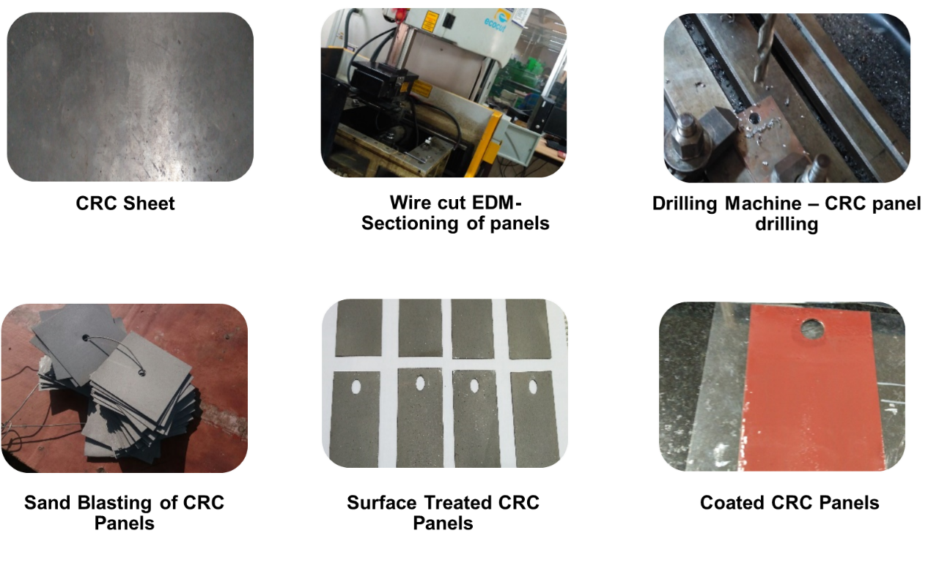
FIG. S2. Step-by-step procedure for the preparation of blend coatings.

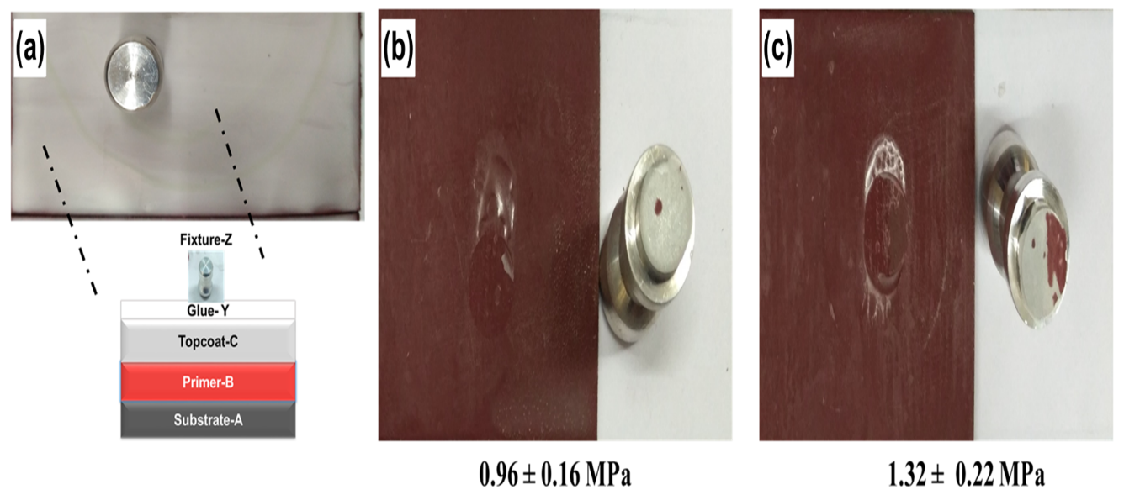
FIG. S3. (a) Methodology of pull-off adhesion test (b) Cohesive failure in N-EP coating (c) Adhesive failure in EP-hPD/70-30 coating.

