Supporting information

High performance coaxial wire-shaped supercapacitors using ionogel electrolyte toward sustainable energy system
Yongchao Liu¹, Mugilan Narayanasamy¹, Cheng Yang², Minjie Shi^{*,1},
Wei Xie⁵, Hanzhao Wu¹, Chao Yan^{*,1}, Hua Hou,⁴ and Zhanhu Guo^{3, 6} *

1. School of Materials Science and Engineering, Jiangsu University of Science and Technology, Zhenjiang, 212003, China
2. State Key Laboratory for Metallic Matrix Composite Materials, School of Materials Science and Engineering, Shanghai Jiao Tong University, Shanghai 200240, China
³Integrated Composites Laboraotry (ICL), Department of Chemical and Biomolecular Engineering, University of Tennessee, Knoxville, TN 37996, USA
⁴College of Materials Science and Engineering, North University of China, Taiyuan, 030051, China
⁵ Key Laboratory of Lightweight and Reliability Technology for Engineering Vehicle, Education Department, Changsha University of Science & Technology, Changsha, China
⁶ Key Laboratory of Materials Processing and Mold (Zhengzhou University), Ministry of Education, National Engineering Research Center for Advanced Polymer Processing Technology, Zhengzhou University, Zhengzhou, China
* Corresponding author:
Email: chaoyan@just.edu.cn (C. Yan); shiminjie@ just.edu.cn (M. Shi); zguo10@utk.edu (Z. Guo)

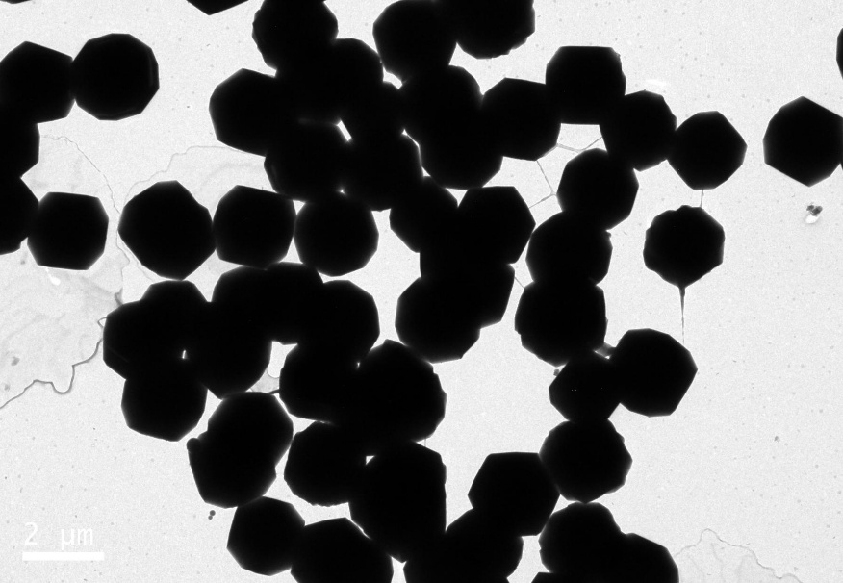
Fig. S1 TEM image of porous carbon dodecahedrons.

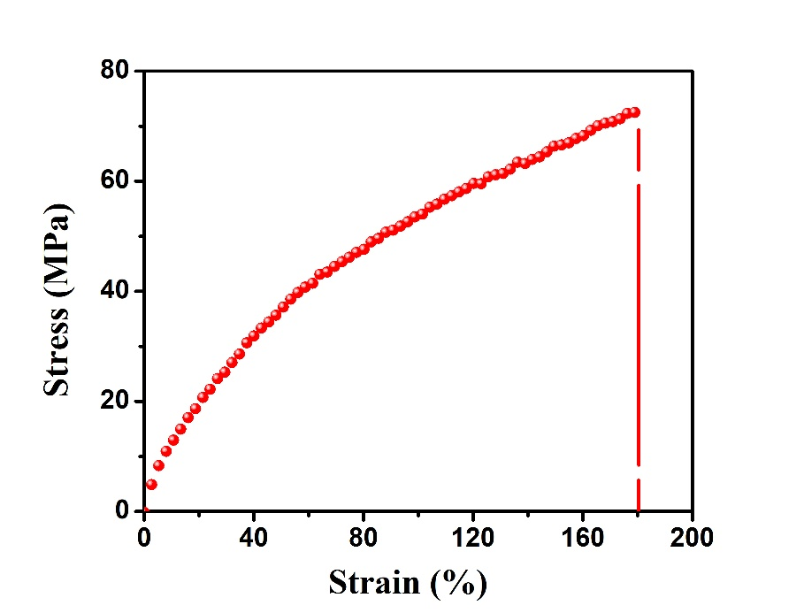
Fig. S2 Tensile stress-strain curve of coaxial WSSCs.

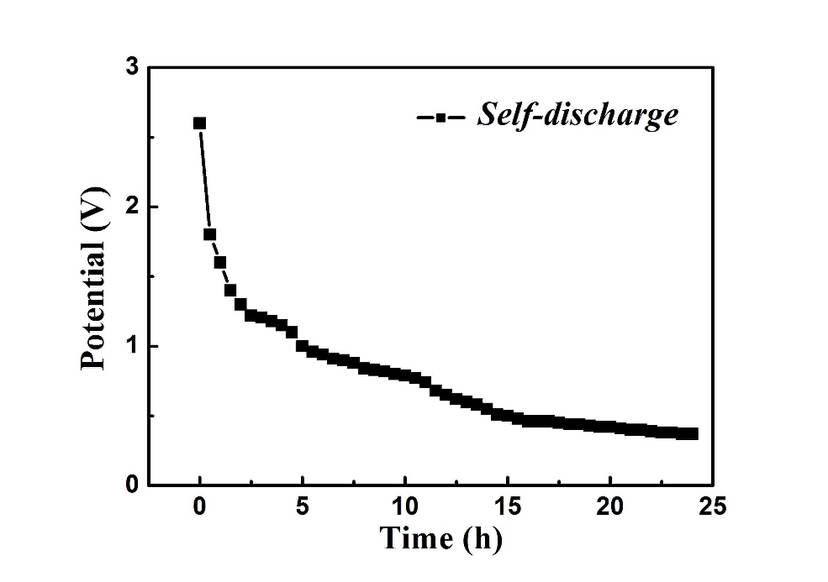
Fig. S3 Self-discharging performance of coaxial WSSCs.

