Supplementary Materials
for
Nanowires assembled from iron manganite nanoparticles: Synthesis, characterization and investigation of electrocatalytic properties for water oxidation reaction

Asude Cetin¹, Ahmet M. Önal¹ and Emren Nalbant Esenturk¹*
¹ Department of Chemistry, Middle East Technical University, 06800 Ankara, Turkey

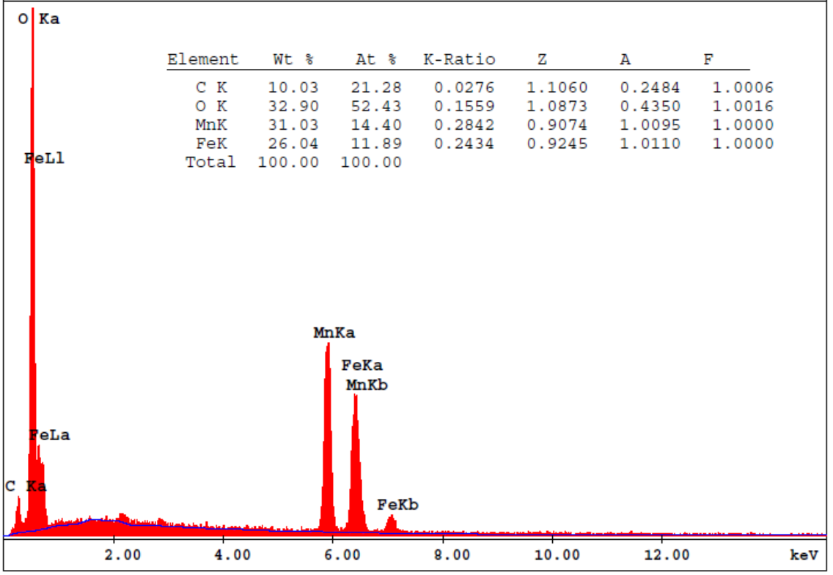

Fig. S1 EDX spectra of FeMnO₃ nanowires.

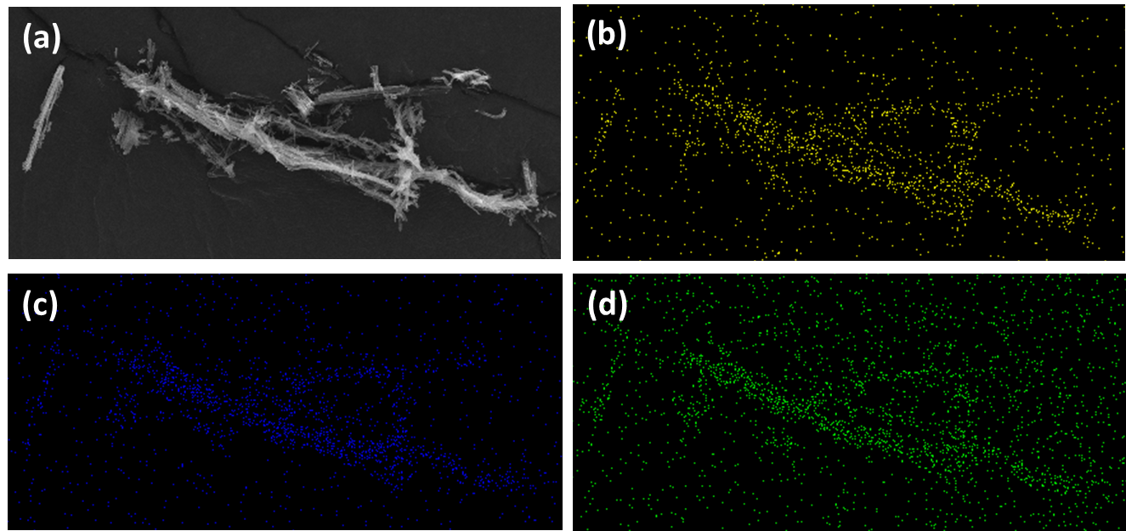
Fig. S2 (a) SEM image and element mapping (b) Fe (yellow), (c) Mn (blue), (d) O (green) of FeMnO₃ nanowires.

