Supplementary Information for
Enthalpies of formation of the solid solutions of Zr_{x}Y_{0.5-x/2}Ta_{0.5-x/2}O₂
(0 ≤ x ≤ 0.2 and 0.65 ≤ x ≤ 1)

Maren Lepple, Kristina Lilova, Carlos G. Levi, Alexandra Navrotsky

XRD patterns with results of Rietveld refinement:

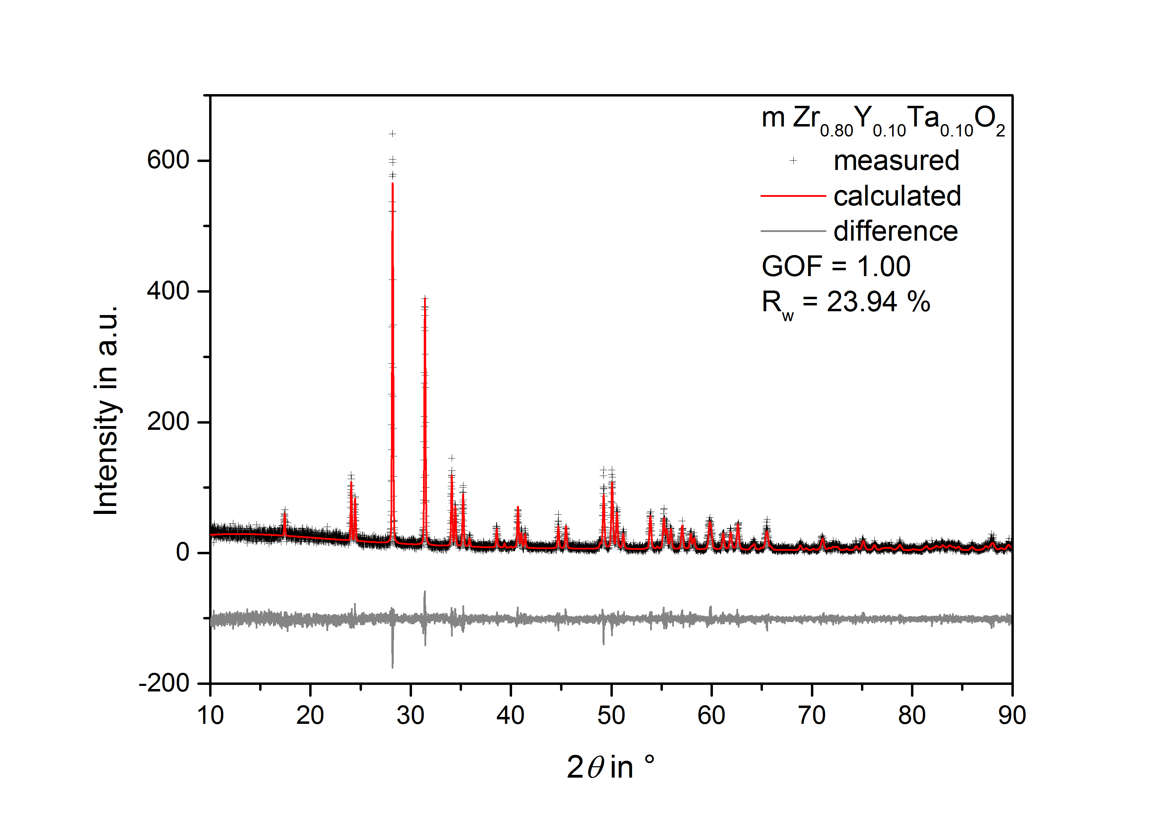
FIG S1. XRD pattern of sample Zr_{0.8}Y_{0.1}Ta_{0.1}O₂ heat treated at 1773 K in air including the results of the Rietveld refinement.
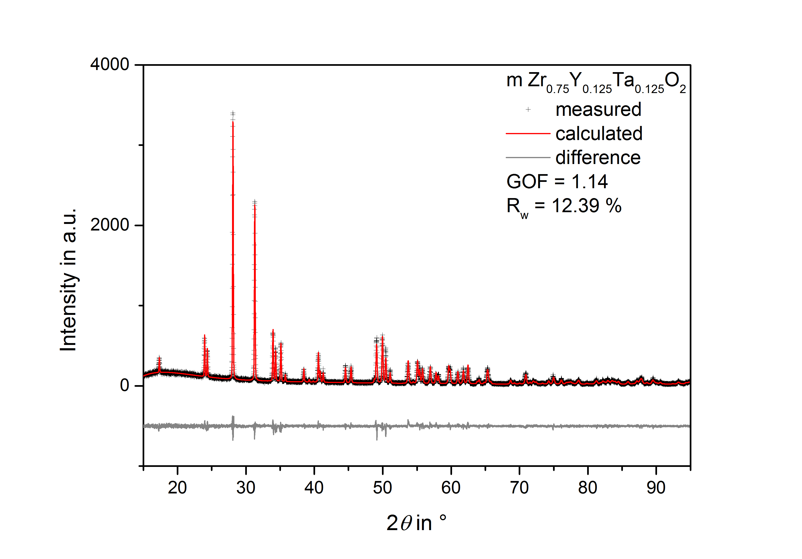
FIG S2. XRD pattern of sample Zr_{0.75}Y_{0.125}Ta_{0.125}O₂ heat treated at 1773 K in air including the results of the Rietveld refinement.
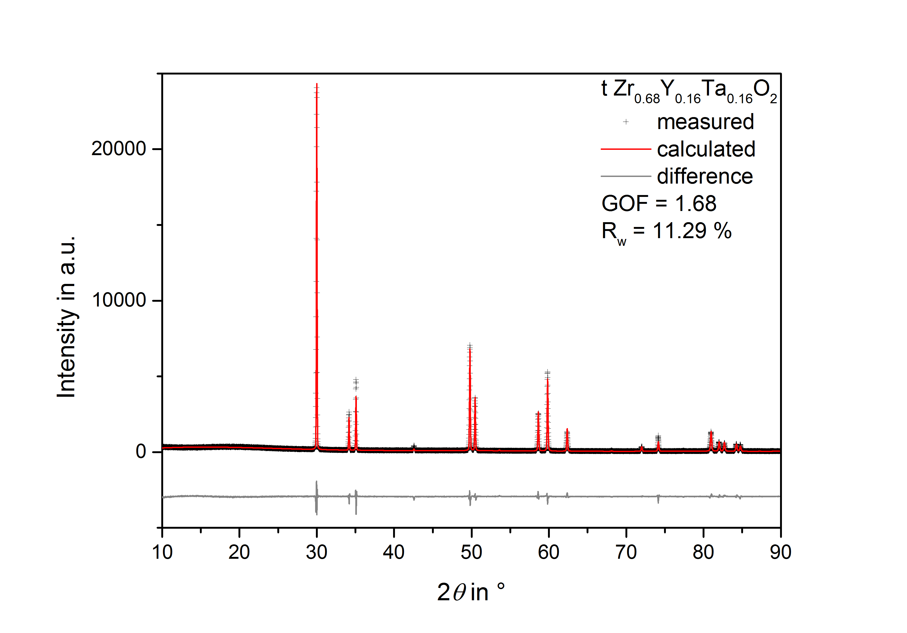
FIG S3. XRD pattern of sample Zr_{0.68}Y_{0.16}Ta_{0.16}O₂ heat treated at 1773 K in air including the results of the Rietveld refinement.

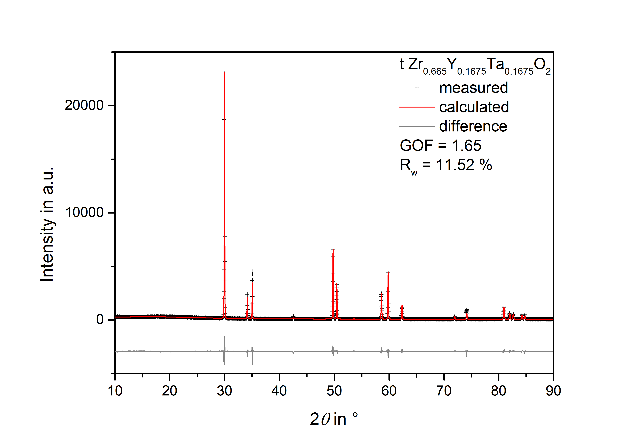
FIG S4. XRD pattern of sample Zr_{0.665}Y_{0.1675}Ta_{0.1675}O₂ heat treated at 1773 K in air including the results of the Rietveld refinement.
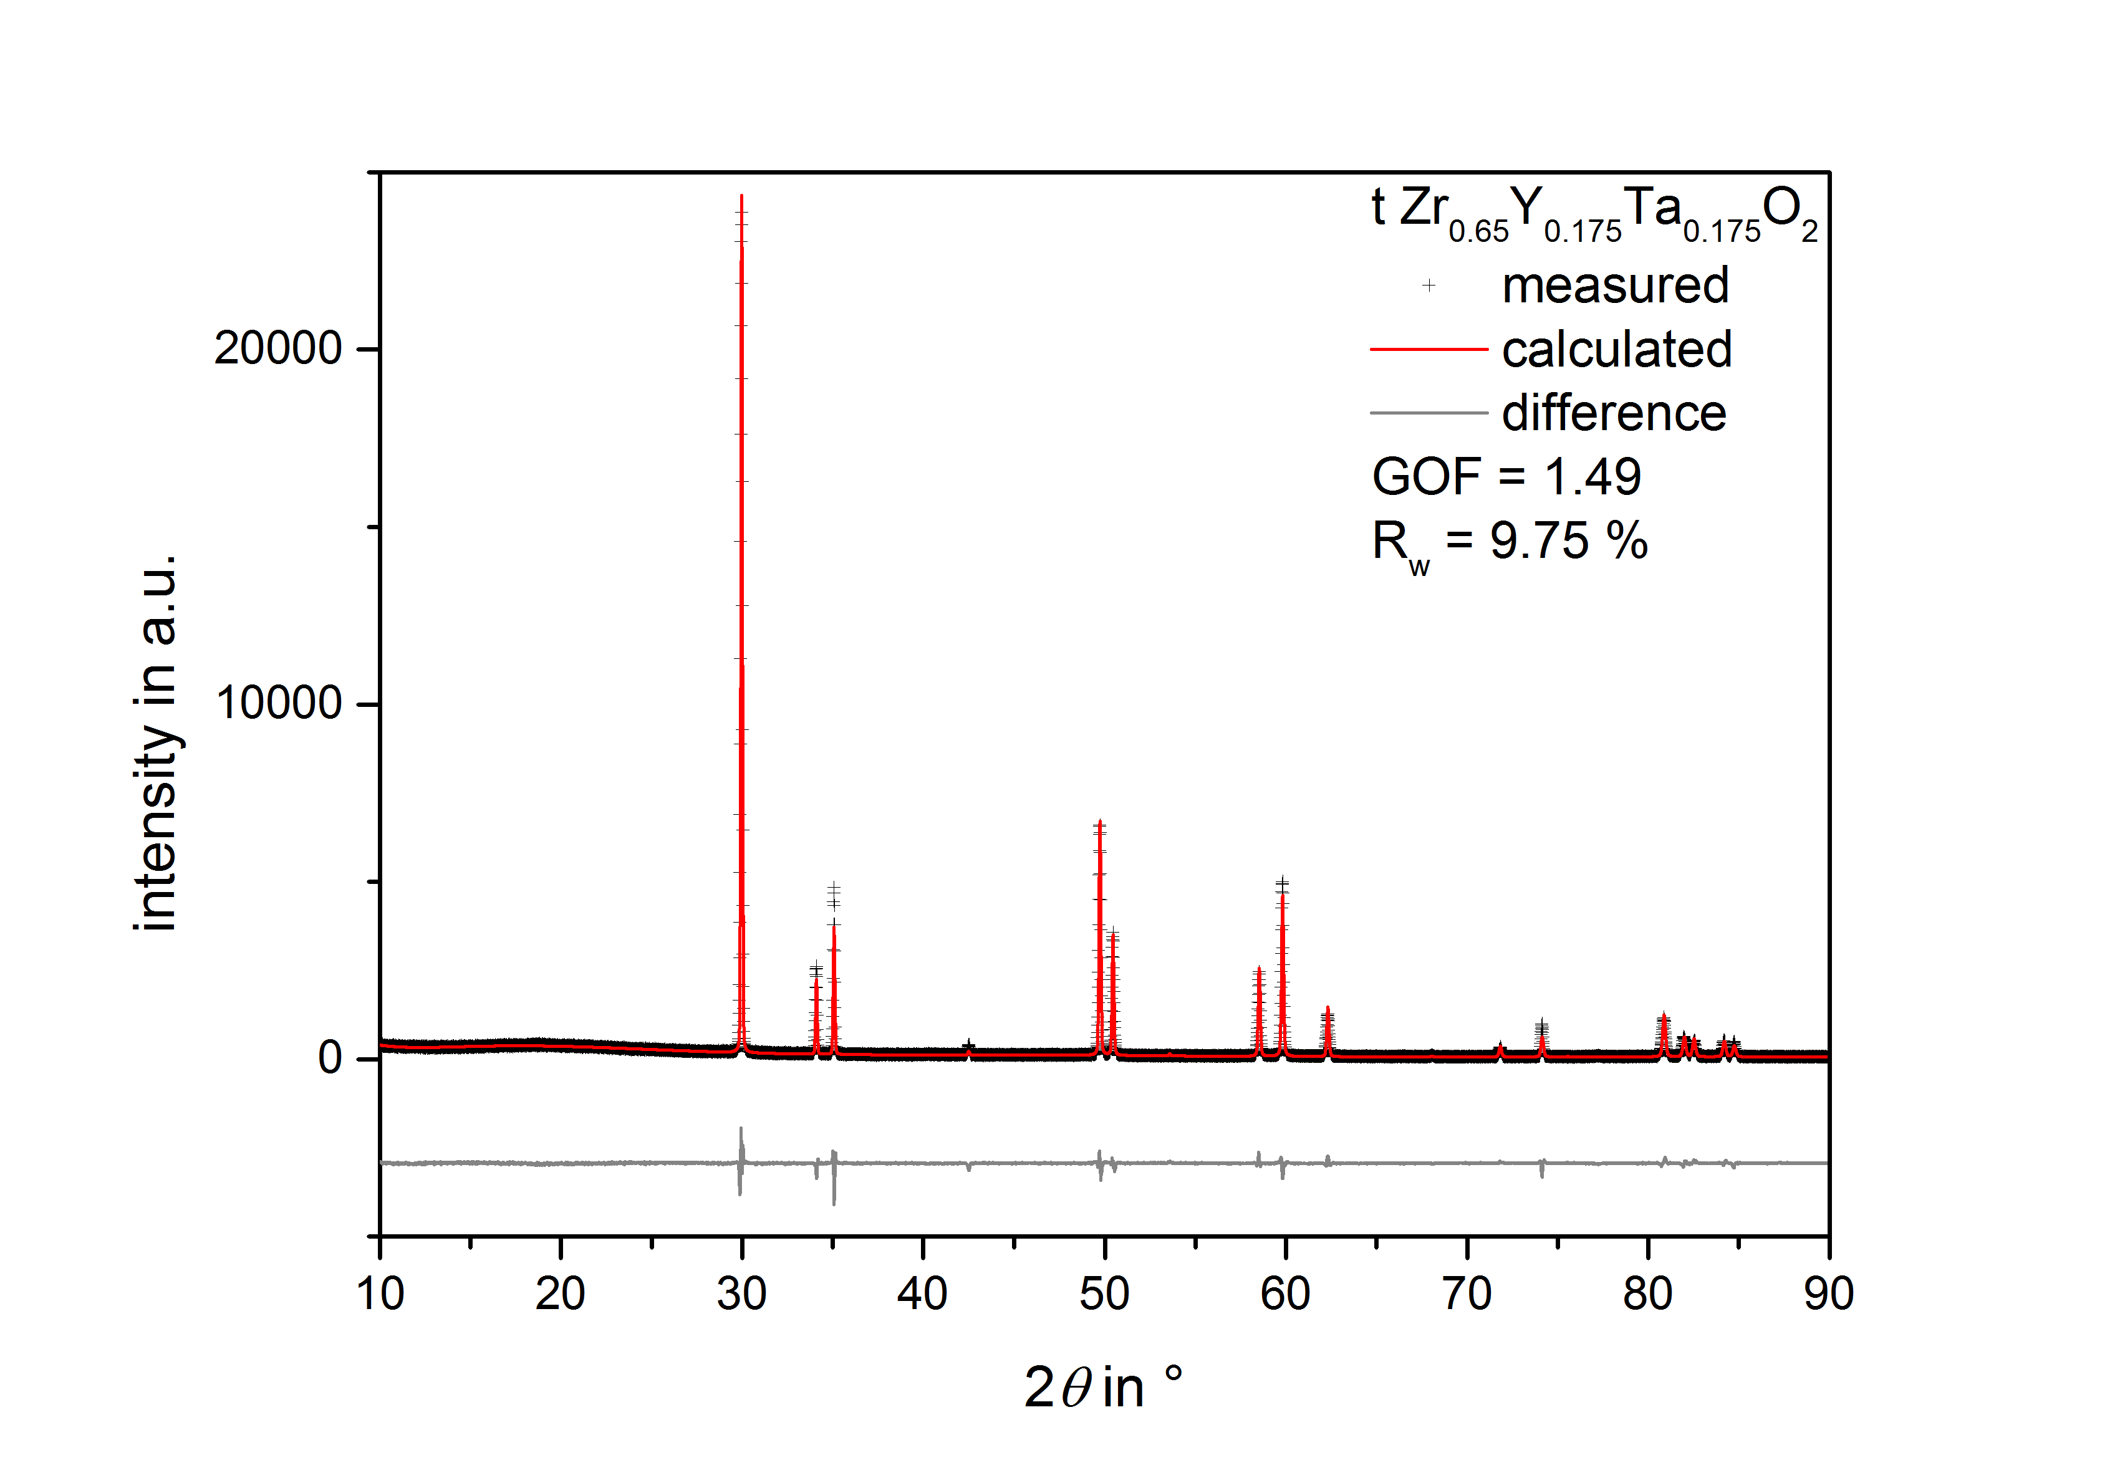
FIG S5. XRD pattern of sample Zr_{0.65}Y_{0.175}Ta_{0.175}O₂ heat treated at 1773 K in air including the results of the Rietveld refinement.
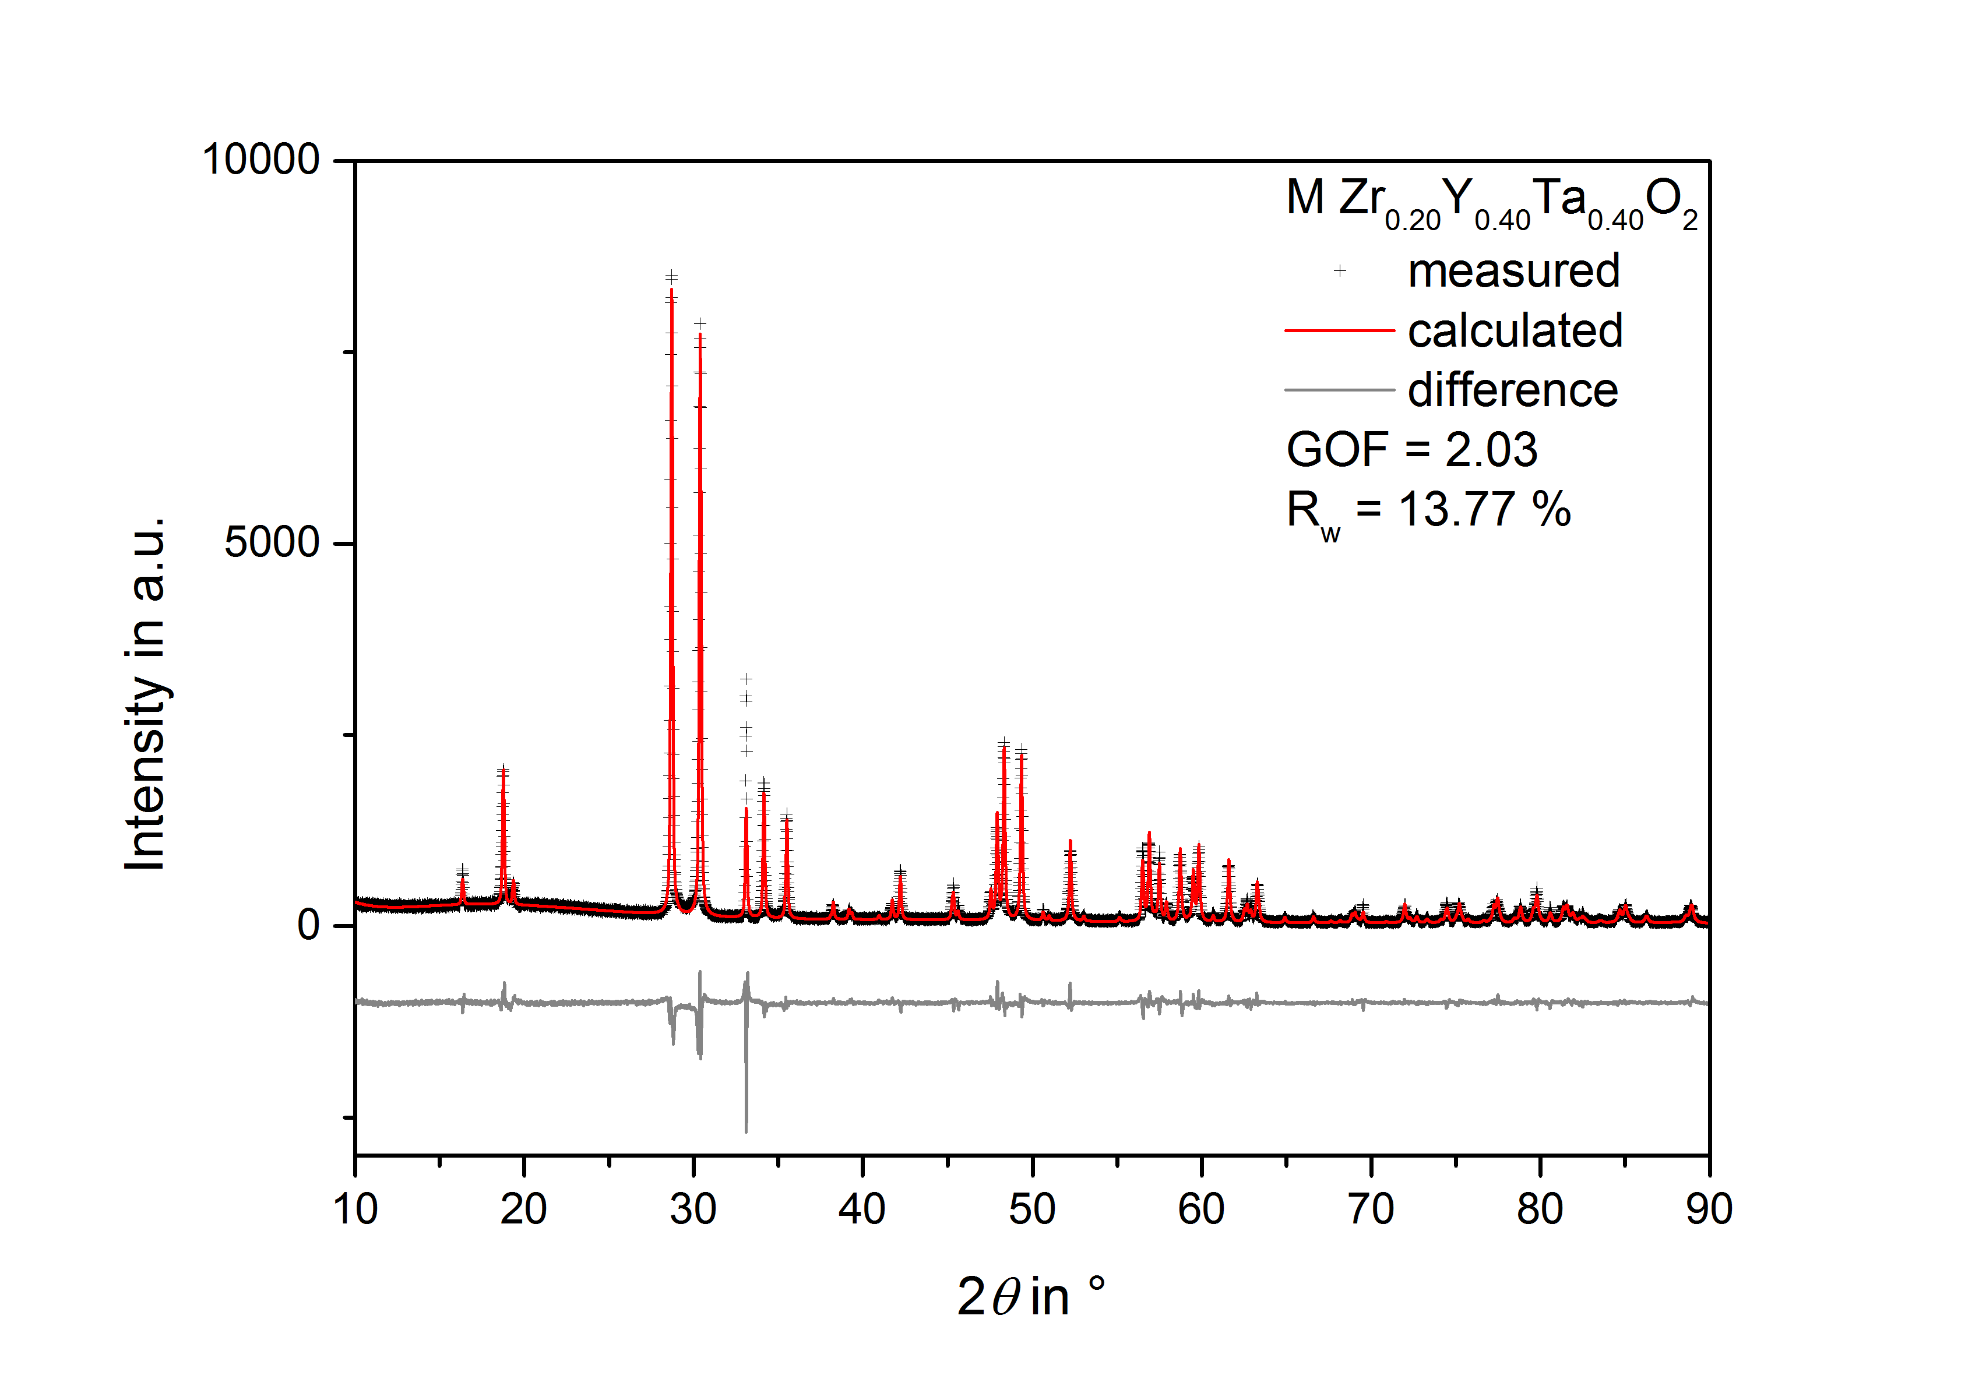
FIG S6. XRD pattern of sample Zr_{0.2}Y_{0.4}Ta_{0.4}O₂ heat treated at 1773 K in air including the results of the Rietveld refinement.
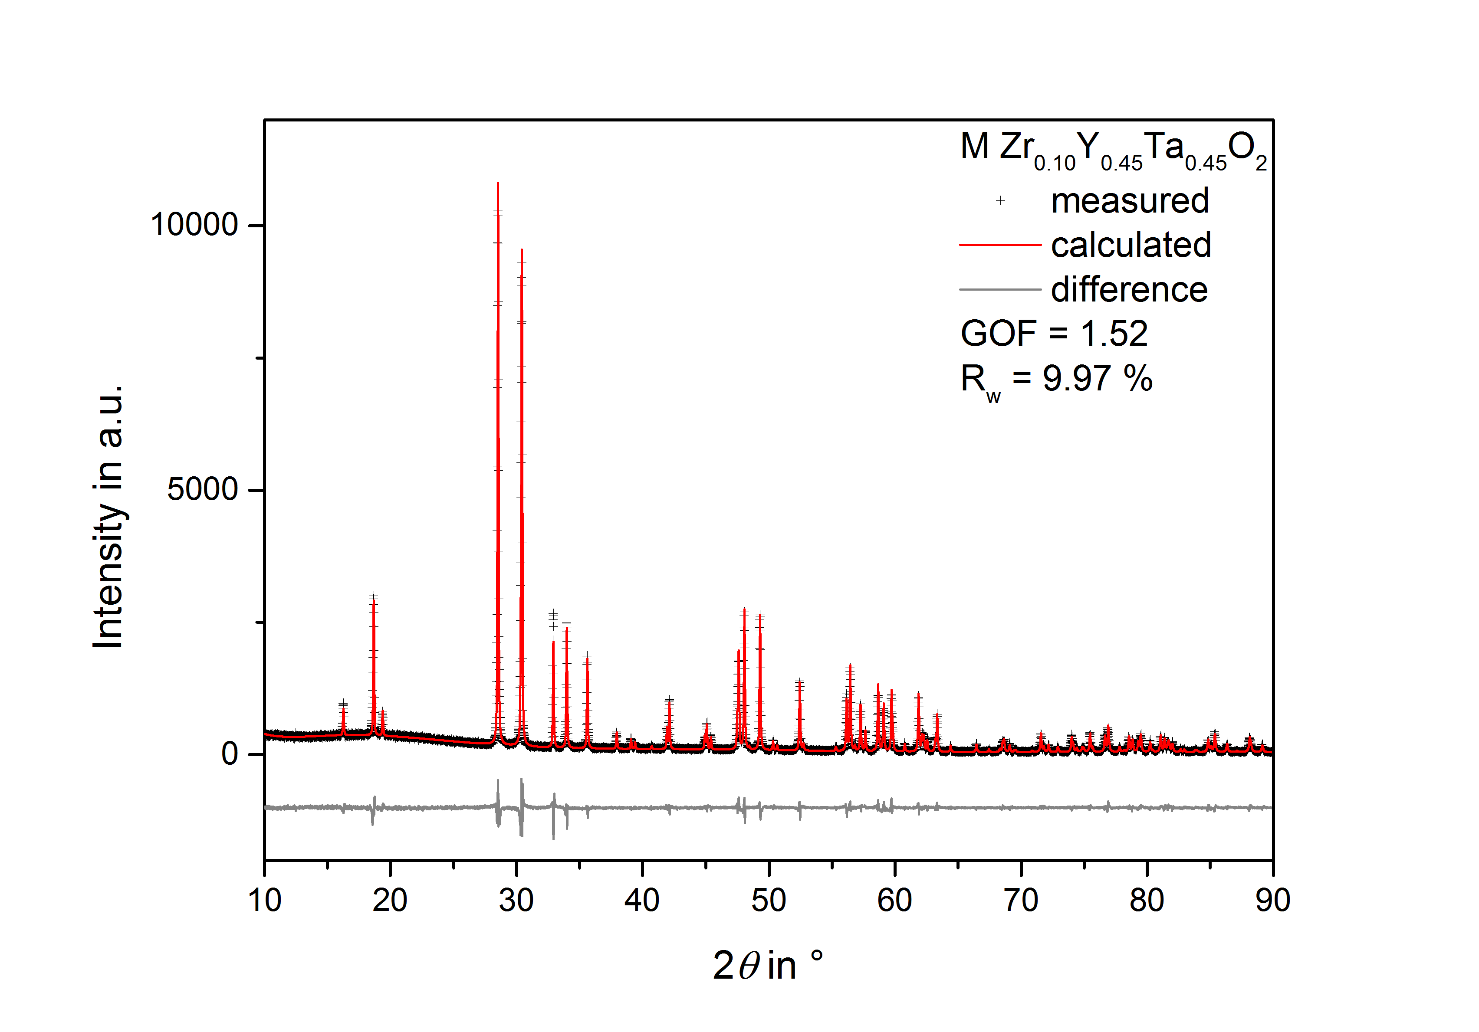
FIG S7. XRD pattern of sample Zr_{0.1}Y_{0.45}Ta_{0.45}O₂ heat treated at 1773 K in air including the results of the Rietveld refinement.
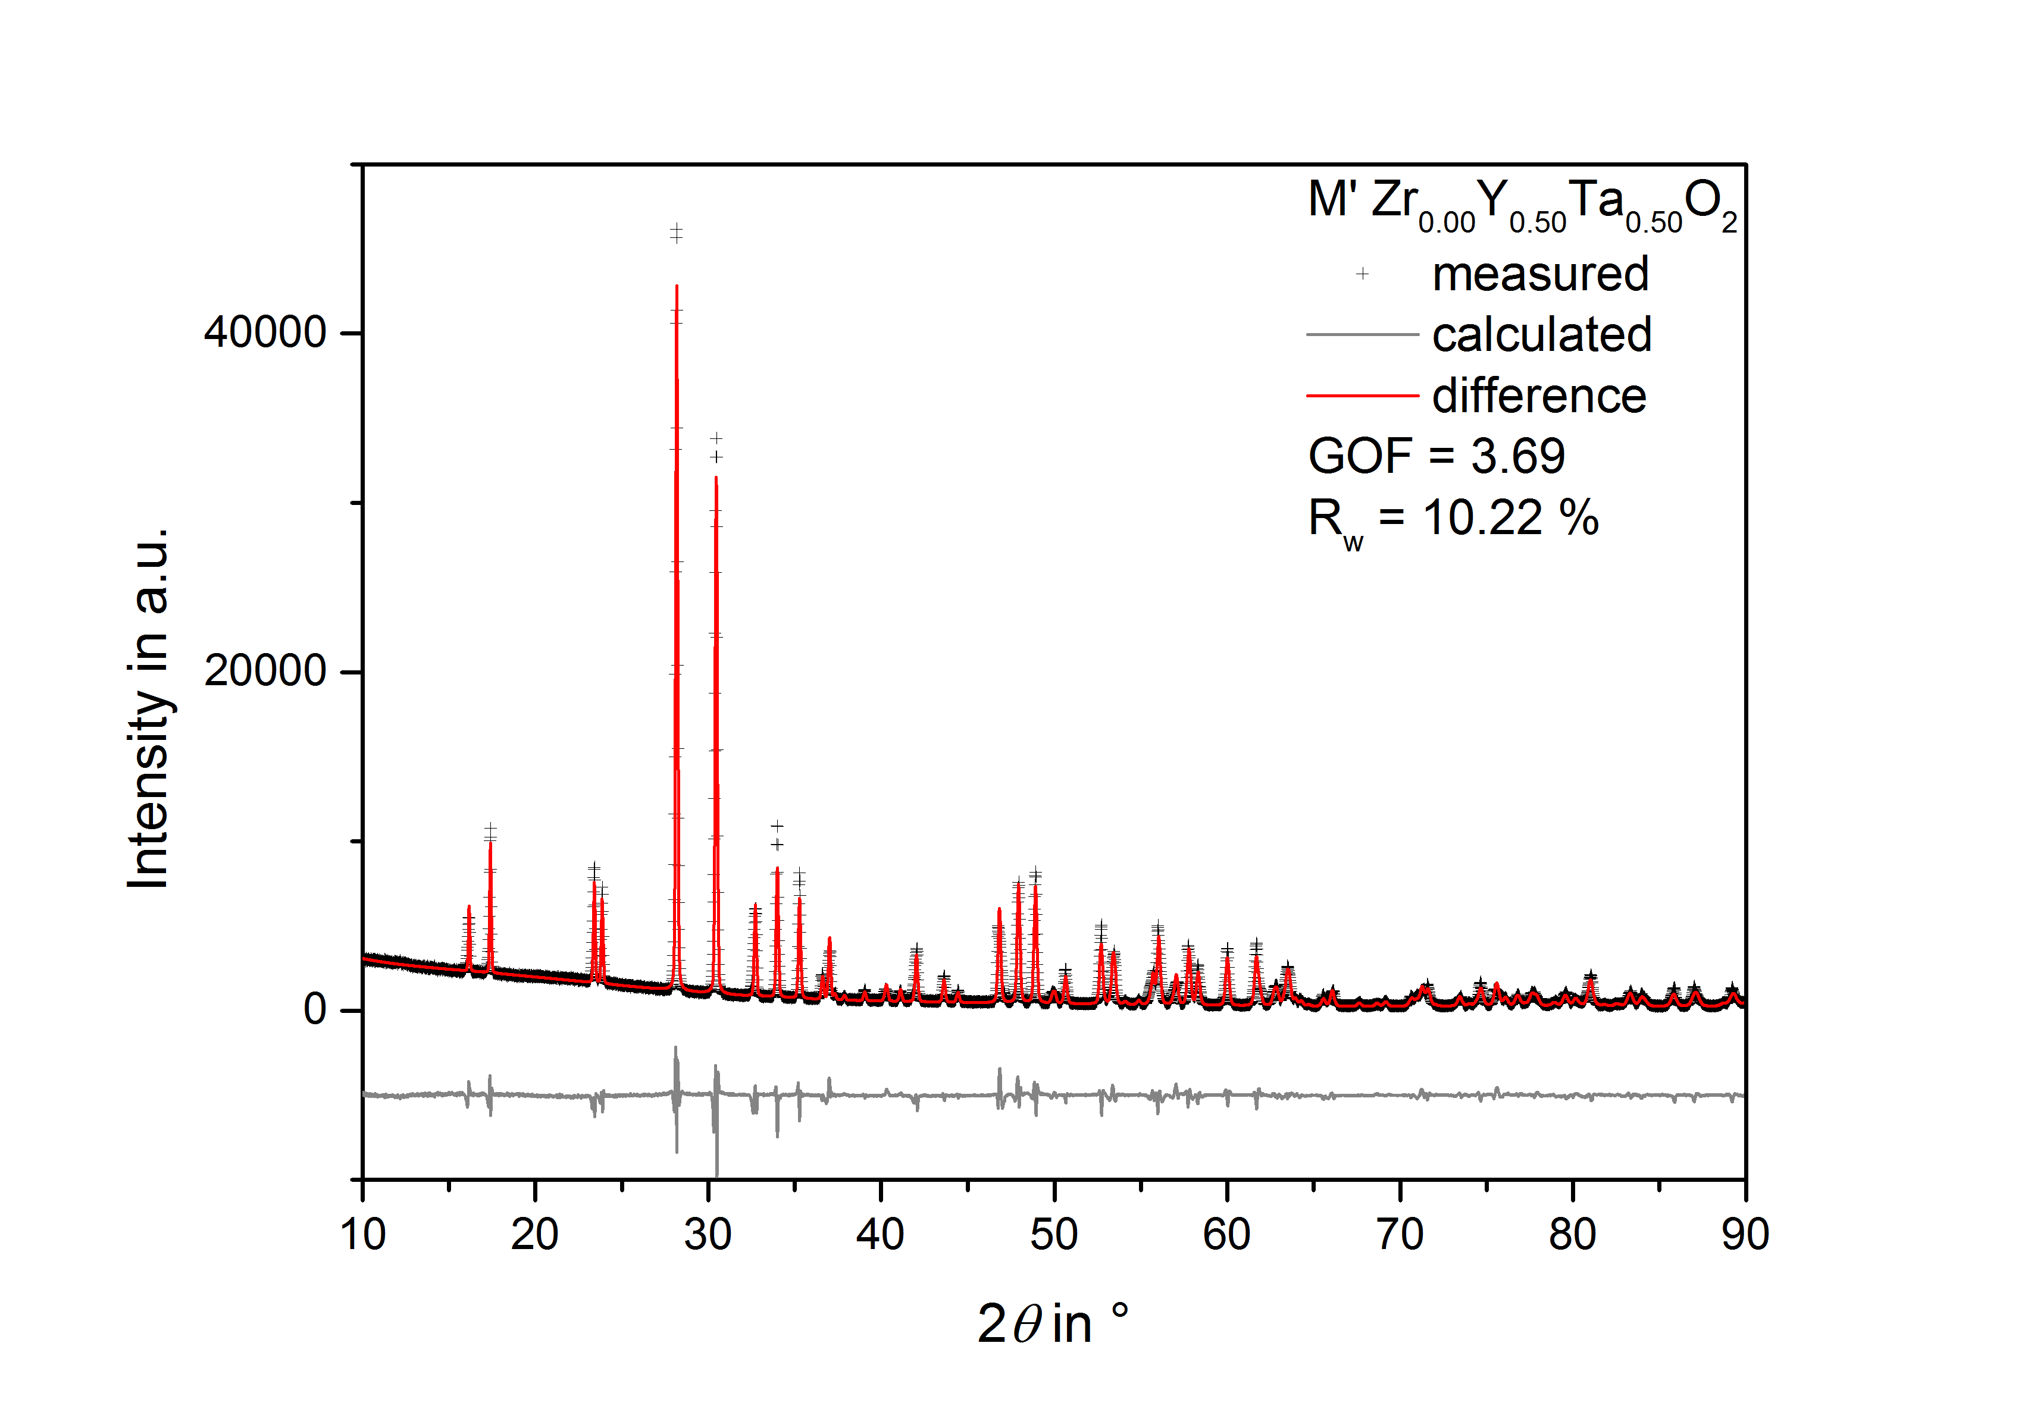
FIG S8. XRD pattern of sample Zr_{0.0}Y_{0.5}Ta_{0.5}O₂ heat treated at 1253 K in air including the results of the Rietveld refinement.
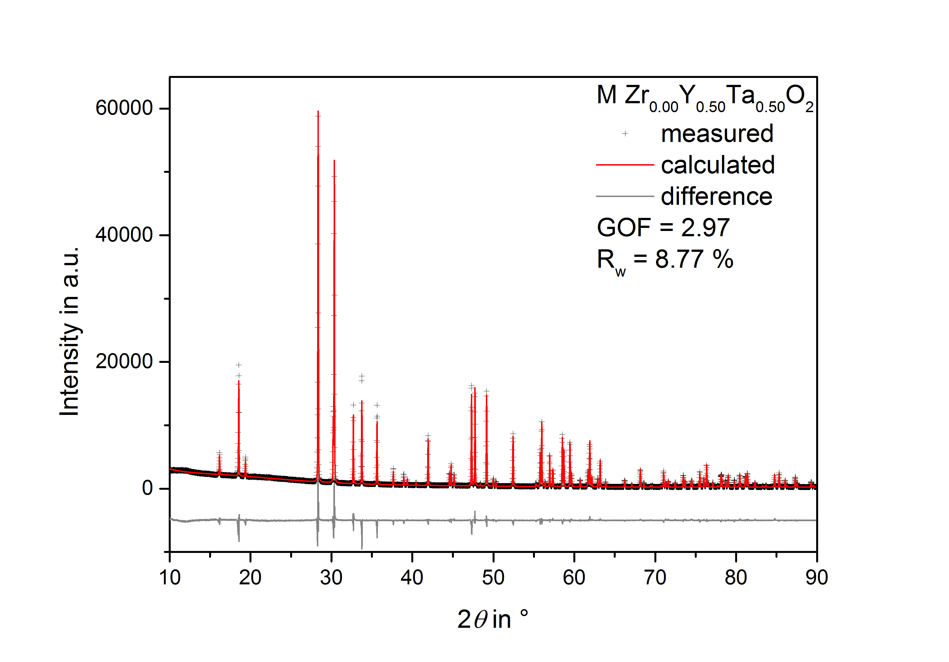
FIG S9. XRD pattern of sample Zr_{0.0}Y_{0.5}Ta_{0.5}O₂ heat treated at 1773 K in air including the results of the Rietveld refinement.

Chemical composition measured by EPMA:
Table S1. Measured chemical composition of the compositions in the ZrO₂ – Y_{0.5}Ta_{0.5}O₂ quasibinary. The error is two standard deviation of the mean.
Nominal stoichiometry | Measured data (at%)
 | Zr | Y | Ta | O
Zr_{0.8}Y_{0.1}Ta_{0.1}O₂ | 27.9 ± 1.2 | 3.3 ± 0.2 | 3.3 ± 0.2 | 65.5 ± 1.3
Zr_{0.75}Y_{0.125}Ta_{0.125}O₂ | 26.6 ± 0.7 | 4.1 ± 0.2 | 3.9 ± 0.2 | 65.4 ± 0.9
Zr_{0.68}Y_{0.16}Ta_{0.16}O₂ | 24.5 ± 0.3 | 5.3 ± 0.1 | 5.4 ± 0.1 | 64.8 ± 0.3
Zr_{0.665}Y_{0.1675}Ta_{0.1675}O₂ | 23.9 ± 0.5 | 5.6 ± 0.1 | 5.7 ± 0.1 | 64.8 ± 0.5
Zr_{0.65}Y_{0.175}Ta_{0.175}O₂ | 23.6 ± 0.4 | 6.0 ± 0.1 | 6.1 ± 0.1 | 64.3 ± 0.5
Zr_{0.2}Y_{0.4}Ta_{0.4}O₂ | 6.7 ± 0.4 | 14.0 ± 0.3 | 14.1 ± 0.1 | 65.2 ± 0.2
Zr_{0.1}Y_{0.45}Ta_{0.45}O₂ | 3.8 ± 0.2 | 15.4 ± 0.2 | 15.2 ± 0.2 | 65.6 ± 0.3
Zr₀Y_{0.5}Ta_{0.5}O₂ | 0 | 17.4 ± 0.2 | 17.1 ± 0.6 | 65.5 ± 0.7

