A Novel and Facile Way to Synthesis Diamondoids Nanowire-Cluster Array

Jilong Wang^{a,b}, Jingjing Qiu^{b} *, Shiren Wang^{c} *
ª Key Laboratory of Textile Science & Technology of Ministry of Education, College of Textiles, Donghua University, Shanghai 201620, PR China
^{b} Department of Mechanical Engineering, Texas Tech University, 2500 Broadway, P.O. Box 43061, Lubbock, TX 79409, United States
^{b} Department of Materials Science and Engineering, Texas A&M University, 3131 TAMU College Station, TX 77843-3131, United States
* E-mail: jenny.qiu@ttu.edu; Phone: 806.742.3563; Fax: 506.742.3540.
E-mail: s.wang@tamu.edu; Phone: 979.458.2357.

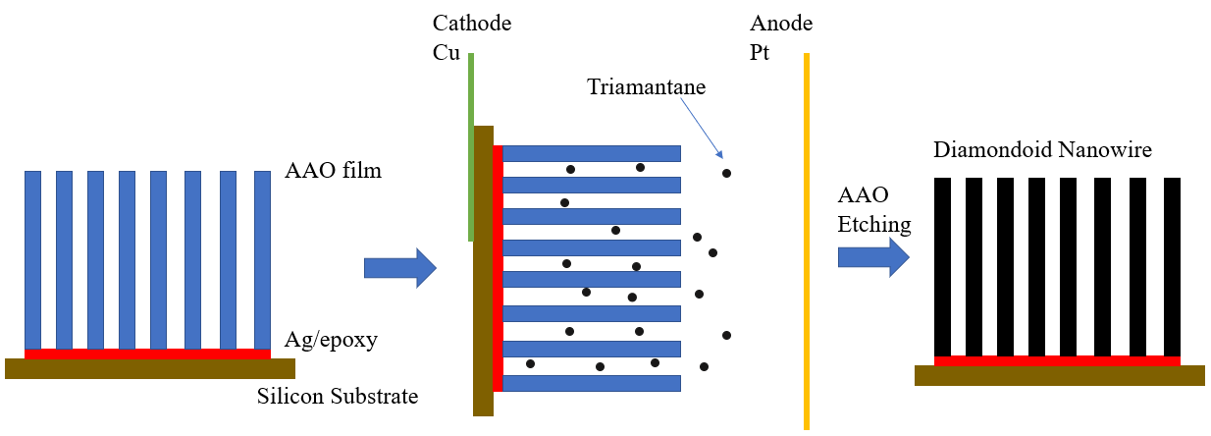
Figure S1. Schematic illustration of diamondoid nanowires fabrication via cathodic electrophoretic deposition
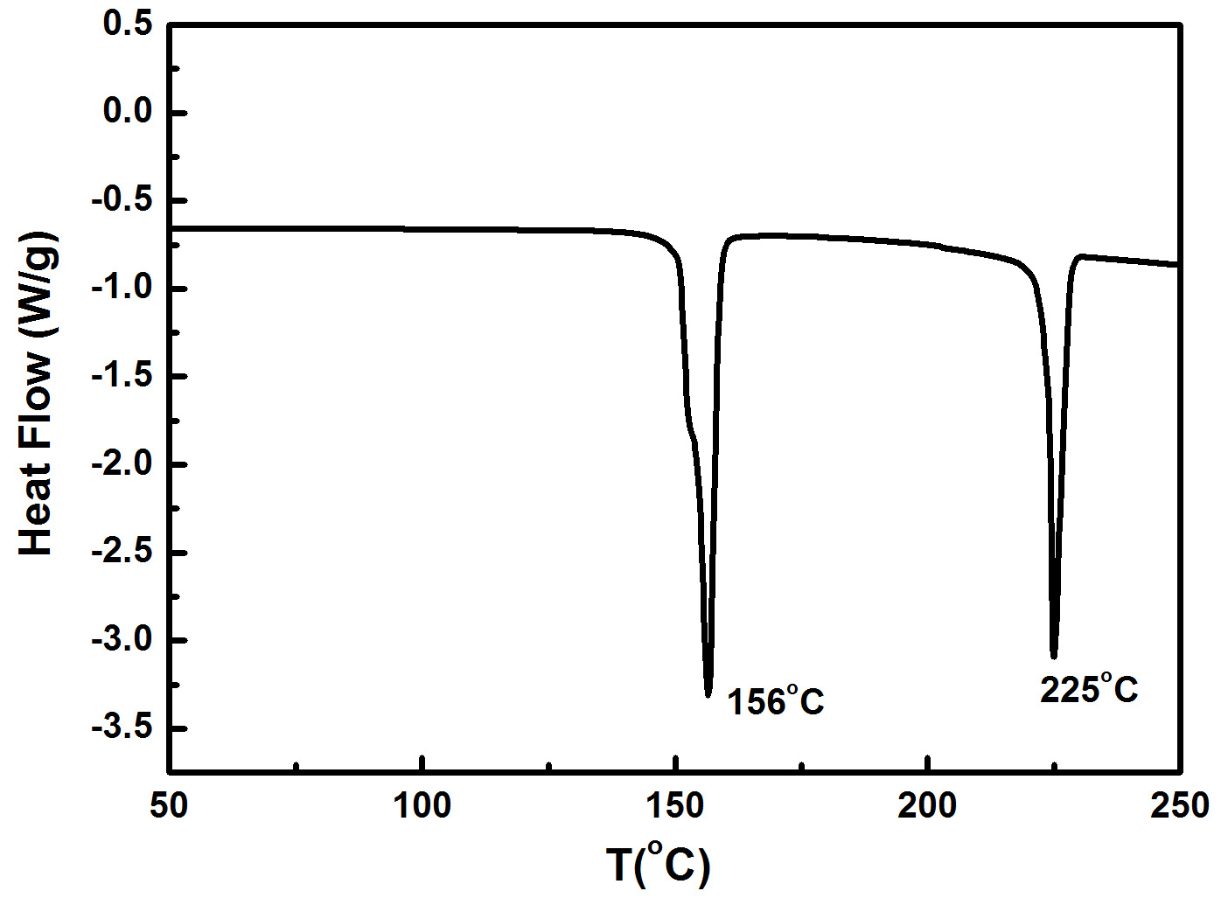
Figure S2. DSC thermograms of the triamantane
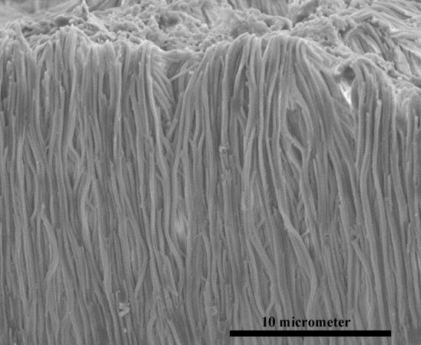
Figure S3. SEM images of diamondoid nanowire array with critical point drying

