Characterization of AlN-based Ceramic Composites for Use as Millimeter Wave Susceptor Materials at High Temperature: Dielectric Properties of AlN:Mo with 0.25 v% to 4.0 v% Mo from 25-550 °C

Brad W. Hoff,¹†* Steven C. Hayden,²† Martin S. Hilario,¹ Rachael O. Grudt,² Frederick W. Dynys,³ Anthony E. Baros,¹ Ian M. Rittersdorf,⁴ and Michele L. Ostraat²

¹ Air Force Research Laboratory, Kirtland AFB, NM, 87117, USA
² Aramco Research Center – Boston, Aramco Services Company, Cambridge, MA 02139, USA
³ NASA Glenn Research Center, Cleveland, Ohio 44135, USA
⁴ Naval Research Laboratory, Washington DC, 20375

† These authors contributed equally to this work.
* To whom correspondence should be addressed: brad.hoff@us.af.mil

Supporting Information.

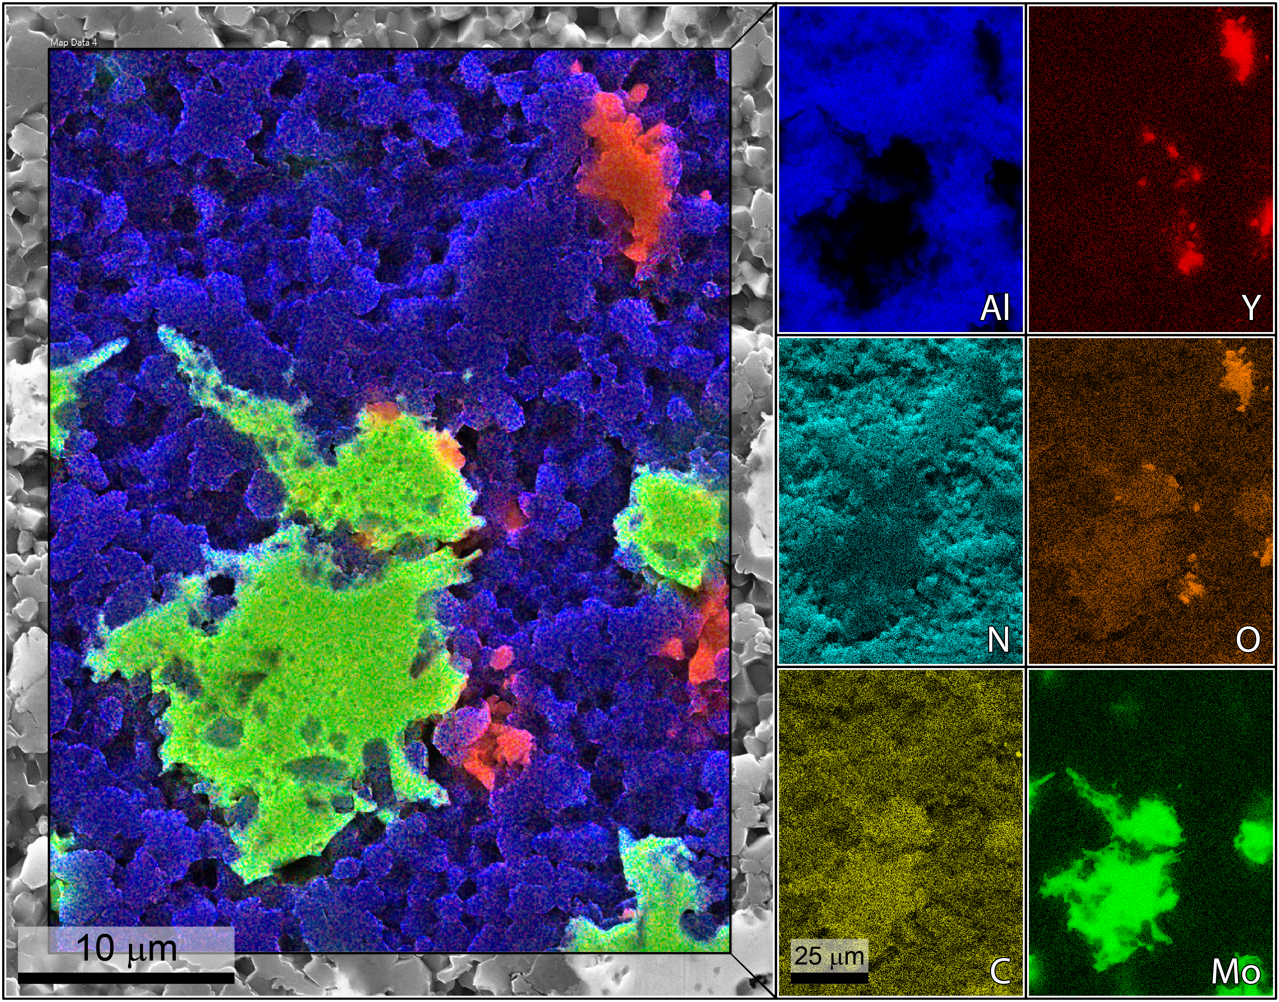
Figure S1. SEM micrograph with elemental compositional maps as individual breakout maps by element and as an overlay on the micrograph. Color corresponds to elemental identity as indicated, while intensity corresponds to relative concentration for that element. The nitrogen signal is hidden in the overlay for clarity. The carbon signal is artificially inflated by the ubiquitous presence of carbon on surfaces, but some co-localization with the Mo grain is evident from the relative increase in carbon signal in the Mo grain area.

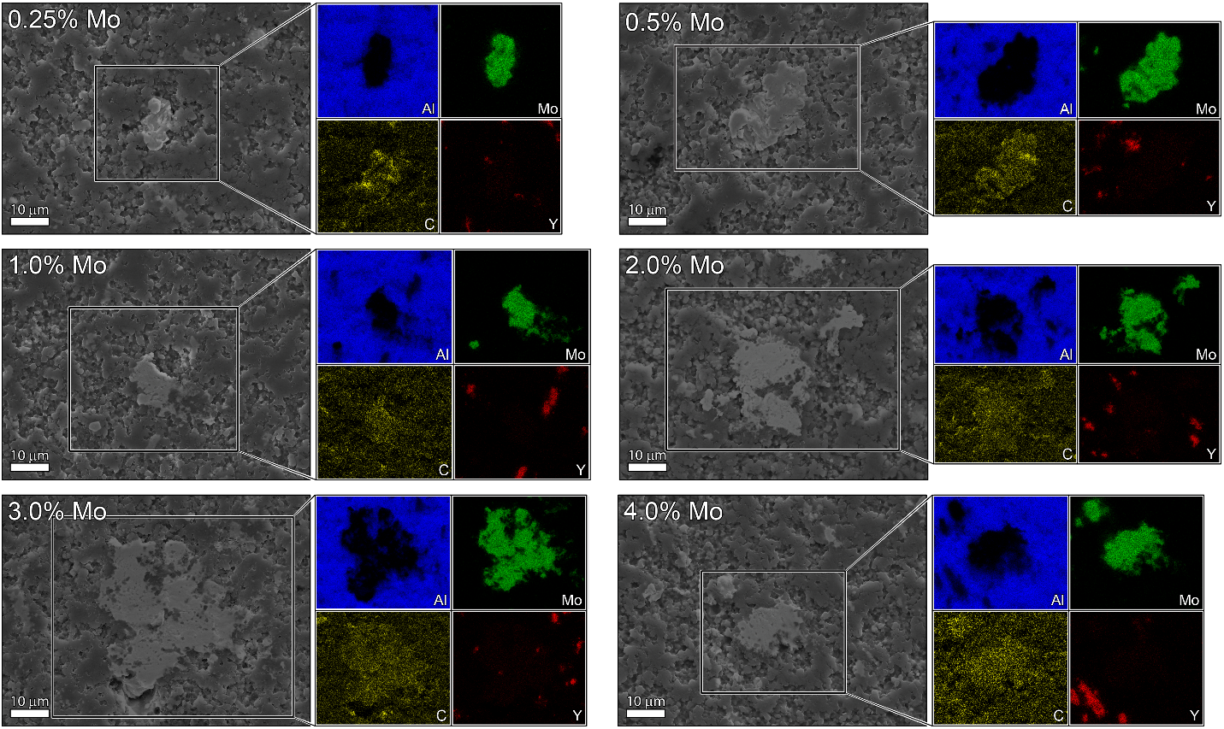
Figure S2. SEM micrographs with elemental compositions as individual breakout maps by element. Short integration/scan settings were employed to provide the best look at carbon distribution, given the carbon-specific limitations related to EDS. Co-localization of the carbon and Mo signals is evident. Color corresponds to elemental identity as indicated, while intensity corresponds to relative concentration for that element.

Figure S3. Photograph of the AlN:Mo composite disks used for free space analysis. Discs are shown next to a sample of AlN without added molybdenum to show color contrast. The AlN sample without molybdenum was not measured as part of the present study.

