Supplementary material for: Deconvolution of the elastic properties of bivalve shell nanocomposites from direct measurement and finite element analysis

Matthias O’Toole-Howes, Ruth Ingleby, and Melanie Mertesdorf
Department of Earth Sciences, University of Cambridge, Downing Street, Cambridge CB2 3EQ, UK
James Dean, and Wei Li
Department of Materials Science and Metallurgy, University of Cambridge, 27 Charles Babbage Road, Cambridge CB3 0FS, UK
Michael A. Carpenter,^{a)} and Elizabeth M. Harper
Department of Earth Sciences, University of Cambridge, Downing Street, Cambridge CB2 3EQ, UK

(a)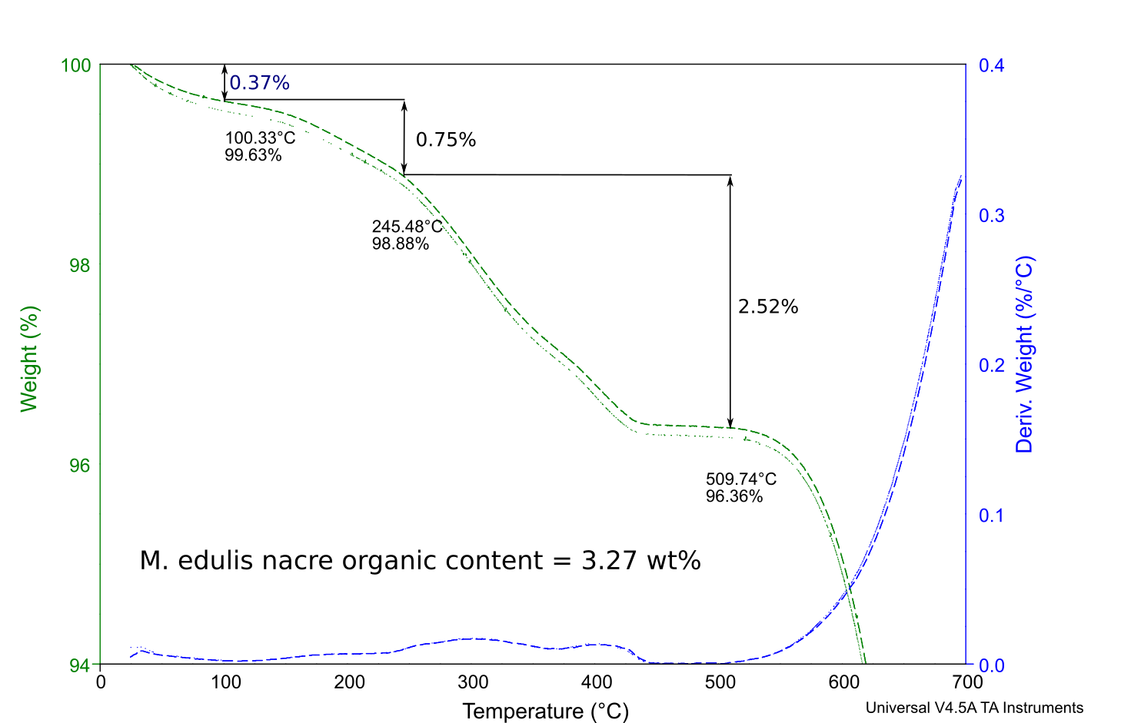
(b)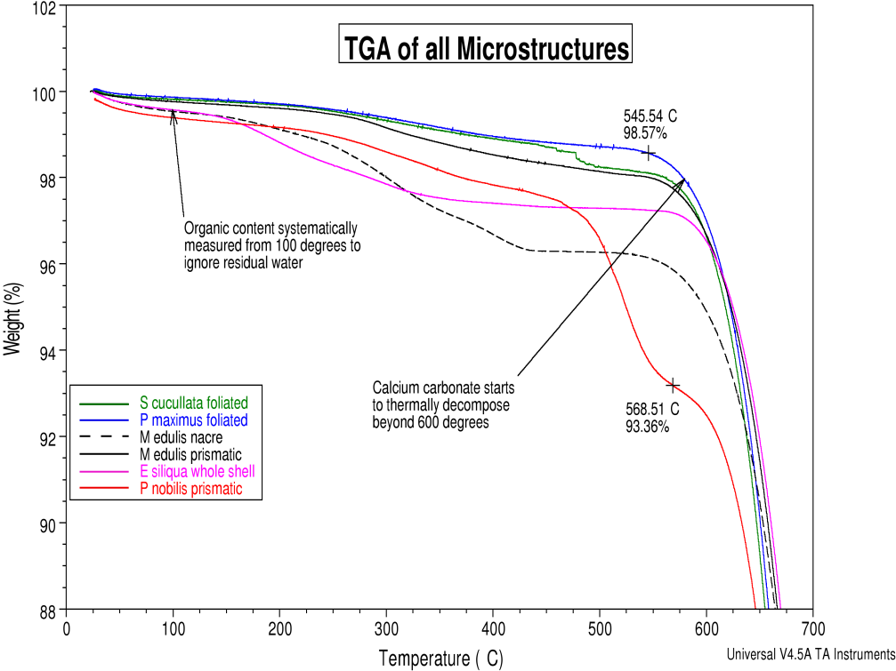

FIG. S1. TGA (a) Representative TGA curves used to estimate organic content for the example of Mytilus edulis. Curves from two separate measurements are shown (green colour) to illustrate reproducibility. Two different slopes in the loss curve, seen between 100 and 500 °C in some datasets, are due to the successive loss of the inter- and then intra-crystalline organics.¹ Numbers are given to illustrate the total weight loss with respect to the starting state of the sample. An estimate of the organic content has been taken as the sum of the percentage loss between 100 and 500 °C so as to exclude the contribution of adsorbed water. (b) Representative TGA traces for all microstructures tested.

(a)
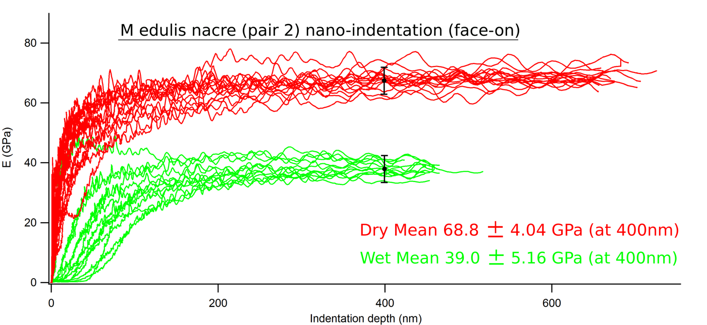
(b)
FIG. S2. Representative data for nanoindentation measurements on M. edulis nacre. (a) Typical variations of penetration depth as a function of load. (b) Typical shape of modulus-depth graph, with full set of repeat measurements. The measured Young’s modulus increases until it reaches a plateau. Natural variation and experimental conditions (temperature, scratches and outside vibrations) cause some spread in resulting E values.

TABLE SI. Summary of four point bending data. Note that the numbers in brackets in the second line refer to the shell orientations illustrated in Figure 4c. Data in the mean values columns for “all” are the combined averages of ~20 measurements in all orientations for each species. The definitions of “widthways” and “lengthways” and orientations with respect to the ridges of P. maximus are illustrated in Figure 4(a). Literature values are from three point bending tests on wet samples.
 |  | Young’s Modulus (GPa) |  |  |  |  | Mean Values (GPa)
Species | Wet (1) |  | Dry (1) | Wet (2) | Dry (2) | Wet |  | Dry |  | Literature values
M. edulis (all) | 22.9±3.7 |  | 23.7±5.4 | 18.9±4.2 | 16.8±6.5 | 20.9 ± 4.3 |  | 20.5 ± 6.8
M. edulis (widthways) | 20.7±3.4 |  | 24.9±7.5 | 19.0±2.4 | 15.9±9.4 | 19.9±3.0 |  | 20.4±9.2
M. edulis (lengthways) | 25.1±2.7 |  | 22.5±2.5 | 18.8±5.8 | 17.6±4.0 | 22.0±5.4 |  | 20.1±4.1
E. siliqua (all) | 28.3±8.6 |  | 20.5±6.1 | 20.5±6.5 | 15.7±4.1 | 24.4 ± 8.4 |  | 18.1 ± 5.7
E. siliqua (widthways) | 30.7±10.0 |  | 22.2±5.3 | 18.4±6.5 | 13.4±2.8 | 24.6±10.3 |  | 17.8±6.1
E. siliqua (lengthways) | 25.9±7.4 |  | 18.8±6.8 | 22.5±6.5 | 17.9±4.3 | 24.2±6.9 |  | 18.4±5.6 | 55 Length  ways²
P. maximus (all) | 8.7±3.3 |  | 9.3±3.0 | 10.6±5.5 | 9.5±2.2 | 9.7 ± 4.6 |  | 9.3 ± 2.6
P. maximus  (Parallel to ridges) | 7.3±2.4 |  | 9.0±2.5 | 8.54±4.0 | 11.3±1.5 | 15.8±3.3 |  | 10.2±2.3
P. maximus  (Perpendicular to ridges) | 10.1±3.8 |  | 9.5±3.8 | 12.7±6.5 | 7.6±0.9 | 11.4±5.2 |  | 8.6±2.7 | 30±3.2 Length  ways³

TABLE SII. Young’s modulus values obtained by nanoindentation. Note: “side-on” refers to indentations which were performed on surfaces cut in cross section and “face-on” refers to indentations performed on surfaces prepared parallel to the plane of the shell.
Microstructure | Young’s modulus, E (GPa)
 |  | Wet | Dry | From literature, all “dry” unless stated
sheet-nacre  M. edulis: aragonite  P. nobilis:  Aragonite face-on |  | 41 ± 5  26 ± 2 | 68 ± 8  50 ± 4 | 54 ± 3 nacre of Pinctada maxima, face-on⁴; 29-45 GPa, depending on depth of indenter, nacre of Haliotis rufescens, face-on⁵
Prismatic  M. edulis: calcite face-on  M. edulis: calcite side-on  P. nobilis: calcite face-on  P. nobilis: side-on |  | 41 ± 4  36 ± 11  38 ± 6  53 ± 14 | 61 ± 8  70 ± 8  45 ± 7  72 ± 5 | P. nobilis (1000 nm depth)⁶:  44 ± 13 inner layer face-on,  27 ± 18 inner layer side-on,  46 ± 12 outer layer face-on,  75 ± 24 middle layer side-on,  20 ± 38 outer layer side-on
Crossed-lamellar  E. siliqua:  aragonite, face-on |  | 60 ± 6 | 81 ± 9 | E. Siliqua: 82 ± 3 with little variation between face-on and side-on⁷
Complex crossed-lamellar  E. siliqua:  Aragonite face-on  E. siliqua:  Aragonite side-on |  | 53 ± 6  51 ± 8 | 74 ± 10  70 ± 17
Foliated Calcite  S. cucullata face-on  P. maximus: face-on  P. maximus: side-on |  | 18 ± 2  16 ± 5  25 ± 2 | 58 ± 7  19 ± 2  29 ± 4 | P maximus: 87 ± 5 side-on⁸  P maximus nacre: 62 ± 14⁹
Organic phase in nacre of M. edulis |  | Using graphical method: 0.5 ± 0.3 (wet) | Using graphical method: 1.5 ± 0.5 (dry)
Periostracum of M. edulis, side-on |  | 1.0 ± 0.3 (wet) | 3.6 ± 0.7 (dry) | Mytilus sp. ~0.5-1.75 (wet)⁹
Periostracum of M. edulis, face-on |  |  |  | Mytilus sp.: 8 ± 3 (dry),  0.21 ± 0.05 (wet)¹⁰
Organic layer in S. cucullata  face-on at 800 nm |  | 4.2 ± 0.2 (wet) | 7 ± 2 (dry)

1. E.M. Harper, A. Checa, and A. Rodríguez‐Navarro: Organization and mode of secretion of the granular prismatic microstructure of Entodesma navicula (Bivalvia: Mollusca). Acta Zoologica 90, 132 (2009).
2. J.D. Currey, and J.D. Taylor: The mechanical behaviour of some molluscan hard tissues. J. Zool. 173, 395 (1974).
3. J.D. Currey: Further studies on the mechanical properties of mollusk shell material. J. Zool. 180, 445 (1976).
4. P. Stempflé, O. Pantale, M. Rousseau, E. Lopez, and X. Bourrat: Mechanical properties of the elemental nanocomponents of nacre structure. Mat. Sci. Eng. C 30, 715 (2010).
5. F. Barthelat, C.M. Li, C. Comi, and H.D. Espinosa: Mechanical properties of nacre constituents and their impact on mechanical performance. J. Mat. Res. 21, 1977 (2006).

6. C. Bignardi, M. Petraroli, and N.M. Pugno: Nanoindentations on conch shells of Gastropoda and Bivalvia molluscs reveal anisotropic evolution against external attacks. J. Nanosci. Nanotechnol. 10, 6453 (2010).
7. D. Scurr, and S. Eichhorn: Analysis of local deformation in indented Ensis Siliqua mollusk shells using Raman spectroscopy. J. Mater. Res. 21, 3099 (2006).
8. X. Li, and P. Nardi: Micro/nanomechanical characterization of a natural nanocomposite material – the shell of Pectinidae. Nanotechnol., 15, 211 (2004).
9. F.D. Fleischli, M. Dietiker, C. Borgia, and R. Spolenak: The influence of internal length scales on mechanical properties in natural nanocomposites: a comparative study on inner layers of seashells. Acta Biomaterialia 4, 1694 (2008).
10. F. Wählisch, N.J. Peter, O.T. Abad, M.V. Oliveira, A.S. Schneider, W. Schmahl, E. Griesshaber, and R. Bennewitz: Surviving the surf: the tribomechanical properties of the periostracum of Mytilus sp.. Acta Biomaterialia 10, 3978 (2014).

