Supplementary Information:
SI-1:
Prior to the in situ TEM fracture tests, Selected Area Diffraction (SAD) patterns are acquired on different grains near the sharp introduced notch as shown in the figure SI-1(a). Inset is the corresponding Diffraction Pattern (DP) for the selected grain. This allows to index the crystallographic orientation of this grain with respect to the specimen configuration and the microstructure, reveling that the grain has a zone axis near [110]. This allow us to estimate a significant tensile stress direction along [1$\overline{1}$2]. For this stress direction and crystal configuration, the highest Schmid factor is ~ 0.408 for 2 out of 12 possible slip systems with slip plane {110} and slip directions <111>.
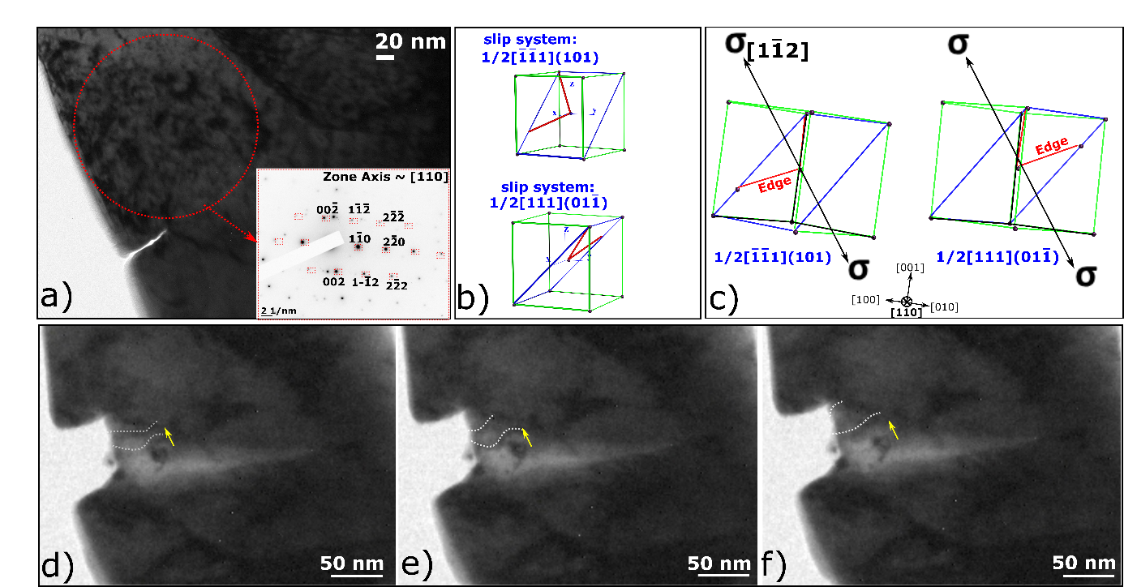
SI-1: a) TEM image of a notched specimen with the notch along a GB. Inset: SAD pattern or the selected grain. b) schematic representation of the two possible slip systems likely to be activated in the corresponding configuration of the crystal in the specific grain near the notch. c) Same slip systems viewed along the zone axis [110], in correspondence to the TEM images. d-f) Consecutives TEM images extracted from the in situ TEM test with dislocation emission and glide along the direction presented by the arrow.

These two slip systems are ½ [$\overline{1}\overline{1}1](101)$ and ½ [111] (01$\overline{1})$. Schematic representation of these two slip systems with screw and edge dislocations are presented in the figures SI-1(b) and in SI-1(c) seen along the zone axis [110]. Based on these two configurations of the two slip systems, one can see that dislocations emitted from the notch as seen in the figure SI-1(d-f) correspond to edge dislocations with the visibility criterion g.b$≠$0 respected. These dislocations move in the direction indicated by the arrow on the TEM images, which corresponds to a Burgers vector along <111>, confirmed by the DP. This explains the opening of the notch along the Burgers vector direction. Note that these TEM images are extracted from a second cycle of loading unloading on this pre-notched bending beam.

SI-2:
Video test of the second cycle of loading-unloading performed on the specimen presented in Figure 6 of the paper. One can see from this test the notch opening and crack propagation. The video test is accelerated (x 5).

SI-3:
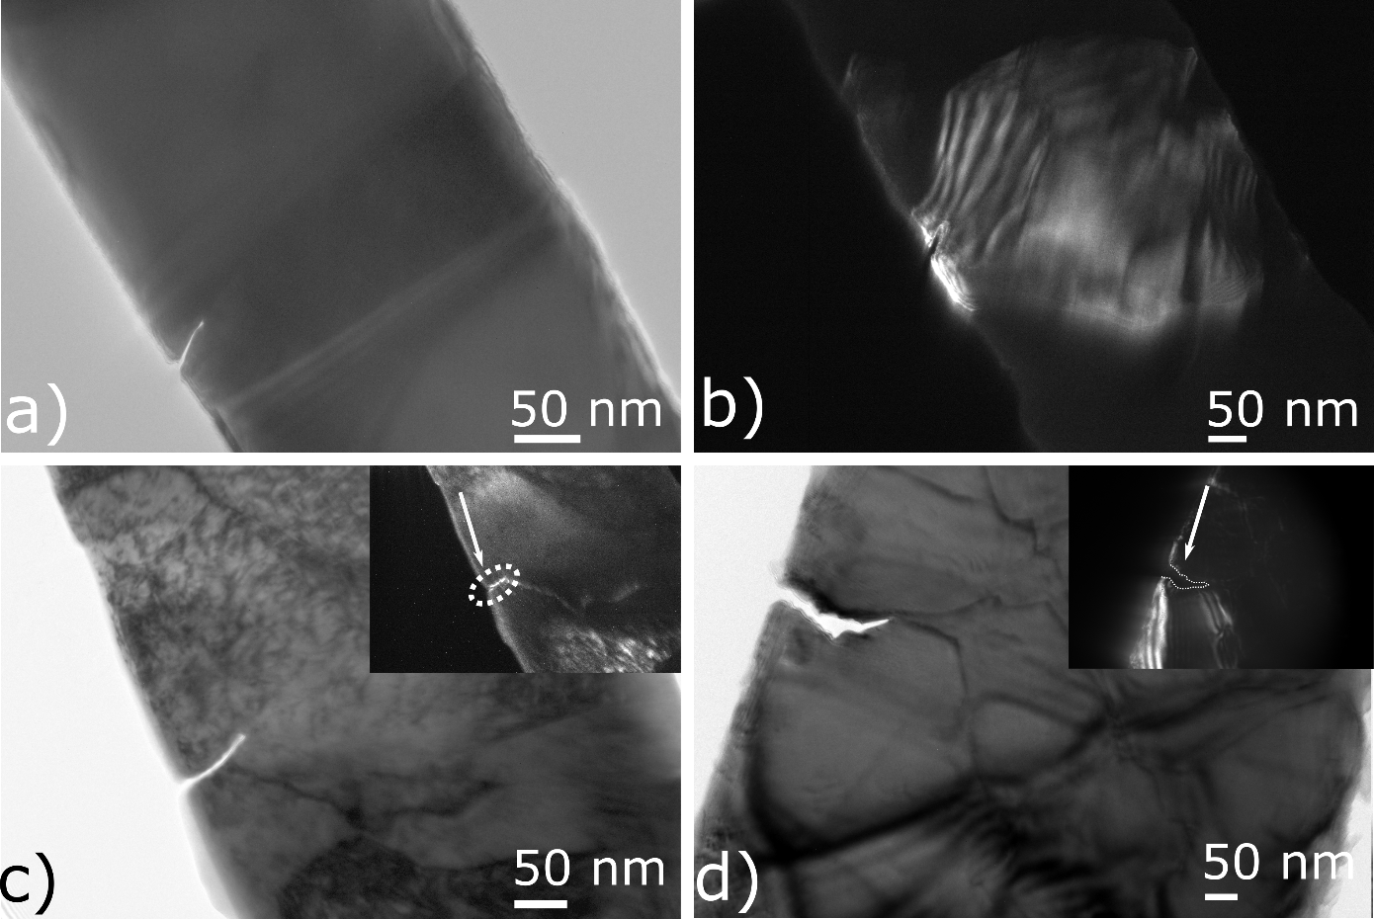
SI-3: a-b) Bright field (BF) and Dark Field (DF) TEM images, respectively, of notched cantilevers with notches situated within a grain. c-d) BF TEM images of notched cantilevers with notches along GBs. Insets corresponding to DF TEM images.

