Facile synthesis of monodisperse AgCu alloy nanoparticles with synergistic effect against oxidation and electromigration

Qianqian Dou, Yang Li, Ka Wai Wong, Ka Ming Ng*

Department of Chemical and Biological Engineering, The Hong Kong University of Science and Technology, Clear Water Bay, Kowloon, 999077, Hong Kong, China

*Corresponding author
Tel: +852 23587238; Email: kekmng@ust.hk 0000-0001-5439-4744

Supplementary Material

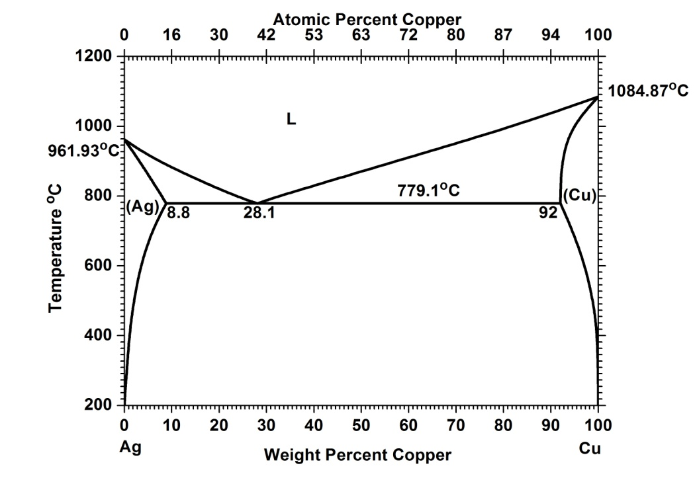
Fig. S1 Phase diagram of Ag-Cu bimetallic system.

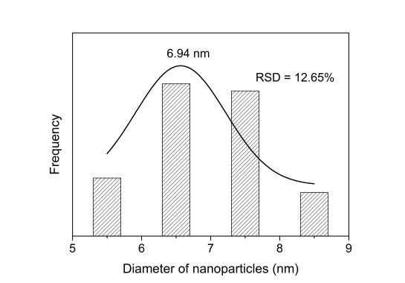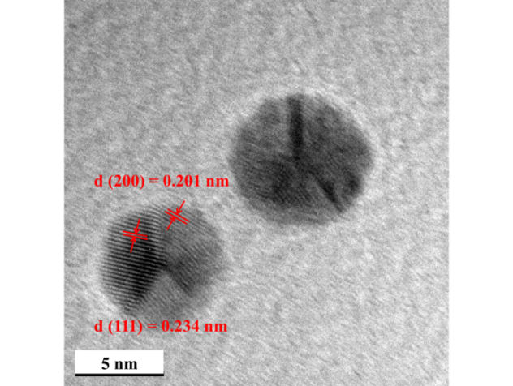
(a)
(b)
(c)
(d)
Fig. S2 (a) XRD pattern; (b) TEM image; (c) relative size distribution histograms and (d) HRTEM image of Ag NPs.

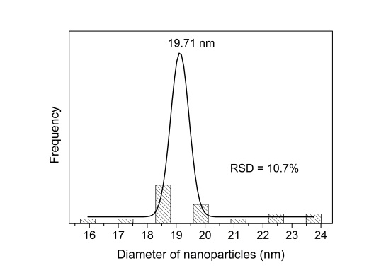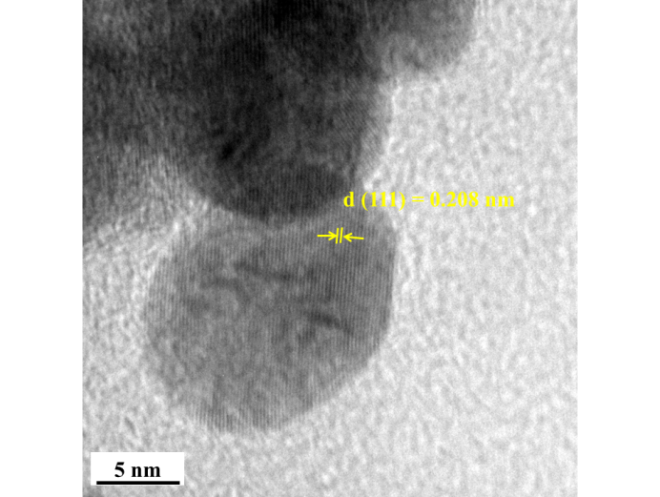
(a)
(b)
(c)
(d)
Fig. S3 (a) XRD pattern; (b) TEM image; (c) relative size distribution histograms and (d) HRTEM image of Cu NPs.

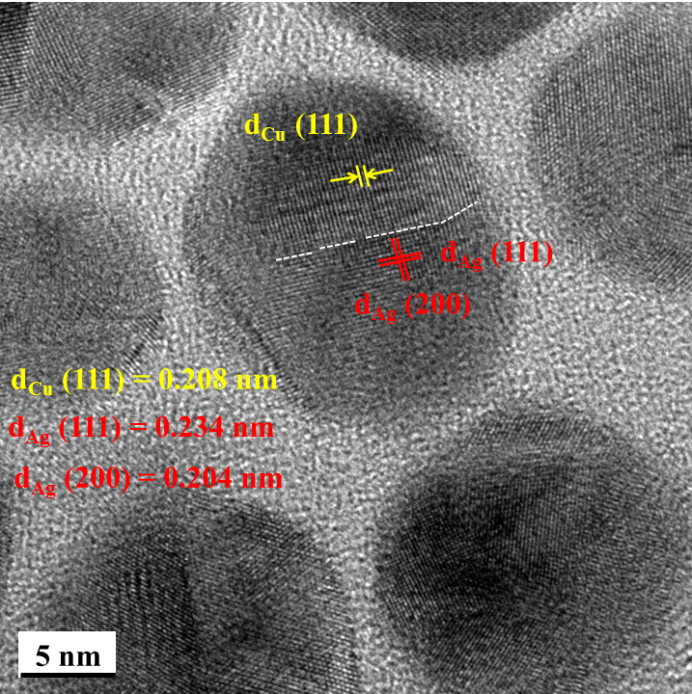

Fig. S4 HRTEM image of sample Ag7Cu3.

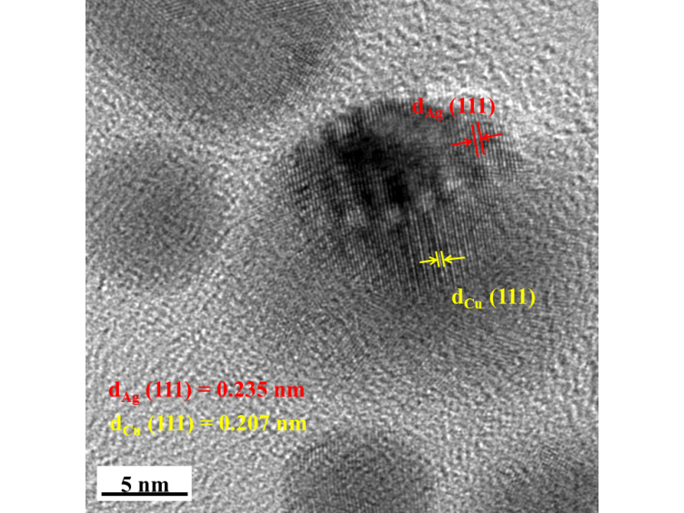
(a)
(b)
Fig. S5 (a) HRTEM image of sample Ag9Cu1 and (b) TEM-EDS spectrum of the particle measured.

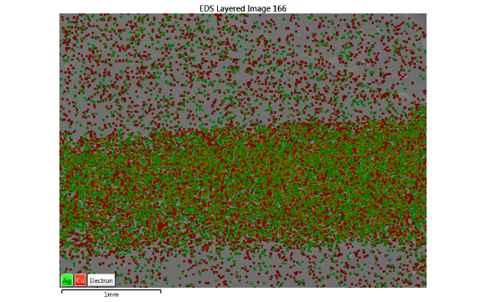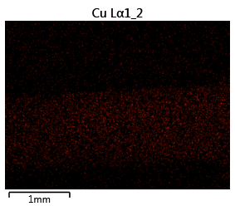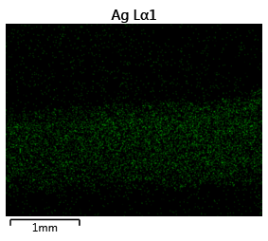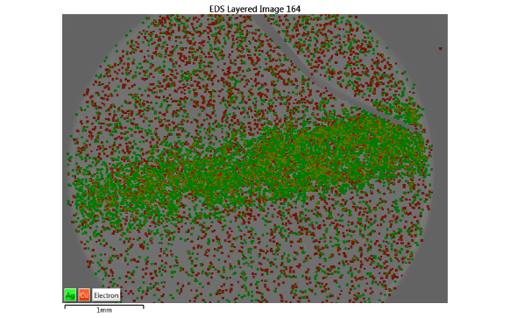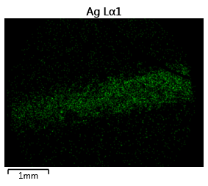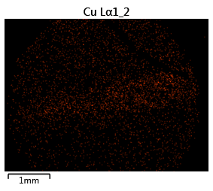
(a)
(b)
(c)
(d)
(e)
(f)
Fig. S6 EDS mapping of sample Ag5Cu5 (a) metal line, (b) element Ag and (c) element Cu; sample AgCu mixture (d) metal line, (e) element Ag and (f) element Cu

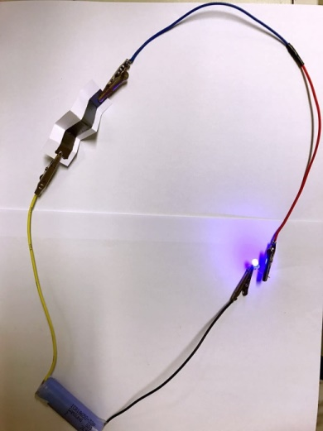
Fig. S7 Optical images of Ag5Cu5 conductive lines with five folds

