Supplementary note
Microstructure and Magnetic behavior of FeCoNi (Mn-Si)_{x}(x= 0.5,0.75,1.0) High Entropy Alloys

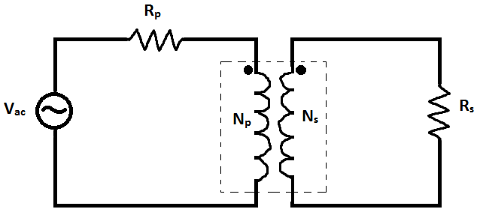
Fig A1: systematically basic circuit of transformer

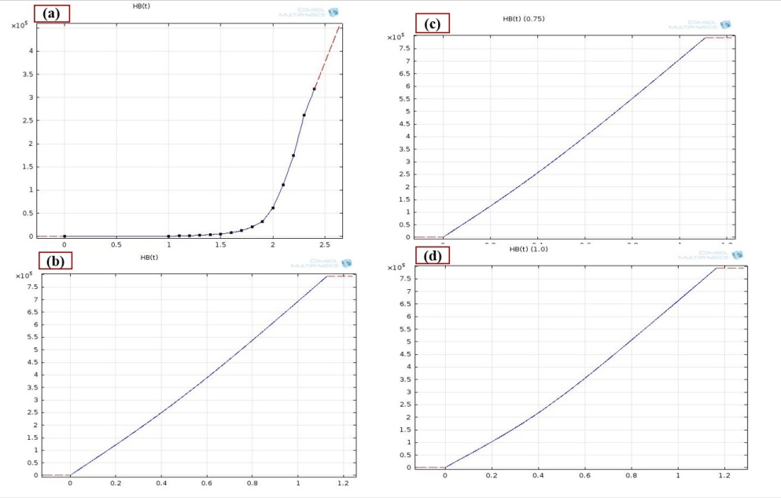
Fig A2(a):(a) H-B curve of soft iron (without loss) ,(b) H-B curve of FeCoNi(Mn-Si)_{0.5} after 25hrs milling, (c) H-B curve of FeCoNi(Mn-Si)_{0.75} after 25hrs milling,(d) H-B curve of FeCoNi(Mn-Si)_{1.0} after 25hrs milling

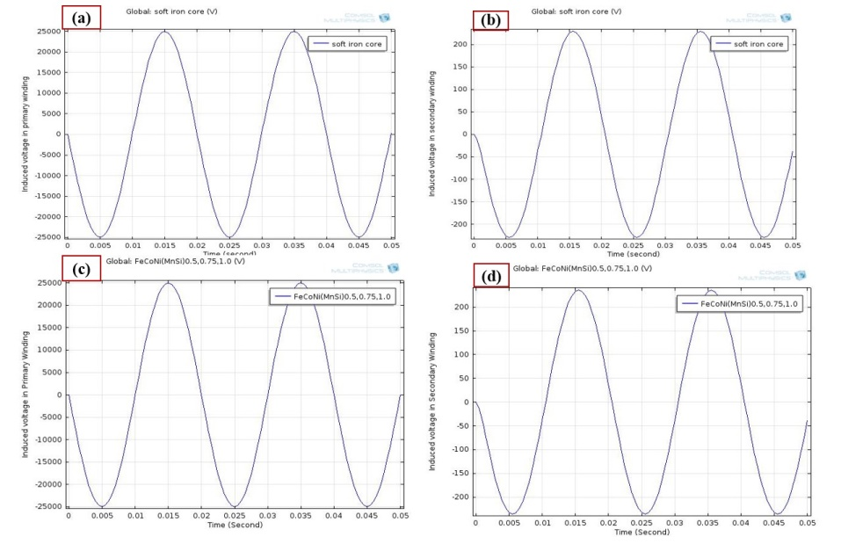
Figure A3:(a & b) shows induced voltage in primary coil and secondary coil in soft iron and
(c & d) Induced voltage in primary coil and secondary coil FeCoNi(Mn-Si)_{0.5}, FeCoNi(Mn-Si)_{0.75}and FeCoNi(Mn-Si)_{1.0}HEAs

The deconvoluted peak of 25hour as milled powders of FeCoNi(Mn-Si)_{0.5,} FeCoNi(Mn-Si)_{0.75} and FeCoNi(Mn-Si)_{1.0} HEAs respectively.
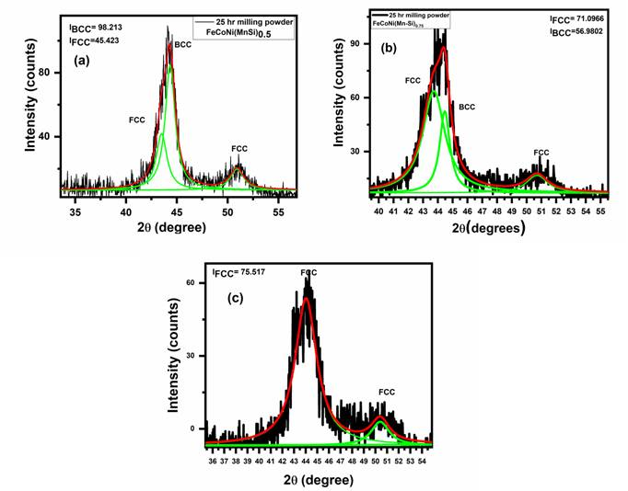
Fig.A4 (a) Deconvoluted peak of 25hour of FeCoNi(Mn-Si)_{0.5 ,} (b) Deconvoluted peak of 25hour of FeCoNi(Mn-Si)_{0.75}and (c) Deconvoluted peak of 25hour of FeCoNi(Mn-Si)_{1.0}

