**Supplementary Material**

Synthesis of YAG:Ce/ZnO core/shell nanoparticles with enhanced UV-visible and visible light photocatalytic activity and application for the antibiotic removal from aqueous media

*Lobna Zammouri,ab Abdelhay Aboulaich,b* Bruno Capoen,c Mohamed Bouazaoui,c Mohamed Sarakha,b Mostafa Stitou,a and Rachid Mahiou b\**

a Université Abdelmalek Essaadi, Faculté des Sciences de Tétouan, Laboratoire de L’Eau, d’Etude et des Analyses Environnementales, B.P. 2121 Mhannech II, 93002 Tétouan. Morocco.

b Université Clermont Auvergne, Institut de Chimie de Clermont Ferrand UMR 6296 CNRS/UBP/Sigma Clermont, Campus des Cézeaux, TSA 60026-CS 60026, 63178, AUBIERE Cedex, France

c Laboratoire de Physique des Lasers, Atomes et Molécules (PhLAM), CNRS (UMR 8523), CERLA/IRCICA, Université Lille 1- Sciences et Technologies, UFR de Physique, Bâtiment P5, F-59655 Villeneuve D’ASCQ cedex, France

*Corresponding authors :

[rachid.mahiou@uca.fr](mailto:rachid.mahiou@uca.fr); a.abdelhay@hotmail.com

FIG. S1. *Schema of the synthetic method of YAG:Ce/ZnO CSN* 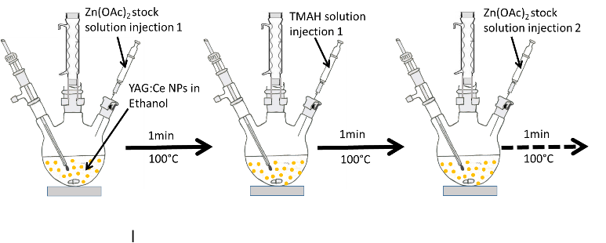

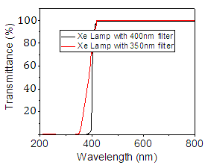

FIG. S2. *Transmittance curve and the light output of the Xe lamp with 350nm and 400nm glass filters*

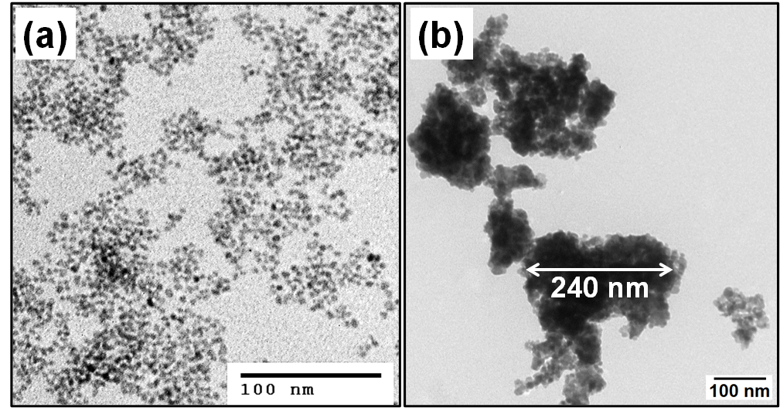

FIG. S3. *TEM image of ZnO NC before (a) and after* *(b) 500°C calcination.*



FIG. S4. *FTIR spectra of ZnO NCs, YAG:Ce NPs and YAG:Ce/ZnO CSN with different weight ratios.*

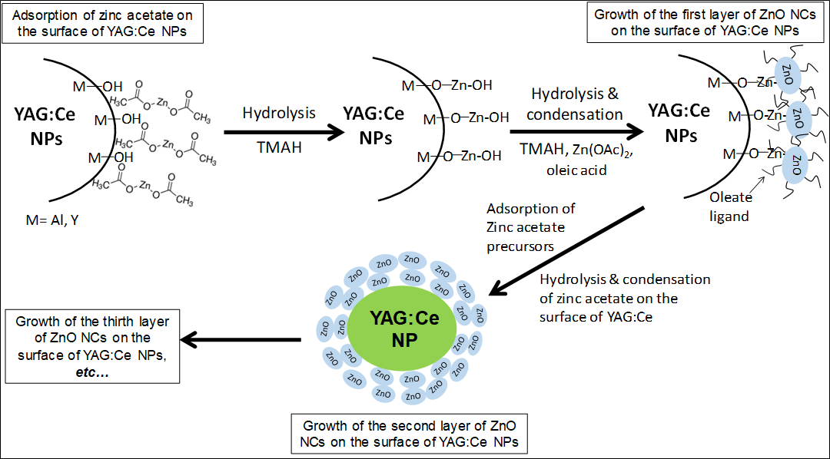

FIG. S5: *Growth mechanism of ZnO NCs shell around YAG:Ce NPs*



FIG. S6. *N2 adsorption/desorption isotherm of the pure ZnO NCs and YAG:Ce/ZnO 1/1 CSN*

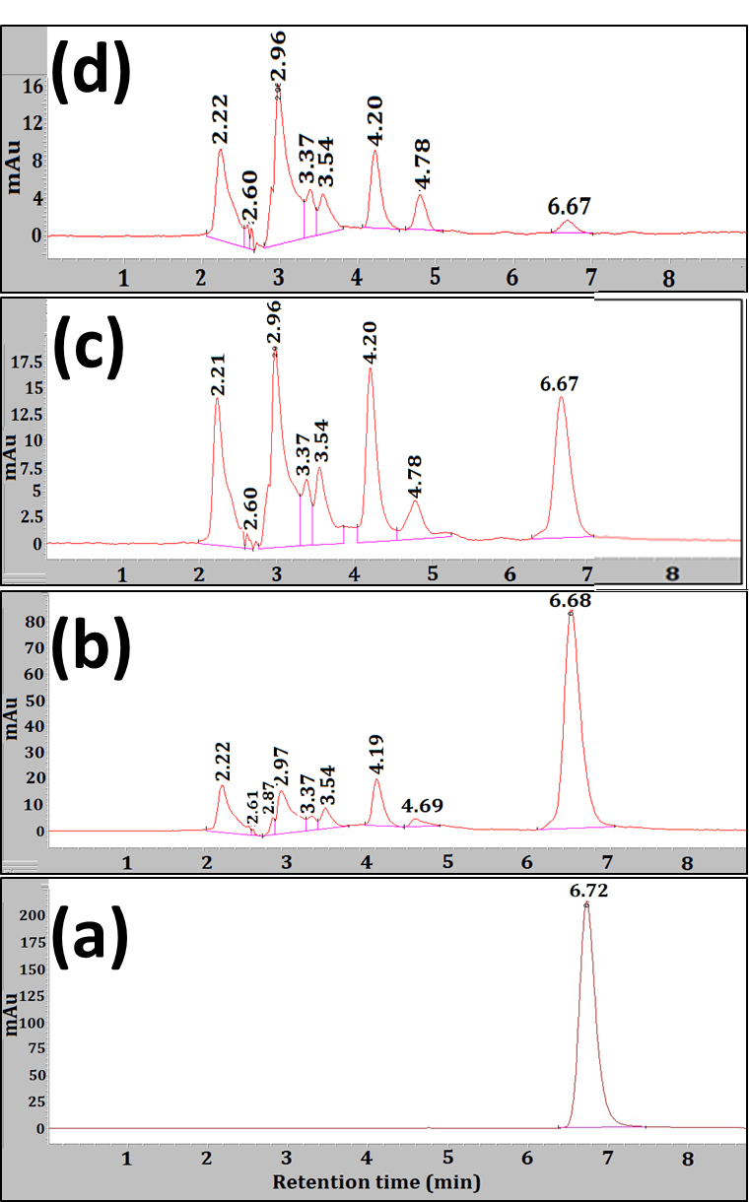

FIG. S7. *HPLC chromatogram recorded on the STZ aqueous solution containing YAG:Ce/ZnO 1/1 CSN before (a) and after 10 min (b) 30 min (c) 90 min (d) UV-vis irradiation.*

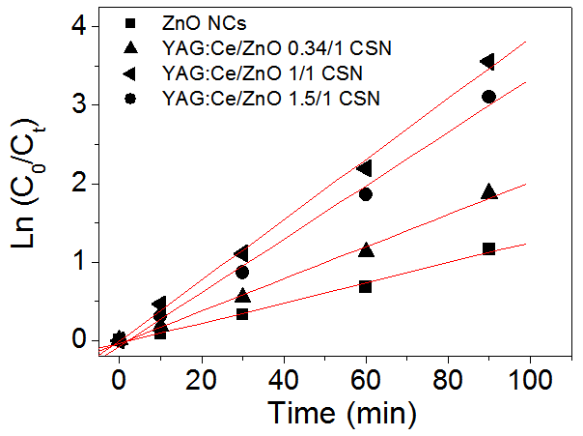

FIG. S8. *ln(C0/Ct) plots vs time of ZnO NCs and YAG:Ce/ZnO CSN.*



FIG. S9. *PL spectra of ZnO NCs and YAG:Ce/ZnO 1/1 CSN. Excitation at 365nm.*

Table SI. *Specific surface area and pore volume of YAG:Ce/ZnO 1/1 CSM. Results corresponding to YAG:Ce/ZnO 1/1 CSN are also provided for comparison.*

|  |  |  |
| --- | --- | --- |
| Photocatalyst | Specific surface area (m2.g-1) | Pore volume (cm3.g-1) |
| YAG:Ce/ZnO 1/1 CSM | 30 | 0.11 |
| YAG:Ce/ZnO 1/1 CSN | 71 | 0.38 |