FIG. EDS Mapping of homogenized Al_{0.4}FeCrNiCox(x=0, 0.25, 0.5, 1.0 mol) HEAs.

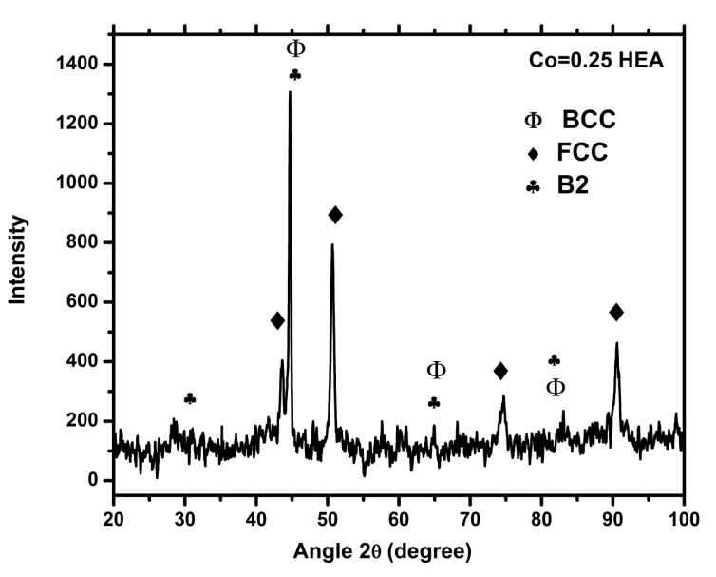
FIG. X-ray diffraction of Co=0.25 HEA

