Deformation behavior of core-shell nanowire structures with coherent and semi-coherent interfaces
Hang Ke* and Ioannis Mastorakos
Department of Mechanical and Aeronautical Engineering, Clarkson University, Potsdam, NY 13699, USA

* Address all correspondence to this author.
e-mail: keh@clarkson.edu

Supplementary Material

TABLE SI. Yield strength of uniaxial tensile loading of different pure metallic nanowires
Metal | Radius | Yield Strength (GPa)
Cu | r=1 nm | 7.98
 | r=5 nm | 8.65
 | r=10 nm | 8.67
 | r=15 nm | 8.84
Au | r=1 nm | 4.49
 | r=5 nm | 4.54
 | r=10 nm | 4.80
 | r=15 nm | 4.90

TABLE SII. Yield Strength of uniaxial tensile loading of semi-coherent Cu-Ni nanowires
Core Radius | Shell Thickness | Yield Strength | Core Radius | Shell Thickness | Yield Strength
 | d=0.1nm | 5.69 |  | d=0.5nm | 3.94
 | d=0.2nm | 6.07 |  | d=1nm | 4.29
r=1nm | d=0.3nm | 6.23 | r=5nm | d=1.5nm | 4.70
 | d=0.4nm | 6.70 |  | d=2nm | 5.02
 | d=0.5nm | 7.76 |  | d=2.5nm | 5.35
 | d=1nm | 4.95 |  | d=1nm | 4.95
 | d=2nm | 5.20 |  | d=2nm | 5.31
r=10nm | d=3nm | 5.84 | r=15nm | d=3nm | 5.72
 | d=4nm | 6.03 |  | d=4nm | 6.07
 | d=5nm | 6.38 |  | d=5nm | 5.91

TABLE SIII. Yield Strength of uniaxial tensile loading of coherent Cu-Ni nanowires
Core Radius | Shell Thickness | Yield Strength | Core Radius | Shell Thickness | Yield Strength
 | d=0.1nm | 7.87 |  | d=0.5nm | 7.65
 | d=0.2nm | 7.58 |  | d=1nm | 8.24
r=1nm | d=0.3nm | 8.34 | r=5nm | d=1.5nm | 8.73
 | d=0.4nm | 9.13 |  | d=2nm | 9.11
 | d=0.5nm | 9.78 |  | d=2.5nm | 9.58
 | d=1nm | 7.35 |  | d=1nm | 7.06
 | d=2nm | 7.43 |  | d=2nm | 7.34
r=10nm | d=3nm | 7.59 | r=15nm | d=3nm | 7.81
 | d=4nm | 8.33 |  | d=4nm | 7.92
 | d=5nm | 9.77 |  | d=5nm | 8.58
TABLE SIV. Yield Strength of uniaxial tensile loading of composite Au-Ni bimetallic nanowires
Core Radius | Shell Thickness | Yield Strength | Core Radius | Shell Thickness | Yield Strength
 | d=0.1nm | 3.66 |  | d=0.5nm | 3.91
 | d=0.2nm | 3.63 |  | d=1nm | 4.63
r=1nm | d=0.3nm | 3.66 | r=5nm | d=1.5nm | 5.87
 | d=0.4nm | 3.81 |  | d=2nm | 6.62
 | d=0.5nm | 4.07 |  | d=2.5nm | 7.36
 | d=1nm | 4.63 |  | d=1nm | 4.54
 | d=2nm | 5.89 |  | d=2nm | 5.52
r=10nm | d=3nm | 6.94 | r=15nm | d=3nm | 6.22
 | d=4nm | 7.65 |  | d=4nm | 6.81
 | d=5nm | 8.22 |  | d=5nm | 7.28

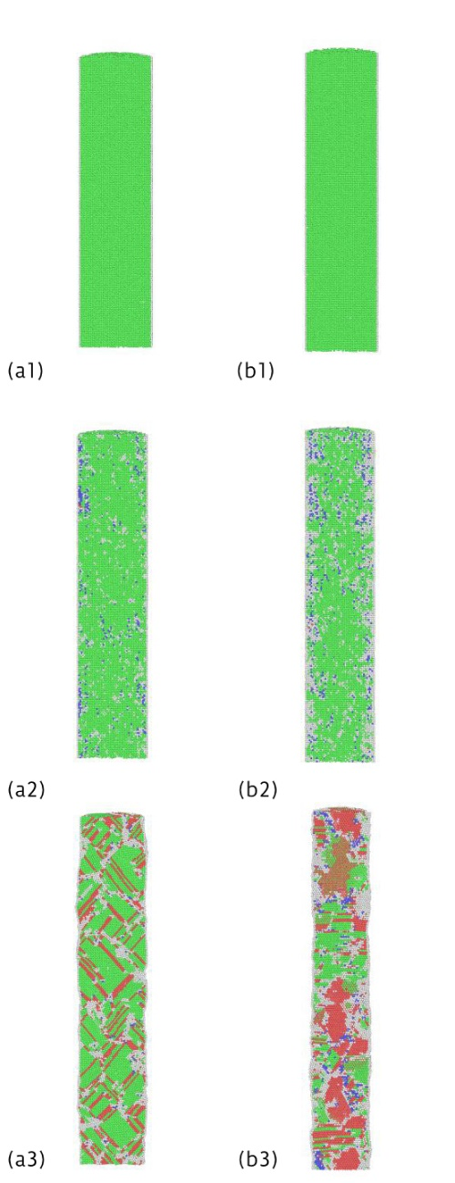

FIG. S1. Snapshots of atomistic configuration of the pure metal nanowires (r=5 nm) during the uniaxial loading process. Group (a) and (b) are corresponding to Cu and Au nanowires, respectively. The following numbers within each group are shown for different stages. 1 for the initial stage, 2 for the stage where the first dislocation is formed and 3 for the final stage. The colors are shown according to common neighbor analysis: green for FCC, red for HCP, blue for BCC and grey for other structure type.

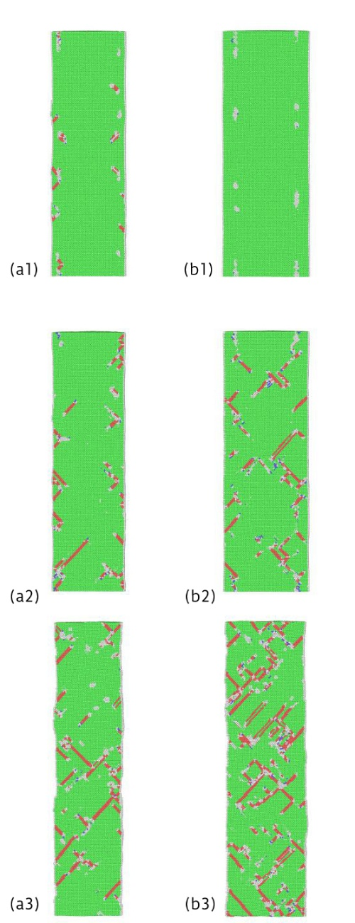

FIG. S2. Snapshots of atomistic configuration of the semi-coherent Cu/Ni nanowires (core radius r=5 nm) during the uniaxial loading process. Group (a) and (b) are corresponding to shell thickness of 1 nm and 2 nm, respectively.

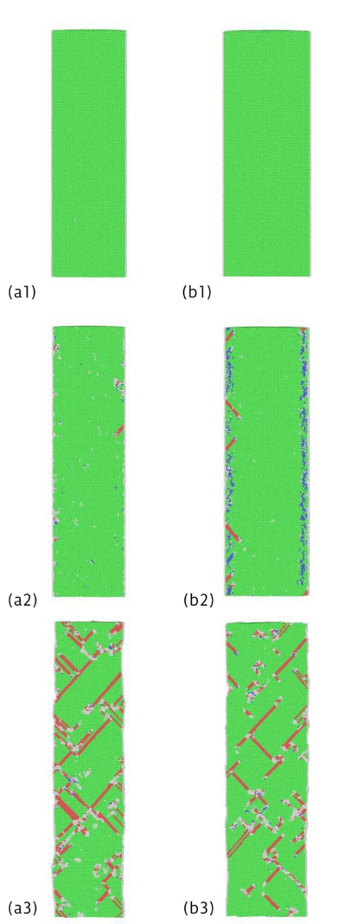

FIG. S3. Snapshots of atomistic configuration of the coherent Cu/Ni nanowires (core radius r=5 nm) during the uniaxial loading process. Group (a) and (b) are corresponding to shell thickness of 1 nm and 2 nm, respectively.

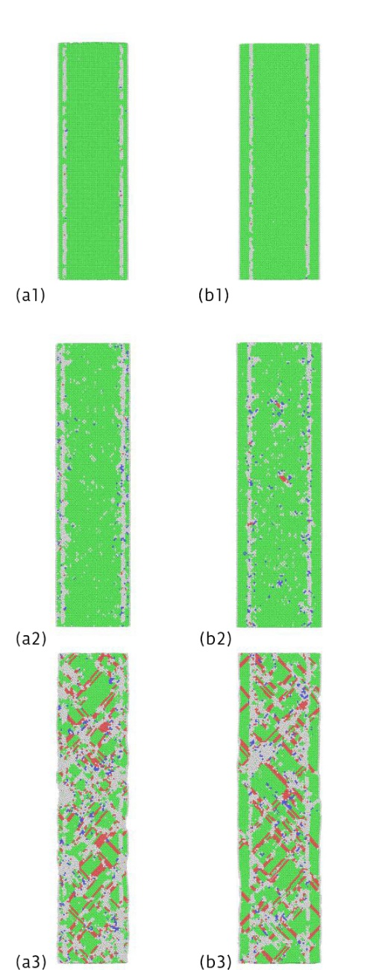

FIG. S4. Snapshots of atomistic configuration of the composite Au/Ni nanowires (core radius r=5 nm) during the uniaxial loading process. Group (a) and (b) are corresponding to shell thickness of 1 nm and 2 nm, respectively.

