Supplementary note
Phase evolution of refractory high entropy alloy CrMoNbTiW during mechanical alloying and spark plasma sintering
Lavanya Raman¹, K. Guruvidyathri^{1,2}, Geeta Kumari¹, S.V.S. Narayana Murty³, Ravi Sankar Kottada¹ and B.S. Murty¹
¹Department of Metallurgical and Materials Engineering, Indian Institute of Technology Madras, Chennai 600036, India
²High Entropy Materials Center, Department of Materials Science and Engineering, National Tsing Hua University, Hsinchu, Taiwan
³Materials and Metallurgy Group, Vikram Sarabhai Space Center, Trivandrum 695022, India

S1: Effect of milling speed on the morphology of the 10 h MA powder
The milling speed is known to have an effect on the morphology of the milled powders. The BSE-SEM micrographs (Fig. S1) represents the morphology of the 10 h MA powder at different milling speeds. From Fig. S1, it can be inferred that, at lower milling speed (200 rpm), the degree of plastic deformation is lesser due to less impact energy. The degree of fracturing of the powder is limited and hence the MA powder at 200 rpm remains highly irregular in shape. Moreover, the W particle (bright particle) remain coarser and has a flaky nature at 200 and 250 rpm. At higher rpm, the fracturing efficiency is improved and it results in the fragmentation of W particle into further smaller particles. Therefore, it can be concluded that the morphology of the MA powder at 200, 250 and 300 rpm is irregular, irregular + flaky and flaky + semi equiaxial, respectively. These results are similar to those reported by Biyik et al.¹, during the milling of Cu-25W alloy.

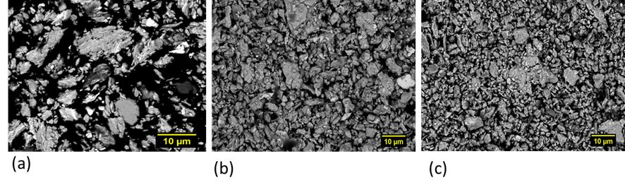

Fig. S1: Effect of milling speed on the morphology of the 10 h MA powder at (a) 200 rpm (b) 250 rpm and (c) 300 rpm.

S2. Microstructure of the sintered samples at 1100 and 1200 °C:
The SEM microstructure of the sample sintered at 1100 and 1200 °C is shown in Fig. S2 a and b. It shows the particle-particle boundary and porosity.

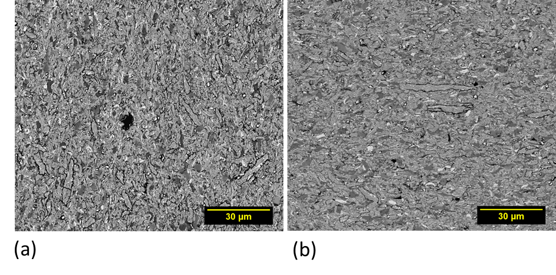
Fig. S2: Microstructure of CrMoNbTiW alloy sintered at (a) 1100 °C and (b) 1200 °C with 50 MPa

S3. Precise Lattice parameter calculation for the Laves phase:
The lattice parameter of the Cr₂Nb Laves phase was calculated using the Nelson-Riley function given by the following equation. The value was found to be 0.6980 nm as shown in Fig. S3 which confirms to the C15 cubic structure.
NRF = $\frac{1}{2}\left(\frac{\cos^{2}{θ}}{\sin{θ}} + \frac{\cos^{2}{θ}}{θ}\right)$
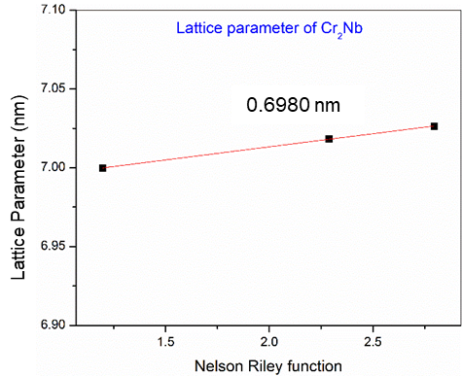
Fig. S3: Lattice parameter calculation of Cr₂Nb C15 cubic structure

S4. Phase fraction quantification of the sintered samples:
The volume fraction of the phases of the 1300 °C sintered sample was obtained from SEM studies using Fiji image analysis software are shown in Fig. S4. It can be inferred that the BCC1 solid solution is the major phase.

Fig. S4: Volume fraction of phases of 10 h MA powder at 200 rpm after sintering at 1300 °C and 50 MPa

References:
1. S. Biyik and M. Aydin: The effect of milling speed on particle size and morphology of Cu-25W composite powder. Acta Phys. Pol. A 127, 1255 (2015).

