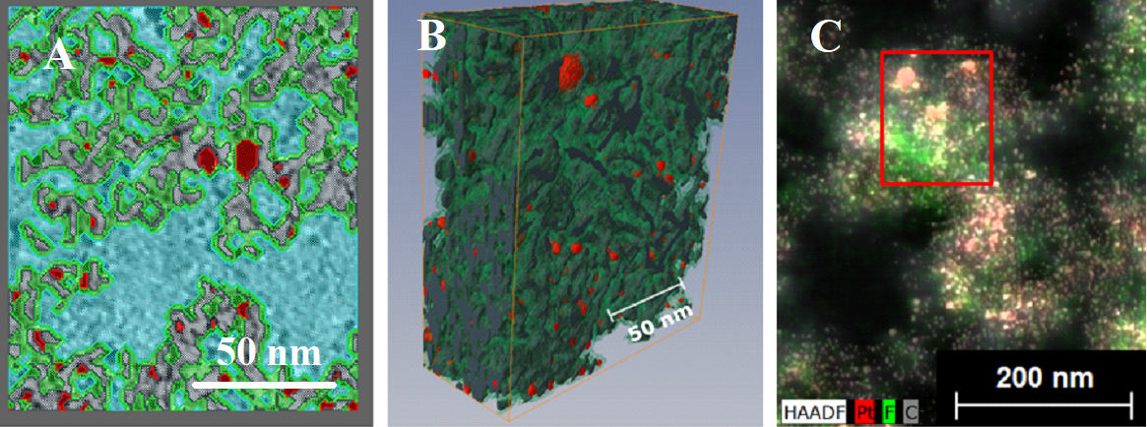

FIG. S1. Electron-tomography 3D model of Pt/C agglomerate – ROI region: (a) surface cut through the model with segmented carbon (grey), Pt (red), ionomer (green) and pores (blue); (b) 3D representation of the model; (c) TEM-EDS map of the same region revealing the distribution of carbon, Pt and ionomer. Color image available online.

