G protein-coupled receptors function as logic gates for nanoparticle binding using Systems & Synthetic Biology approach

Aman Chandra Kaushik¹, Xueying Mao³, Cheng-Dong Li¹, Yan Li⁴, *Dong-Qing Wei¹, *Shakti Sahi²

¹State Key Laboratory of Microbial Metabolism and School of life Sciences and Biotechnology, Shanghai Jiao Tong University, Shanghai 200240, China
²School of Biotechnology, Gautam Buddha University, Greater Noida, India-201312
³Qianweichang College, Shanghai University Shanghai, China
⁴College of Computer Science and Information Tech., Henan Normal University, Xixiang, China

*Corresponding Author

Figure S1: GPCR mechanism where drug bind with GPR142 and GPR119 receptor which enhance the insulin secretion using Gq dependent pathway.
Figure S2: Type 2 diabetes mechanism where investigate the drug effect on insulin secretion using Gq dependent pathway.
Table S1. Supplementary represents the GPR142 agonist mechanism, where Drug, DAG and PKC signalling within the GPR142 agonist mechanism signalling network and understand which patients or genes would respond to insulin and improved glucose tolerance. Graph represents the GPR142 agonist mechanism where green peak represent the insulin production, cyan peak represents the cAMP production and light green peak represents the drug amount (μM), where small amount drug was effective for improved glucose tolerance at different concentrations of glucose.
Kinetic simulations were also performed at different concentrations of glucose level, where low concentrations effective for improved glucose tolerance which increase insulin production.
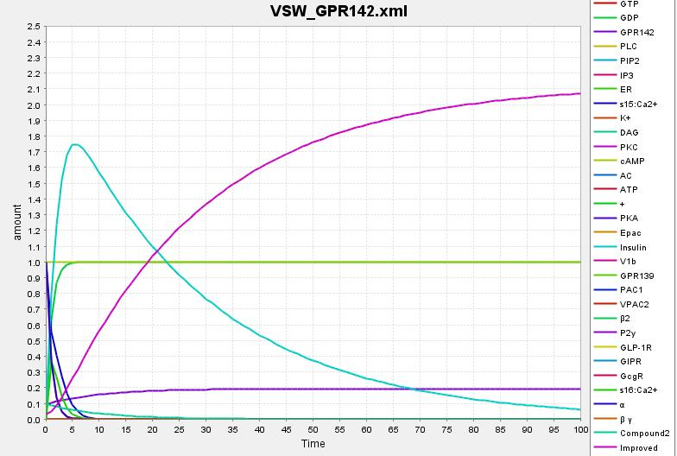  Glucose effect on Insulin Production at 0.036μM | 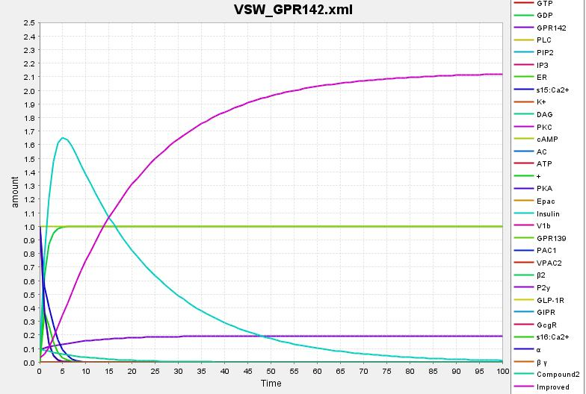  Glucose effect on Insulin Production at 0.052μM
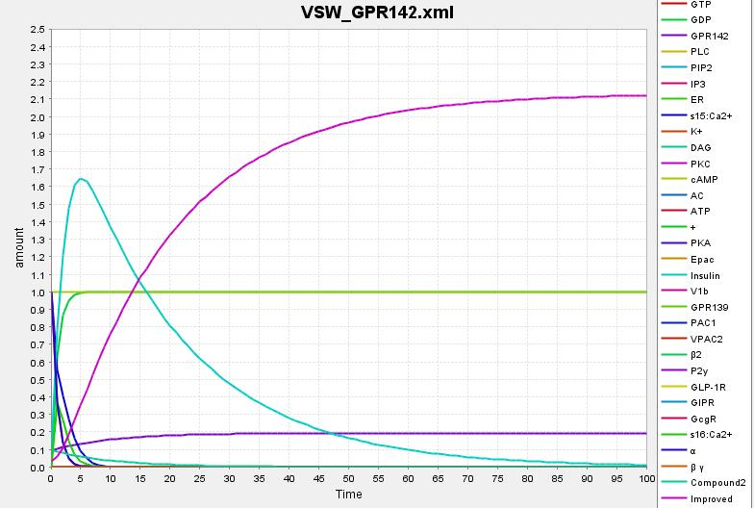  Glucose effect on Insulin Production at 0.053μM | 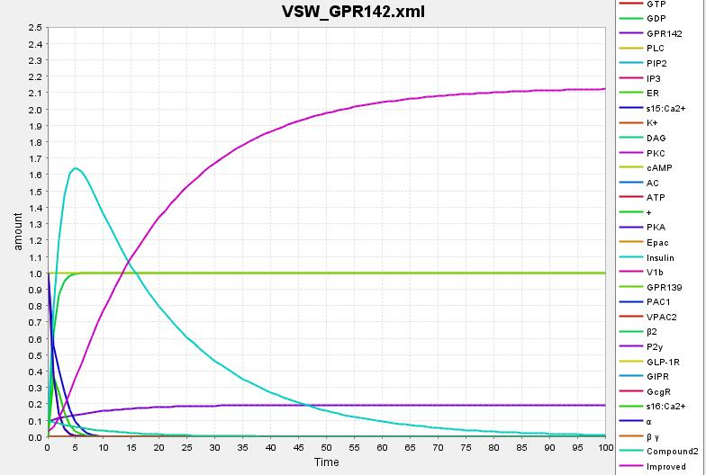  Glucose effect on Insulin Production at 0.054μM
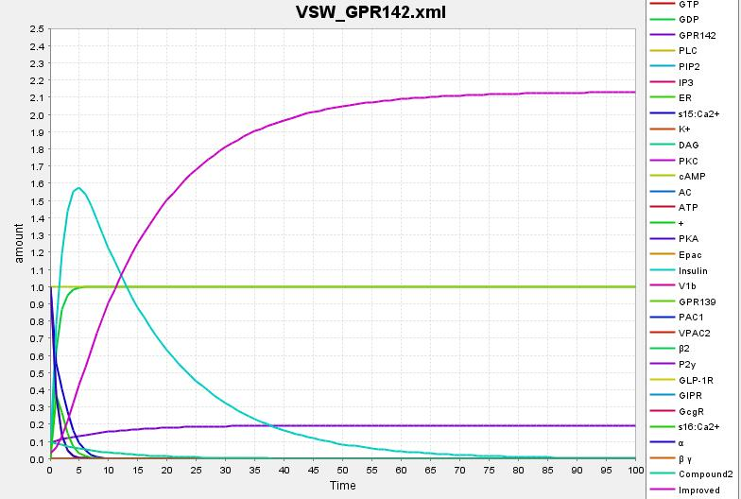 Glucose effect on Insulin Production at 0.067μM | 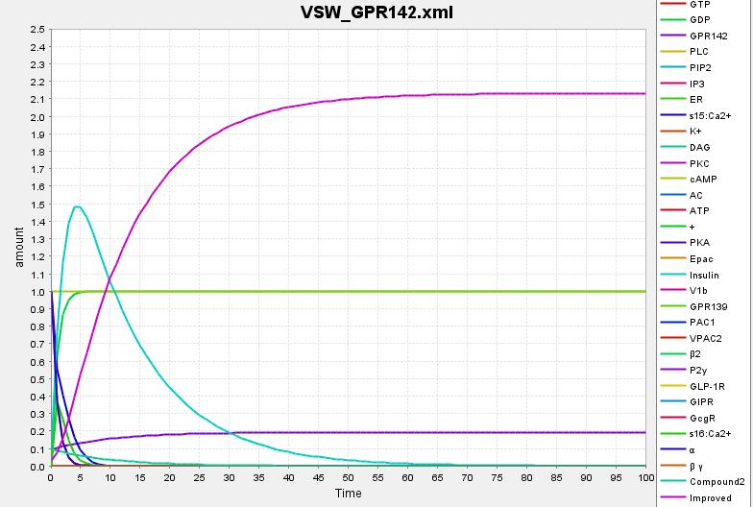  Glucose effect on Insulin Production at 0.086μM
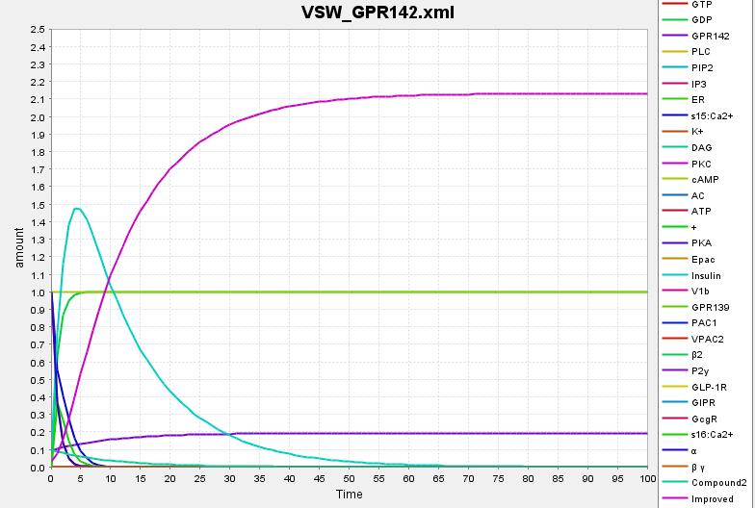  Glucose effect on Insulin Production at 0.088μM | 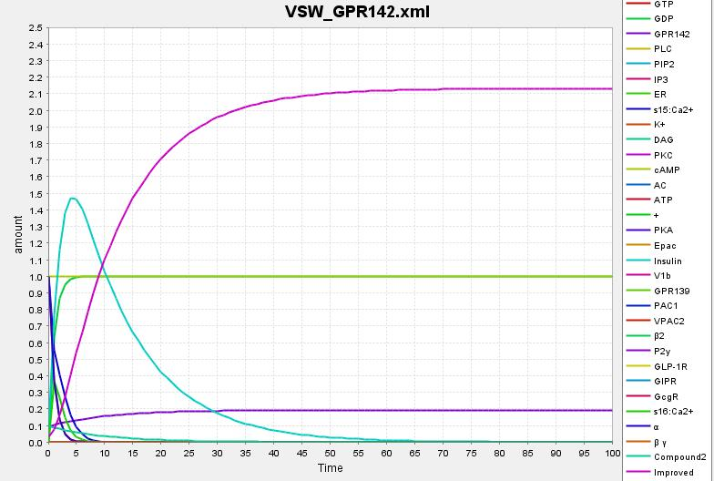  Glucose effect on Insulin Production at 0.089μM
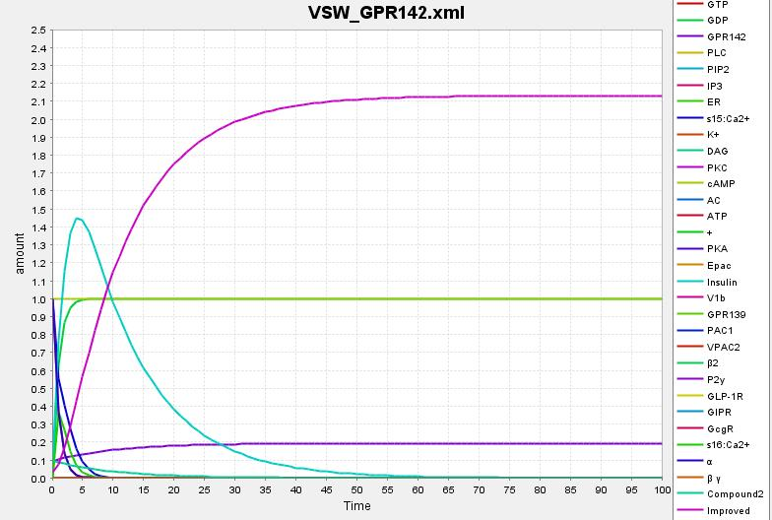  Glucose effect on Insulin Production at 0.095μM | 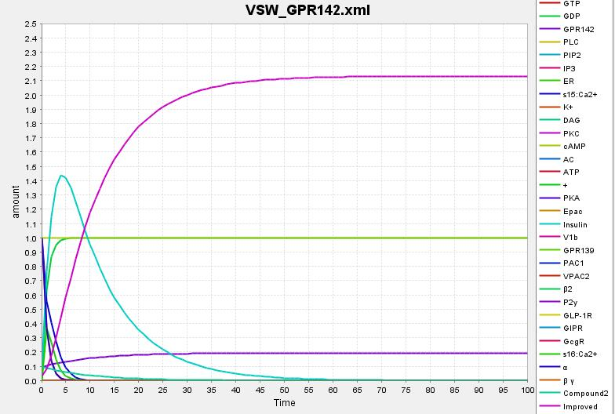  Glucose effect on Insulin Production at 0.099μM

Using a Systems Biology approach identified new lead compound obtained from structure based virtual screening, which improved glucose tolerance and increase insulin production and inhibit the type 2 diabetes signalling pathway. In order to understand biological function of GPR142 in case of Type 2 diabetes. Using Kinetic simulation predict the biological behaviour of GPR142 which involved in Type 2 diabetes disease inhibition, and also predict the biochemical pathway of GPR142 in presence of drug compound where GPR142 interact with different molecules which play important role in Type 2 diabetes inhibition and improved glucose tolerance.

Figure S3. Time course simulation analysis of the Type 2 Diabetes biochemical pathway where Glucose appearance in Plasma in presence of drug doses, where red colored lines indicates the Glucose Conc. X-axis represents the Time (Hour) and Y-axis represents the states.

