Evaluation and validation of synergistic effect of predicted Amyloid-Beta (Aβ) inhibitor by deep neural network approach and gold nanoparticles on the Alzheimer’s disease

Aman Chandra Kaushik¹, Ajay Kumar⁴, Zhennan Peng², Abbas Khan¹, Muhammad Junaid¹, Arif Ali¹, Shiv Bharadwaj³ and *Dong Quing Wei¹
¹State Key Laboratory of Microbial Metabolism and School of life Sciences and Biotechnology, Shanghai Jiao Tong University, Shanghai 200240, China
²College of Life Sciences, Lanzhou University, Lanzhou, China
³Nanotechnology Research and Application Center, Sabanci University, Istanbul, Turkey
⁴Department of Mechanical and Electro-Mechanical Engineering, National Sun Yat-Sen
University, Kaohsiung City 804, Taiwan

*Corresponding Author- dqwei@weislab.com

Results and Discussion
S1. Systems Biology approach to predict dynamic changes in Alzheimer Disease

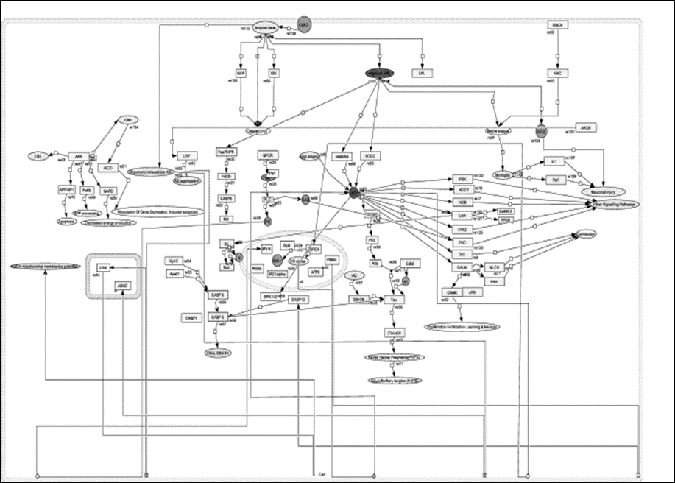
FIG. S1. The complete biochemical pathway of AD induced by Aβ-42 and treated with wgx-50+AuNP complex generated by employing deep neural network approach based virtual screening reflected the inhibition of AD.
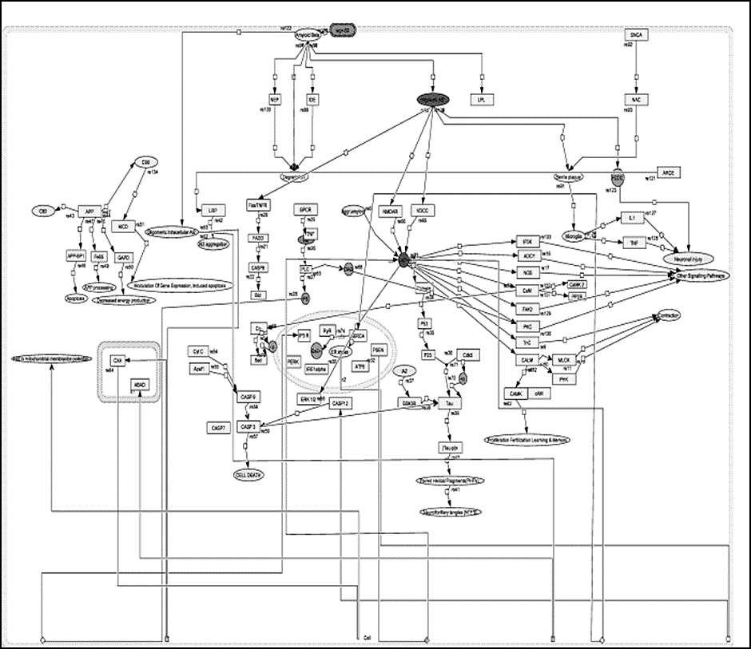
FIG. S2. The complete biochemical pathway of AD induced by Aβ-42 and treated with only wgx-50 generated by employing deep neural network approach based virtual screening reflected the inhibition of AD.

