Supporting Information
Combustion Synthesis and Photoelectrochemical Characterization of Gallium Zinc Oxynitrides
Austin E. Kennedy¹ and Benjamin H. Meekins*¹
¹Department of Chemical Engineering, Univ. of South Carolina, 301 Main Street, Columbia, SC 29208
*Corresponding author: ben.meekins@gmail.com
Figure S1: A) Ga 2p and B) Ga 3d XPS spectra of the 1:1:10 Ga_{x}Zn_{1-x}O_{y}N_{1-y} sample. Peaks were assigned according to literature and confirm the presence of GaN.
Figure S2: Absorbance of 0:1:5, 2:1:10, and 1:2:10 Ga_{x}Zn_{1-x}O_{y}N_{1-y} powders. Scan was from 850 nm to 350 nm at 1 nm/s.

Figure S3: X-ray diffraction patterns of 1:1:10 Ga_{x}Zn_{1-x}O_{y}N_{1-y} powders at different reaction temperatures. Scans were collected at 1º/min with a step size of 0.04º.
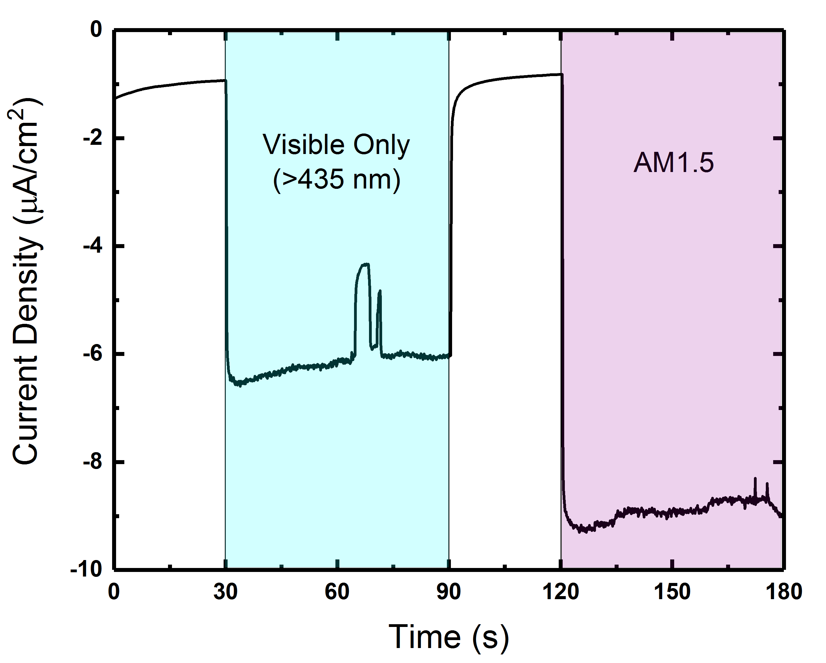
Figure S4: Current-time measurement of a 1:1:10 Ga_{x}Zn_{1-x}O_{y}N_{1-y} film (500 ºC synthesis temperature) under both visible-only and AM1.5 irradiation. The electrolyte is 0.2M Na₂SO₃/0.1M Na₂SO₄, and the potential was held at 0V vs. SCE. Counter electrode was a Pt wire. Dips in the measured photocurrent were caused by fluctuations in the light intensity.
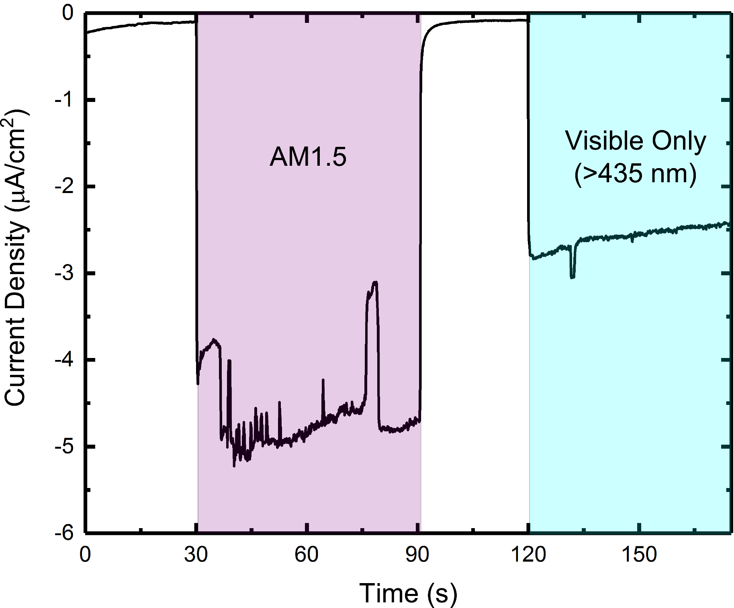
Figure S5: Current-time measurement of a 1:1:10 Ga_{x}Zn_{1-x}O_{y}N_{1-y} film (500 ºC synthesis temperature) under both visible (λ > 435 nm) and AM1.5 irradiation. The electrolyte is 0.5M Na₂SO₄, and the potential is held at 0V vs. SCE throughout. Counter electrode is a Pt wire, and fluctuations of the photocurrent are due to fluctuations in the irradiation source’s intensity.
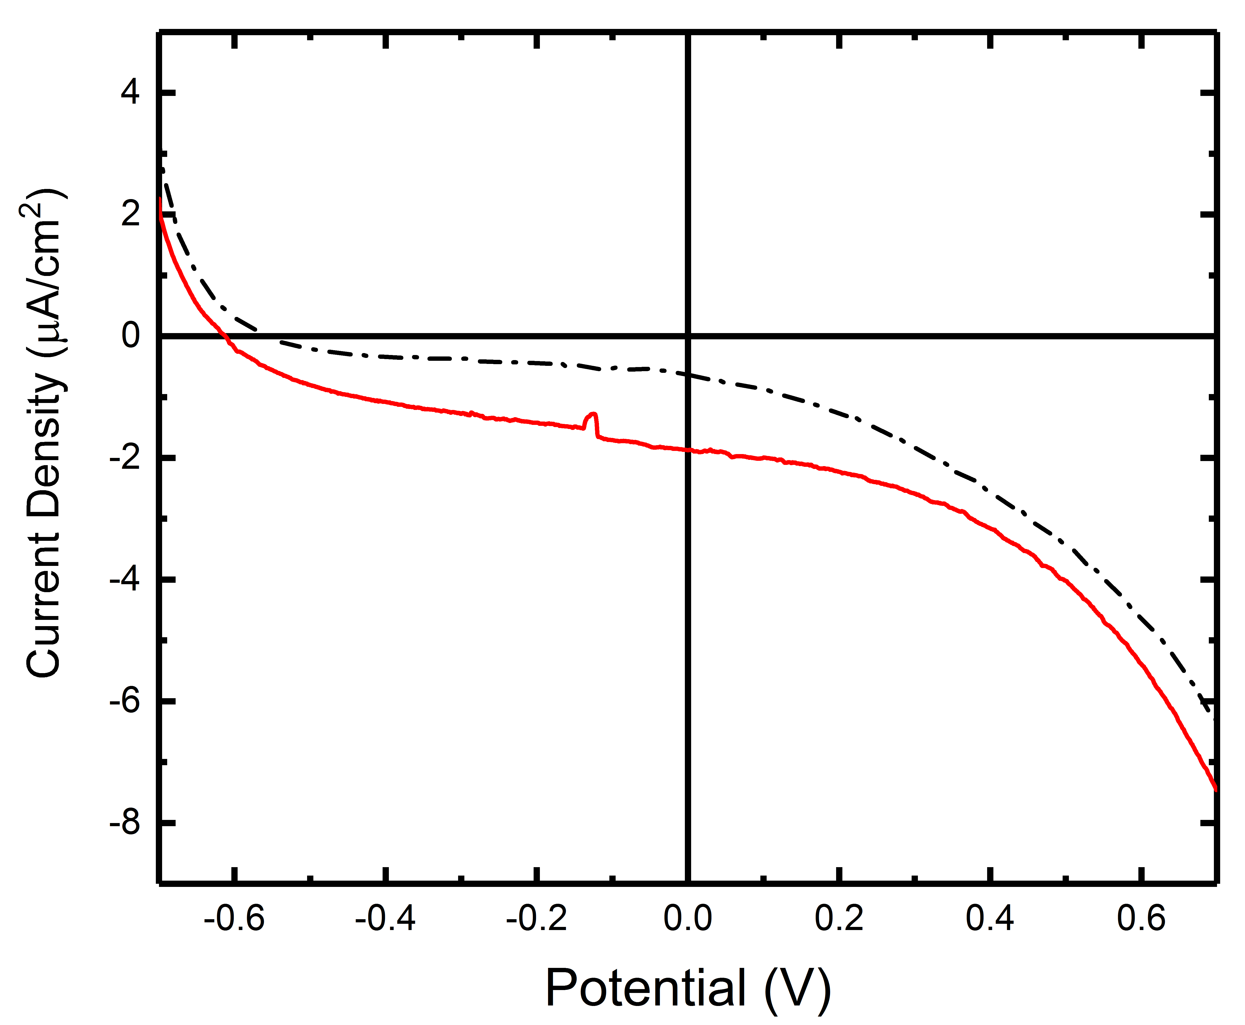
Figure S6: Current-voltage measurement in a 2-electrode system. Counter electrode is a Pt wire, and the electrolyte is 0.5M Na₂SO₄. Potential was scanned from negative to positive at a rate of 10 mV/s. The red solid line is with AM1.5 irradiation while the black dash-dot line is the dark measurement.
Figure S7: A) Hydrogen evolution over time. 0.1g of 1:1:10 Ga_{x}Zn_{1-x}O_{y}N_{1-y} powder loaded with 1wt% Rh/1.5wt% CrOx in 50 vol% ethanol solution (200 mL total). 100 mW/cm² AM1.5 irradiation.

Figure S8: Oxygen evolution over time. 0.1g of 1:1:10 Ga_{x}Zn_{1-x}O_{y}N_{1-y} powder in 10 mM AgNO₃ (aq) solution with 200 mg of La₂O₃. 100 mW/cm² AM1.5 irradiation.

Table SI. Comparison of current work and other relevant reported work
Entry | Photocatalyst | Light Source | H₂/O₂ Evolution Rate (μmol h⁻¹ g⁻¹) | Solution | Ref
1 | ZrO₂/TaON (IrO_{x}/Cr₂O₃/RuO_{x}) | 450W High Pressure Mercury | 27.5 / 10 | H₂O (pH=3) | ¹
2 | RuO₂/  Ga_{0.88}Zn_{0.12}N_{0.88}O_{0.12} | 450W High Pressure Mercury | 200 / 100 | H₂O | ²
3 | CoO_{x}/BaNb_{0.5}T_{0.5}O₂N | 300W Xe (λ > 420 nm) | 0 / 300 | 10 mM AgNO₃ (aq) | ³
4 | CrO_{x}/Rh/  Ga_{0.88}Zn_{0.12}N_{0.88}O_{0.12} | 450W High Pressure Mercury (λ > 300 nm) | 12783 / 6626 | H₂O | ⁴
5 | CrO_{x}/Rh/  Ga_{0.88}Zn_{0.12}N_{0.88}O_{0.12} | 450W High Pressure Mercury (λ > 420 nm) | 800 / 400 | H₂O | ⁴
6 | CrO_{x}/Rh/  Ga_{0.45}Zn_{0.55}N_{0.45}O_{0.55} | 300W Xe lamp (AM1.5) | 273ª / 30 | 50 vol% EtOH / 10 mM AgNO₃ (aq) | This Work
ªAverage rate for the linear increase between hours 1 and 4.

Table SII: Comparison of precursor molar ratios and final surface atomic composition of Ga_{x}Zn_{1-x}O_{y}N_{1-y} samples synthesized at 500 ºC as determined by XPS
Initial Ratio (Ga:Zn:Urea) | Final Composition
0:1:5 | ZnO
0:1:10 | ZnO_{0.094}N_{0.06}
1:1:5 | Ga_{0.33}Zn_{0.67}O_{0.75}N_{0.25}
1:1:10 | Ga_{0.33}Zn_{0.67}O_{0.62}N_{0.38}
1:2:15 | Ga_{0.22}Zn_{0.78}O_{0.72}N_{0.28}
1:3:20 | Ga_{0.17}Zn_{0.83}O_{0.79}N_{0.21}
2:1:15 | Ga_{0.49}Zn_{0.51}O_{0.55}N_{0.45}
3:1:20 | Ga_{0.58}Zn_{0.42}O_{0.61}N_{0.39}
4:1:25 | Ga_{0.66}Zn_{0.34}O_{0.55}N_{0.45}

References:
(1) Maeda, K.; Takata, T.; Hara, M.; Saito, N.; Inoue, Y.; Kobayashi, H.; Domen, K. GaN : ZnO Solid Solution as a Photocatalyst for Visible-Light-Driven Overall Water Splitting. J. Am. Chem. Soc. 2005, 127, 8286–8287.
(2) Maeda, K.; Domen, K. New Non-Oxide Photocatalysts Designed for Overall Water Splitting under Visible Light. J. Phys. Chem. C 2007, 111 (22), 7851–7861.
(3) Kawashima, K.; Hojamberdiev, M.; Yubuta, K.; Domen, K.; Teshima, K. Synthesis and Visible-Light-Induced Sacrificial Photocatalytic Water Oxidation of Quinary Oxynitride BaNb_{0.5}Ta_{0.5}O₂N Crystals. J. Energy Chem. 2018, 27 (5), 1415–1421.
(4) Maeda, K.; Teramura, K.; Saito, N.; Inoue, Y.; Domen, K. Improvement of Photocatalytic Activity of (Ga_{1−x}Zn_{x})(N_{1−x}O_{x}) Solid Solution for Overall Water Splitting by Co-Loading Cr and Another Transition Metal. J. Catal. 2006, 243 (2), 303–308.

