Supplementary information
Additive manufacturing-enabled shape transformations via FFF 4D printing
R Abisheraª, S Kumar^{a,}*
ªDepartment of Mechanical and Materials Engineering, Khalifa University of Science and Technology, Masdar Institute, Masdar City, P.O. Box 54224, Abu Dhabi, UAE
*Corresponding author: s.kumar@eng.oxon.org

Figure S1: An optical image showing the printed part with raft and brim
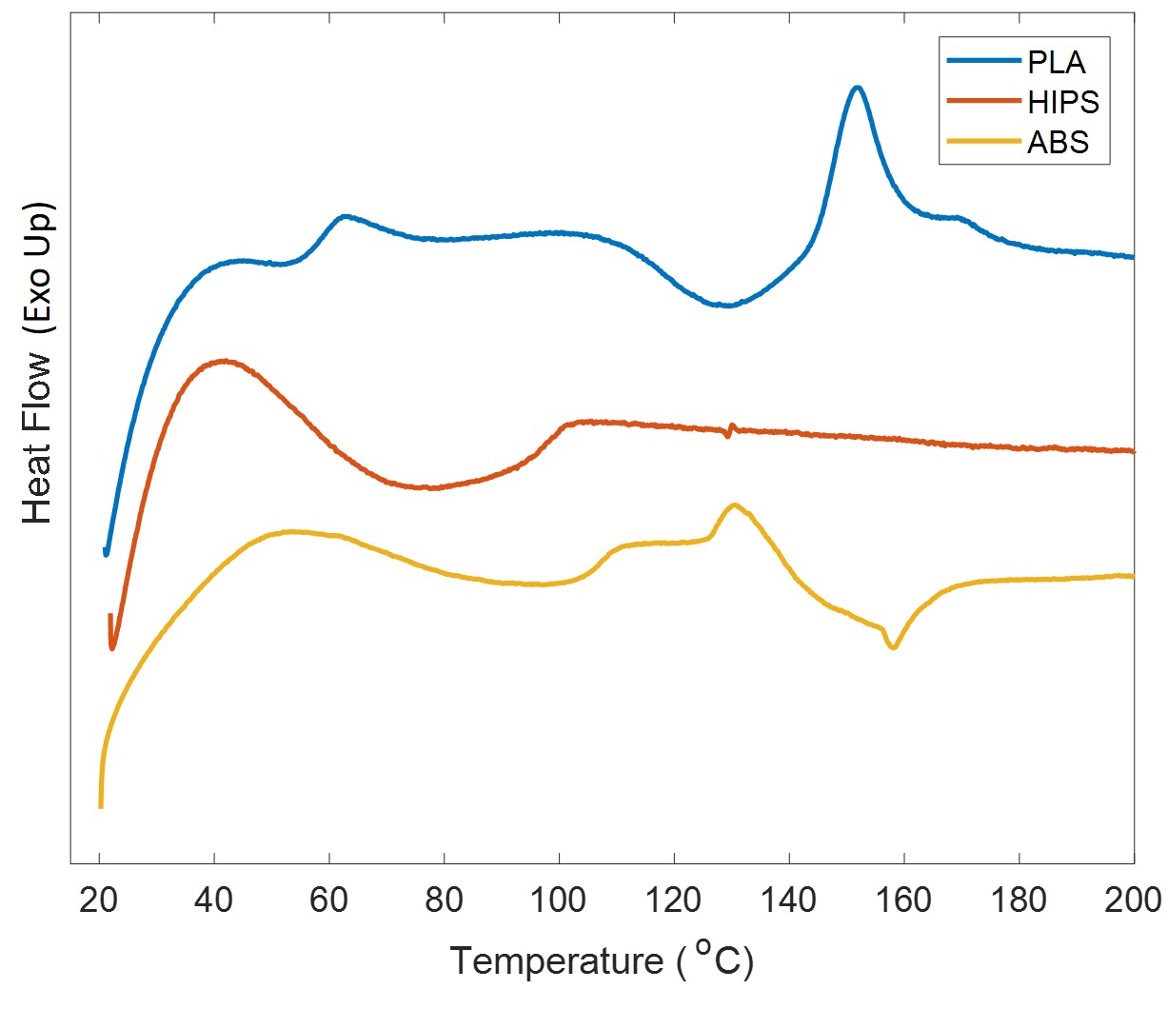
Figure S2: DSC thermo-graphs for different 3D printing filaments
Figure S3: Effect of temperature on the tensile performance of different 3D printed thermoplastics, a)PLA, b)HIPS and c)ABS

Table S1: Effect of temperature on the mechanical properties of various materials
Material | Property | Temperature (°C)
 |  | 22 | Tg-20 | Tg | Tg+20
PLA | Modulus (MPa) | 1440 ± 13.9 | 213 ± 27.3 | 59 ± 4.7 | 12.5 ± 2.7
 | Strength (MPa) | 47.5 ± 4 | 11.3 ± 1.8 | - | -
 | Failure Strain (%) | 7.1 ± 2.1 | ± 23 | >500% | >500%
HIPS | Modulus (MPa) | 771 ± 47.8 | 652 ± 48.2 | 42.5 ± 4.5 | 3.1 ± 1.1
 | Strength (MPa) | 12.6 ± 2.1 | 8.2 ± 1.3 | 1.3 ± 0.8 | -
 | Failure Strain (%) | 27 ± 3.9 | 65 ± 4.8 | >500% | >500%
ABS | Modulus (MPa) | 1124 ± 7.9 | 801 ± 48.5 | 512 ± 16.4 | 25.8 ± 3.8
 | Strength (MPa) | 37.3 ± 3.7 | 17.3 ± 3.8 | 13.1 ± 2.1 | -
 | Failure Strain (%) | 6.2 ± 1.6 | 9.1 ±1.2 | 372 ± 37 | >500%

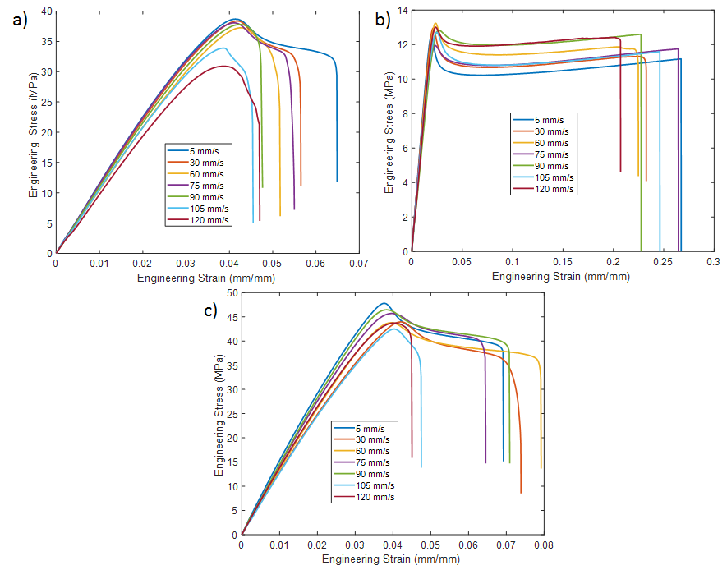
Figure S4: Effect of printing speed on the tensile performance of different 3D printed thermoplastics at room temperature. a)PLA, b)HIPS and c)ABS
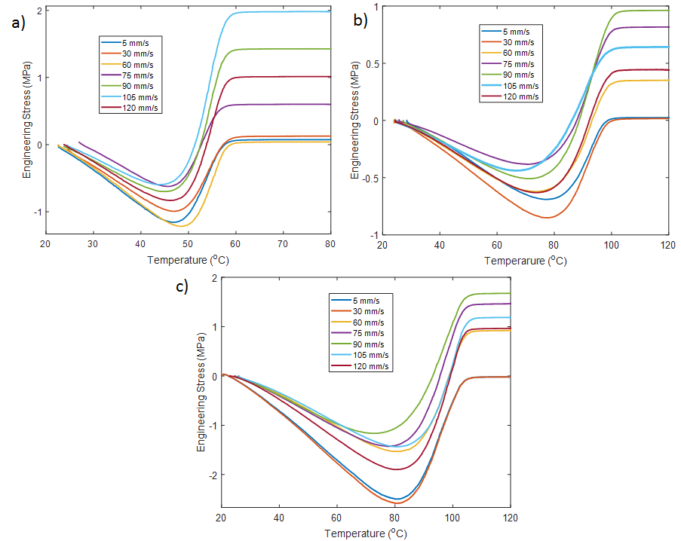
Figure S5: Effect of printing speed on the recovery stress of different 3D printed thermoplastics a)PLA, b)HIPS and c)ABS

S1. Parameter determination:
In this section we present a detailed procedure to obtain the various material parameters for the constitutive model.
- Glass transition temperature, $T_{g}$: Obtained directly from the DSC experiments (Figure S2.)
- Volumetric CTE, $α$: Initially, the thermal expansion curves (strain vs. temperature) is obtained by a push rod dilatometer and curve fitted to a second order polynomial (Figure S6). The equation is differentiated to obtain the linear CTE. Under isotropic assumptions, the volumetric CTE is taken as the three times the linear CTE.
- Glassy state shear modulus,$G$: From the tensile tests at room temperature (Table S1) considering a standard Poisson ratio of 0.4
- Glassy state Lame's constant,$λ$: From the tensile tests at room temperature (Table S1) considering a standard Poisson ratio of 0.4
- Rubbery state shear modulus, $μ_{r}$: From the tensile tests at T_{g}+20 (Table S1) considering a standard Poisson ratio of 0.5 (incompressibility)
- Bulk modulus,$κ$: From the tensile tests at room temperature (Table S1) considering a standard Poisson ratio of 0.4
- Initial shear strength, $s_{0}$: By calculating the strength from the tensile tests at room temperature (Table S1):
- WLF parameters ($C_{1},C_{2}$) and Structural relaxation time at$T_{g}$, $τ_{s}^{o}$ is obtained by fitting the heat flow equation to the DSC curves at the glass transition region. Detailed procedure can be found elsewhere [1].
- $η_{g}$, $s_{s}, Q, s_{s}$ are obtained from curve fitting the predictions and experiments by minimizing following the error function [2];
$$Φ=100 \sqrt{\frac{1}{N}\sum_{i=1}^{N}{\left(1-\frac{σ_{pre}^{i}}{σ_{Exp}^{i}}\right) }}$$
Where N is the total no. of experimental data points, $σ_{pre}^{i}$ and $σ_{Exp}^{i}$ are the predicted and experimental values for the $i$th data point.

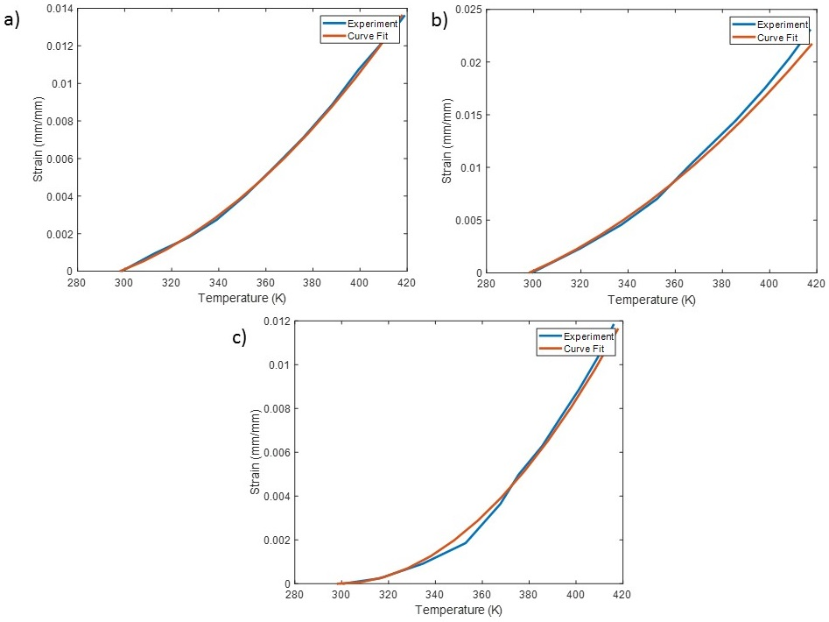
Figure S6: Thermal expansion curves of a)PLA, b)HIPS and c)ABS

References:
[1] R. Abishera, R. Velmurugan, K. N. Gopal, Reversible plasticity shape memory effect in epoxy/CNT nanocomposites-a theoretical study, Compos Sci Technol, 141, 145-153 (2017).
[2] R. Abishera, R. Velmurugan, K. Nagendra Gopal, Free, partial, and fully constrained recovery analysis of cold-programmed shape memory epoxy/carbon nanotube nanocomposites: Experiments and predictions, ‎J. Intell. Mater. Syst. Struct , 29(10), 2164-2176 (2018).

