Supplementary Material

Competitive Interplay of Deposition and Etching Processes
in Atomic Layer Growth of Cobalt and Nickel Metal Films

Alexander Sasinska^{ǂ,1}, Jennifer Leduc^{ǂ,1}, Michael Frank¹, Lisa Czympiel¹, Thomas Fischer¹, Silke H. Christiansen^{2,3} and Sanjay Mathur*^{,1}
¹ Institute of Inorganic Chemistry, University of Cologne, D-50939 Cologne, Germany
² Helmholtz-Zentrum Berlin für Materialien und Energie, Hahn-Meitner Platz 1, D-14109 Berlin, Germany
³ Physics Department, Freie Universität Berlin, Arnimallee 14, D-14195 Berlin, Germany

^{ǂ} both authors contributed equally
*Corresponding author. Email: sanjay.mathur@uni-koeln.de

Supporting Tables
SI F-F distances and sublimation temperatures of precursors ………………………...S3
Supporting Schemes
S1 Two-step synthesis of tridentate enaminone ligands 3a and 3b …………………....S4
S2 Schematic drawing of the precursor binding mode upon chemisorption onto the substrate surface …………………………………………………………………….…………….......S4
S3 Schematic illustration of the role of hydrogen plasma as activant and etchant during the ALD process …………………………………………………………...…………………....S4

Supporting Figures
S1 High-resolution XPS spectra after one precursor pulse using [Co(tfb-dmpda)₂] 4b and the free ligand Htfb-dmpda 3b……………………………………………….... S5
S2 Cross-section SEM analysis …………….………………………………….............S6
S3 AFM micrographs of metallic Co and Ni films…………………………………..... S6
S4 High-resolution XPS spectra of metallic Co and Ni films before and after argon etching………………………………………………………………………. S7
S5 High-resolution XPS spectra of as deposited Co and Ni films after argon etching...S8
S6 XRD patterns of Co and Ni films after annealing under argon……………………. S8
S7 Resistance measurements of metallic Co and Ni films……………………………. S9
S8 Nuclear reaction analysis of Ni based samples….…………………………….........S9

Table SI: F-F distances and sublimation temperatures of precursors 4a, 4b, 5a and 5b.

Compound | F-F distance  [Å] | Sublimation temperature [°C] / 10⁻³ mbar
4a | 3.06 | 170
5a | 3.04 | 180
4b | 3.12 | 140
5b | 3.08 | 150

Scheme S1: Two-step synthesis of tridentate enaminone ligands 3a and 3b.

Scheme S2: Schematic drawing of the precursor binding mode upon chemisorption onto the substrate surface.

Scheme S3: Schematic illustration of the role of hydrogen plasma as activant and etchant during the ALD process.
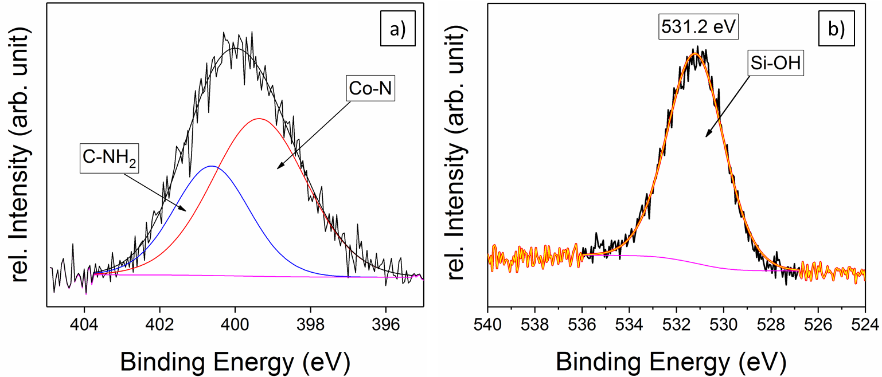
FIG. S1: a) High-resolution N 1s XPS spectrum after one precursor pulse using [Co(tfb-dmpda)₂] 4b, b) high-resolution O 1s XPS spectrum of the free ligand Htfb-dmpda 3b deposited on a Si-wafer.

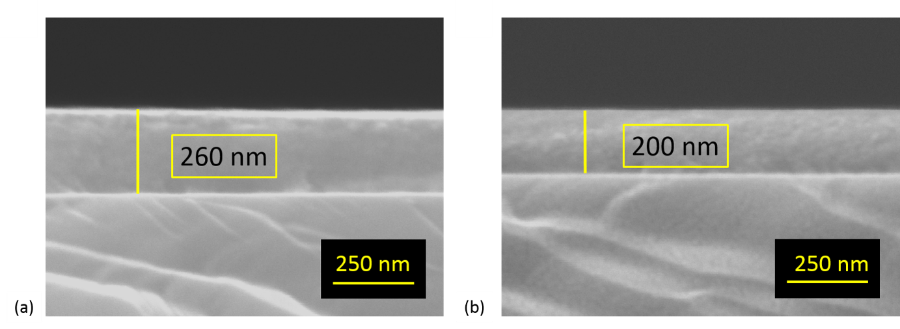
FIG. S2: Cross-section SEM analysis: a) ALD-deposited and hydrogen plasma treated cobalt film with a thickness of 260 nm (on a Si-wafer). b) Nickel film deposited under similar conditions with a thickness of 200 nm.

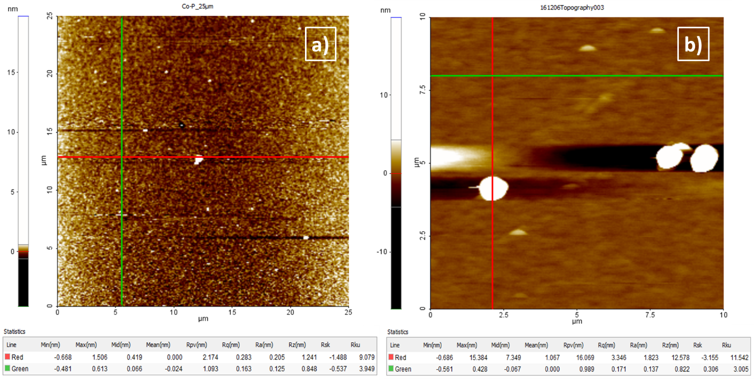
FIG. S3: AFM micrographs of a) metallic cobalt after H₂-plasma treatment, b) metallic nickel after H₂-plasma treatment.
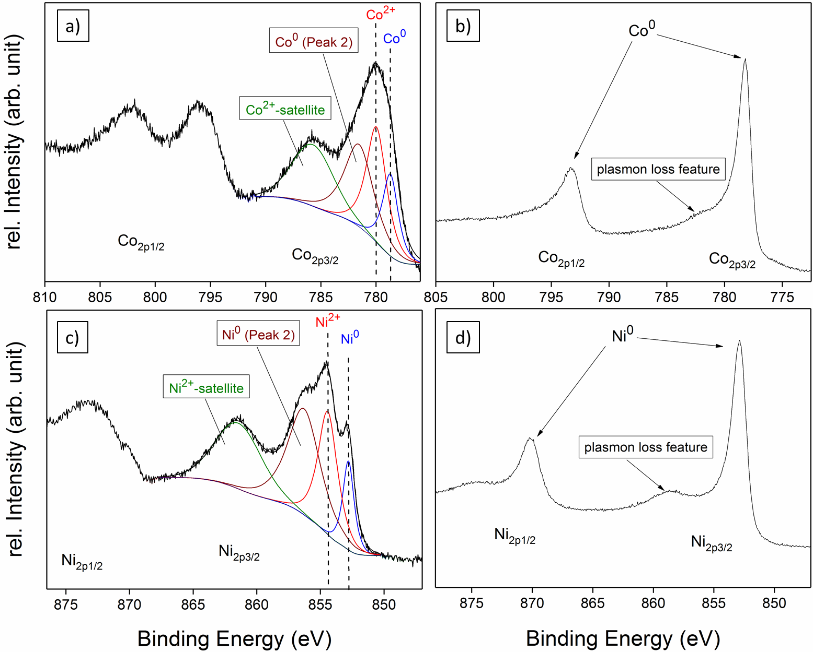
FIG. S4: High-resolution Co 2p XPS spectra of plasma treated cobalt films a) before and b) after argon etching, high-resolution Ni 2p XPS spectra of plasma treated nickel films c) before and d) after argon etching.

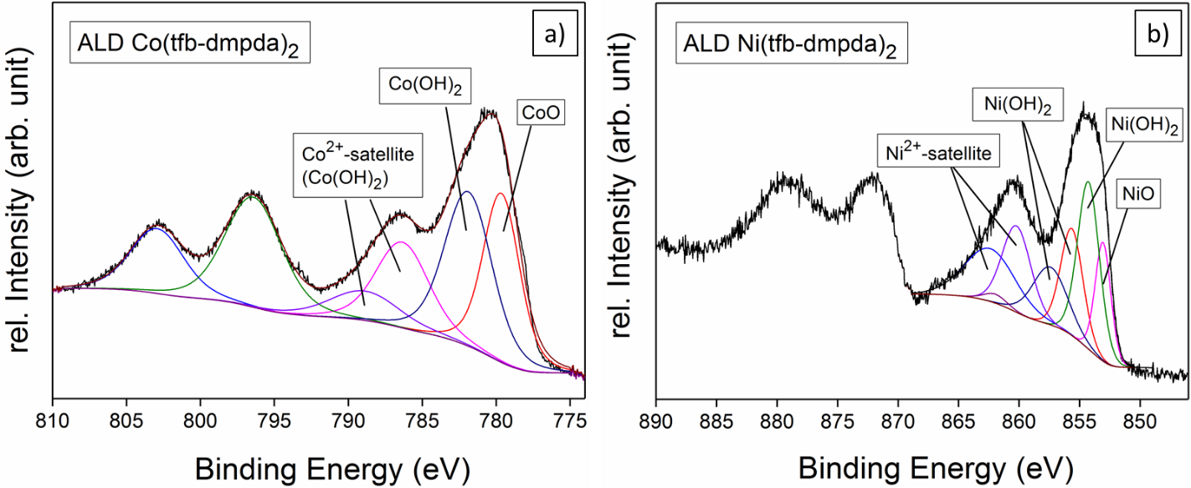
FIG. S5: High-resolution a) Co 2p XPS spectrum of as deposited Co films using [Co(tfb-dmpda)₂] 4b without post-deposition H₂-treatment and b) Ni 2p XPS spectrum of as deposited Ni films using [Ni(tfb-dmpda)₂] 5b without post-deposition H₂-treatment, subjected to argon sputtering.

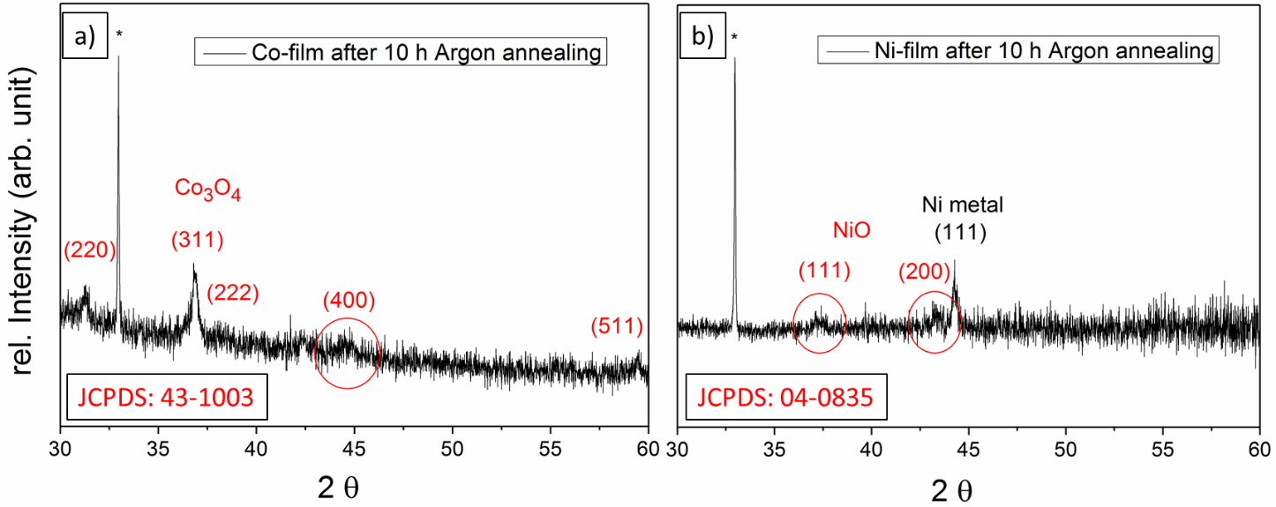
FIG. S6: XRD analysis of a) cobalt and b) nickel films after additional annealing under argon atmosphere deposited on Si-wafers (*).

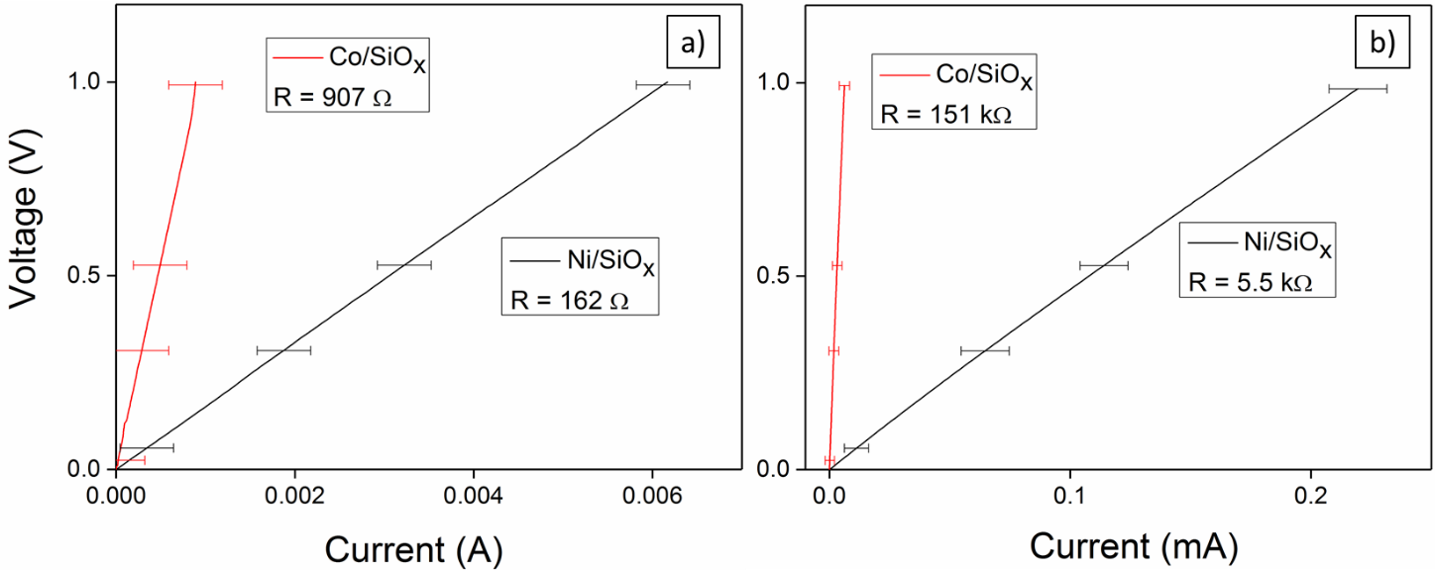
FIG. S7: Resistance measurements of cobalt and nickel films after a) 500 cycles and b) 1000 cycles of post-deposition hydrogen radical treatment.

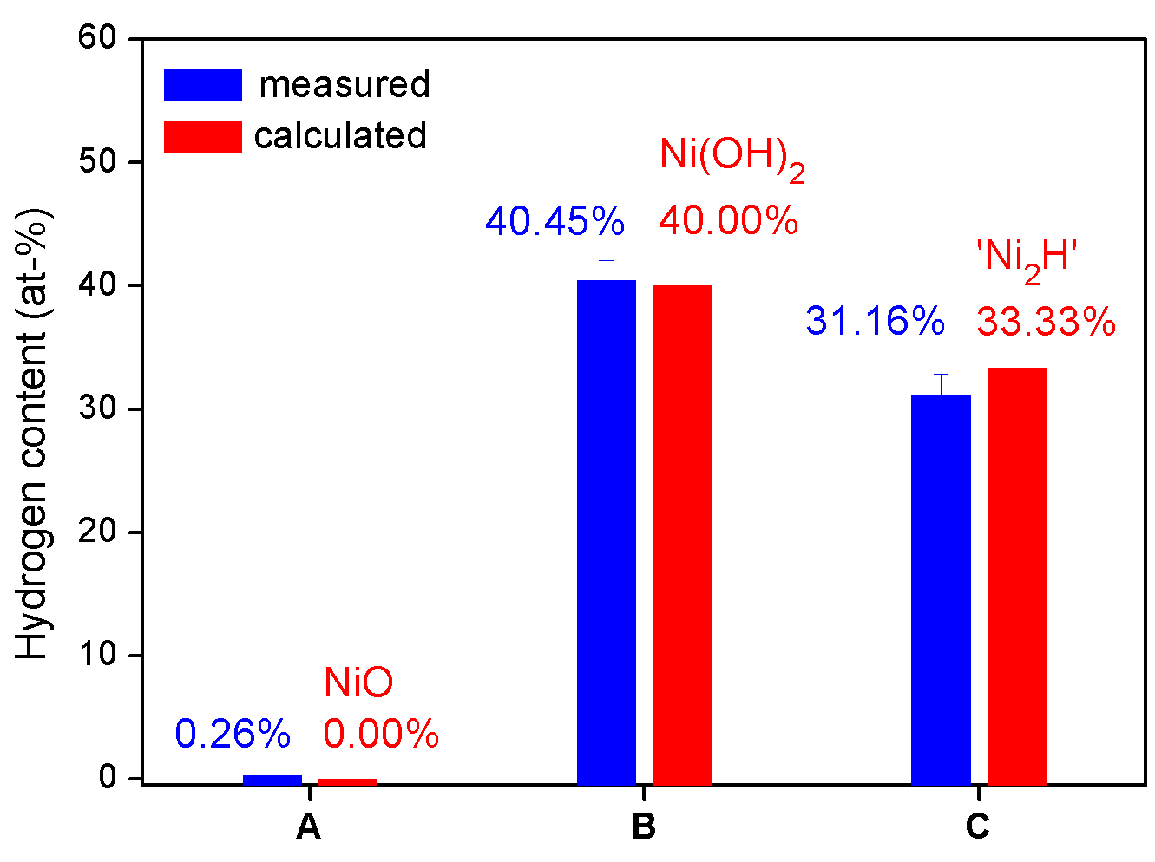
FIG. S8: Nuclear reaction analysis to quantify the hydrogen content in the following samples, A: deposition of NiO using oxygen plasma, B: deposition of Ni(OH)₂ using hydrogen plasma as activant, C: B with excessive hydrogen plasma as etchant presumably forming nickel hydride.

