Electronic Supplementary Information

Green Synthesis of Functionalized Graphene and Their use as solid acid catalysts
Xu Zhang, Qiuyu Fan and He Yang
School of Petroleum & Chemical Engineering, Dalian University of Technology, Panjin 124221, China

The S content of the different catalysts were measured by elemental analysis. The highest S content was observed in PSS-RGO. After sulfonation, the S content of all the sulfonate catalysts was higher than that of RGO.
Table S1. The elemental sulfur content of different catalysts.
Catalysts | RGO | S-RGO | A-RGO | PSS-CNTs | PSS-RGO
Sulfur content  (wt. %) | 0.4 | 1.2 | 1.2 | 1.0 | 4.9

The prepared PSS-RGO sample dispersed well in ethanol, DMF and water (1 mg mL⁻¹) compared with raw RGO. After sonication, the PSS-RGO could disperse and stable for several hours, but for raw RGO, the appearance of black “ﬂuffy” precipitates at the bottom was happened immediately.
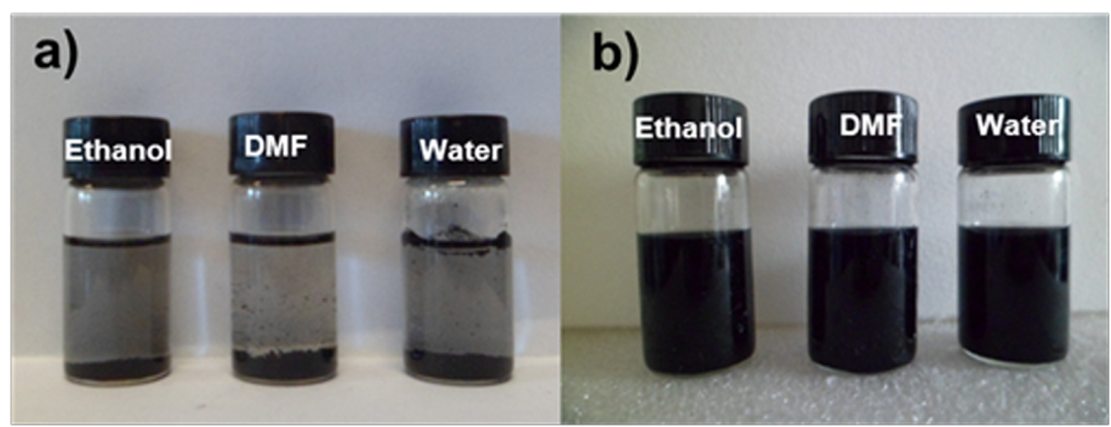
Fig. S1. Digital photographs of the RGO (a) and PSS-RGO (b) dispersed in ethanol, DMF and water.

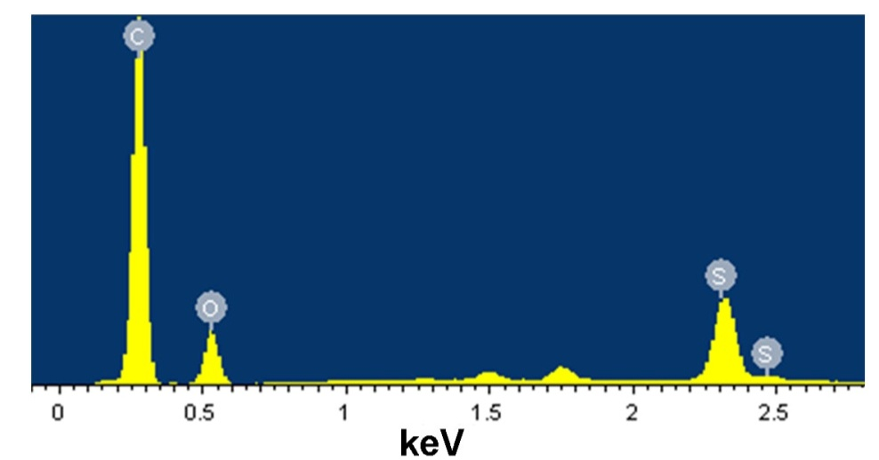
Fig. S2. EDS image of the as-made PSS-RGO.

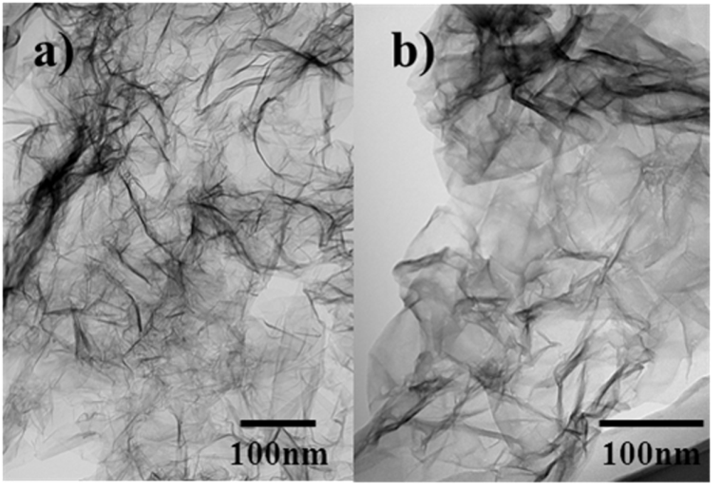
Fig. S3. TEM images of the RGO (a) and PSS-RGO (b).
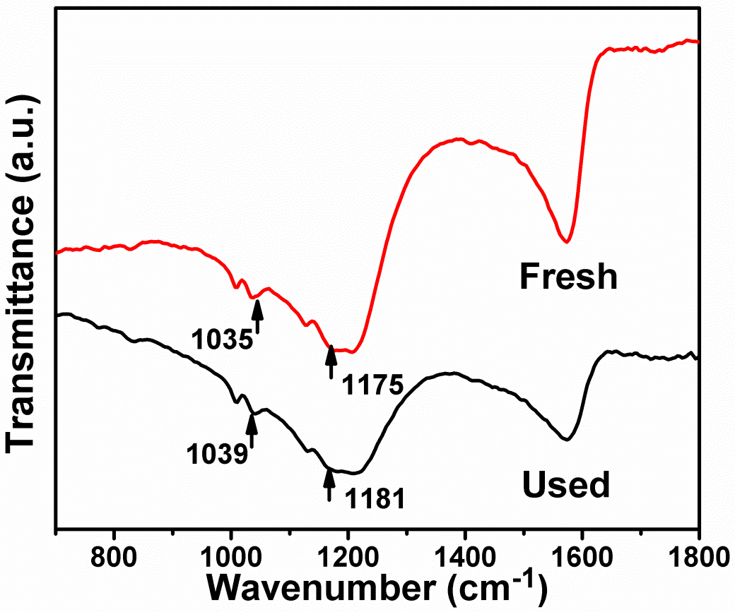
Fig. S4. Micro FT-IR spectra of the PSS-RGO catalysts before and after use.

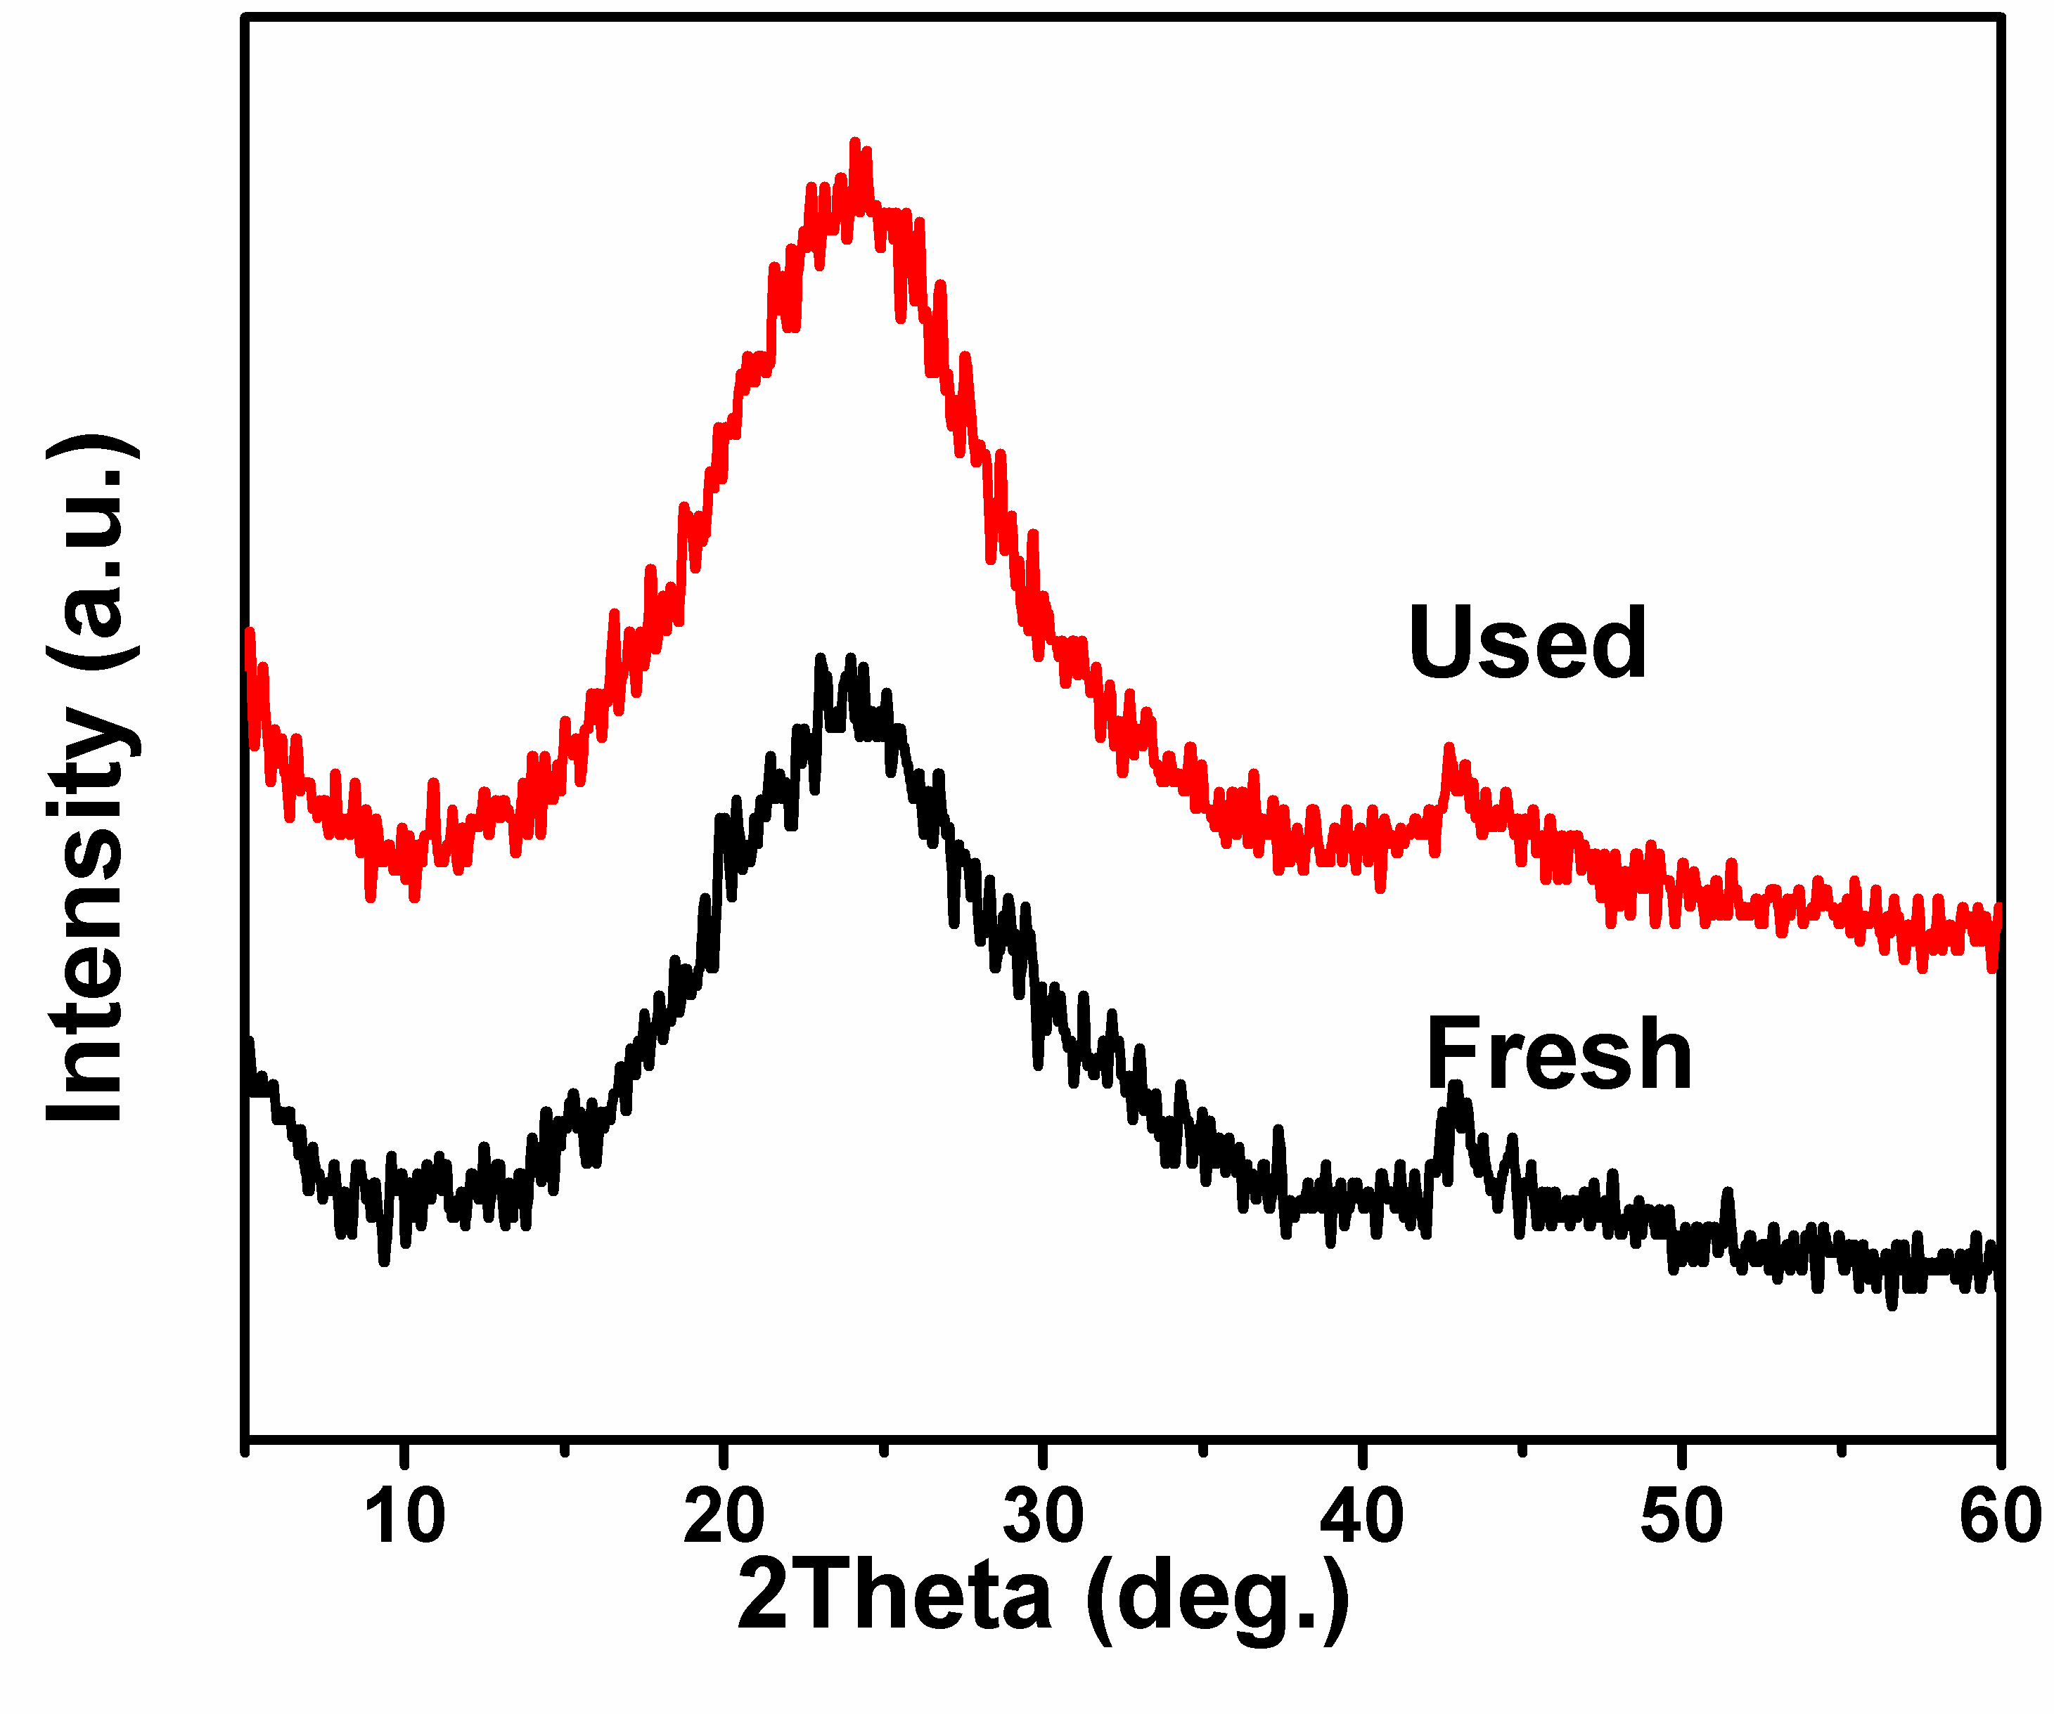
Fig. S5. XRD patterns of the PSS-RGO catalysts before and after use.

Corresponding author. Tel.: +86 427 2631815. E-mail: zhangxu@dlut.edu.cn.

