Supplement S1
Material Design and Processing of a New Class of Titanium Boride (TiB) Cermets with Tough Metallic Phases and Mechanical Properties
A. Lark, J. Du and K. S. Ravi Chandran*
Department of Metallurgical Engineering
135 South 1460 East, Room 412
University of Utah, Salt Lake City, UT 84112, USA
*Corresponding Author; Email: ravi.chandran@utah.edu

Distribution of elements in TiB cermets as determined by WDS analysis
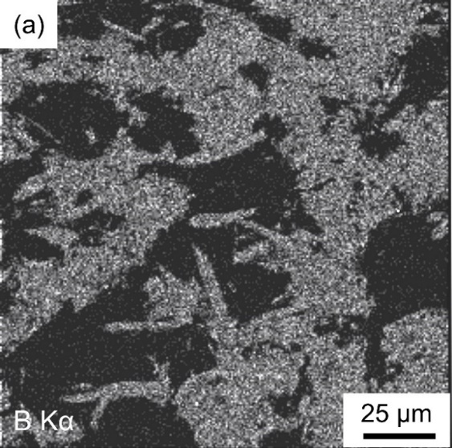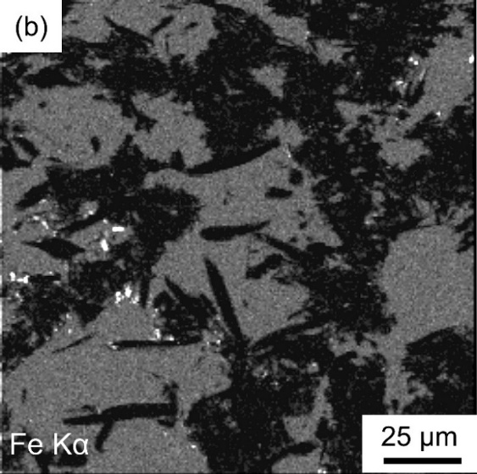
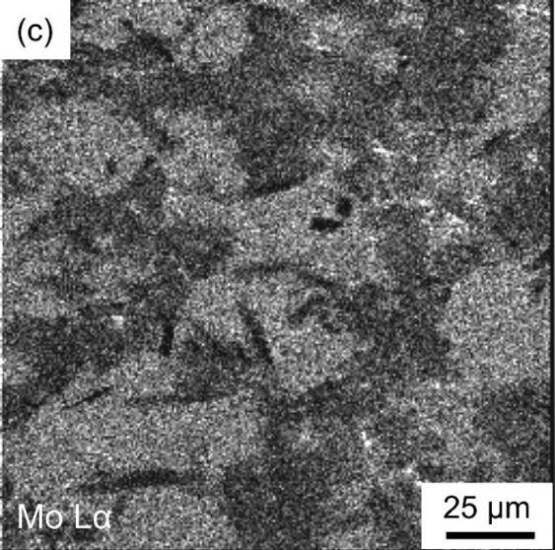
Figure S1: WDS mapping of elements in a typical TiB-β-Ti cermet sample showing the distribution of (a) boron, (b) iron, and (c) molybdenum in the microstructure.
The distributions of β-stabilizing elements, resulting from in situ formations of TiB whiskers, were also investigated. Using wavelength-dispersive-spectroscopy (WDS), the spatial distributions of B, Fe, and Mo were mapped and are shown in Figure S1(a-c), given in Supplementary Material. Figure S1(a) shows the typical distribution of B within the TiB phase—the light regions indicate the presence of B and the dark regions indicate the absence of B, relatively. It is evident that there is no B within the large β-Ti islands, as well as within the smaller islands within in TiB. This is consistent with the Ti-B binary phase diagram, showing almost no solubility of B in α/β Ti phases. If is therefore clear that nearly all of B is in the form of TiB phase. However, Fe and Mo are distributed differently between the ceramic and metal phase. The light regions in (b) and (c) suggest that Fe and Mo are essentially concentrated within the β-Ti phase forming the large as well as the small islands. Although Fe seems to be exclusively concentrated within β-Ti phase, there appears to be some distribution of Mo within the TiB regions, possibly, formatting a ternary boride of stoichiometry Ti_{x}Mo_{1-x}B, where “x” the mole fraction of Ti atoms within the boride. However, interestingly in Figure S1(c), the large TiB whiskers that seem to grow into the large β-Ti islands appear to be darker than the major bundles of TiB whiskers, and hence appear to have a much less concentration of Mo in them. A more detailed analysis of these two different forms of spatial distribution of Mo, within the TiB phases, is beyond the scope of the present study.

