SUPPLEMENTARY MATERIAL
Toward the design of interstitial nonmetals co-doping for Mg-based hydrides as hydrogen storage material
Zhen Wu, Luying Zhu and Fusheng Yang
School of Chemical Engineering and Technology, Xi’an Jiaotong University, Xi’an 710049, P. R. China
Serge N. Nyamsi,
HySA Systems Competence Centre, South African Institute for Advanced Materials Chemistry (SAIAMC), University of the Western Cape, Bellville, 7535, South Africa
E Porpatham,
School of Mechanical Engineering, VIT University, Vellore, 632014, India
Zaoxiao Zhang*
State Key Laboratory of Multiphase Flow in Power Engineering, School of Chemical Engineering and Technology, Xi’an Jiaotong University, Xi’an 710049, P. R. China
*Corresponding author, Email: zhangzx@mail.xjtu.edu.cn Fax(Tel):86-29-82660689

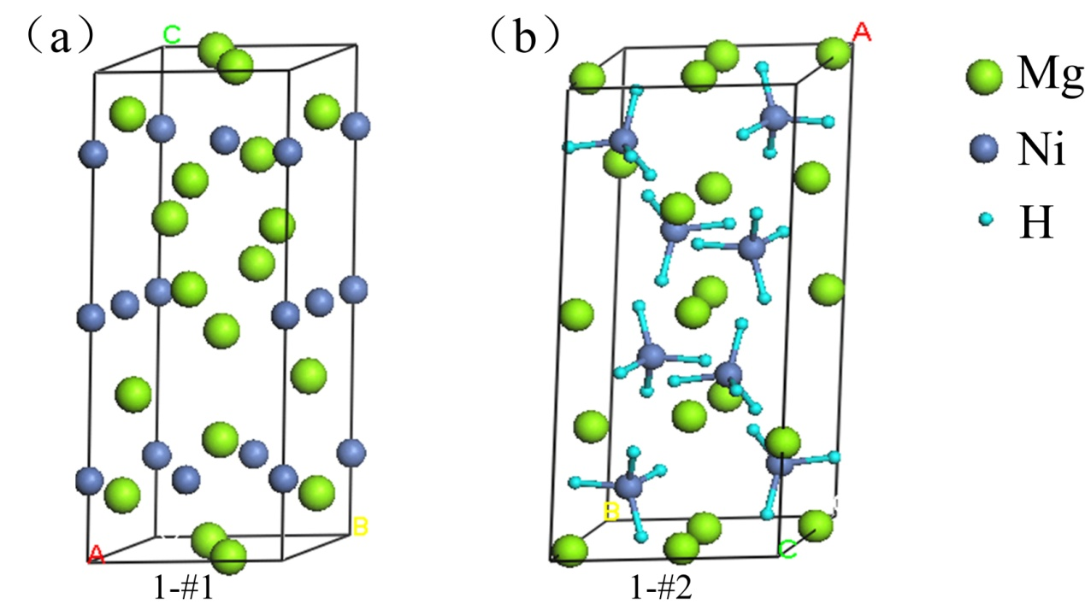
FIG. S1. Crystal structures of pure Mg₂Ni and its hydride unit cells. (a) Mg₂Ni, and (b) Mg₂NiH₄. (green - Mg, blue - Ni, cyan - H) (Color online)

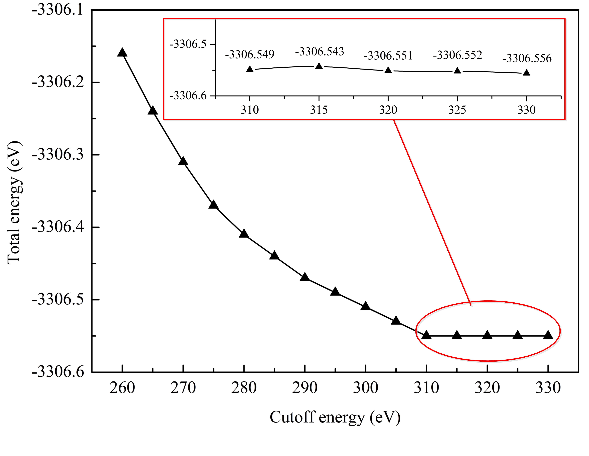
FIG. S2. Relationship between the cutoff energy and total energy. (Color online)
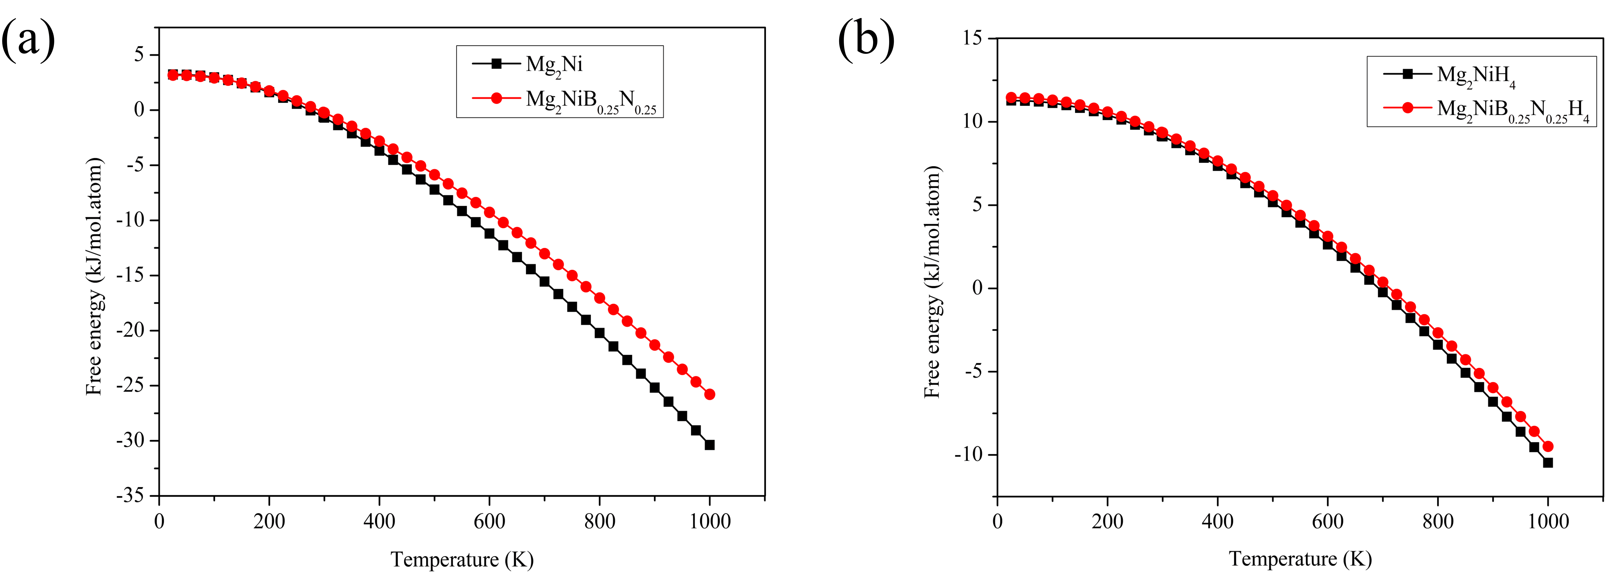
FIG. S3. Variations of the free energy with temperature for the pure Mg₂Ni and its hydride and their B+N co-doped counterparts. (a) Mg₂Ni and Mg₂NiB_{0.25}N_{0.25}, and (b) Mg₂NiH₄ and Mg₂NiB_{0.25}N_{0.25}H₄. (Color online)

TABLE SⅠ. Atomic positions of the atoms Mg and Ni in Mg₂Ni unit cell with the space group P6₂22.
Atom | Wyckoff position | x | y | z
Mg1 | 6f | 0.5 | 0 | 1/9
Mg2 | 6i | 1/6 | 1/3 | 0
Ni1 | 3b | 0 | 0 | 1/6
Ni2 | 3d | 0 | 0.5 | 1/6

TABLE SⅡ. Atomic positions of the atoms Mg, Ni and H in Mg₂NiH₄ unit cell with the space group C2/c.
Atom | Wyckoff position | x | y | z
Mg1 | 8f | 0.2652 | 0.4827 | 0.0754
Mg2 | 4e | 0 | 0.0144 | 0.25
Mg3 | 4e | 0 | 0.5130 | 0.25
Ni | 8f | 0.1194 | 0.2308 | 0.0832
H1 | 8f | 0.2113 | 0.2995 | 0.3037
H2 | 8f | 0.1360 | 0.3163 | 0.8811
H3 | 8f | 0.0105 | 0.2868 | 0.0537
H4 | 8f | 0.1306 | 0.995 | 0.0815

TABLE SⅢ. Total energies of Mg₂NiB_{0.25}N_{0.25} and Mg₂NiB_{0.25}N_{0.25}H₄ with all possible interstitial sites of co-doping B and N after the geometry optimization.
Crystals | Total energies of the primitive cell (eV)
Mg₂NiB_{0.25}N_{0.25} | 2-#1 | 2-#2 | 2-#3 | 2-#4 | 2-#5 | 2-#6
Mg₂NiB_{0.25}N_{0.25} | -3389.32 | -3389.38 | -3388.52 | -3388.47 | -3389.22 | -3389.02
Mg₂NiB_{0.25}N_{0.25}H₄ | 3-#1 | 3-#2 | 3-#3 | 3-#4 | 3-#5 | 3-#6
Mg₂NiB_{0.25}N_{0.25}H₄ | -3456.87 | -3456.86 | -3456.79 | -3456.85 | -3456.82 | -3456.90

TABLE SⅣ. Atomic positions in Mg₂NiB_{0.25}N_{0.25}unit cell with the space group P6₂22.
Label | Atom | x | y | z
Mg1 | Mg | 0.5000 | 0.0000 | 0.1110
Mg2 | Mg | 0.0000 | 0.5000 | 0.7777
Mg3 | Mg | 0.5000 | 0.5000 | 0.4443
Mg4 | Mg | -0.0000 | 0.5000 | 0.5557
Mg5 | Mg | 0.5000 | 0.0000 | 0.8890
Mg6 | Mg | 0.5000 | 0.5000 | 0.2223
Mg7 | Mg | 0.1665 | 0.3330 | 0.0000
Mg8 | Mg | 0.6670 | 0.8335 | 0.6667
Mg9 | Mg | 0.1665 | 0.8335 | 0.3333
Mg10 | Mg | 0.8335 | 0.6670 | 0.0000
Mg11 | Mg | 0.3330 | 0.1665 | 0.6667
Mg12 | Mg | 0.8335 | 0.1665 | 0.3333
Ni1 | Ni | 0.0000 | 0.0000 | 0.1667
Ni2 | Ni | 0.0000 | 0.0000 | 0.8333
Ni3 | Ni | 0.0000 | 0.0000 | 0.5000
Ni4 | Ni | 0.0000 | 0.5000 | 0.1667
Ni5 | Ni | 0.5000 | 0.5000 | 0.8333
Ni6 | Ni | 0.5000 | 0.0000 | 0.5000
NE1^{b} | B_{0.5}N_{0.5}ª | 0.5000 | 0.5000 | 0.3333
NE2^{b} | B | 0.5000 | 0.0000 | 0.0000
NE3^{b} | N | 0.0000 | 0.5000 | 0.6667
a: The atom consists of 50% B and 50% N
b: 3c Wyckoff position for interstitial nonmetals

TABLE SⅤ. Atomic positions in Mg₂NiB_{0.25}N_{0.25}H₄ unit cell with the space group C2/c.
Label | Atom | x | y | z
Mg1 | Mg | 0.2652 | 0.4827 | 0.0754
Mg2 | Mg | 0.7652 | 0.9827 | 0.0754
Mg3 | Mg | 0.7348 | 0.4827 | 0.4246
Mg4 | Mg | 0.2348 | 0.9827 | 0.4246
Mg5 | Mg | 0.7348 | 0.5173 | 0.9246
Mg6 | Mg | 0.2348 | 0.0173 | 0.9246
Mg7 | Mg | 0.2652 | 0.5173 | 0.5754
Mg8 | Mg | 0.7652 | 0.0173 | 0.5754
Mg9 | Mg | 0.0000 | 0.0244 | 0.2500
Mg10 | Mg | 0.0000 | 0.5130 | 0.2500
Mg11 | Mg | 0.5000 | 0.5244 | 0.2500
Mg12 | Mg | 0.5000 | 0.0130 | 0.2500
Mg13 | Mg | 0.0000 | 0.9756 | 0.7500
Mg14 | Mg | 0.0000 | 0.4870 | 0.7500
Mg15 | Mg | 0.5000 | 0.4756 | 0.7500
Mg16 | Mg | 0.5000 | 0.9870 | 0.7500
Ni1 | Ni | 0.1194 | 0.2308 | 0.0832
Ni2 | Ni | 0.6194 | 0.7308 | 0.0832
Ni3 | Ni | 0.8806 | 0.2308 | 0.4168
Ni4 | Ni | 0.3806 | 0.7308 | 0.4168
Ni5 | Ni | 0.8806 | 0.7692 | 0.9168
Ni6 | Ni | 0.3806 | 0.2692 | 0.9168
Ni7 | Ni | 0.1194 | 0.7692 | 0.5832
Ni8 | Ni | 0.6194 | 0.2692 | 0.5832
H1 | H | 0.2113 | 0.2995 | 0.3037
H2 | H | 0.1360 | 0.3163 | -0.1189
H3 | H | 0.0105 | 0.2868 | 0.0537
H4 | H | 0.1306 | -0.0050 | 0.0815
H5 | H | 0.7113 | 0.7995 | 0.3037
H6 | H | 0.6360 | 0.8163 | -0.1189
H7 | H | 0.5105 | 0.7868 | 0.0537
H8 | H | 0.6306 | 0.4950 | 0.0815
H9 | H | 0.7887 | 0.2995 | 0.1963
H10 | H | 0.8640 | 0.3163 | 0.6189
H11 | H | 0.9895 | 0.2868 | 0.4463
H12 | H | 0.8694 | -0.0050 | 0.4185
H13 | H | 0.2887 | 0.7995 | 0.1963
H14 | H | 0.3640 | 0.8163 | 0.6189
H15 | H | 0.4895 | 0.7868 | 0.4463
H16 | H | 0.3694 | 0.4950 | 0.4185
H17 | H | 0.7887 | 0.7005 | 0.6963
H18 | H | 0.8640 | 0.6837 | 1.1189
H19 | H | 0.9895 | 0.7132 | 0.9463
H20 | H | 0.8694 | 1.0050 | 0.9185
H21 | H | 0.2887 | 0.2005 | 0.6963
H22 | H | 0.3640 | 0.1837 | 1.1189
H23 | H | 0.4895 | 0.2132 | 0.9463
H24 | H | 0.3694 | 0.5050 | 0.9185
H25 | H | 0.2113 | 0.7005 | 0.8037
H26 | H | 0.1360 | 0.6837 | 0.3811
H27 | H | 0.0105 | 0.7132 | 0.5537
H28 | H | 0.1306 | 1.0050 | 0.5815
H29 | H | 0.7113 | 0.2005 | 0.8037
H30 | H | 0.6360 | 0.1837 | 0.3811
H31 | H | 0.5105 | 0.2132 | 0.5537
H32 | H | 0.6306 | 0.5050 | 0.5815
NE1ª | B | 0.7500 | 0.2500 | 0.5000
NE2ª | B | 0.2500 | 0.7500 | 0.5000
NE3ª | N | 0.2500 | 0.2500 | 0.0000
NE4ª | N | 0.7500 | 0.7500 | 0.0000
a: 4c Wyckoff position for interstitial nonmetals

