Supplementary Material

Facile synthesis of Pt-Ag octahedral and tetrahedral nanocrystals with enhanced activity and durability toward methanol oxidation

Ming Zhao
School of Chemistry and Biochemistry, Georgia Institute of Technology, Atlanta, Georgia 30332, USA
Xuan Yang
The Wallace H. Coulter Department of Biomedical Engineering, Georgia Institute of Technology and Emory University, Atlanta, Georgia 30332, USA
Zachary D. Hood
School of Chemistry and Biochemistry, Georgia Institute of Technology, Atlanta, Georgia 30332, USA; and Center for Nanophase Materials Sciences, Oak Ridge National Laboratory, Oak Ridge, Tennessee 37831, USA
Miaofang Chi
Center for Nanophase Materials Sciences, Oak Ridge National Laboratory, Oak Ridge, Tennessee 37831, USA
Younan Xia^{a)}
The Wallace H. Coulter Department of Biomedical Engineering, Georgia Institute of Technology and Emory University, Atlanta, Georgia 30332, USA; and School of Chemistry and Biochemistry, Georgia Institute of Technology, Atlanta, Georgia 30332, USA

^{a)}Address all correspondence to this author: younan.xia@bme.gatech.edu

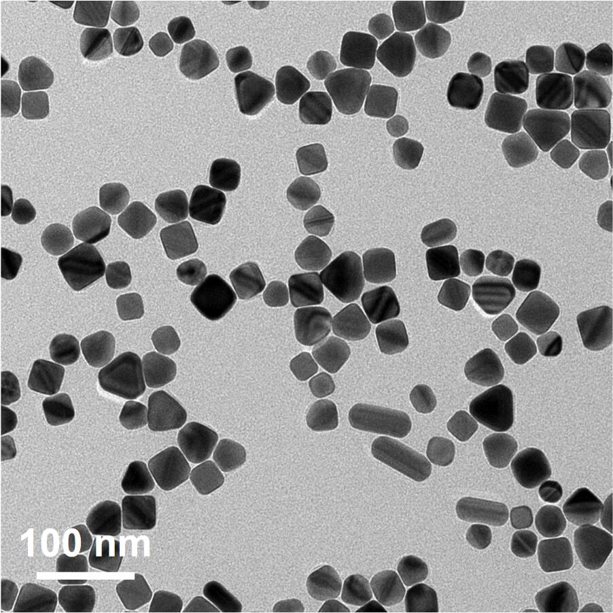
FIG. S1. TEM image of the Ag nanocrystals prepared using the standard protocol except for the absence of the Pt(IV) precursor.

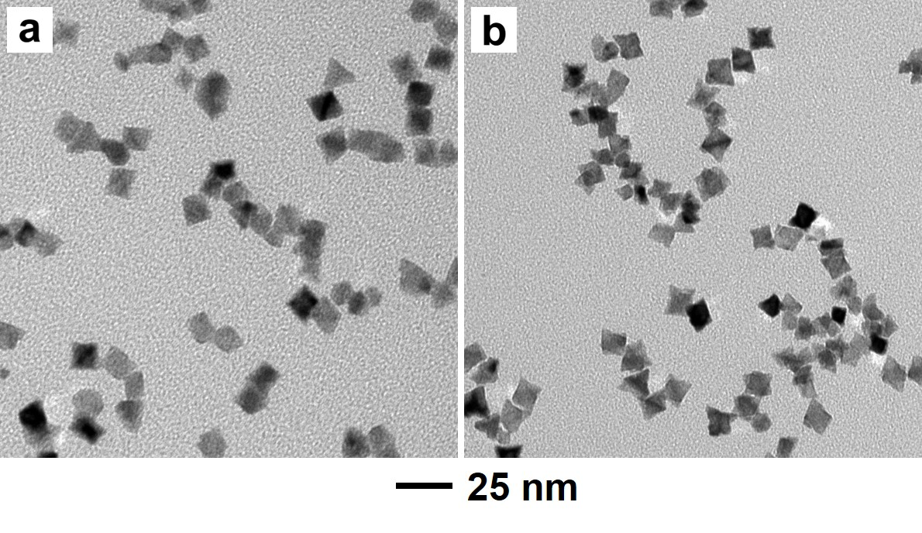
FIG. S2. TEM images of the Pt-Ag nanocrystals prepared using the standard protocol except for the use of different reaction temperatures: (a) 150 °C and (b) 170 °C, respectively.

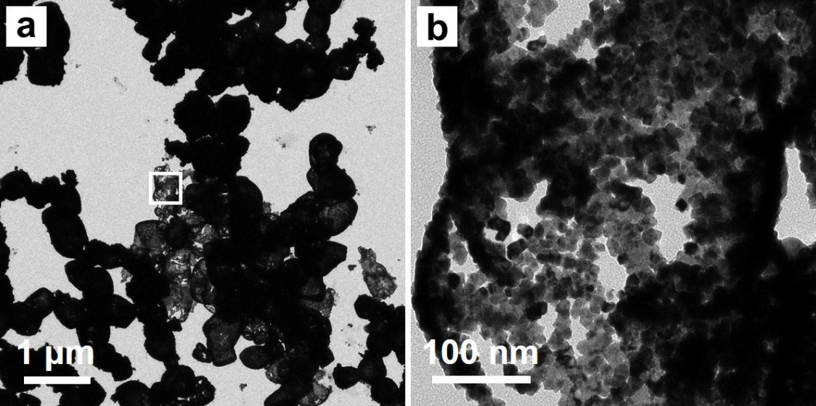
FIG. S3. (a) TEM image of the nanoparticles obtained using the standard protocol except for the absence of PVP. (b) TEM image at a high magnification taken from the region marked by a box in panel a.

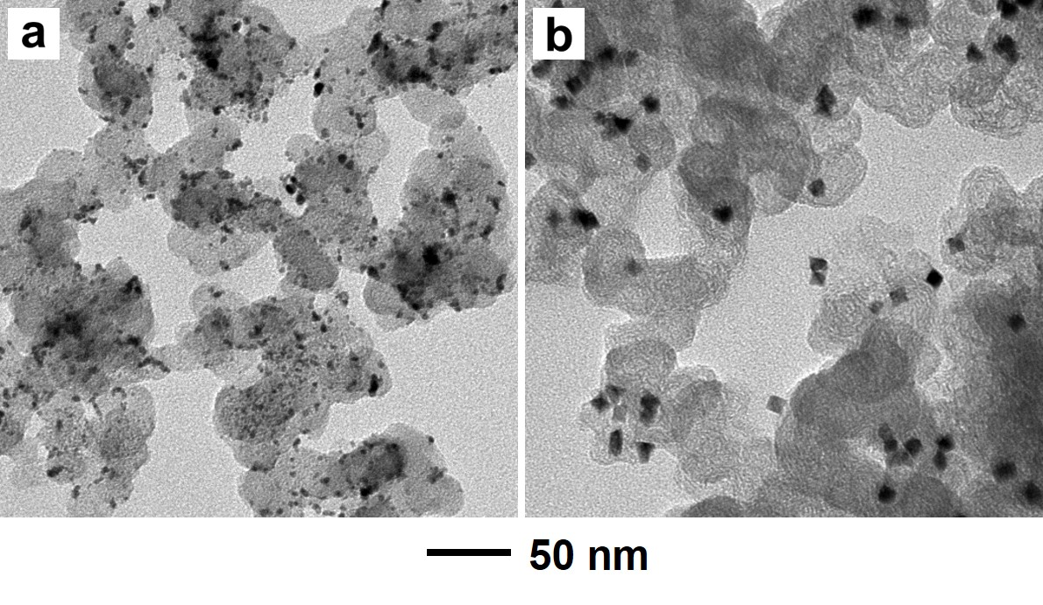
FIG. S4. TEM images of carbon-supported catalysts: (a) the commercial Pt/C and (b) the Pt-Ag alloy nanocrystals.

Table SI. The elemental composition of Pt-Ag alloy nanocrystals prepared using the standard protocol.

 | Percentage of Pt (wt.%) | Percentage of Ag (wt.%) | Pt : Ag (mol/mol)
Pt-Ag nanocrystals | 72.2 | 27.8 | 3:2

