Supplementary Material

Phase Stability as a Function of Temperature in a Refractory High Entropy Alloy
Vishal Soni^{a, b}**, Bharat Gwalani^{a,b}**, O.N. Senkov ^{c,d}, B. Viswanathan^{c,e}, T. Alam^{a, b}, D. B. Miracle^{c} and R. Banerjee^{a, b#}
ª Advanced Materials and Manufacturing Processes Institute, University of North Texas
Denton, TX-76207, USA
^{b} Department of Materials Science and Engineering, University of North Texas
Denton, TX-76207, USA
^{c} Air Force Research Laboratory, Materials and Manufacturing Directorate,
Wright-Patterson AFB, OH-45433, USA
^{d} UES Inc., 4401 Dayton-Xenia Road, Beavercreek, OH-45432, USA
^{e} Department of Materials Science and Engineering, The Ohio State University, Columbus, OH 4310, USA

** These authors contributed equally
# Corresponding Author: Raj.Banerjee@unt.edu
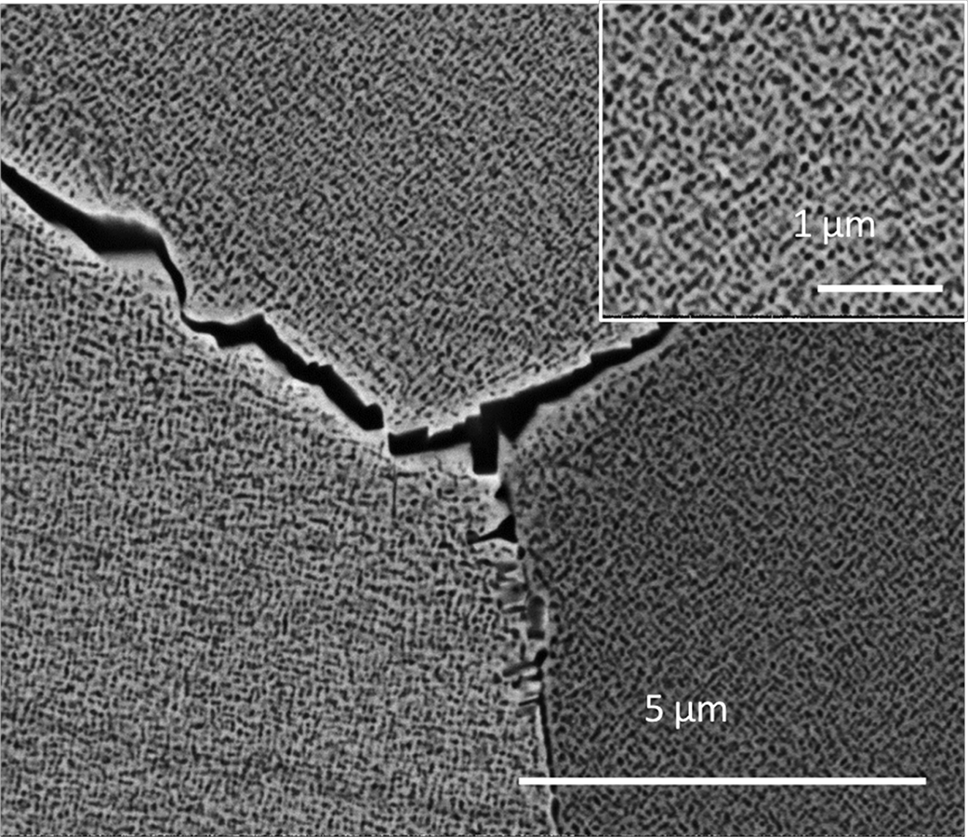
Supplementary Figure S1. SEM-BSED image of AP-600 sample (inset shows a high magnification image).

