Supplementary Material

Title: Two-Step Growth of High Quality Nb/(Bi_{0.5}Sb_{0.5})₂Te₃/Nb Heterostructures for Topological Josephson Junctions

H. Zhang^{1,2,3,4}, X. Ma^{1,2,3}, L. Li^{2,3}, D. Langenberg², C. G. Zeng¹, G. X. Miao^{2,3}*
- Hefei National Laboratory for Physical Sciences at the Microscale (HFNL), University of Science and Technology of China, Hefei, China zip: 230026
- Institute for Quantum Computing ,University of Waterloo, 200 University Ave. West, Waterloo, Ontario, Canada zip: N2L 3G1,
- Electrical and Computer Engineering (ECE), University of Waterloo, 200 University Ave. West, Waterloo, Ontario, Canada zip: N2L 3G1,
- National Synchrotron Radiation Laboratory, University of Science and Technology of China, Hefei, China zip: 230026

*To whom correspondence should be addressed. E-mail: guo-xing.miao@uwaterloo.ca

- (Bi_{0.5}Sb_{0.5})₂Te₃ deposition on various substrates
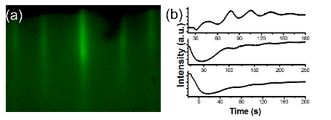
FIG. S1 (a) RHEED pattern of (Bi_{0.5}Sb_{0.5})₂Te₃ grown on SrTiO₃(111) substrates. (b) RHEED intensity oscillation of(Bi_{0.5}Sb_{0.5})₂Te₃films on SrTiO₃(111), Al₂O₃(0001) and H-passivated Si(111)surface, respectively.

- (Bi_{0.5}Sb_{0.5})₂Te₃ film directly on Nb surfaces
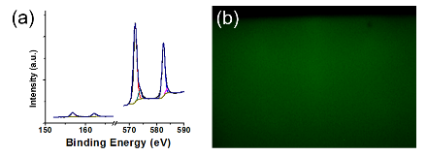
FIG. S2 (a) XPS results of the Bi 4f peak (left) and Te 3d (right) peak of the poor film deposition at the temperature 280°C. (b) RHEED pattern of the film at the deposition temperature 280°C.

- RHEED pattern monitoring of (Bi_{0.5}Sb_{0.5})₂Te₃ on H-passivated Si(111)
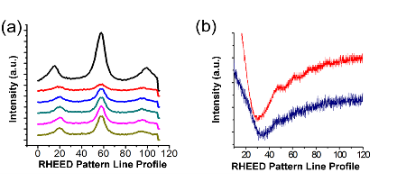
FIG. S3 (a) Line profile of RHEED streak of (Bi_{0.5}Sb_{0.5})₂Te₃ thin films on H-passivated Si(111)surface. From top to bottom: Substrate, 1QL deposition to 5 QL deposition. (b) RHEED intensity oscillation (red line) and the peak width of RHEED streak (blue line) on the (Bi_{0.5}Sb_{0.5})₂Te₃ thin films on H-passivated Si(111)surface.

