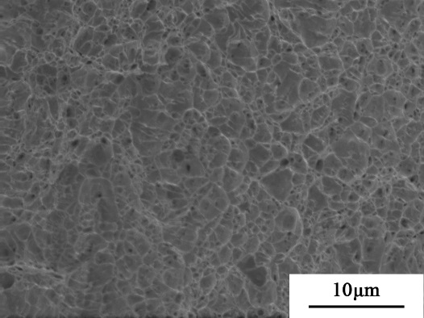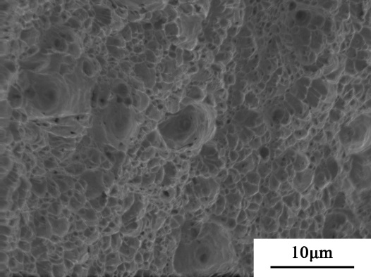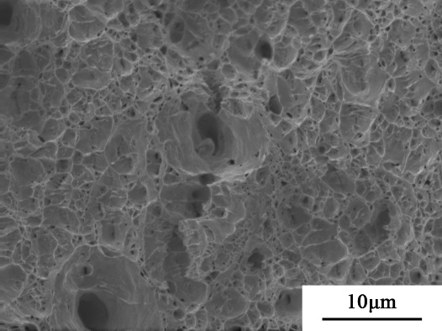
(b)
(c)
(a)
dimples
FIG. S1. SEM of the fracture surfaces of tensiled X70 pipeline steel following three directions: (a) LD, (b) TD, (c) DD.

