Supporting information
Microstructure and electrochemical properties of nanoporous Gold produced by dealloying Au-based thin film nano-glass
Pierre Denis†*, Hans-Jörg Fecht†, Yanpeng Xue‡*, Eirini Maria Paschalidou‡, Paola Rizzi‡, Livio Battezzati‡
†Institute of Micro and Nanomaterials, University of Ulm, Albert-Einstein-Allee 47, 89081 Ulm, Germany
‡Dipartimento di Chimica e Centro Interdipartimentale NIS (Nanostructured Surfaces and Interfaces), Università di Torino, Via Pietro Giuria 7, 10125 Torino, Italy

Cyclic voltammetry (CV) cycles in 0.5 M KOH solution with a scan rate of 20 mV/s for samples A, B and C de-alloyed in 2 M HNO₃ at 70 °C for 1 h.
Considering the elements present in the deposited thin film before de-alloying, the redox reactions potentially occurring over the tested potential range (-0.1 to 0.5 V vs Ag/AgCl) are the following:
- At -0.1 V the Au surface is covered by OH⁻ groups, which are adsorbed on it. Then the Au-OH_{ads} are transformed to a monolayer oxide of the trivalent state of Au around 0.25 V. When reverting the potential the reduction of this state produces a negative current with a peak around 0.1 V vs Ag/AgCl [1–3].
- Cu atoms are oxidized to the Cu^{II} state from the beginning of the scan, and further oxidized to the Cu^{III} state close to 0.5 V [4,5].
- Ag atoms are oxidized to Ag₂O, giving a peak around 0.31 V vs Ag/AgCl, while the reduction of Ag₂O to Ag gives a peak around 0.05 V [6,7].
- OH⁻ chemisorbed species on Pd atoms are transformed into higher valence oxides such as PdO from the beginning of the scan and PdO₂ from 0.3 to 0.5 V, while the reduction of PdO₂ gives a broad reduction peak with a small current contribution from around 0.3 V to -0.1 V [8,9].

The difference in the CV scans reveals that each electrode contains a different amount of less noble elements. These elements are oxidized and reduced giving overlapping current contributions in addition to the redox reactions of Au. This effect is more pronounced for sample A and progressively less for B and C.
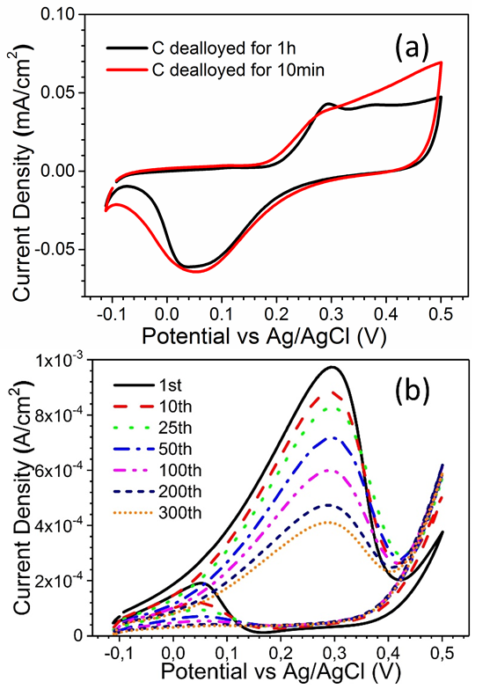
FIG. S1 (a) CV Cycles of samples C de-alloyed in 2 M HNO₃ at 70 °C for 10 min and 1 h in 0.5 M KOH solution with a scan rate of 20 mV/s. (b) Electro-catalytic performance of sample C de-alloyed in 2 M HNO₃ at 70°C for 10 min tested for 300 cycles with a scan rate of 20 mV/s in 0.5 M KOH + 5 M CH₃OH solution.

FIG. S2 SEM images of samples C, de-alloyed for 10 min ((a) and (b)) and 1 h ((c) and (d)) in 2 M HNO3 at 70 °C, before((a) and (c)) and after ((b) and (d)) methanol electro-catalysis experiments. The size and morphology of the ligaments remain constant for the two tested samples.

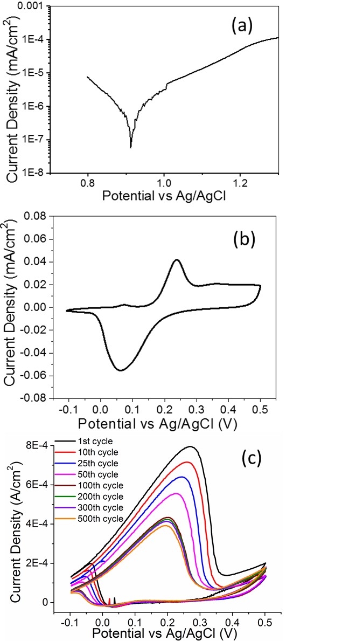

FIG. S3 (a) Potentiodynamic polarization curve of a Au standard obtained with a scan rate of 5 mV/s in a 1 M HNO₃ aqueous solution at 70 °C. (b) Cyclic voltammetry (CV) cycles of a nanoporous Au standard in 0.5 M KOH solution with a scan rate of 20 mV/s. (c) CV cycles of nanoporous Au obtained from a Au-based ribbon dealloyed 8 h in 1 M HNO₃ at 70 °C and at a potential of 1.05 V. The sample contained mostly Au at the end of the dealloying process. The sample was tested for 400 cycles with a scan rate of 20 mV/s in 0.5 M KOH+5 M CH₃OH.

TABLE SI EDX measurements on the as-sputtered thin films. The nominal composition of the thin films is compared with the one of the target. The composition of the thin film varies in an acceptable range, considering the difficulty in determining it precisely in a thin film composed of multiple elements, whose EDX peaks tend to overlap each other.

 | Target | Sample A | Sample B | Sample C
Au | 40 | 42 | 44 | 43.4
Cu | 28 | 29.2 | 26.5 | 25.3
Pd | 5 | 5 | 5.5 | 4.9
Ag | 7 | 6.2 | 6.9 | 6.3
Si | 20 | 17.5 | 17.2 | 20.1

References
[1] J. Zhang, P. Liu, H. Ma, Y. Ding: Nanostructured porous gold for methanol electro-oxidation. J. Phys. Chem. C. 111, 10382 (2007)
[2] Z. Borkowska, A. Tymosiak-Zielinska, G. Shul: Electrooxidation of methanol on polycrystalline and single crystal gold electrodes. Electrochim. Acta. 49, 1209 (2004)
[3] X. Lang, H. Guo, L. Chen, A. Kudo: Novel Nanoporous Au− Pd Alloy with High Catalytic Activity and Excellent Electrochemical Stability. J. Phys. Chem. C. 114, 2600 (2010)
[4] H. Heli, M. Jafarian, M.G. Mahjani, F. Gobal: Electro-oxidation of methanol on copper in alkaline solution. Electrochim. Acta. 49, 4999 (2004)
[5] S.B. Asmea Khouchaf, Driss Takky, Mohammed El Mahi Chbihi: Electrocatalytic Oxidation of Methanol on Glassy Carbon Electrode Modified by Metal Ions (Copper and Nickel) Dispersed into Polyaniline Film. J. Mater. Sci. Chem. Eng. 4, 97 (2016)
[6] S.S. Abd El Rehim, H.H. Hassan, M. a. M. Ibrahim, M. a. Amin: Electrochemical Behaviour of a Silver Electrode in NaOH Solutions. Monatshefte Fuer Chemie/Chemical Mon. 129, 1103 (1998)
[7] Y. Wan, X. Wang, S. Liu, Y. Li, H. Sun, Q. Wang: Effect of electrochemical factors on formation and reduction of silver oxides. Int. J. Electrochem. Sci. 8, 12837 (2013)
[8] M.-C. Jeong: Voltammetric Studies on the Palladium Oxides in Alkaline Media. J. Electrochem. Soc. 140, 1986 (1993)
[9] M. Grdeń, M. Łukaszewski, G. Jerkiewicz, A. Czerwiński, Electrochemical behaviour of palladium electrode: Oxidation, electrodissolution and ionic adsorption. Electrochim. Acta. 53, 7583 (2008)

