Supplementary Materials

Submicro-Sized Si-Ge Solid Solutions with High Capacity and Long Cyclability for Lithium Ion Batteries

Kuber Mishra,^{1,}*,† Xiao-Chen Liu,^{2,†} Mark Geppert,¹ James J. Wu,⁴ Jun-Tao Li,³ Ling Huang,³ Shi-Gang Sun,³ Xiao-Dong Zhou^{3,5,}* and Fu-Sheng Ke,^{2,}*

¹Department of Chemical Engineering, University of South Carolina, Columbia SC 29208, USA
²College of Chemistry and Molecular Science, Wuhan University, Wuhan 430072, China
³State Key Laboratory of Physical Chemistry of Solid Surfaces, Xiamen University, Xiamen, 361005, China.
⁴Electrochemistry Division, NASA Glenn Research Center, Cleveland, OH 44135, USA
⁵ Institute for Materials Research and Innovation, University of Louisiana, Lafayette, La, 70503, USA
† These authors contributed equally to this work

*Corresponding author: Tel.: 803-777-7540. Email addresses: kefs@whu.edu.cn (F.-S. Ke), zhou@louisiana.edu (X.-D. Zhou) , kmishra@email.sc.edu (K.M.)

FIG. S1. Plot of β_{Total vs} 4sinθ/cosθ to calculate the lattice strain for (a) Si_{0.50}Ge_{0.50} and (b) Si_{0.75}Ge_{0.25}. (c) is the relation used to calculate the lattice strain. The slope of the plot β_{Total vs} 4sinθ/cosθ provides the lattice strain (Δd/d).

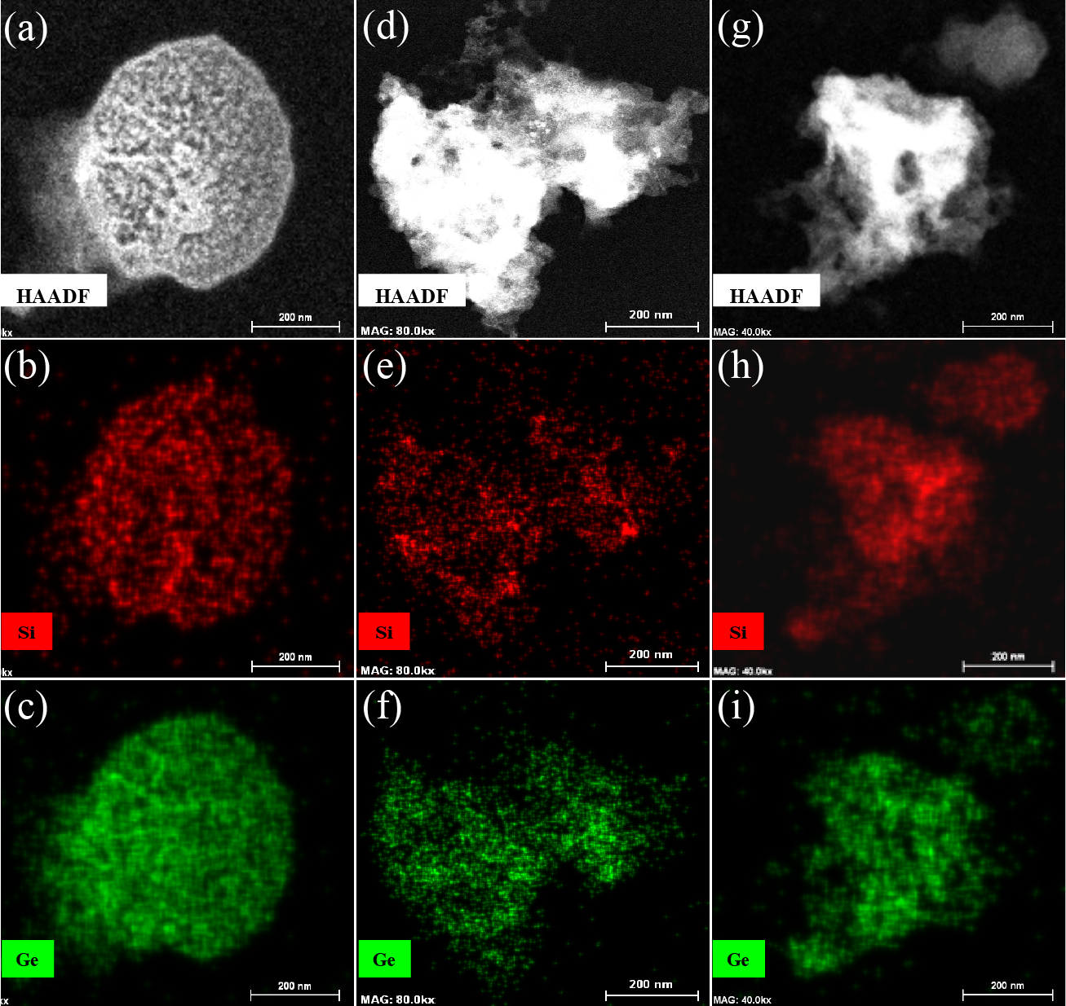

FIG. S2. Post cycling TEM and elemental mapping images of (a,b,c) Si_{0.25}Ge_{0.75}, (d,e,f) Si_{0.5}Ge_{0.5} and (g,h,i) Si_{0.75}Ge_{0.25}.
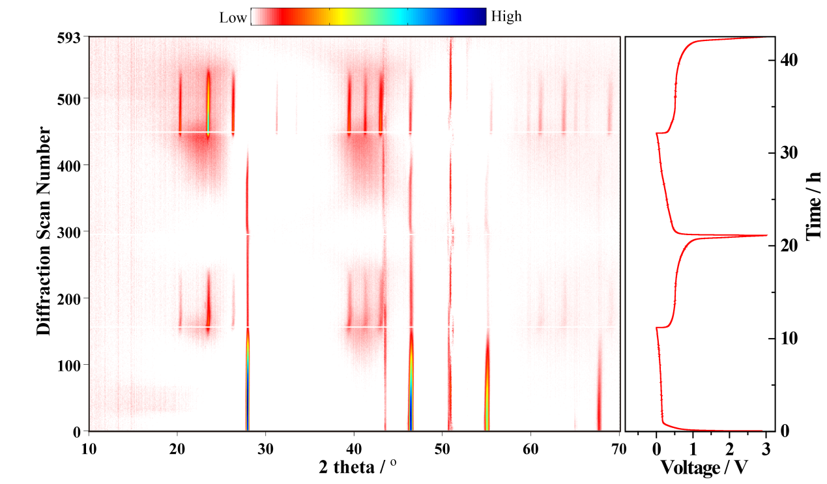
(a)

(b)
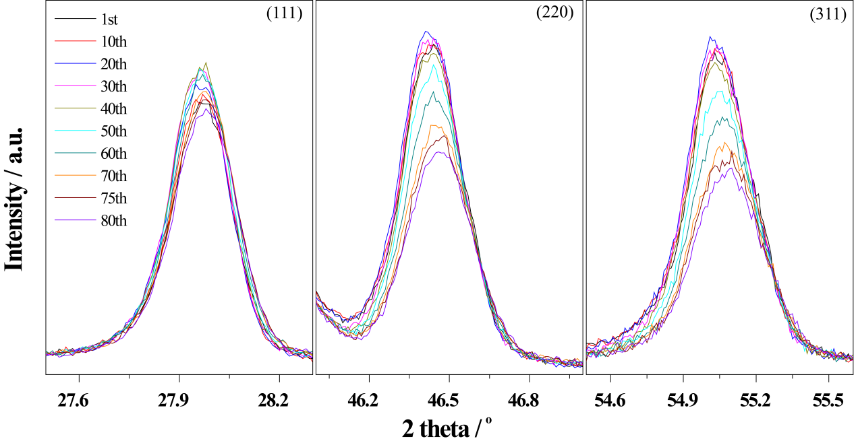
(c)
FIG. S3. (a) First two-cycle discharge-charge curves and the corresponding in situ XRD patterns corrected between 0.01 and 3.0 V at 0.15 A g⁻¹ of the Si_{0.5}Ge_{0.5} solid solution anode. Last diffraction scan as background. (b) Discrete XRD, prior to background subtraction, selected from (a). (c) Selected XRD patterns during the 1st discharge process of the Si_{0.5}Ge_{0.5} solid solution anode, prior to background subtraction.

(a)
(b)
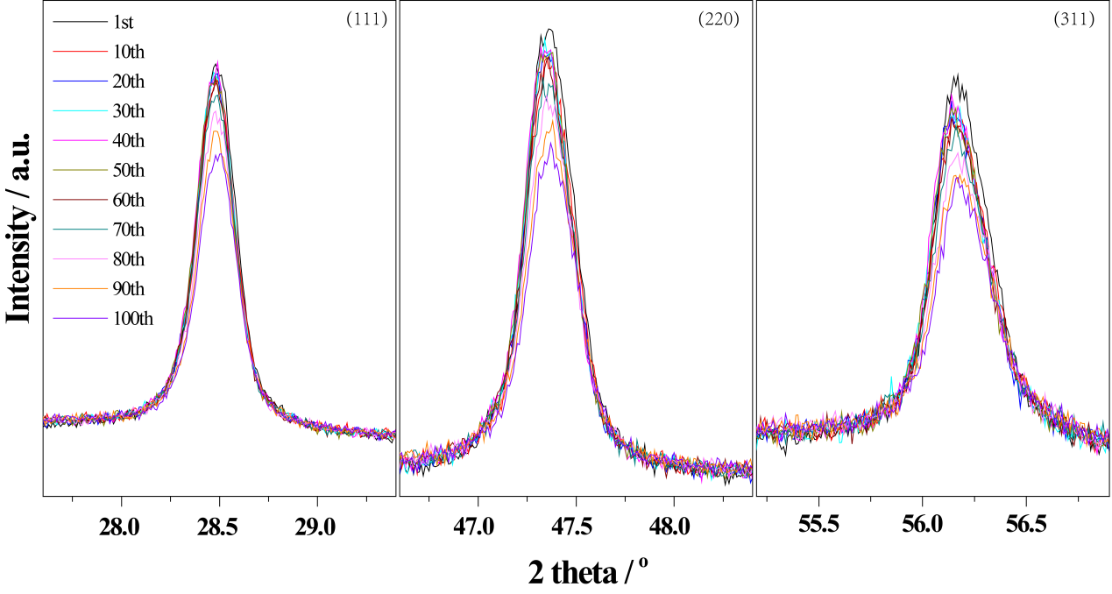
FIG. S4. (a) First cycle discharge-charge curves and the corresponding in situ XRD patterns corrected between 0.01 and 3.0 V at 0.2 A g⁻¹ of the Si anode. Last diffraction scan as background. (b) Selected XRD patterns during the 1st discharge process of the Si anode, prior to background subtraction.

(a)
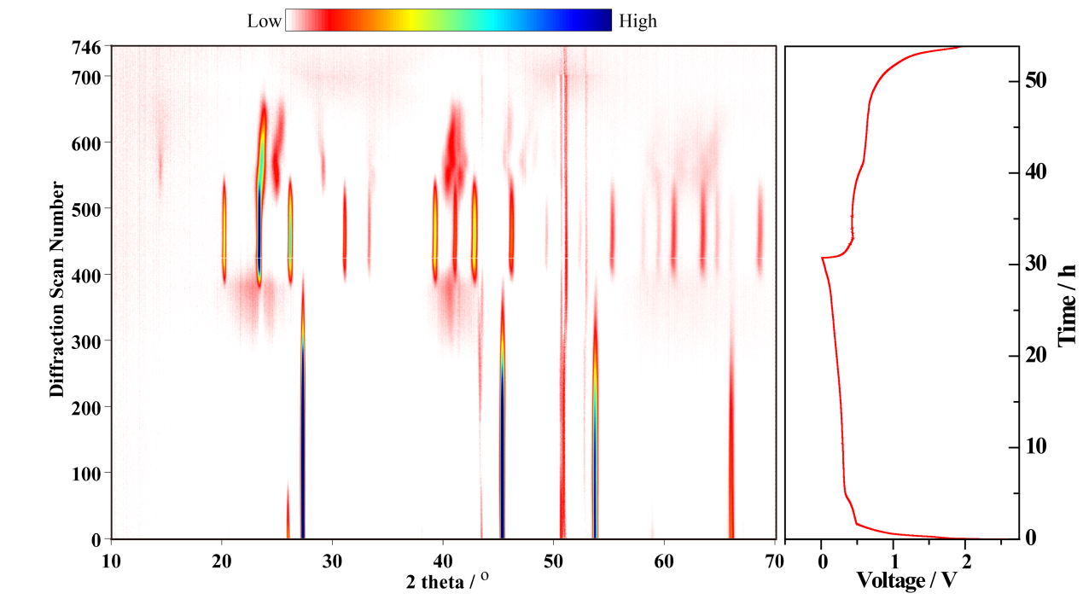
(b)
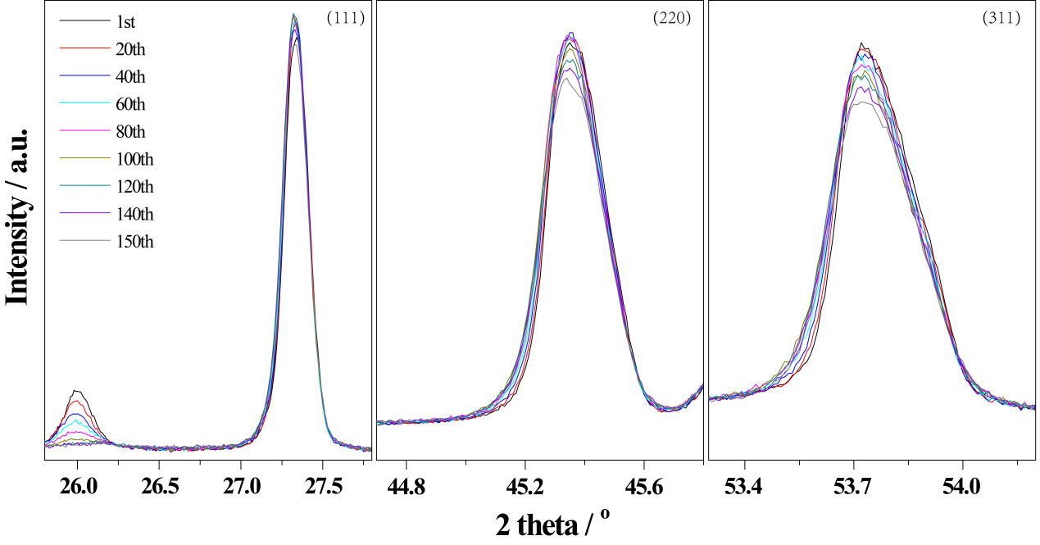
FIG. S5. (a) First cycle discharge-charge curves and the corresponding in situ XRD patterns corrected between 0.01 and 2.0 V at 0.05 A g⁻¹ of the Ge anode. Last diffraction scan as background. (b) Selected XRD patterns during the 1st discharge process of the Ge anode, prior to background subtraction.

