Supporting Information

New insights into polymer solar cells stability: the crucial role of PCBM oxidation
Anthony Perthué, Thérèse Gorisse, Hugo Santos Silva, Christian Lombard, Didier Bégué, Piétrick Hudhomme, Brigitte Pépin-Donat, Agnès Rivaton*, Guillaume Wantz*
*Corresponding authors: agnes.rivaton@uca.fr and guillaume.wantz@ enscpb.fr

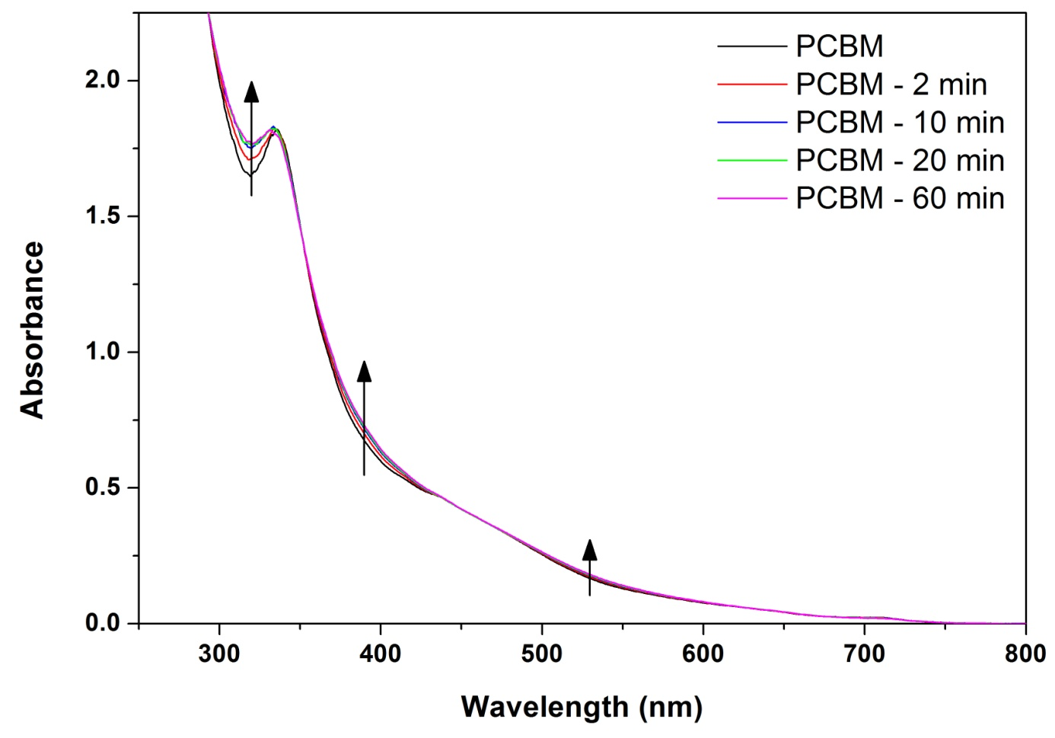
Figure S1: UV-visible spectra of PCBM samples with different irradiation times under ambient conditions

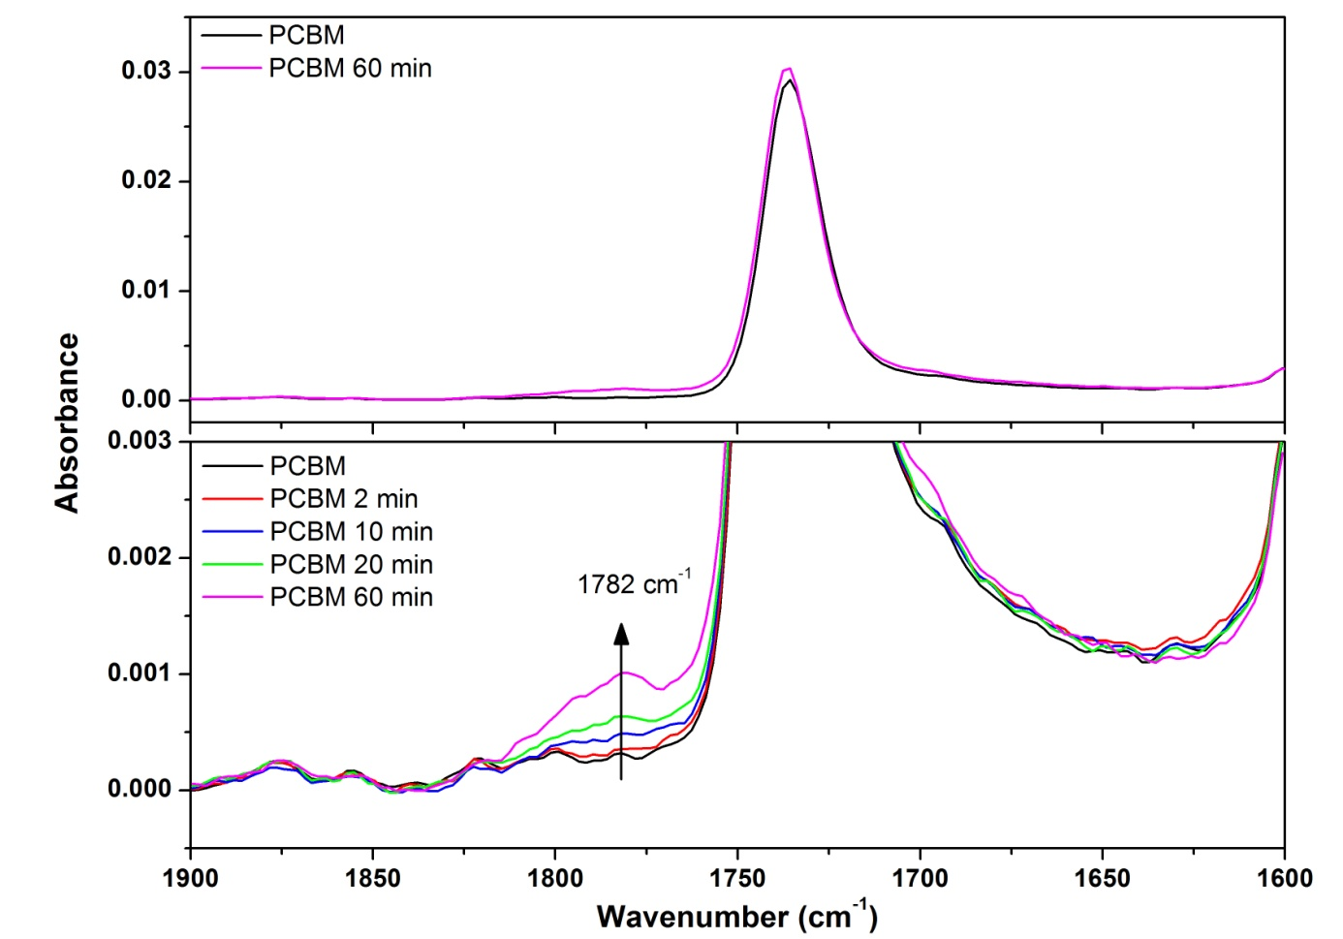
Figure S2: Infrared spectra of the carbonyl area of PCBM before and after 60 min of irradiation (top) and a close-up on the same area for 0, 2, 10, 20 and 60 min of irradiation (bottom)

Figure S3: Evolution of serie resistance of solar cells as a function of the photo-oxidation time of PCBM.

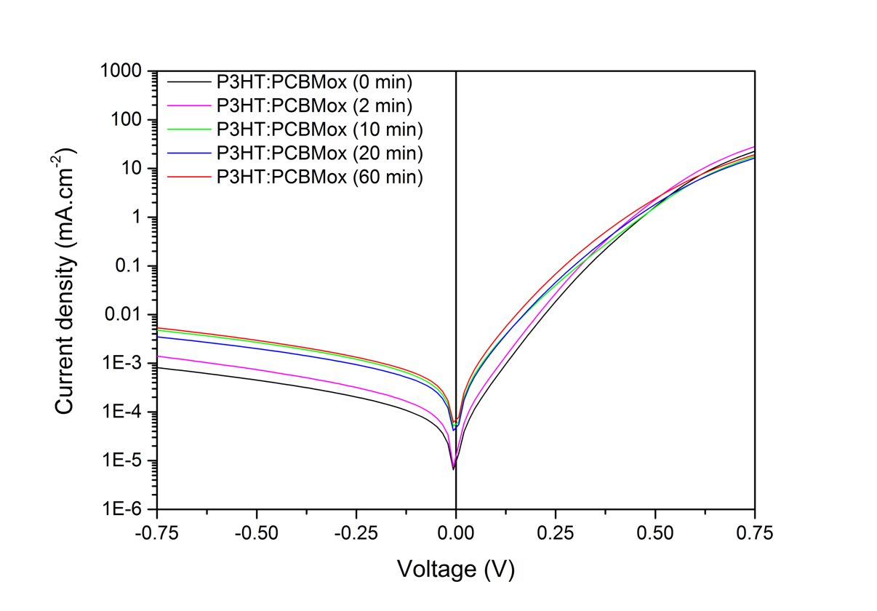
Figure S4: Dark IV curves of solar cells with different level of photooxidation of PCBM

Density Functional Theory (DFT) calculations on the g-factors
For each number of oxygen atoms, several different isomers were studied. These isomers had a common constraint: a single carbon atom could not be bonded to more than one oxygen at a time. In this way, we studied: 10 isomers with 1 oxygen atom, 8 isomers with 2 oxygen atoms, 1 single molecule with 3 oxygen atoms and 4 isomers with 4 oxygen atoms. This allowed us to provide averaged g-factor values over a large range of oxidized PCBM isomers.
The g-factor of the pristine PCBM anion (charged with -1e) is 2.0001879. The chemical shift compared to the free electron (∆g) is then 2131 ppm (g_{e} – g_{PCBM}). Then, g-factor for each fullerene oxide was calculated, and its chemical shift was compared to the free electron. This yields averaged shifts of -1701 (1 oxygen atom), -1200 (2 oxygen atoms), +859 (3 oxygen atoms) and +934 ppm (4 oxygen atoms).
The chemical shift relative to the free electron that is caused by an oxidation reaction is then considered as the chemical shift of pristine PCBM plus the chemical shift of PCBM oxide for any given quantity of oxygen atoms. Knowing the chemical shift that each oxidation step imposes on PCBM, we can take the experimental g-factor of pristine PCBM and correct it to estimate the g-factor of each experimental oxide as a function of the chemical shifts found in our calculations. In this way, we provided a correction to the experimental g-factor in order to correlate it to the theoretically calculated value of a PCBM oxide. The calculations of the g-factors performed in this work are extremely heavy from a computational perspective. This is mainly due to the choice to work in a high-precision, high level of theory capable of providing accurate and reliable results for such a sensitive electronic property. For illustration, all of the calculations herein performed took ~ 100 000 computing hours.

Electron Paramagnetic Resonance spectroscopy
In the L-EPR experiment, the bulk heterojunction was irradiated in situ by light with a photon energy higher than the π-π*energy gap of P3HT, forming polarons (P^{+•}) (on the donor polymer chain) and PCBM^{-•} anion radicals, which were detected and characterized by EPR: an irradiated P3HT/PCBM active layer was subjected to an external magnetic field (H) that varies linearly over time during recording. For a free radical species with a single unpaired electron, the interaction with H, called the electronic Zeeman interaction, the results in the generation of two separate energy levels that are otherwise (i.e with no magnetic field) degenerate. Absorption of electromagnetic radiation of a fixed frequency ν is observed when the applied magnetic field creates a separation between the two Zeeman levels that exactly matches the hν quantum energy. This resonance phenomenon has the relationship hν = g ßeH₀, where g is the Landé factor, h is Planck’s constant, ße the Bohr magneton and H₀ the magnitude of the magnetic field H at the resonance. The Landé g-factor is specific to the investigated free radical species and is determined from the independent measurements of ν and H₀. The g-value of a free electron is g_{e} = 2.002319. Deviations from the free electron g-value in a non-orbitally degenerate molecule are mostly caused by a complicated interplay of differences between orbital energies, the unpaired electron spin density on each nucleus of the spin-carrying molecule, and the spin-orbit coupling constant of that nucleus. In other words, the Landé g-factor is sensitive to the chemical structure on which the unpaired electron is trapped; for example, oxygen-centered organic free radical tends to have higher g-values than carbon centered ones. For organic molecules containing mostly light atoms, such as polymers or fullerenes, the principal g-values are typically very close to the value of a free electron (g ≈ g_{e}).
The PCBM anion radical exhibits a rhombic tensor (all three principal values (g_{x}, g_{y}, g_{z}) are different). These principal values and their linewidths were determined precisely by a high-frequency EPR study and computer simulation (W-band, 95 GHz, and D band (130 GHz)), which allows complete separation of the signals from the polymer cation and the fullerene PC₆₁BM anion: gx = 2.0003, gy = 2.0001, and gz = 1.9982.

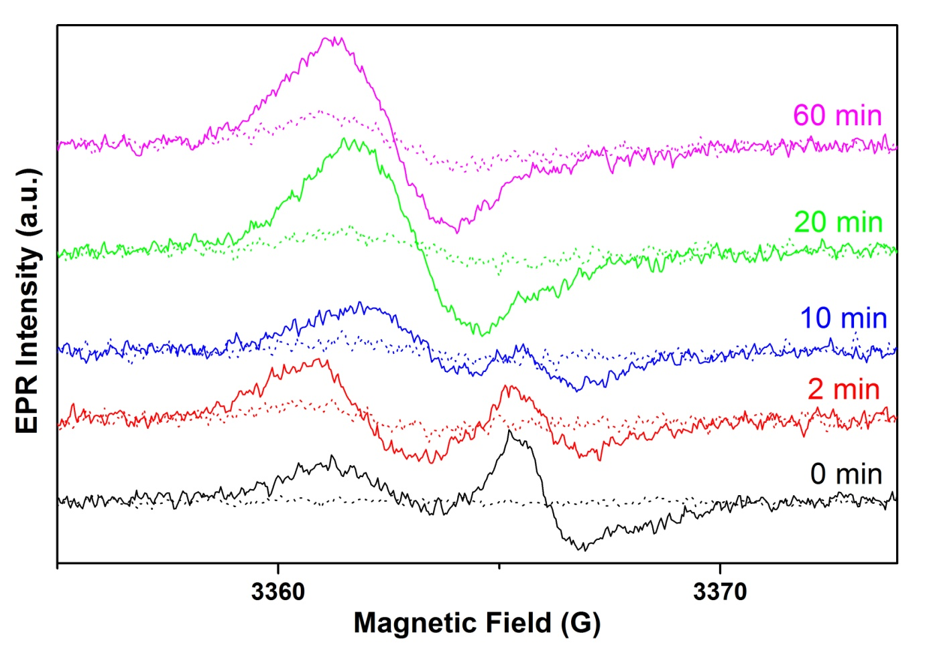
Figure S3: EPR spectra (dotted lines) and L-EPR spectra (continuous line) of P3HT:PCBMox (0, 2, 10, 20 and 60 min) blends obtained at 20K

PV performances of blends with PCBMox:
Table S1: Summary of the photovoltaic parameters of the BHJ OPV devices.
PC₆₁BM photo-oxidation time (min) | Voc (mV) | Jsc  (mA.cm⁻²) | FF | PCE | Rs  (ohm) | Rshunt  (kohm)
0 | 490 ± 5 | 8.9 ± 0.20 | 59 % ± 0.0 | 2.60 % ± 0.06 | 55.6 ± 10.3 | 7094 ±2360
2 | 452 ± 8 | 7.2 ± 0.31 | 55 % ± 0.0 | 1.80 % ± 0.10 | 38.1 ± 1.8 | 4289 ± 1052
10 | 401 ± 18 | 5.6 ± 0.39 | 53 % ± 1.0 | 1.19 % ± 0.14 | 50.8 ± 6.6 | 1194 ± 1467
20 | 363 ± 9 | 3.8 ± 0.10 | 49 % ± 0.3 | 0.68 % ± 0.02 | 57.8 ± 2.8 | 1427 ± 770
60 | 345 ± 14 | 3.2 ± 0.04 | 49 % ± 0.2 | 0.55 % ± 0.04 | 53.2 ± 3.7 | 1361 ± 563

AFM images and RMS roughness:

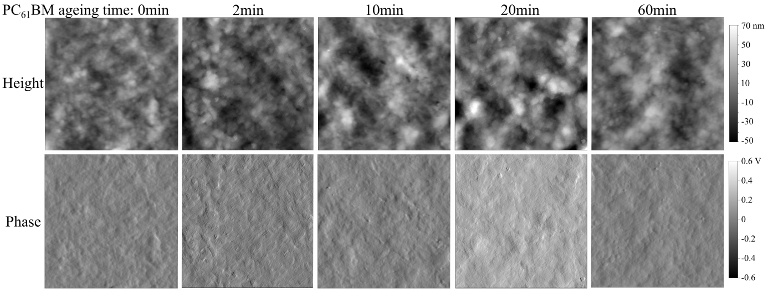
Figure S4: Height and phase of AFM images of the active layer containing PC₆₁BM photo-oxidized for different durations. Images are 5x5 µm².

Table S2: Root mean square (RMS) roughness extracted from the AFM images of Figure S1.

PCBM ageing time | 0 min | 2 min | 10 min | 20 min | 60 min
RMS roughness: | 12.05 nm | 14.21 nm | 17.45 nm | 19.6 nm | 13.82 nm

L-EPR analysis of a complete cell
Figure S5: L-EPR spectra of the P3HT-PCBM blend and of a piece of a full cell, recorded at 20 K under visible light (473 or 660 nm)

[] F. Neese (2009), Density Functional Theory and EPR Spectroscopy: a guided tour. EPR Newsletter, 18(4), Pro & Contra section.
[] N. S. Sariciftci, L. Smilowitz, A. J. Heeger, F. Wudl, Science, 1992, 258, 1474
[] J. Niklas, O. G. Poluektov, Adv. Energy Mater., 2017, 7, 10, 1602226

