SUPPORTING INFORMATION

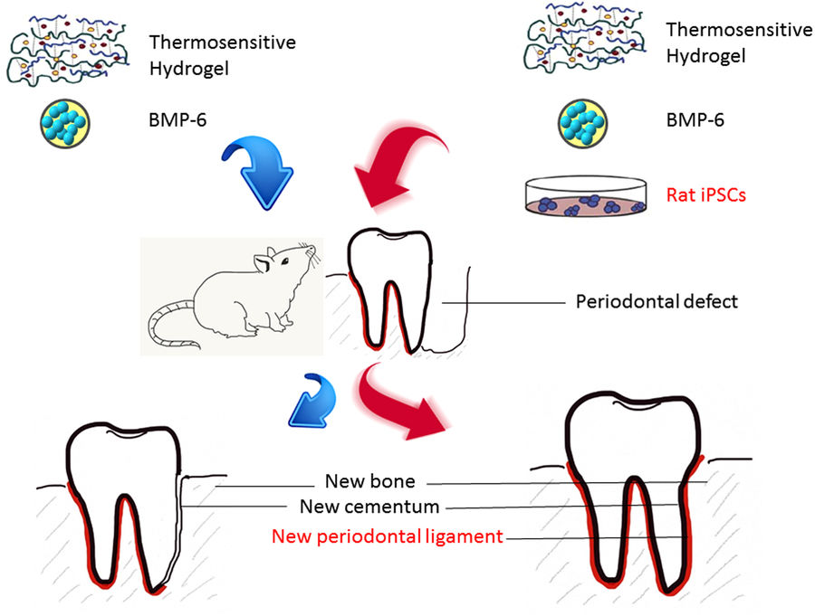

FIG. S1: Schematic of the study design. A combination of iPSCs, BMP-6 (10 ng/ml) and hydrogel was designed to be injected into periodontal defects of rats to regenerate layers of cementum (bone and connective tissues) and periodontal ligaments. Reproduced with permission from reference [105] Copyright Nature Publishing Group.

