Supporting Information

Low-temperature synthesis of high-purity boron carbide via an aromatic polymer precursor
Shujuan Wanga, Yuefeng Lia, Xiaolong Xinga, Xinli Jinga,*

aDepartment of Applied Chemistry, School of Science, Xi’an Jiaotong University, Xi'an, Shaanxi 710049, China.
bMOE Key Laboratory for Nonequilibrium Synthesis and Modulation of Condensed Matter, Xi'an, Shaanxi 710049, China.

Characterization

Nitrogen adsorption/desorption isotherms were measured at 77 K using an ASAP 2020 Micromeritics Instrument. The BET surface areas of samples were calculated from the adsorption data using the Brunauer-Emmett-Teller (BET) method. The pore size distributions were derived from the adsorption branches of the isotherms using BJH (Barrett-Joyner-Halenda) method.

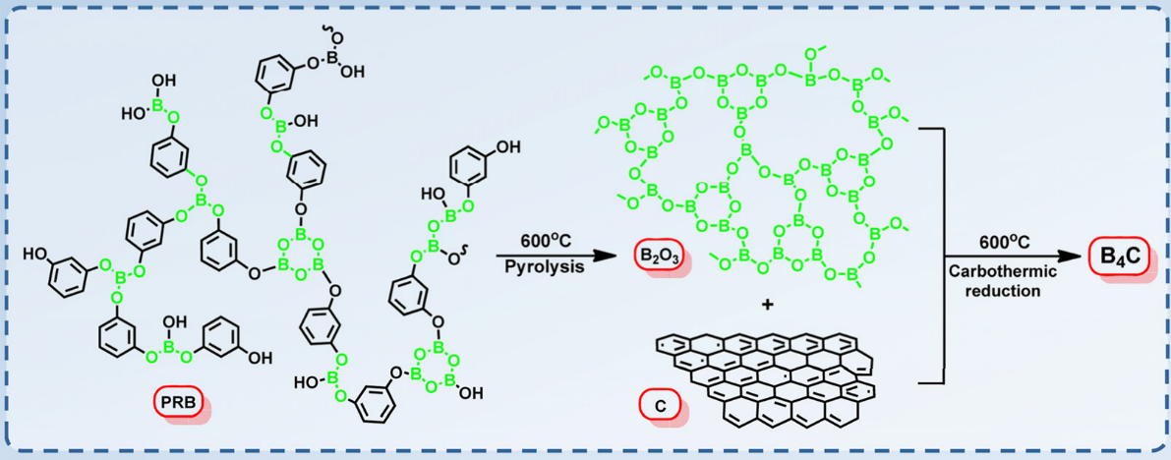

SCHEME S1. The possible synthesis process of the B4C.

TABLE SI. The percentage areas of the deconvoluted signals obtained from the XPS spectra of

PRB.
 |  |  | Functional
Polymer | Component | Binding energy (eV) |  | % of total area
 |  |  | groups
 |  | 284.68 | C–C | 62.37
 | C | 286.28 | C–O | 19.82
PRB |  | 288.33 | O–C=O | 17.81
 |  | 194.7 | B–OH | 12.23
 | B | 192.3 | B–O–B | 19.36
 |  | 190.9 | B–O | 68.41

TABLE SII. Thermal characteristics of PRB from TGA results.

a b c o d
Weight loss (%)

T5%
T10%
Tmax
R800 C

Polymer

(oC)

(oC)

(oC)

(%)
First stage (200-450 oC)
Second stage (450-700 oC)
Third stage (700-800 oC)

PRB 226 311 440 69.0 5.24 10.75 1.77

a Thermal decomposition temperature at 5% weight loss.

b Thermal decomposition temperature at 10% weight loss.

c The temperature of the maximum degradation rate.

d Residue weight at 800 oC.

TABLE SIII. The percentage areas of the deconvoluted signals obtained from the XPS spectra

of the carbonized products of PRB.

Polymer Component Binding energy (eV) Functional groups % of total area

283.51 C–B 12.54

C
600 oC/2 h
284.48 C–C 68.69
285.28 C–H 9.51
286.50 C–O 9.25

192.18 B–O–B 7.70
B 190.48 B–O 81.95
189.58 B–C 10.35
283.58 C–B 12.01

C
600 oC/4 h

284.58 C–C 55.08

285.78 C–H 29.24

288.38 O–C=O 3.67

192.20 B–O–B 26.76
B 190.68 B–O 60.69
189.63 B–C 12.56
283.55 C–B 22.83

C
600 oC/6 h
284.48 C–C 46.97
285.28 C–H 23.51
286.38 C–O 6.68

192.22 B–O–B 17.39
B 190.63 B–O 58.74
189.55 B–C 23.87

600 oC/8 h C
283.43 C–B 32.74
284.48 C–C 46.62

 |  | 285.78 | C–H | 15.38
 |  | 287.28 | C=O | 5.26
 |  | 192.18 | B–O–B | 13.87
 | B | 190.56 | B–O | 52.63
 |  | 189.51 | B–C | 33.50
 |  | 283.40 | C–B | 39.87
 |  | 284.51 | C–C | 44.90
 | C
 |  | 285.38 | C–H | 8.57
600 oC/10 h |  | 287.18 | C=O | 6.66
 |  | 192.24 | B–O–B | 11.68
 |  | 190.63 | B–O | 43.27
 | B
 |  | 189.54 | B–C | 41.69
 |  | 187.78 | B–C | 3.35

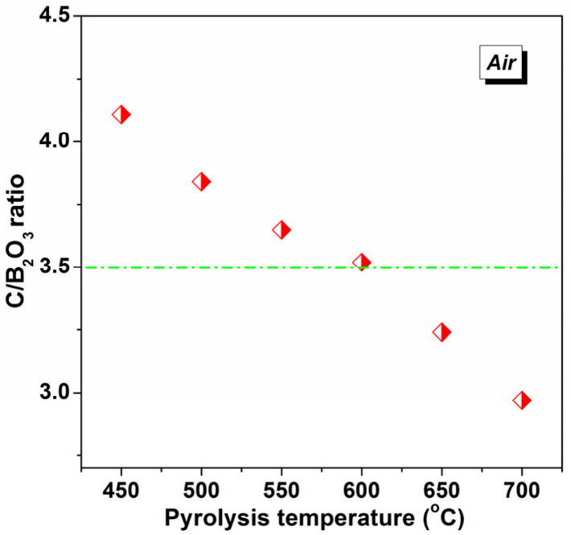

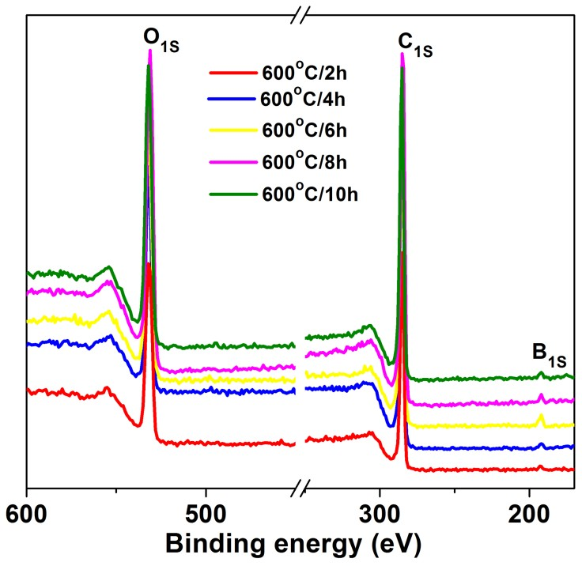
FIG. S1. Changes in the C/B2O3 molar ratios of the precursor powders prepared after pyrolysis at temperatures of 450-700 oC for 2 h in a muffle furnace under an air atmosphere.

FIG. S2. The full scanned XPS spectra of the pyrolysis products of PRB obtained by heat treatment at 600 °C for different durations in air after washing.

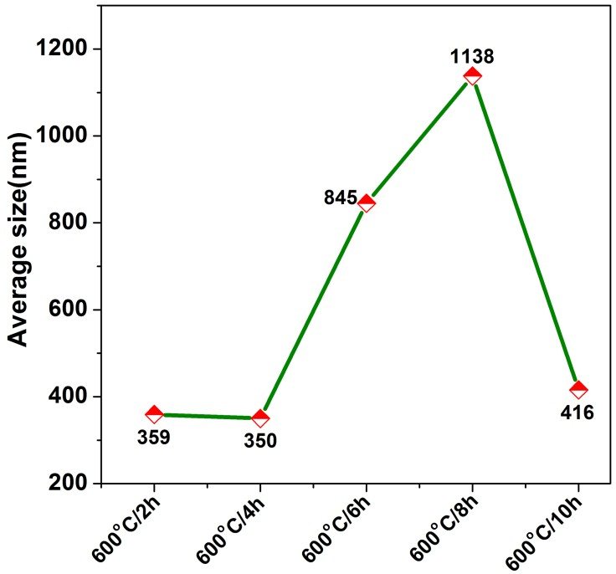

FIG. S3. The particle size of the pyrolysis products of PRB obtained by heat treatment at 600 °C for different durations in air after washing.

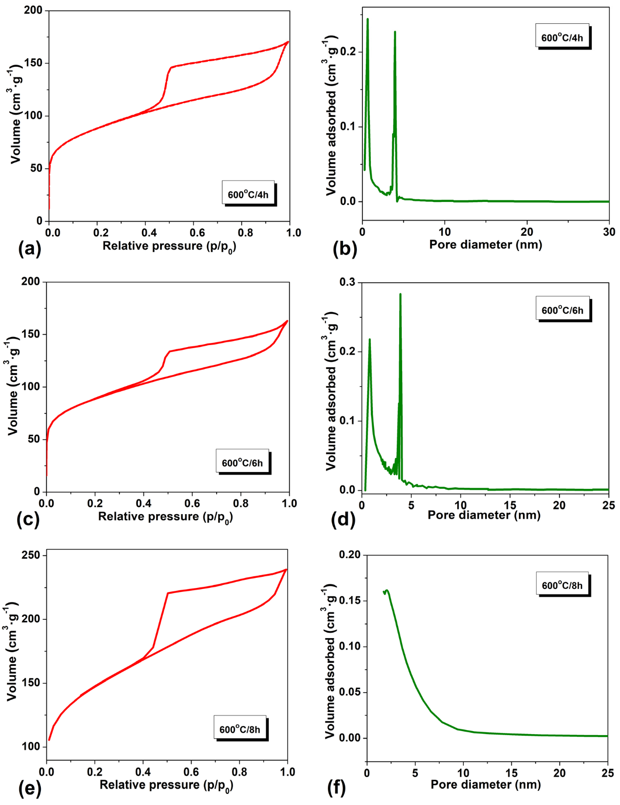

FIG. S4. The N2 adsorption-desorption isotherm curves (a, c, e) and pore size distribution (b, d, f) plots of the pyrolysis products of PRB obtained by heat treatment at 600 °C for different durations in air after washing.

