Supporting Information

Photocrosslinking of Low Band-gap Conjugated Polymers Using Alkyl Chloride Sidechains: Towards High-efficiency, Thermally-stable Polymer Solar Cells

Chi Zhang and Steven Holdcroft*

Department of Chemistry, Simon Fraser University, 8888 University Drive, Burnaby, BC, V5A 1S6, Canada



FIG. S1. NMR spectra of PTB-Cls at room temperature highlighting the region of 2.7–5.3 ppm.



FIG. S2. NMR spectra of PTB-Cls at 120 °C highlighting the region of 2.7–5.3 ppm.



FIG. S3. Heteronuclear single quantum coherence spectroscopy (HSQC) of PTB-Cl100 at room temperature.

|  |  |
| --- | --- |
| **(a)** |  |
| **(b)** |  |

FIG. S4. The chemical structure (a) and dynamic NMR spectra (b) of TTBDTTT-Cl highlighting the region of 2.7–5.3 ppm.

|  |  |  |  |  |  |
| --- | --- | --- | --- | --- | --- |
| (a) |  | (b) |  | (c) |  |

FIG. S5. Visual appearances of the peeled-off PTB-Cl12.5 films in CB with (a) 10 min, (b) 20 min, and (c) 30 min of UV exposure.

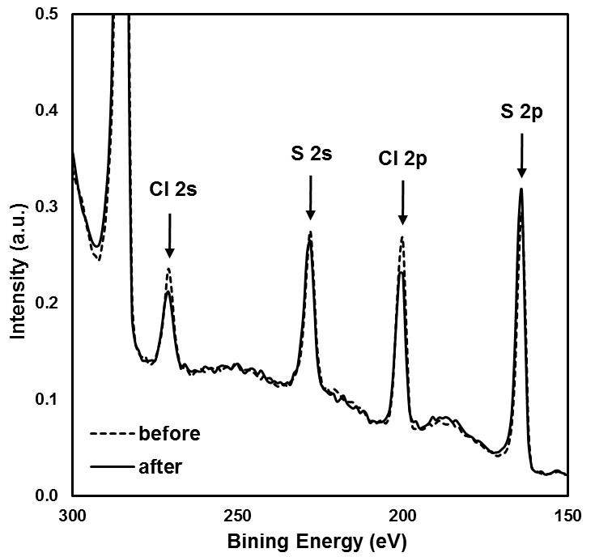

FIG. S6. XPS spectra of PTB-Cl100 before and after UV irradiation.

|  |  |  |  |
| --- | --- | --- | --- |
| **(a)** |  | **(b)** |  |
| **(c)** |  | **(d)** |  |

FIG. S7. Jsc as a function of thermal treatment time at 120 °C of PTB-Cl100/PC71BM (a), PTB-Cl50/PC71BM (b), PTB-Cl25/PC71BM (c), and PTB-Cl12.5/PC71BM (d) devices with various amounts of UV exposure, compared to PTB7/PC71BM device.

|  |  |  |  |
| --- | --- | --- | --- |
| **(a)** |  | **(b)** |  |
| **(c)** |  | **(d)** |  |

FIG. S8. Voc as a function of thermal treatment time at 120 °C of PTB-Cl100/PC71BM (a), PTB-Cl50/PC71BM (b), PTB-Cl25/PC71BM (c), and PTB-Cl12.5/PC71BM (d) devices with various amounts of UV exposure, compared to PTB7/PC71BM device.

|  |  |  |  |
| --- | --- | --- | --- |
| **(a)** |  | **(b)** |  |
| **(c)** |  | **(d)** |  |

FIG. S9. FF as a function of thermal treatment time at 120 °C of PTB-Cl100/PC71BM (a), PTB-Cl50/PC71BM (b), PTB-Cl25/PC71BM (c), and PTB-Cl12.5/PC71BM (d) devices with various amounts of UV exposure, compared to PTB7/PC71BM device.

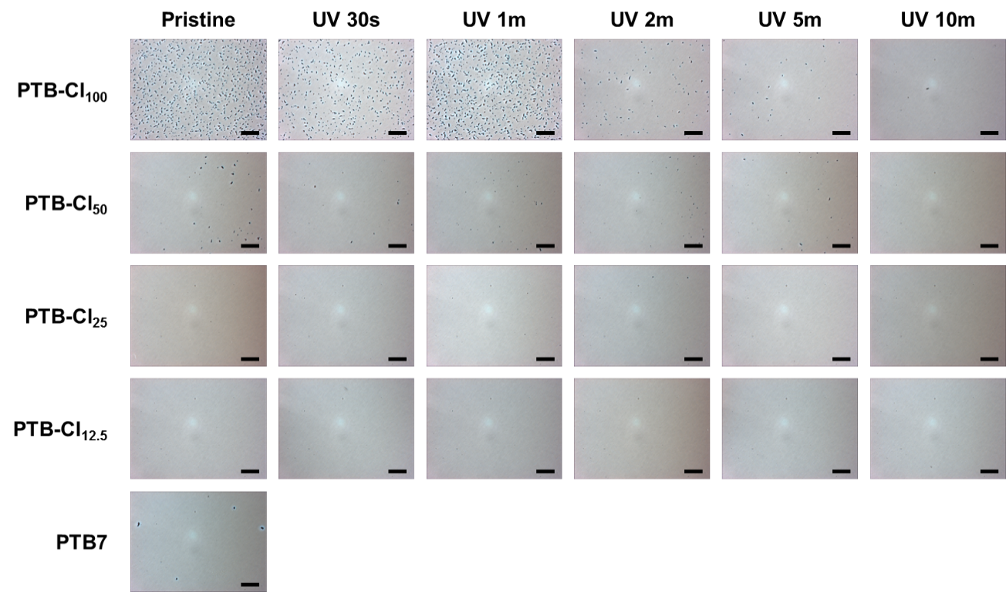

FIG. S10. Optical microscopic images of the active layers of pristine and UV irradiated PTB-Cl devices and the PTB7 device after 10 h at 150 °C. Scale bar: 20 m.

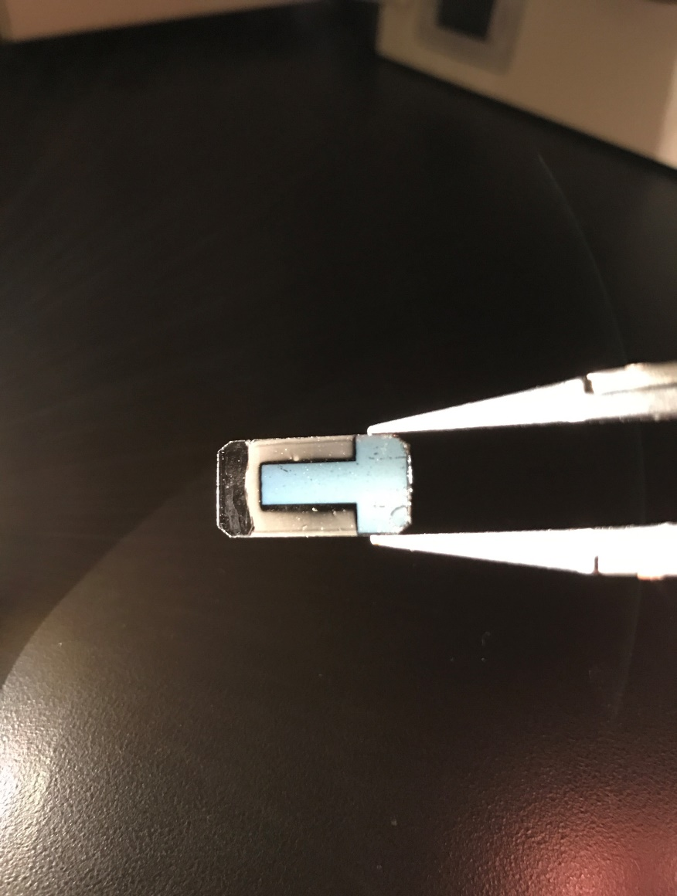

FIG. S11. Visual appearance of a pristine PTB-Cl100/PC71BM device after 20 h at 150 °C. The haze on the active layer is caused by a high density of PCBM crystallites; the clear part surrounding the top electrode is free of PCBM crystallite.