Supplementary Information
TABLE SI. Extinction coefficients of MDMO-PPV monomer units.
The extinction coefficient ε was calculated from the UV-Vis absorbance maximum, E, and the layer thickness, d, of the polymer, which was measured by a scratch test with AFM, according to the formula: $ε=E∙d^{-1}∙ρ^{-1}∙M$, where ρ and M stand for the density of the film and for the molecular mass of a monomer unit of the polymer, respectively. The average extinction coefficient is $1600 m^{2}∙{mol}^{-1}$, inserting ρ= 1.0 ${g∙cm}^{-3}$ and M = 288.42 ${g∙mol}^{-1}$.

Sample | 1 | 2 | 3 | 4 | 5 | 6
Absorbance (500 nm) | 1.925 | 1.249 | 1.730 | 1.558 | 1.741 | 1.923
MDMO-PPV film thickness (nm) | 358 | 216 | 298 | 294 | 315 | 346
Extinction coefficient $({mol}^{-1}∙m^{2})$ | 1552 | 1667 | 1676 | 1529 | 1595 | 1604

TABLE SII. Sample parameters of PMMA layers on top of P3HT films.
Sample | 1 | 2 | 3 | 4 | 5 | 6
Absorbance (510 nm) | 1.170 | 1.183 | 1.215 | 1.176 | 1.279 | 1.175
P3HT film thickness (nm) | 223 | 225 | 231 | 224 | 244 | 224
Total film thickness (PMMA + P3HT) (nm) | 288 | 285 | 291 | 268 | 284 | 244
PMMA film thickness (nm) | 65 | 60 | 60 | 44 | 40 | 20
Roughness of PMMA film (nm) | 2.4 | 2.1 | 1.9 | 1.5 | 1.4 | 1.1
TABLE SIII. Critical volumes (V_{c}) and critical temperatures (T_{c}) of CO₂, O_{3,} and O₂
 | $${V_{c}}/{{10}^{-6}∙m^{3}∙{mol}^{-1}}$$ | T_{c} / K
CO₂ | 94 | 304
O₃ | 89 | 261
O₂ | 74 | 155
https://encyclopedia.airliquide.com/ozone, accessed on 14.02.2018

FIG. S1. Logarithmic presentations of the decay kinetics of the absorption of P3HT films at 510 nm under ozone of different concentrations at a flow rate of 100 mL/min.
FIG. S2. Logarithmic presentations of the decay kinetics of the absorption of MDMO-PPV films at 495 nm under ozone of different concentrations in synthetic air at a flow rate of 100 mL/min.

FIG. S3. SEM of thin PMMA layer on top of P3HT. The P3HT film thickness is 225 nm and the PMMA film thickness is 20 nm. The PMMA layer near the edge of the scratch test was detached from the P3HT film.
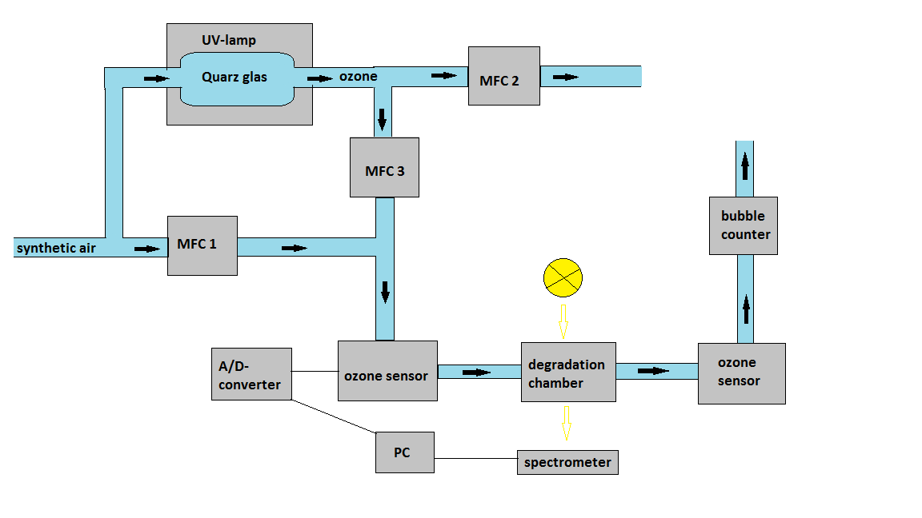
FIG. S4. Gas flow setup used for the ozonation experiments described in this manuscript. The ozone generator consists of a UV lamp which irradiates a quartz tube. MFC 1 to 3 are the mass flow controller, which mix the ozone concentration.

FIG. S5. FTIR absorption spectra of PMMA on CaF₂ substrate in 15 ppm ozone atmosphere, resulting in the time traces of Fig. 6. a) C-H-stretch region, b) carbonyl stretch region, c) C-C- stretch region.

FIG S6. Average attenuation coefficient of MDMO-PPV (middle black line) with two times of the standard deviation (transparent area).

