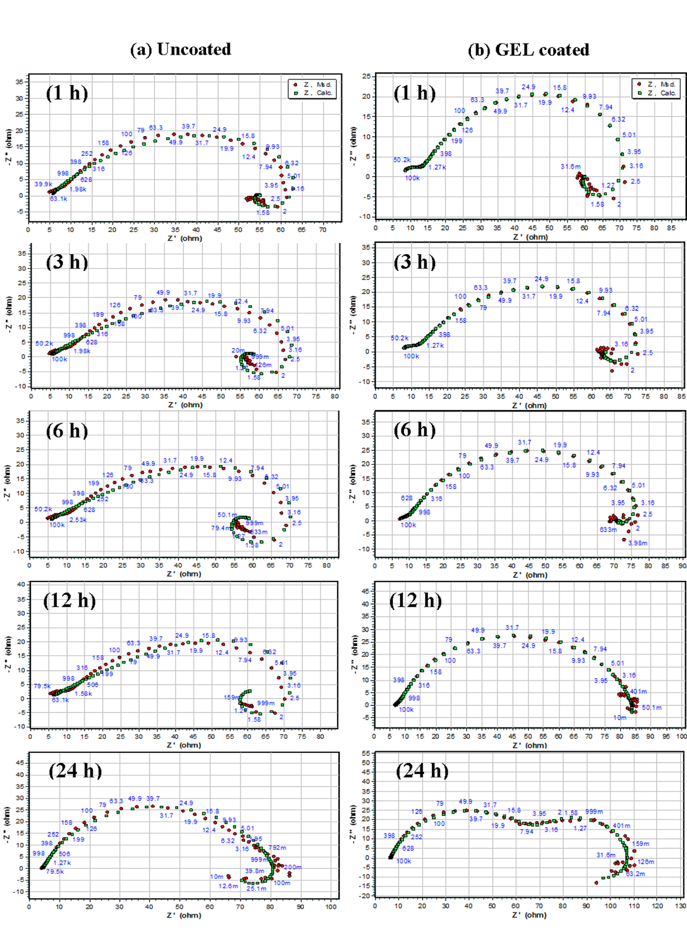
Fig. S1 Equivalent circuit fitted EIS curves as a function of immersion time (1, 3, 6, 12 and 24h) for (a) Uncoated and (b) GEL-coated AZ91 Mg alloys in SBF solution (pH of 7.4±0.2) at 37±0.5 ºC.

