Supplementary material to accompany:
New mechanochemical effects in the poly(N-vinylcaprolactam) –
nano-titanium oxides (IV) system
Olesya Timaeva*¹, Irina Chihacheva¹, Galina Kuzmicheva¹, Natalia Ivanovskaya², Andrey Dorohov¹
¹ Moscow Technological University, Institute of Fine Chemical Technologies, 86 Vernadskogo prospect, Moscow 119571, Russia
² FSRC «Crystallography and Photonics» RAS, 59 Leninsky prospect, Moscow 119333, Russsia
* Corresponding Author E-mail address: timaeva@mirea.ru
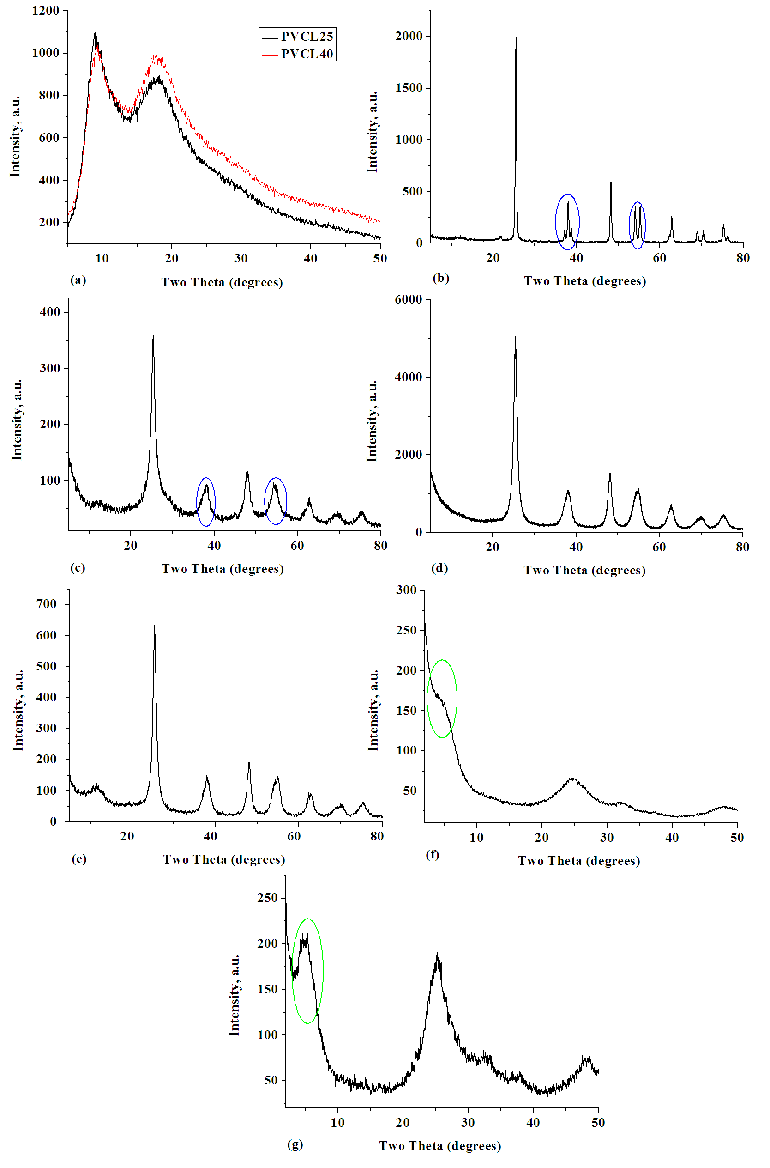
FIG. S1. XRD patterns of the starting samples with PVCL and TNP: (a) PVCL25 and PVCL40, (b) reference anatase (JCPDS 89-4921), (c) A, (d) HF, (e) HK, (f) EP1, (g) EP2.
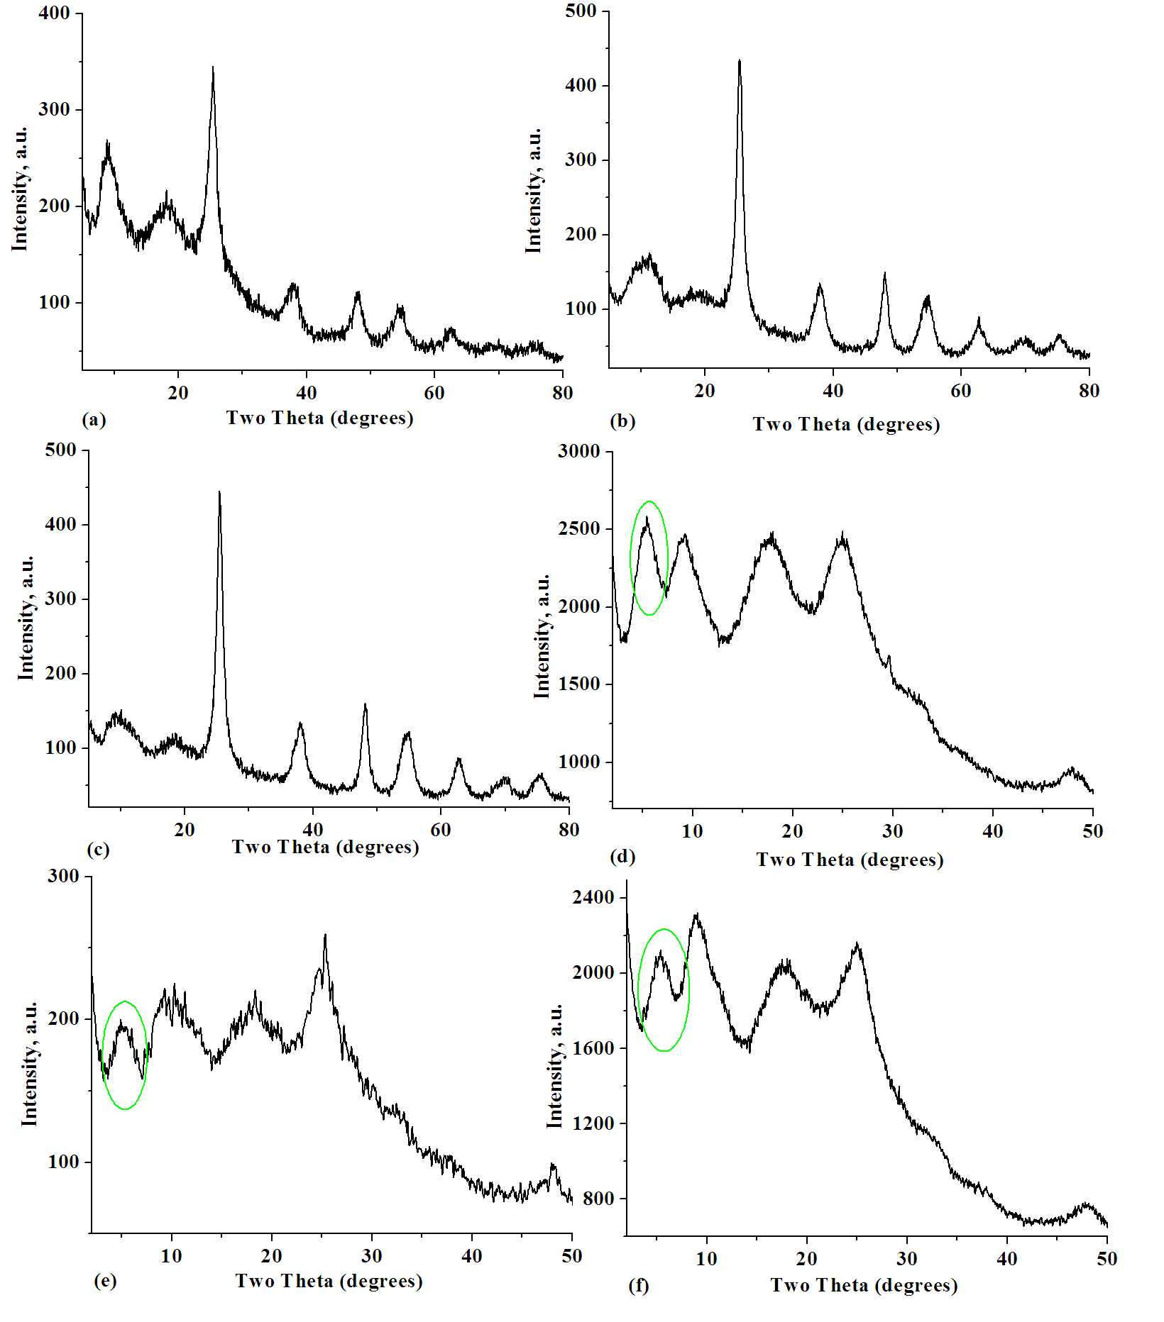
FIG. S2. XRD patterns of nanocomposites (method 1): (a) PVCL25/A, (b) PVCL25/HK, (c) PVCL40/HK, (d) PVCL25/EP1, (e) PVCL25/EP2, (f) PVCL40/EP2.

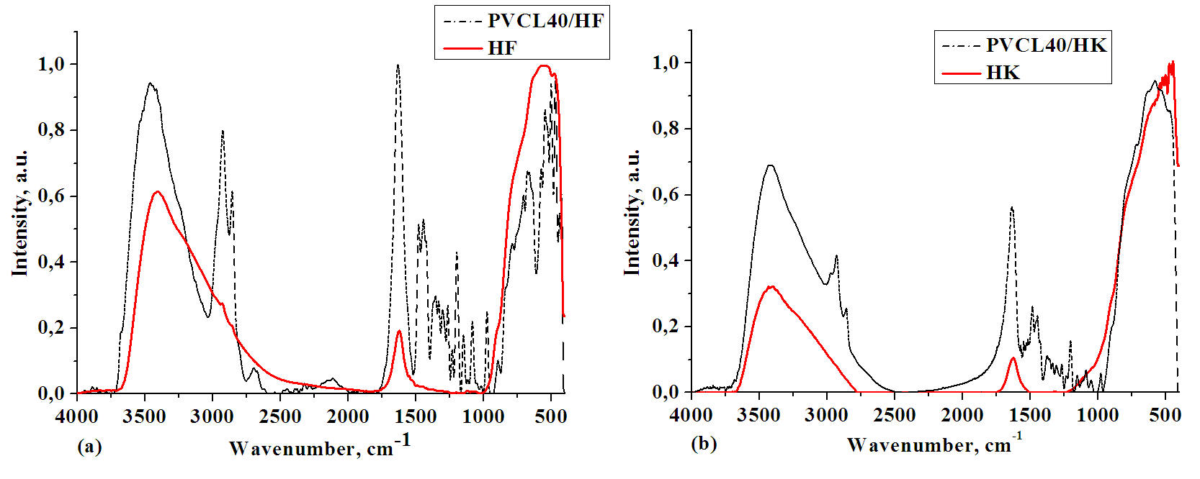
FIG. S3. IR spectra of the starting samples and the nanocomposites (a) HF and PVCL40/HF and (b) HK and PVCL40/HK.
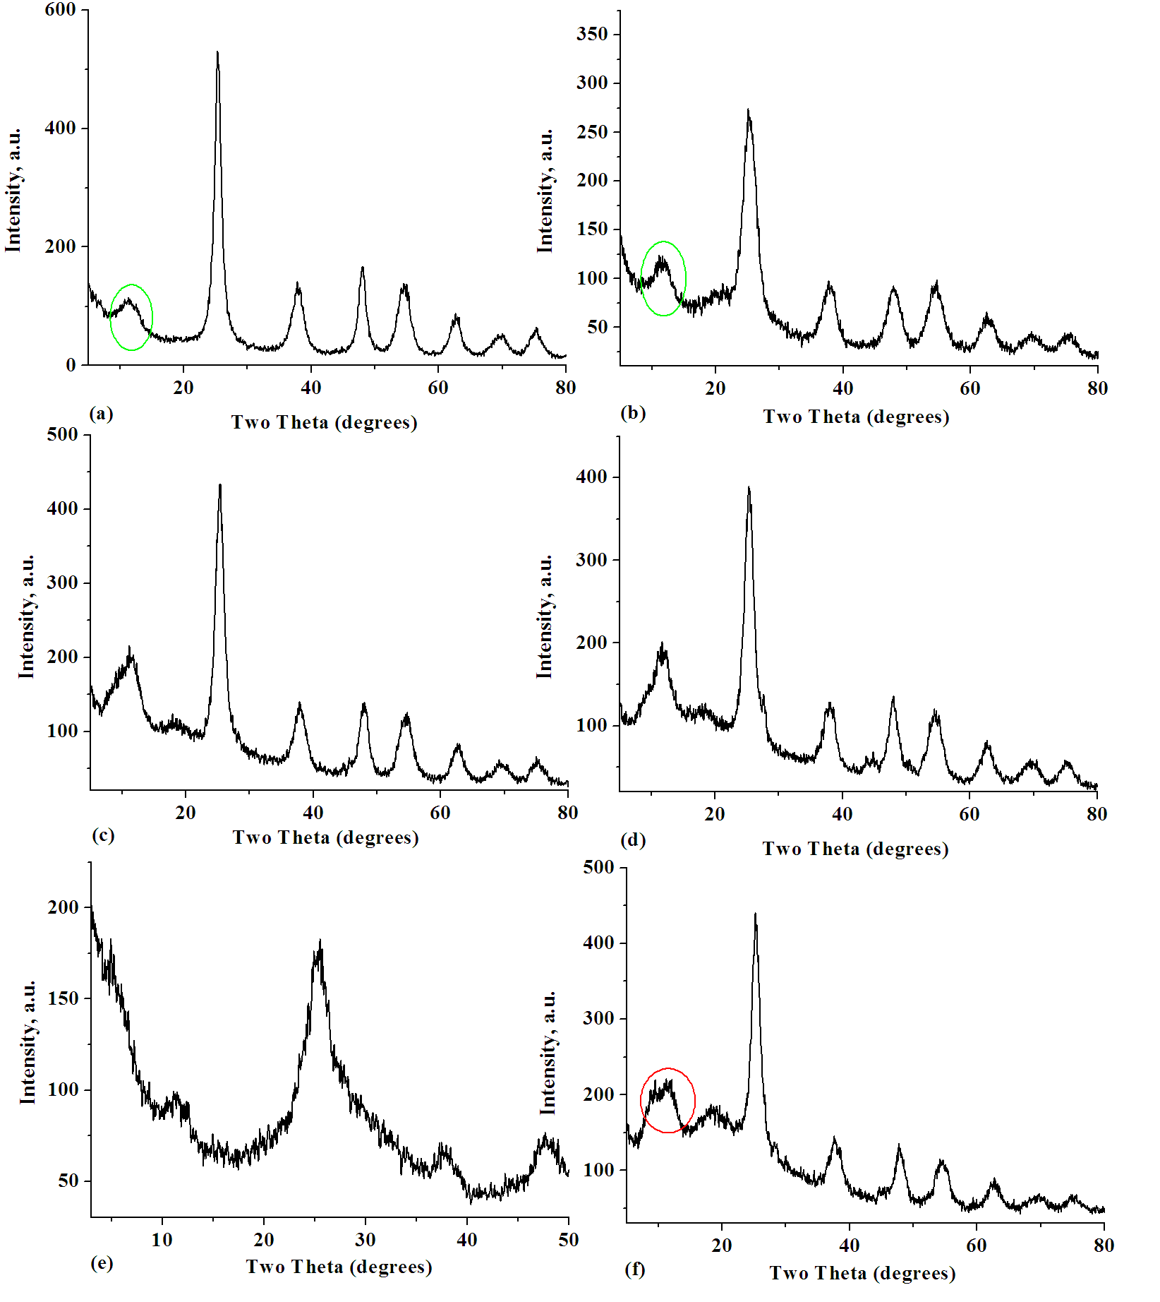
FIG. S4. XRD patterns (method 2) of (a) HF (200 rpm, 15 min, Ar), (b) А (400 rpm, 25 min, air),
(c) PVCL25/HF (1 : 1) (400 rpm, 20 min, Ar), (d) PVCL40/HF (1 : 1) (400 rpm, 20 min, Ar),
(e) EP2 (400 rpm, 25 min, air), (f) PVCL25/HF (2 : 1) (400 rpm, 20 min, Ar).

