Effects of peroxo precursors and annealing temperature on properties and photocatalytic activity of nanoscale titania
E. V. Savinkinaª*, L. N. Obolenskayaª, G. M. Kuzmichevaª, I. D. Morozovª,
R. G. Chumakov^{b}
ª Moscow Technological University, Vernadskogo 86, Moscow, Russia
^{b} National Research Centre «Kurchatov Institute», Akademika Kurchatova pl. 1, Moscow, Russia
* e-mail address: e.savinkina@mail.ru

Supplementary material

X-ray diffraction patterns
Fig. s1. XRD patterns of titanyl sulphate treated with H₂O₂ and annealed at various temperatures: TSP250 (1), TSP600 (2), TSP800 (3) and TSP900 (4).

Fig. s2. XRD patterns of titanyl sulphate stored at room temperature for 48 h and annealed at 850 °C after treatment with H₂O₂ (TSP(48h)850) (1), (NH₄)₂S₂O₈ (TSAPS(48h)850) (2), and (NH₂)₂CO.H₂O₂ (TSUP(48h)850) (3).

IR spectra
Fig. s3. IR spectra of titanyl sulphate treated with H₂O₂ and annealed at 550 °C (TSP550) (1) and 700 °C (TSP700) (2).

Fig. s4. IR spectra of titanyl sulphate treated with (NH₂)₂CO.H₂O₂ (TSUP25) (1) and annealed at 185 °C (TSUP185) (2), 515 °C (TSUP515) (3), and 850 °C TSUP850 (4).

Elemental analysis
Anal. Calcd for (NH₂)₂CO.H₂O₂ (%): C 12.77; H 6.38; N 29.79. Found (%): C 13.02; H 6.51; N 30.15. Anal. Calcd for 1.9TiO₂ + (NH₂)₂CO.H₂O₂ (TSUP185) (%): C 4.88; H 2.44; N 11.38. Found (%): C 4.90; H 3.15; N 13.70. Anal. Calcd for TiO₂ (TSUP515) (%): C 0; H 0; N 0. Found (%): C 0; H 0.32; N 0.94.

X-ray microanalysis
Sample TSUP100
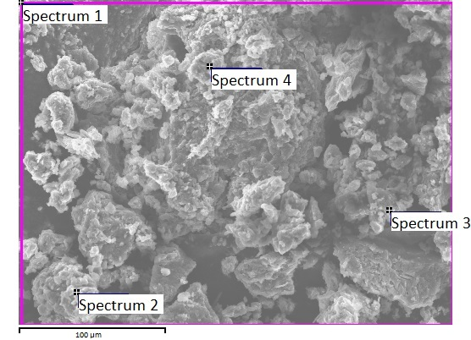
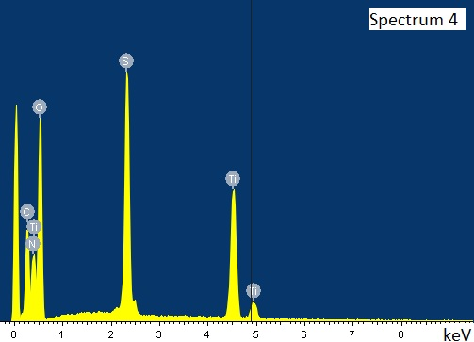
Atomic %
Spectrum | C | N | O | S | Ti
1 | 9.83 | 15.86 | 65.40 | 5.02 | 3.89
2 | 10.19 | 11.55 | 60.04 | 9.88 | 8.33
3 | 23.80 | 8.73 | 44.90 | 11.41 | 11.15
4 | 26.30 | 17.27 | 48.22 | 4.54 | 3.67
Average | 17.53 | 13.35 | 54.64 | 7.71 | 6.76
Standard deviation | 8.74 | 3.92 | 9.68 | 3.45 | 3.63
Max | 26.30 | 17.27 | 65.40 | 11.41 | 11.15
Min | 9.83 | 8.73 | 44.90 | 4.54 | 3.67

Sample TSUP160
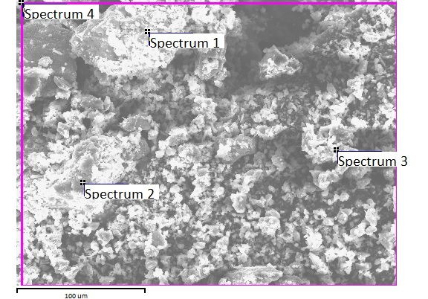
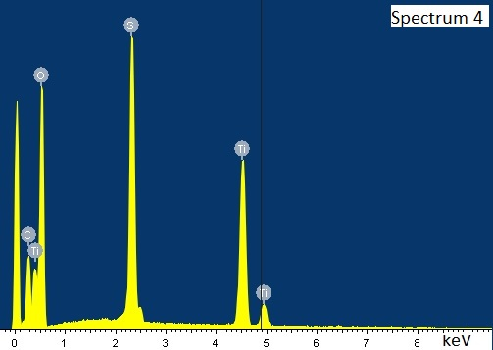
Atomic %
Spectrum | C | O | S | Ti
1 | 8.78 | 74.71 | 9.34 | 7.17
2 | 7.61 | 72.43 | 10.93 | 9.03
3 | 7.61 | 45.45 | 22.25 | 24.69
4 | 27.74 | 60.14 | 6.51 | 5.61
Average | 12.93 | 63.18 | 12.26 | 11.62
Standard deviation | 9.89 | 13.44 | 6.91 | 8.82
Max | 27.74 | 74.71 | 22.25 | 24.69
Min | 7.61 | 45.45 | 6.51 | 5.61

Sample TSUP185
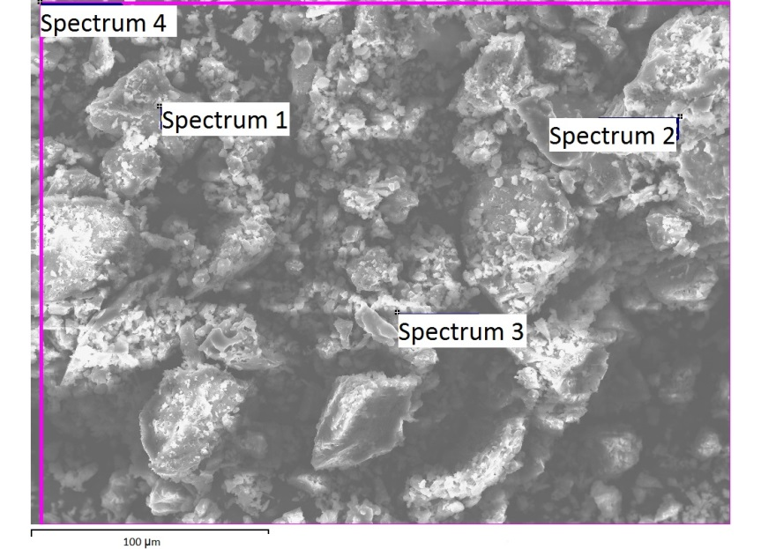
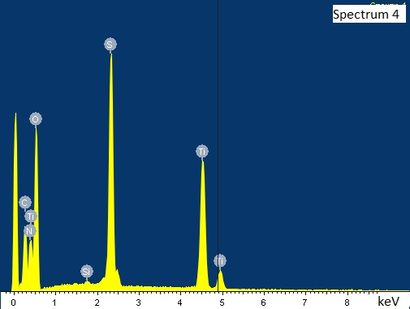
Atomic %
Spectrum | C | N | O | Si | S | Ti
1 | 7.54 | 12.26 | 62.26 |  | 9.96 | 7.98
2 | 9.17 | 15.40 | 59.19 |  | 9.12 | 7.12
3 | 9.64 | 13.25 | 47.27 | 0.16 | 15.00 | 14.68
4 | 25.62 | 15.23 | 49.00 | 0.07 | 5.48 | 4.60
Max | 25.62 | 15.40 | 62.26 | 0.16 | 15.00 | 14.68
Min | 7.54 | 12.26 | 47.27 | 0.07 | 5.48 | 4.60

Sample TSUP515
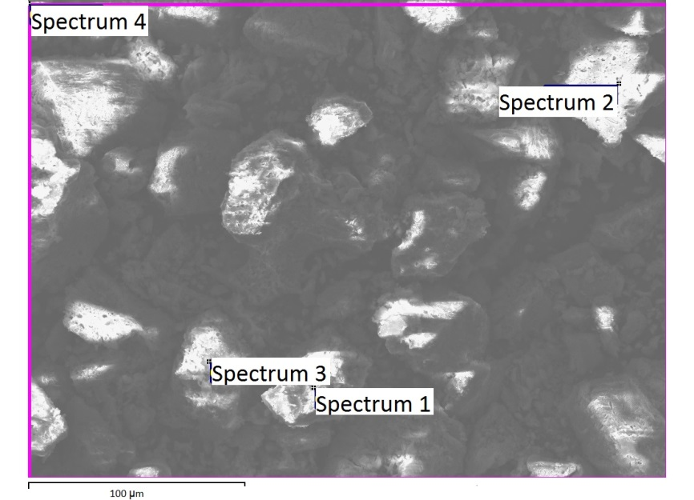
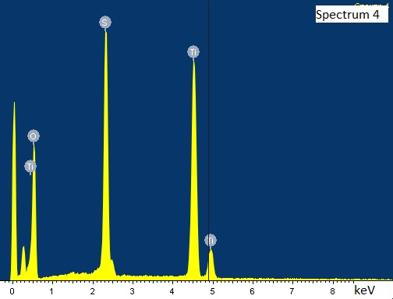
Atomic %
Spectrum | O | Al | S | Ti
1 | 76.39 | 0.20 | 11.60 | 11.81
2 | 29.03 |  | 29.29 | 41.68
3 | 79.94 |  | 9.20 | 10.86
4 | 74.89 |  | 10.90 | 14.21
Max | 79.94 | 0.20 | 29.29 | 41.68
Min | 29.03 | 0.20 | 9.20 | 10.86

Details of preparing samples for elemental analysis and X-ray microanalysis
Sample | 1st reagent | 2nd reagent | Annealing temperature, °C | Annealing time, min
TSUP100 | TiOSO₄∙2H₂O  (2.55 g, 13.5 mmol) | (NH₂)₂CO∙H₂O₂  (1.5 g, 16.5 mmol) | 100 | 60
TSUP160 | TiOSO₄∙2H₂O  (2.55 g, 13.5 mmol) | (NH₂)₂CO∙H₂O₂  (1.5 g, 16.5 mmol) | 160 | 90
TSUP185 | TiOSO₄∙2H₂O  (1.7 g, 9 mmol) | (NH₂)₂CO∙H₂O₂  (1 g, 11 mmol) | 185 | 120
TSUP515 | TiOSO₄∙2H₂O  (1.7 g, 9 mmol) | (NH₂)₂CO∙H₂O₂  (1 g, 11 mmol) | 515 | 330

X-ray photoelectron spectroscopy
Oxygen peaks
Sample | Peak (O₂) area | Peak (O) area | Total area | Peak (O₂) fraction | Peak (O) fraction
TSP700 | 27393,3 | 55490,4 | 82883,7 | 0,3305 | 0,6695
TSPSA700 | 18364,8 | 48837,4 | 67202,2 | 0,27328 | 0,72672
TSUP700 | 31685,4 | 58221,7 | 89907,1 | 0,35242 | 0,64758

