Supplemental Materials for
Assessing texture development and mechanical response
in microscale reverse extrusion of copper

Bin Zhang¹, Yooseob Song², G.Z. Voyiadjis², W.J. Meng¹
¹Mechanical & Industrial Engineering Department, Louisiana State University, Baton Rouge, LA70803
²Civil and Environmental Engineering Department, Louisiana State University, Baton Rouge, LA70803

S1. Microscale reverse extrusion
To execute the reverse extrusion experiments, Cu cylinders were placed into a nominally 3.0 mm cylindrical hole within a die made of D2 tool steel. Cylindrical rod punches made of 52100 tool steel, with diameters ranging from 2.20 mm to 2.95 mm, were fitted into a segmented punch assembly (Fig. S1(a)), which was then placed into a snugly fitting guide hole of an upper 4142 alloy steel plate. This upper plate was aligned with the lower die to ensure that the punch is nominally centered with respect to the 3.0 mm hole within the die (Fig. S1(b)). During the reverse extrusion operation, a hydraulically driven actuator compressed the punch assembly and drove the punch into the Cu cylinder placed within the die hole. The speed of punch displacement was set at 0.01 mm/s. Figure S1(c) shows a cross-sectional schematic of the axisymmetric reverse extrusion process, which produced axisymmetric, cup-shaped Cu parts of varying wall thicknesses. The nominal wall thickness of the extruded part varied with the punch diameter D, decreasing from 400 µm to 25 µm as D increases from 2.20 mm to 2.95 mm.
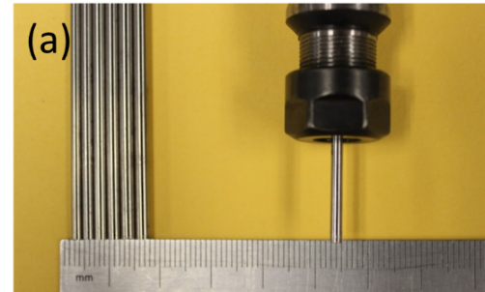
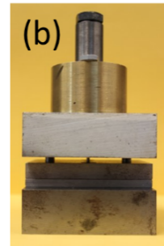
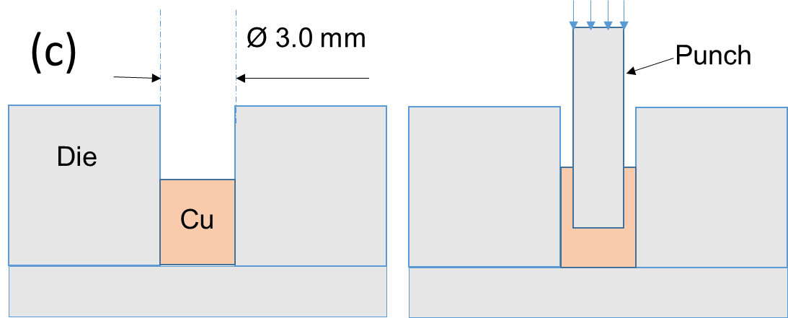

Fig. S1. The axisymmetric reverse extrusion setup: (a) the segmented punch assembly with several cylindrical punches shown on the side, (b) the entire die-and-punch set, (c) a schematic cross sectional drawing of the reverse extrusion process. The sidewall thickness of the extruded part decreases with increasing punch diameter D.

S2. Compression testing of cylindrical Cu specimens
Uniaxial compression testing was conducted on annealed Cu 110 cylinder specimens. Cu cylinder specimens, 3.0 mm in diameter and 4.0 mm in height, were placed between a pair of 52100 tool steel rod platens. The bottom rod platen was fixed into a snugly fitting blind hole on a bottom 4142 alloy steel plate. The top rod platen was put through a snugly fitting, through guiding hole on a top 4142 alloy steel plate. The bottom and top plates were aligned to ensure that compression of the Cu cylinder specimens by the top and bottom rod platens occurred along the cylinder axial direction. The total compression force was measured through a MTS load cell with a full range of 25 kN. In one set of measurements, the displacement was measured through an MTS 632.26F-20 extensometer, with a natural gauge length of 8mm and an extension range of +/- 1.2 mm. Because of the small length of the Cu cylinders, the extensometer was attached to the sides of the bottom and top rod platens as shown in Fig. S2(a). A simple estimate showed that, in the measurement load range, elastic displacements of the sections of the bottom and top rod platens included in between the extensometer gauge can be neglected, and displacements measured by the extensometer were equated to the specimen displacement. In another set of measurements, the extensometer was not used and the specimen displacement was taken as that measured from the LVDT attached to the actuator. Results of the two sets of measurements, expressed in terms of true stress – true strain (σ - ε) curves, are displayed in Fig. S2(b). As shown in Fig. S2(b), good agreement exists between multiple measurements in one data set, and between measurements across the two data sets, with and without extensometer use. Measurements to a larger strain range was achieved without use of the extensometer.
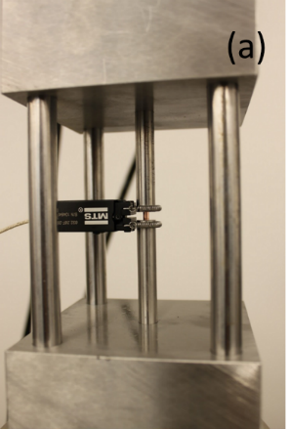
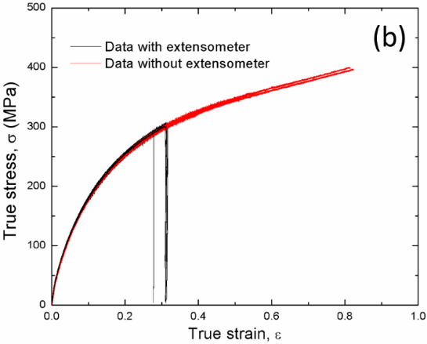

Fig. S2. Measuring stress-strain behavior of annealed Cu cylinders in uniaxial compression: (a) the measurement setup; (b) typical uniaxial true stress – true strain curves obtained with and without the use of the extensometer.
S3. Electron beam scattering diffraction (EBSD) measurements
Polished as-annealed and as-extruded specimens were mounted on a commercial 70° tilt stage for EBSD measurements. Figure S3(a) shows a schematic of the EBSD measurement geometry, together with the default instrument definition of the coordinate system, including the specimen normal direction (ND), rolling direction (RD), and transverse direction (TD). By default, ND is perpendicular to the polished surface being mapped; RD is contained within the plane defined by ND and the electron beam direction, and perpendicular to ND. For an extruded cup structures, as illustrated in Fig. S3(a), polished specimens were mechanically aligned such that extruded cup sidewalls were parallel to RD. For all EBSD runs, over 85% of the data had confidence index (CI) lager than 0.1. As shown in Fig. S3(b), processing of all EBSD data obtained from extruded cup structures began with a coordinate rotation along RD of 90°, such that ND of the rotated coordinate system is perpendicular to the cup sidewall and pointing to the outside of the cup. This coordinate rotation is in accordance with the physics of reverse extrusion, with the new ND aligned with the direction in which Cu is being significantly compressed, and in analogy with conventional macroscale sheet metal rolling.
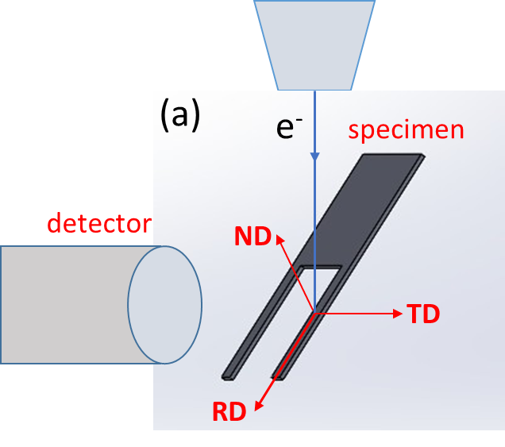
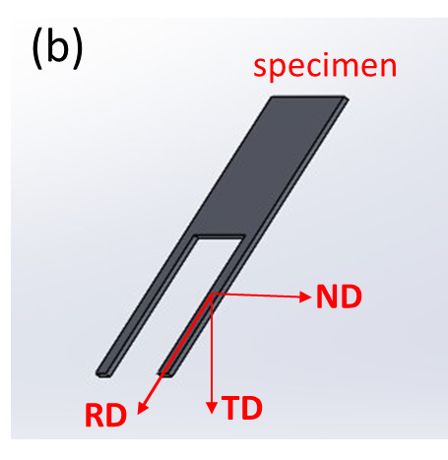

Fig. S3. Schematics of EBSD measurement geometry and coordinate systems: (a) EBSD measurement and the default coordinate system. The specimen illustrated is an extruded cup structure after polishing; (b) the coordinate system used for EBSD data processing, obtained from the default coordinate system by a 90°rotation with respect to the RD direction.

S4. Site-selective instrumented nanoindentation
Site-selective, instrumented nanoindentation was carried out using a NanoMechanics NanoFlip device interfaced to the Quanta3D SEM/FIB instrumentBerkovich tip calibration was conducted following the Oliver-Pharr indenter tip calibration procedures, using a factory supplied fused silica as the calibration specimen. Figure S4(a) shows an example of a 2×5 array of Berkovich indents made on top of a well-polished surface of an as-annealed Cu specimen, made at the same maximum load of 50 mN. The elastic modulus E and hardness H measured from the 10 indents are shown in Fig. S4(b), with averages of E = 111 ± 1 GPa and H = 0.69 ± 0.02 GPa. The measured value of E is consistent with the tabulated value for bulk Cu.
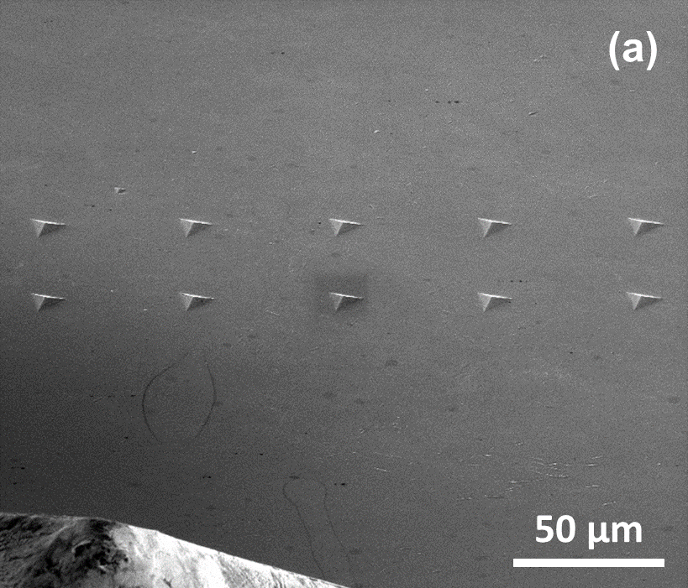

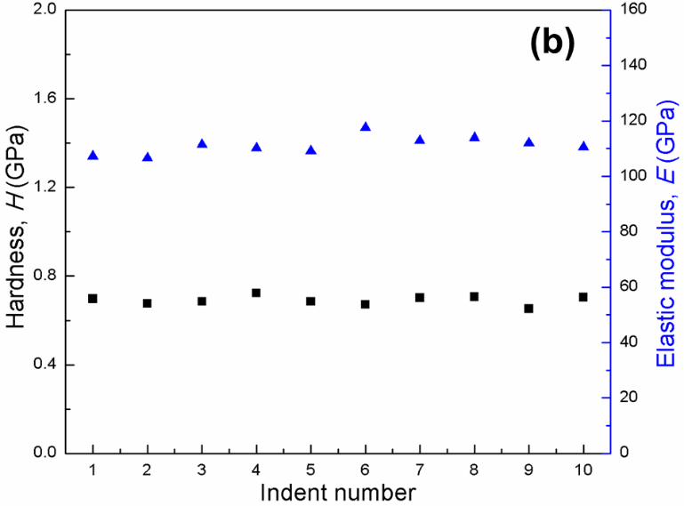

Fig. S4. Site-selective indentation on as-annealed Cu: (a) an SEM image of the 2×5 array of Berkovich indents made on well-polished surface of an as-annealed Cu specimen. A portion of the Berkovich indenter is visible on the lower left corner of the image; (b) measured elastic modulus and hardness values as a function of indent position (indent number).

S5. Continuum plasticity FEA modeling
Figure S5(a) shows a schematic illustration of the continuum plasticity FEA model for simulating the axisymmetric reverse extrusion process, with the die and the punch assumed to be rigid and the Cu assumed to be deformable. In all simulation runs, the plastic behavior of Cu was kept the same and assumed to be that obtained from the uniaxial compression tests on annealed Cu cylinders, with the σ - ε curves given in Fig. S2(b) in the S2 section. Figure S5(b) illustrates the finite element mesh for the deformable Cu, together with the rigid punch and die.
A direct comparison between the implicit and the explicit integration schemes were made. Output following the implicit integration scheme showed good stability, while that following the explicit integration scheme exhibited oscillations. The implicit time integration scheme was therefore chosen for all the simulations in the present work.
Mesh convergence tests were carried out. Numerical results obtained using 750, 1500, 2500, and 3500 elements were compared. Figure S5(c) shows one example of mesh convergence test results for the case of the 2.20 mm diameter punch. The numerical results using 2500 and 3500 elements are nearly equal to each other in all cases. A mesh density with 3500 elements was therefore used in all the simulations.
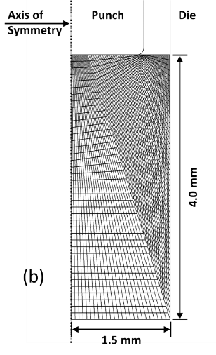
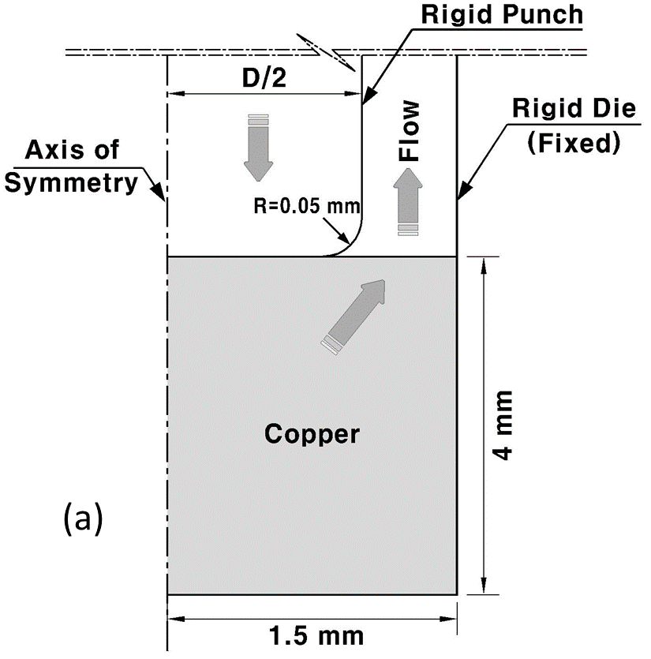
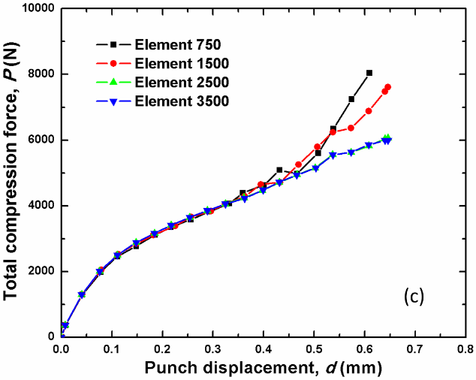

Fig. S5. Continuum plasticity FEA modeling of axisymmetric reverse extrusion: (a) a schematic of the FEA model of the axisymmetric reverse extrusion process, (b) the initial mesh for Cu (3500 elements); (c) a comparison between FEA simulation outputs with 750, 1500, 2500, and 3500 elements at a punch diameter of 2.2 mm.

S6. Converting raw extrusion force-displacement curves into actual mechanical response curves
Raw total compression force P versus total actuator displacement Δ curves associated with reverse extrusion need to be corrected for system compliance contributions and misfits between the initial Cu rod specimen and the die hole. A typical raw data set is shown in Fig. S6(a), plotting the total compression force P versus the total actuator displacement Δ obtained from a reverse extrusion run with a 2.2 mm diameter punch. Because measured Δ includes a system compliance contribution, Δ_{sys}, a separate measurement was made by removing the 3.0 mm diameter Cu rod specimen from the die hole and having the punch bottom surface contacting the bottom steel base plate directly, keeping all other components in the system intact. The result of such a system compliance measurement is shown in Fig. S6(b), where the measured total displacement is taken to be equal to Δ_{sys}. In this case of the 2.20 mm diameter punch, the measured system compliance is 1 mm/12.6 kN. Figure S6(c) shows the result of subtracting the system compliance contribution from the measured total displacement, i.e., P vs. Δ - Δ_{sys}. It is noted that the curve shown in Fig. S6(c) exhibits an initially more compliant section (outlined by the circle) where Δ - Δ_{sys} reaches ~80 µm when P is ~400 N (noted by the arrow). This initially more compliant section is followed by a stiffer section, where P increases more rapidly with increasing Δ - Δ_{sys}. This stiffer section is followed by a “knee”, after which P again increases more slowly with further increase in Δ - Δ_{sys}, in an almost linear fashion. Stylus profilometer measurements were conducted on Cu rod specimens after the value of Δ - Δ_{sys} reached ~80 µm, and showed that the depths of actual indentation on the top surface of the rod specimens were ~10 µm or less. This discrepancy is believed to result from misfits existing between the Cu rod specimen and the die hole, due to imperfections in die and Cu rod specimen geometries. Measured initial displacements, instead of being from actual punch penetration into the top specimen surface, are rather due to expansion of the rod specimen under compression to fill any misfit gaps between the rod specimen and the die hole. Only after such misfit gaps were filled does P increase more rapidly with increasing actual punch penetration into the top specimen surface. To correct for such misfits, the initially more compliant section of the curve shown in Fig. S6(c) was removed by shifting the origin of the x-axis forward by ~70 µm, as shown in Fig. S6(d). The x-value of the final reverse extrusion mechanical response curve shown in Fig. S6(d) is taken to represent the actual punch displacement into the top specimen surface, d. Measured system stiffness values vary with the punch diameter, and are listed in Table S1. Raw P – Δ curves obtained at each punch diameter were processed in the same manner as illustrated in Fig. S6 to arrive at the actual mechanical response associated with the axisymmetric reverse extrusion, i.e., the P – d curves.
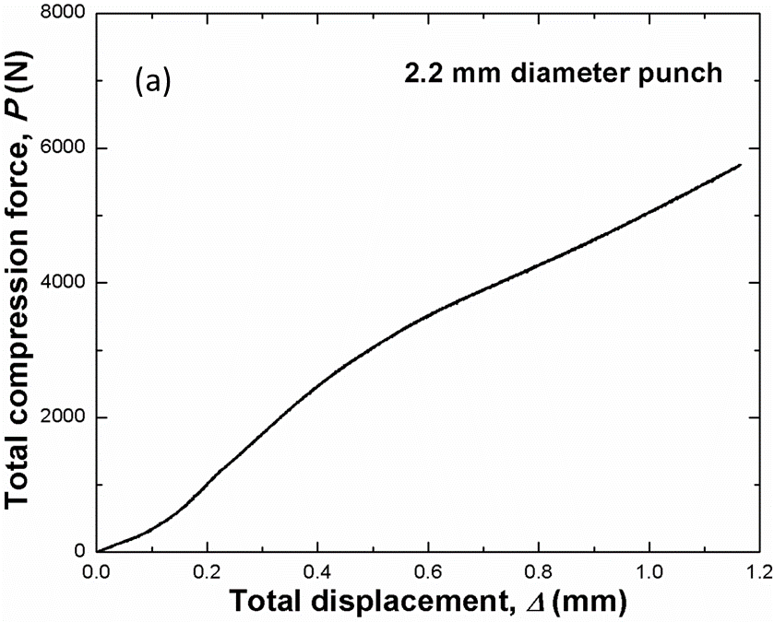
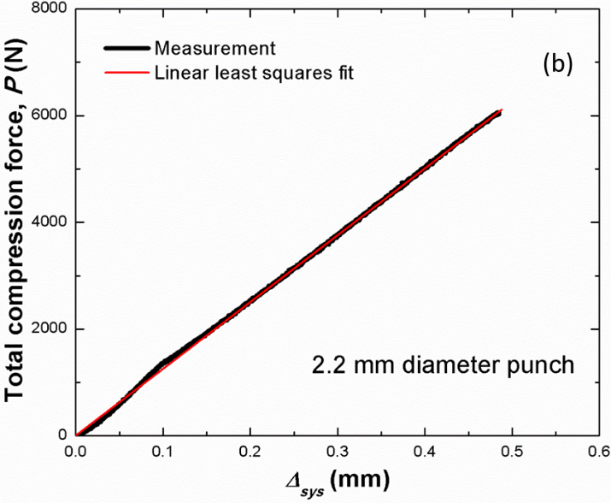

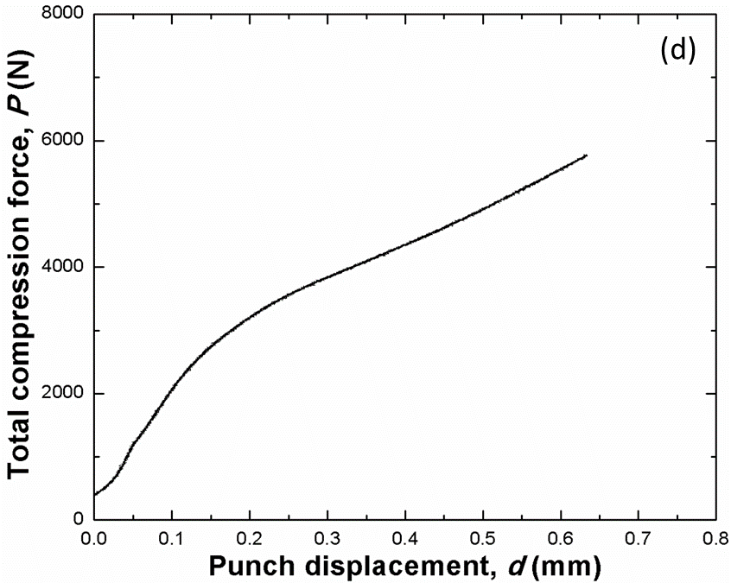
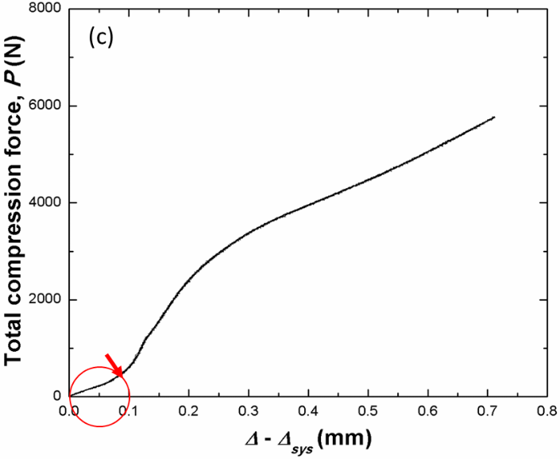

Fig. S6. Measuring mechanical response of axisymmetric reverse extrusion: (a) a typical raw P – Δ curve obtained with a 2.2 mm diameter punch; (b) a typical system compliance measurement using the same punch and reverse extrusion components without the Cu rod specimen; (c) compliance subtracted reverse extrusion response; (d) the true reverse extrusion response correcting for initial misfits between the rod specimen and the die hole.

Table. S1 Measured system stiffness at each punch diameter.
Punch diameter (mm) | 2.20 | 2.30 | 2.40 | 2.50 | 2.60 | 2.70 | 2.80 | 2.90 | 2.95
Average stiffness (kN/mm) | 12.6 | 13.8 | 14.0 | 15.3 | 16.7 | 16.7 | 17.2 | 17.6 | 18.3

