Fabrication and Size-dependent Mechanical Properties of Three-dimensional Microarchitected, High-temperature Ceramic Metamaterials
Huachen Cuiª, Ryan Hensleigh^{b}, Hongshun Chenª and Xiaoyu Zhengª
ª Department of Mechanical Engineering, Virginia Tech, Blacksburg, Virginia 24061, USA
^{b} Macromolecules Innovation Institute, Virginia Tech, Blacksburg, Virginia 24061, USA
Mailing address: 406 Goodwin Hall, Blacksburg, VA 24061
Corresponding author: X. Zheng, address above, Tel.: +1-540-231-6045, Email: raynexzheng@vt.edu.

Contents
- Fig. S1 Fractured surfaces of the tested PDC lattices.

- Fig. S2 Representative stress-strain curves of octet-truss lattice with 13% relative density and cuboctahedron lattice with 17% relative density.

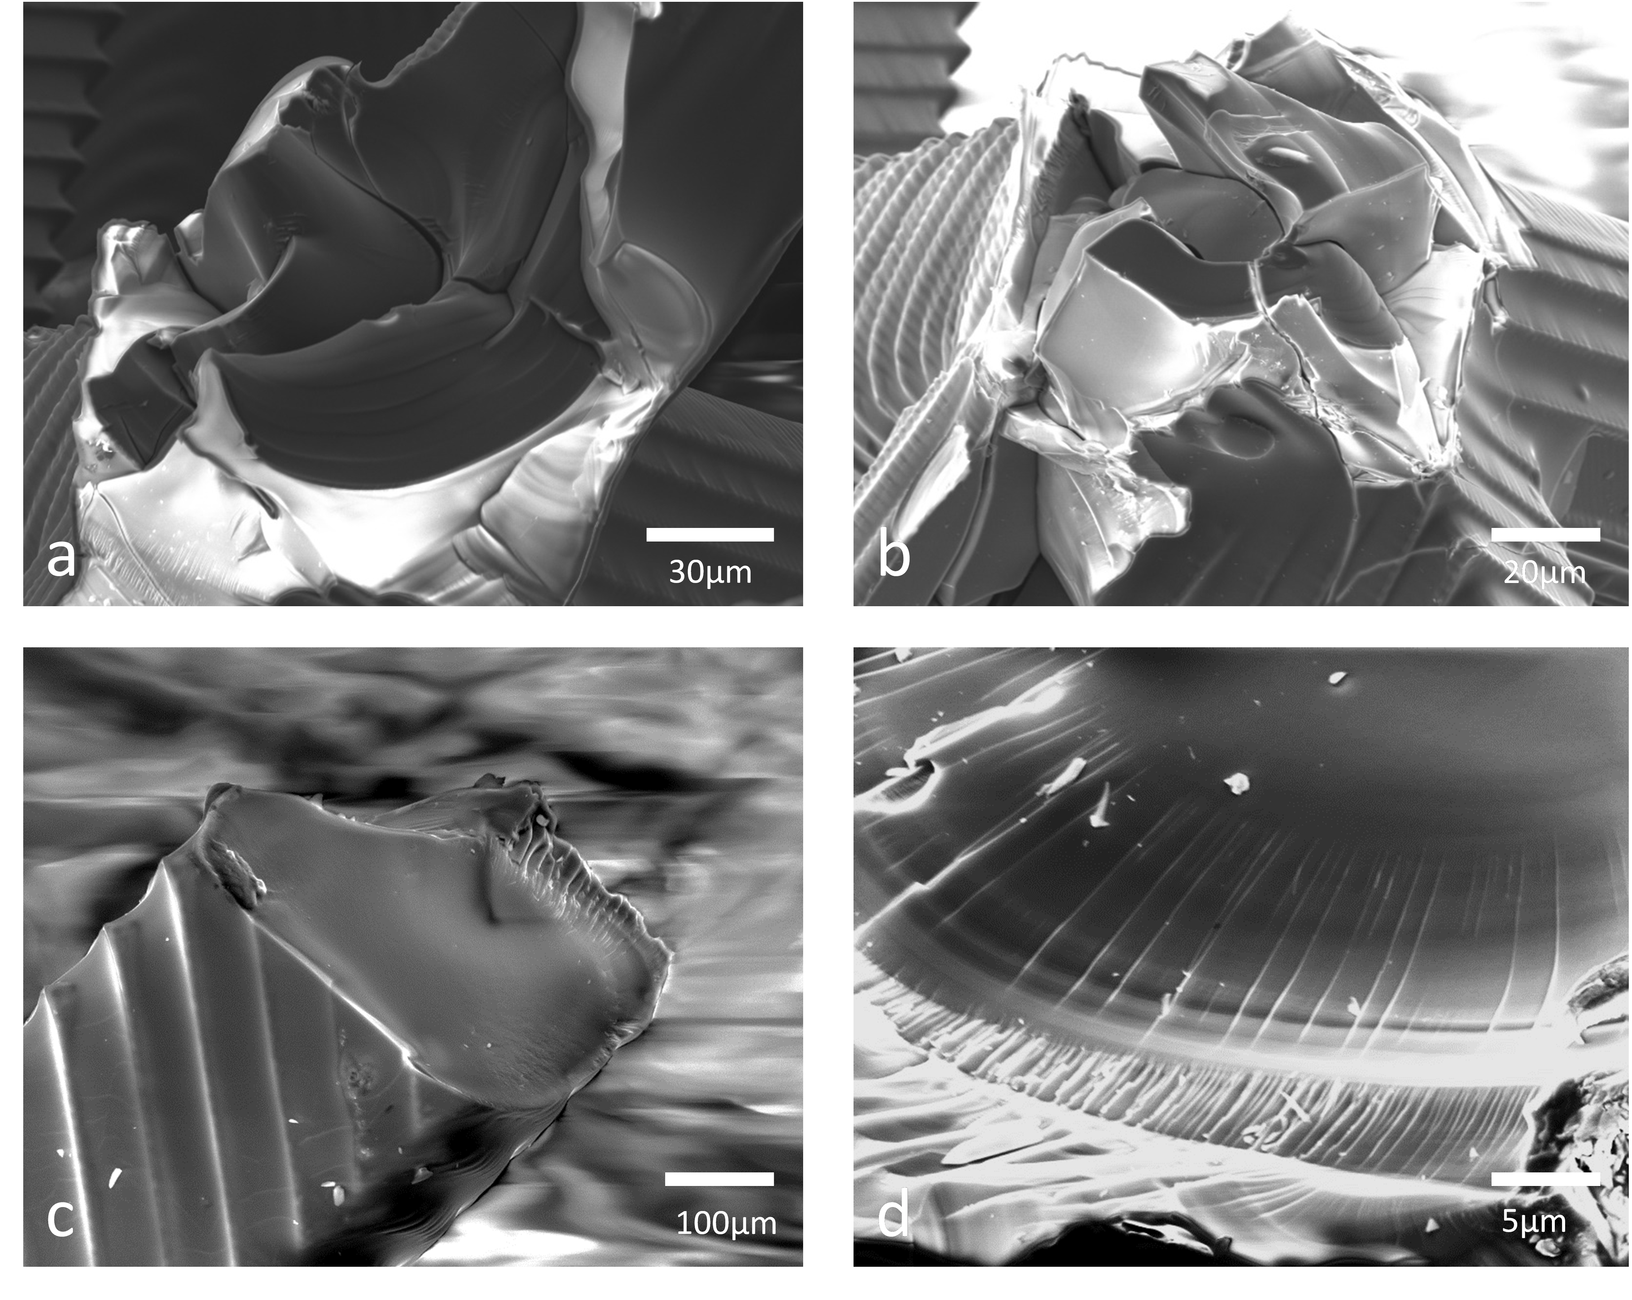
Fig. S1 Fractured surfaces of the tested PDC lattices. We performed compression tests and inspected their fracture surfaces. The easiest and most practical way is to inspect these surfaces under SEM¹. By inspecting these surfaces we indicated that the struts are visually fully dense.

1. Z.C. Eckel, C.Y. Zhou, J.H. Martin, A.J. Jacobsen, W.B. Carter and T.A. Schaedler: 3D PRINTING Additive manufacturing of polymer-derived ceramics Science. 351(6268), 58 (2016).

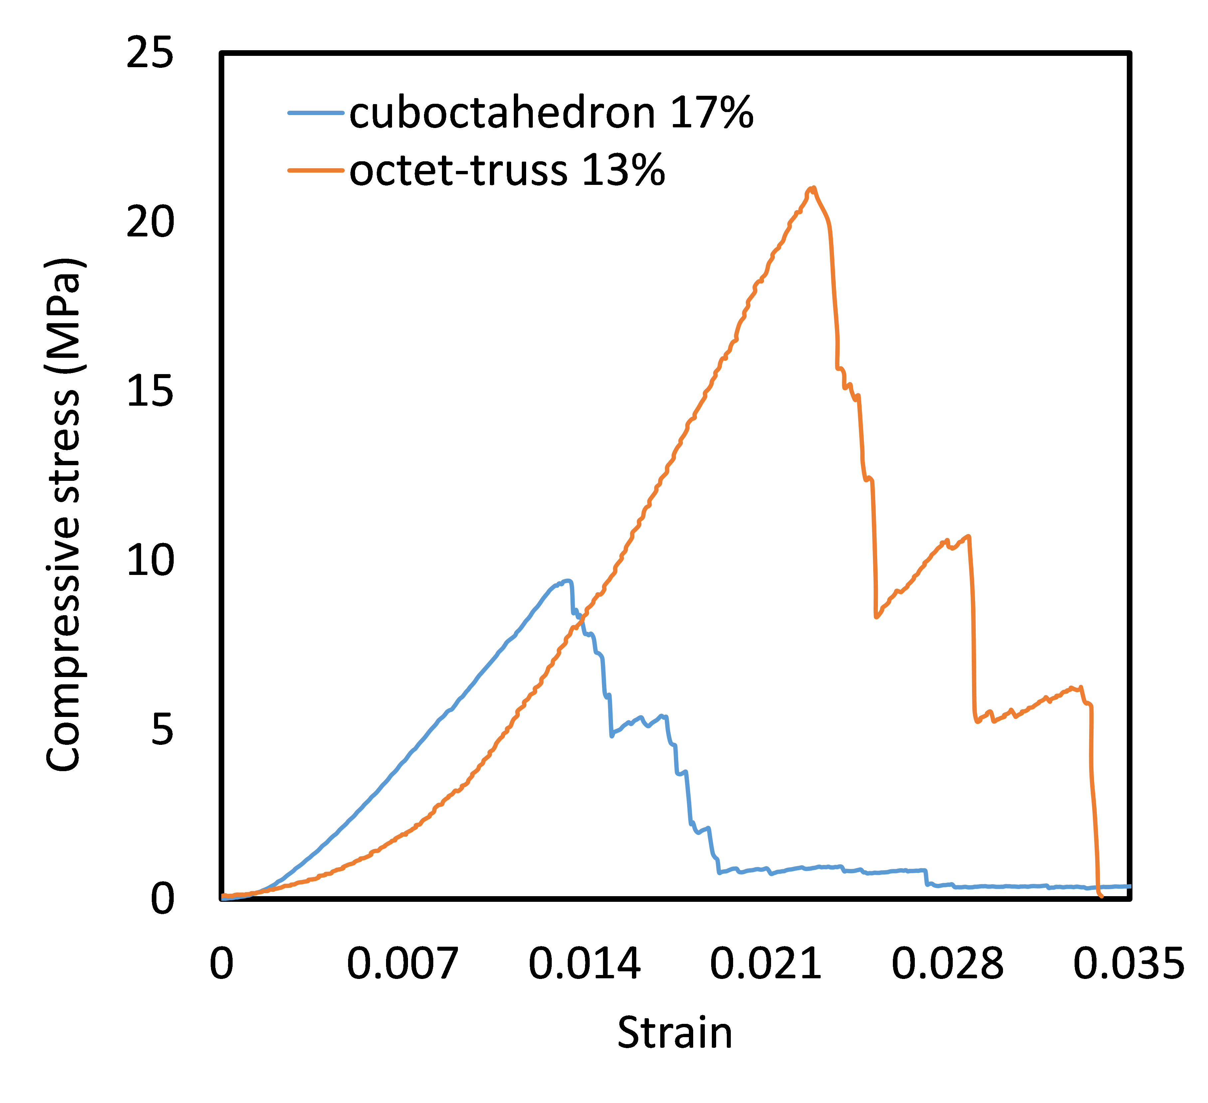
Fig. S2 Representative stress-strain curves of octet-truss lattice with 13% relative density and cuboctahedron lattice with 17% relative density. The strut volume for the octet-truss lattice is 0.000104mm3, while the strut thickness of the cuboctahedron lattice is 0.00144 mm3.

