Supplementary Information

Ni-Co composite metal embedded porous N-doped carbon for an effective binder-free supercapacitor electrode

Kejun Feng^{a*}, Huanfeng Huangª, Dandi Shi ^{c}, Guiqiang Diaoª, Xiyue Zhang ^{b**}

Calculations:
Specific capacitances of the electrodes were calculated from their CVs according to the following equation:
$C_{a}=\frac{Q}{∆V∙S}$$C_{s}=\frac{Q}{∆V×m}$ C_{s} = $\frac{Q}{ΔV×m}$ = $\frac{I×Δt}{ΔV×m}$ = $\frac{I}{\frac{ΔV}{Δt}×m}$ = $\frac{I}{ν×m}$ (1)
where C_{s} (F/g) is the specific capacitance, Q (C) is the average charge during the charging and discharging process, ∆V (V) is the potential window, Δt (s) is the charge/discharge time, I (A) is the discharge current, ν (V/s) is the scan rate, and m (g) is the mass loading of NCO or NCC electrode.

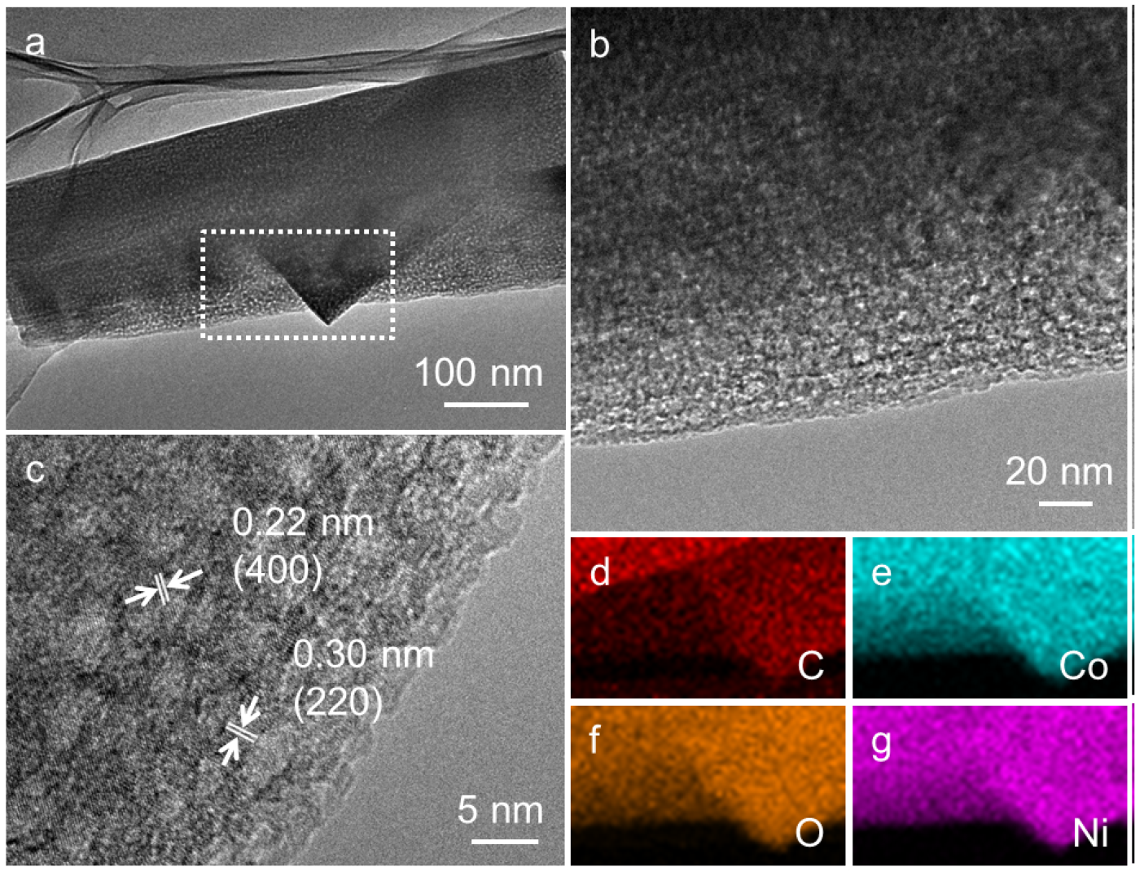
Fig. S1. (a) TEM image, (b) HRTEM image and (c) Enlarged HRTEM image of pristine NCO sample. (d-g) Elemental mappings of the selected area of NCO sample, revealing the elemental distributions of C, O, Co, and Ni.

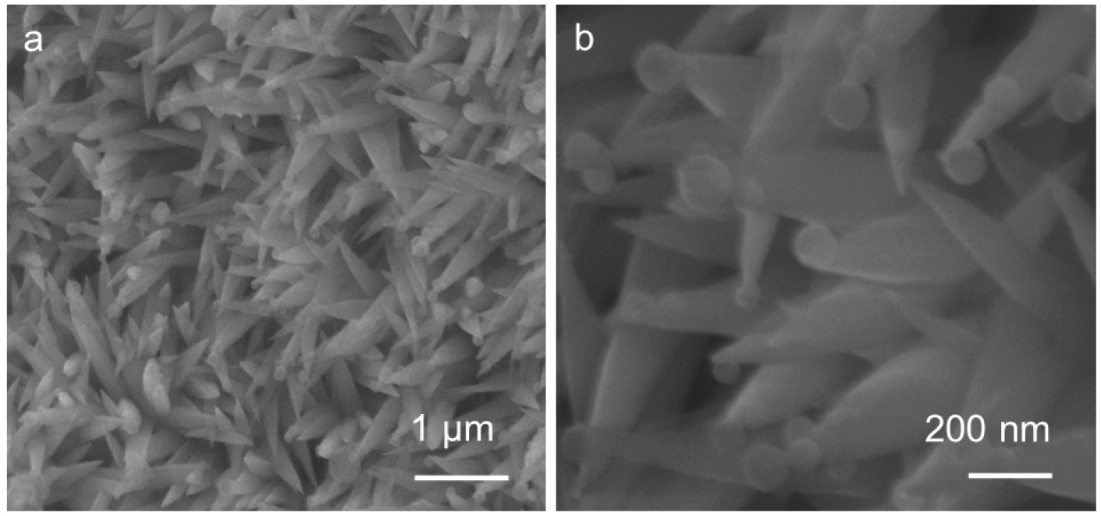
Fig. S2. (a) SEM image and (b) HRSEM image of the NCO/PANI sample.

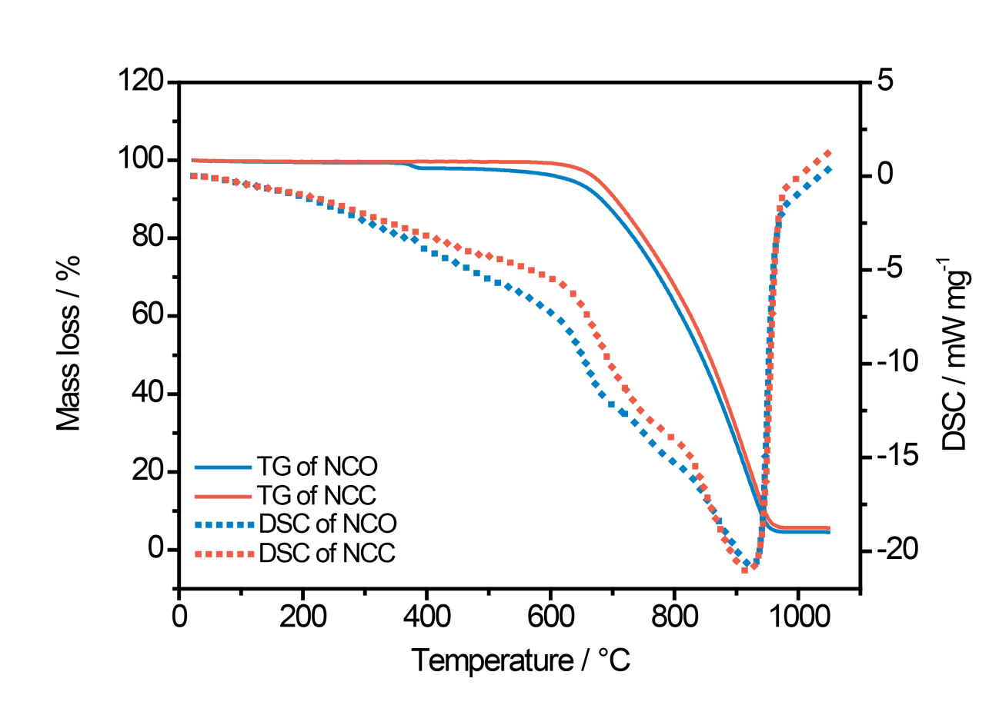
Fig. S3. Correspomding TG and DSC curves of the NCO and NCC electrode.

Fig. S4. (a) CV curves of NCO electrode collected at various scan rates. (b) Galvanostatic charge/discharge curves of NCO electrode collected at different current densities. (c) Specific capacitance as a function of the scan rate of the NCO and NCC electrode.

Fig. S5. GCD curves of (a) NCO electrode and (b) NCC electrode after different cycles. (c) Cycling performance of the NCO electrode collected at 5 mA cm⁻².

