Supporting Information

Investigation on the Properties of Hybrid CH₃NH₃Sn_{x}I₃ (0.9 ≤ x ≤ 1.4) Perovskite Systems

Lucangelo Dimesso^{a)}, Maximilian Stöhr, Chittaranjan Das, Thomas Mayer and Wolfram Jaegermann
Technische Universitaet Darmstadt, Materials Science Department, Jovanka-Bontschits-Strasse 2, D-64287 Darmstadt, Germany
Device preparation
FTO-coated glass sheets (FT15 Pilgington) were etched with zinc powder and hydrochloric acid (HCl (2M)) to obtain the required electrode pattern. The sheets were then washed with soap, deionized water, acetone, and 2-propanol, and finally treated under oxygen plasma for 10 min to remove the last traces of organic residues. A 100 nm thick compact layer of TiO₂ was then sprayed on the glass using titanium iso-propoxide acetilacetonate (99.999% purity) diluted in anhydrous ethanol and sintered for 45 min at 500°C. After the substrate was cooled down to RT, a 200 nm thick layer of TiO₂ was deposited via spin-coating at 5000 rpm for 45 sec. The substrate was then resintered at 500°C for 45min treated again under O₂-plasma for 15 min.
The MASnI₃ perovskite precursor solutions were prepared by dissolving the prepared powders in N-dimethylformamide (DMF) (20-30% w/w). The precursor solution was then spin coated onto the TiO₂ coated substrate under inert atmosphere. The perovskite layer formed during spin coating after heating up to 130°C for 15 min. After formation of the perovskite layer, the hole-transporting layer was then deposited by spin-coating a solution in chlorobenzene of 2,2′,7,7′-tetrakis(N,N′-di-p-methoxyphenylamine)9,9′-spirobifluorene (spiro-OMeTAD), with additives of lithium bis-(trifluoromethanesulfonyl)imide (added in acetonitrile solution) and 4-tert-butylpyridine. Finally gold electrodes were thermally evaporated under vacuum.
Solar cell characterization
Solar cell performance was measured using solar simulator which was calibrated to give simulated AM 1.5 sunlight at an irradiance of 100 mW cm⁻². Current–voltage curves were recorded using a sourcemeter (Keithley 2400, USA). All solar cells were masked with a metal aperture which was used to determine the active area of the devices, which in this case was 0.345 cm².

CHN-Elemental Analysis
CHN analyzer is a scientific instrument which can determine the elemental concentrations of Carbon (C), Hydrogen (H) and Nitrogen (N) in a given sample. This analytical technique can be extended to determine sulfur (S) and halogens (iodine, bromine, chlorine). Sample sizes may differ depending on system, but most often in around a few mg. In our case, the CHN-analysis was performed using a VarioEL III CHN Analyzer (Elementar).
A few milligrams of the samples (1-3 mg) were weighed up in tin crucibles and by combustion (with oxygen) oxidized to
C → CO₂; H →H₂O; N→ N₂, NO, NO₂
respectively. Then, the nitrogen oxides were reduced to elemental nitrogen on a Cu-column at high temperature (∼ 850°C). Finally the evolved gases were separated by gas-chromatography and detected with thermal conductivity detection.
The thermal conductivity detector (TCD), also known as a katharometer, is a bulk property detector and a chemical specific detector commonly used in gas chromatography. This detector senses changes in the thermal conductivity of the column effluent and compares it to a reference flow of carrier gas (helium). Since most compounds have a thermal conductivity much less than that of the common carrier gases of helium or hydrogen, when an analyte elutes from the column the effluent thermal conductivity is reduced, and a detectable signal is produced, digitalized and transferred to a connected computer.

FIG. S1 Typical XRD-patterns of the CH₃NH₃Sn_{x}I₃ systems after annealing in air at T = 150°C, t = 8 h.

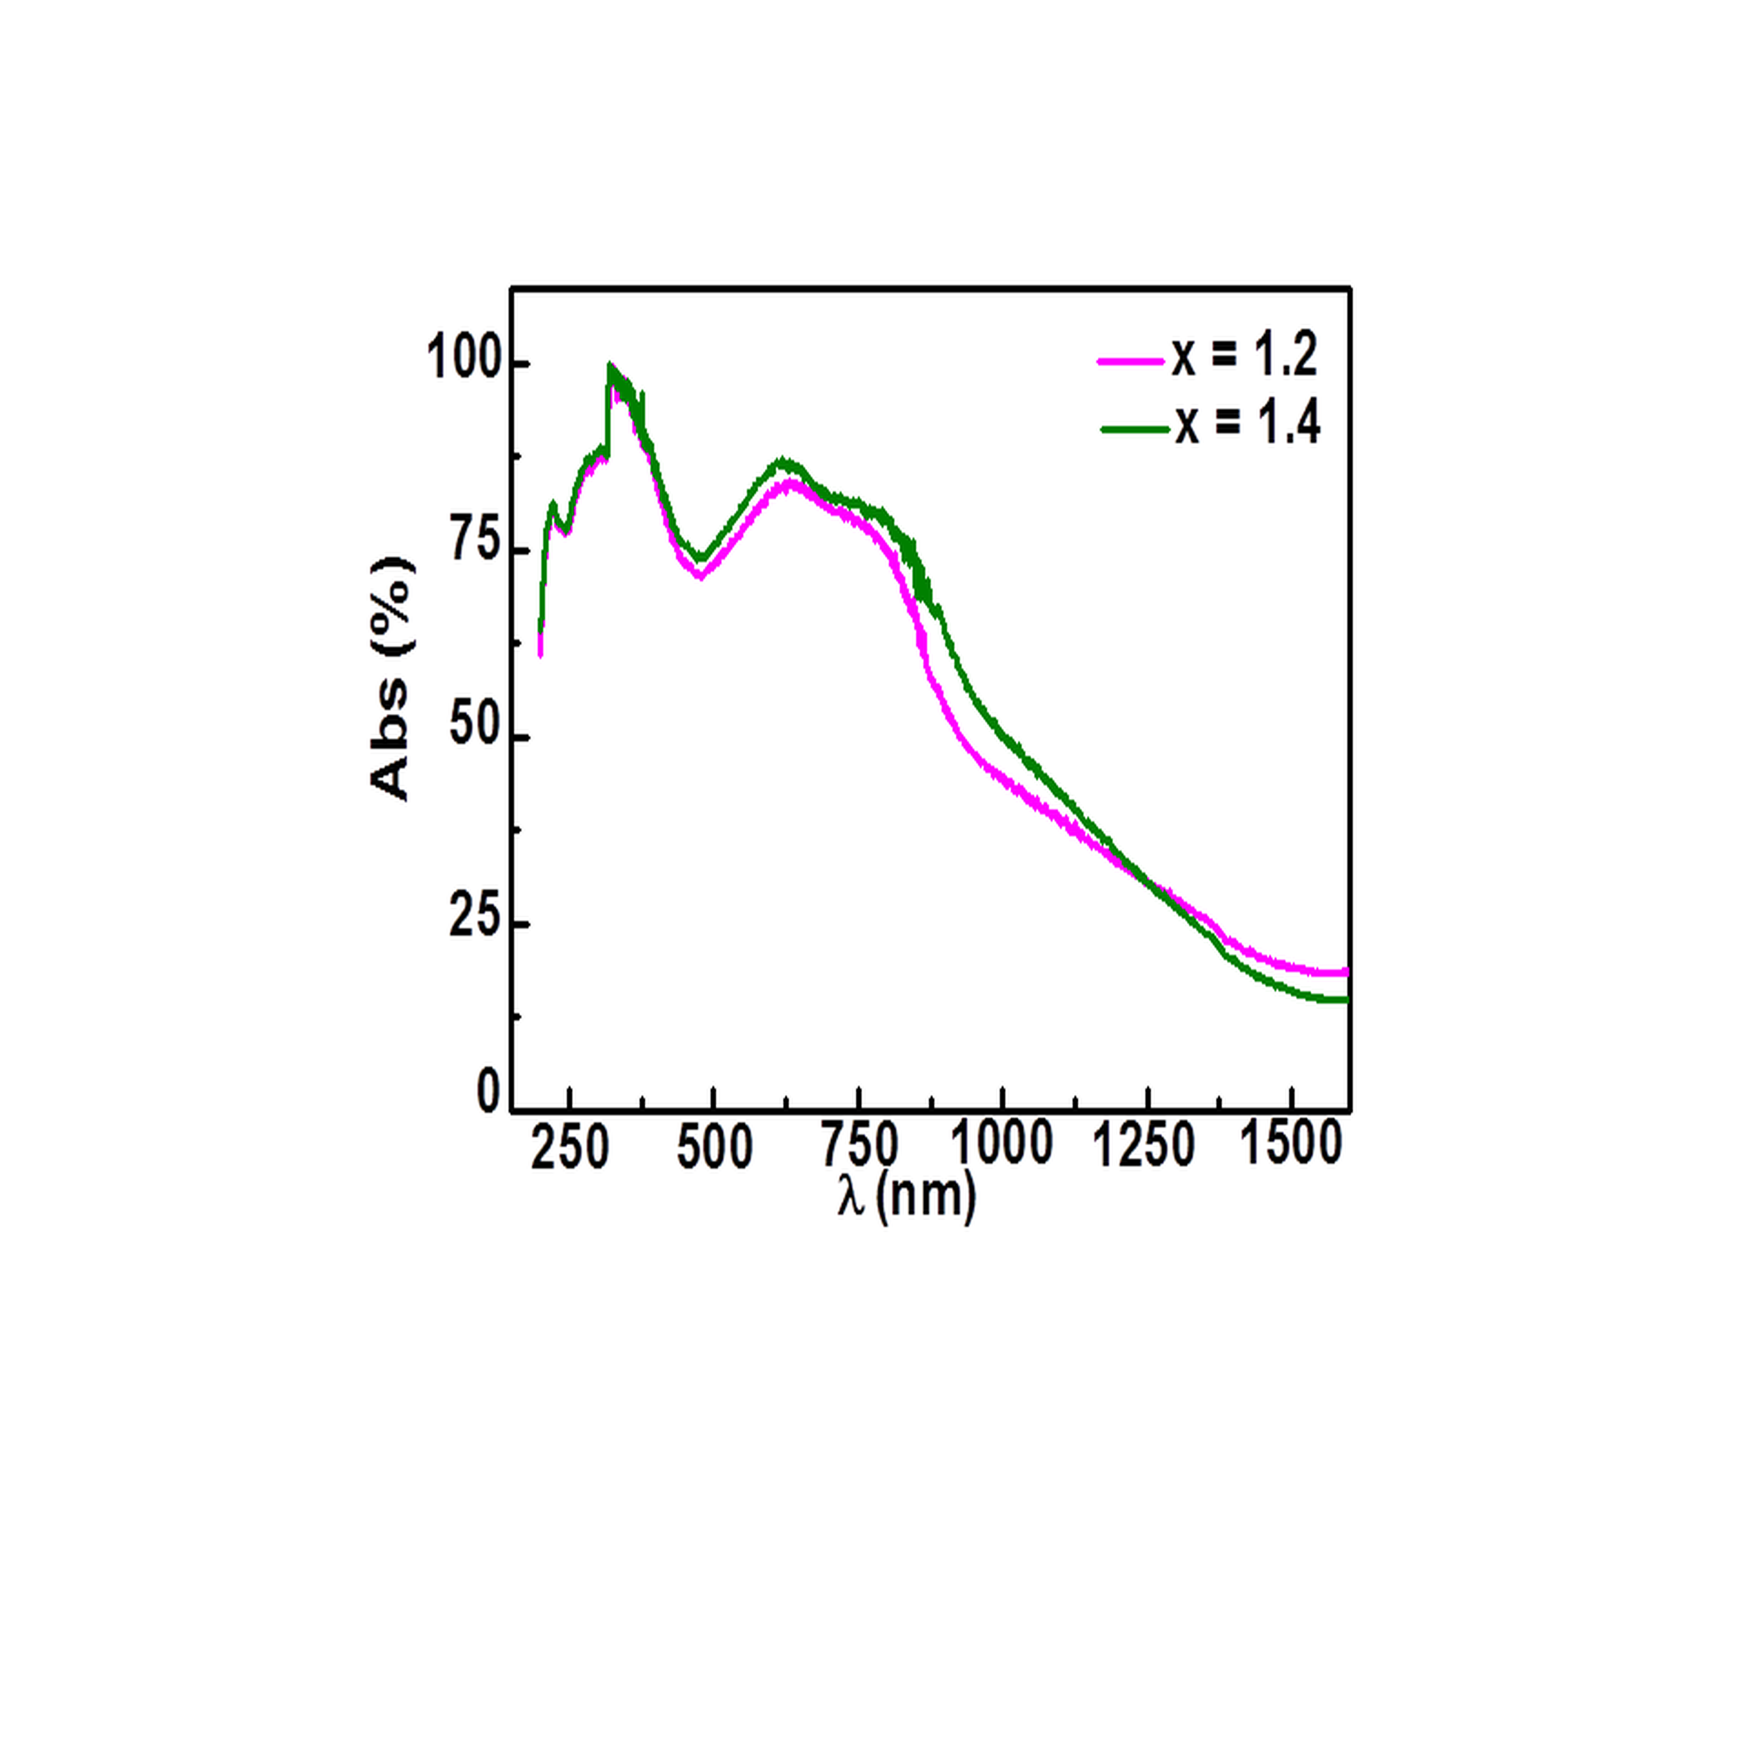

FIG. S2 Normalized absorption spectra of cubic-MASn_{x}I₃ systems for x = 1.2, x = 1.4.

X | Atmosphere | T (°C) | a | b | R²
0.9 | Nitrogen | 85 | 99.231±0.007 | -0.0022±1.0023x10⁻⁴ | 0.7674
 |  | 150 | 97.039±0.007 | -0.0480±9.851x10⁻⁵ | 0.9994
 | Air | 85 | 98.930±0.007 | -0.0062±7.234x10⁻⁵ | 0.9812
 |  | 150 | 92.392±0.030 | -0.2463±4.536x10⁻⁴ | 0.9995
1.0 | Nitrogen | 85 | 99.305±0.004 | -0.0039±6.4946x10⁻⁵ | 0.9806
 |  | 150 | 96.22±0.01 | -0.0693±1.425x10⁻⁴ | 0.9994
 | Air | 85 | 98.924±0.005 | -0.0098±7.872x10⁻⁵ | 0.9915
 |  | 150 | 89.941±0.079 | -0.2885±0.0011 | 0.9978
A linear fit of the data has been used: y = a + b•x

TABLE SI Values of the fit parameters for the CH₃NH₃Sn_{x}I₃ systems (x = 0.9 and x = 1.0) heated at constant temperature for t = 2h obtained from the data in Figure 3.

x | λ_{on-set} (nm) | E_{g} (eV) | PL maxima (nm)
0.9 | 1107.0 | 1.19(6) | 1064; 1078
1.0 | 1098.6 | 1.18(4) | 1014; 1057; 1084
1.1 | 1073.2 | 1.19(1) | 1014; 1058; 1084
1.2 | - | - | 1014; 1057; 1070; 1083
1.4 | - | - | 1014; 1040 ;1058; 1068; 1083

TABLE SII Absorption edge values and photoluminescence properties of the MASn_{x}I₃ systems. The adsorption edges (λ_{on-set} (nm)) were obtained by fitting the linear part of the absorbance spectra according to the model proposed in Ref. [2]. The optical band gap energy values have been calculated according to the model in Ref. [5]. The PL-maxima have been derived from the PL-profiles in Figure 5(a).

